



**MINISTRY OF EDUCATION AND TRAINING**

**FPT UNIVERSITY**

Capstone Project Document



**Application to support mother and baby care**

| **Group GSE21SE44** | |
| --- | --- |
| **Group Members** | Phạm Hoàng Duy – SE130096  Thân Quốc Bình – SE130088  Đỗ Lê Tú Uyên – SE62551  Bùi Hải Nam – SE130124 |
| **Supervisor** | Ms.Vũ Thị Thùy Dương |
| **Capstone Project code** | SU21SE09 |

– **Ho Chi Minh City, July 2021** –

*This page is intentionally left blank*

# Table of Contents

| Table of Contents 3  List of Tables 9  List of Figures 12  I. Project Introduction 15  1. Overview 15  1.1. Project Information 15  1.2. Project Team 15  1.2.1. Supervisors 15  1.2.2. Team Members 15  2. Product Background 15  3. Existing Systems 16  3.1. Traditional method 16  4. Business Opportunity 16  5. Software Product Vision 16  6. Project Scope & Limitations 17  II. Project Management Plan 17  1. Overview 17  1.1. WBS & Estimation 17  1.2. Project Objectives 17  1.3. Project Risks 17  2. Management Approach 18  2.1. Project Process 18  2.2. Quality Management 18  2.3. Training Plan 19  3. Project Communication 19  3.1. Communication Plan 19  3.2. External Interface 19  4. Configuration Management 20  4.1. Tools & Infrastructures 20  4.2. Document Management 20  4.3. Source Code Management 21  III. Software Requirement Specification 21  1. Overall Description 21  2. User Requirements 21  2.1. Overview 21  2.1.1. Use Case Diagram 21  2.1.2. System Actors 23  2.1.3. Use Cases List 23  2.2. Unauthenticated User 24  2.2.1. Login 24  2.3. User 26  2.3.1. Update Phone number 28  2.3.2. Get all list Vaccine 30  2.3.3. Get Vaccine detail 32  2.3.4. Get Vaccine Schedule 33  2.3.5. Create Diary 35  2.3.6. Get Diary Detail 37  2.3.7. Update Diary 38  2.3.8. Delete Diary 40  2.3.9. Get Children Detail 41  2.3.10. Update Children Detail 43  2.3.11. Delete Children 45  2.3.12. Follow Development Milestone 47  2.3.13. Create Family’s Profile 48  2.3.14. Get Family’s Profile Detail 51  2.3.15. Update Family’s Profile 53  2.3.16. Delete Family’s Profile 55  2.4 Staff 56  2.4.1. Create News 58  2.4.2. Get News Detail 60  2.4.3. Update News Detail 61  2.4.4. Delete News 63  2.4.5. Create Guidebooks 65  2.4.6. Get Guidebooks Detail 67  2.4.7. Update Guidebooks Detail 68  2.4.8. Delete Guidebooks 70  2.4.9. Create Guidebooks Type 72  2.4.10. Get Guidebooks Type Detail 74  2.4.11. Update Guidebooks Type Detail 75  2.4.12. Delete Guidebooks Type 77  2.4.13. Create News Type 78  2.4.14. Get News Type Detail 80  2.4.15. Update News Type Detail 81  2.4.16. Delete News Type 83  2.4.17. Get User Detail 84  2.4.18. Update User Status 86  2.4.19. Approve Post 87  2.4.20. Create Activity 89  2.4.21. Get Activity Detail 91  2.4.22. Update Activity Detail 92  2.4.23. Delete Activity 94  2.5. Firebase Service 95  2.5.1. Verify Phone number 96  3. Functional Requirements 98  3.1. Conceptual Diagram 98  3.2. Entity Relationship Diagram 99  3.3 System Functional Overview 101  3.3.1 Screen Flow 101  3.3.1.1 Customer application 102  3.3.1.2. Staff application 102  3.3.2 Screen details 103  3.3.2.1 Customer application 103  3.2.2.2 Staff application 105  4. Non-Functional Requirements 106  4.1. External Interfaces 106  4.1.1. User Interfaces 106  4.1.2. Software Interfaces 106  4.1.3. Communication Interfaces 107  4.2. Quality Attributes 107  4.2.1. Usability 107  4.2.2. Reliability 107  4.2.3. Portability 107  4.2.4. Security 107  IV. Software Design Description 107  1. Overall Description 107  1.1. Assumptions 107  1.2. Design Constraints 108  2. System Architecture Design 108  2.1. Overall Architecture 108  2.2. Package Diagram 109  3. System Detailed Design 111  3.1. Class Diagram 111  3.1.1 Class Diagram 111  3.1.2. Class Specifications 113  3.2. Sequence Diagram 121  3.2.1. Login 121  3.2.2. Get all news 123  3.2.3. Create news 124  3.2.4. Update news 125  3.2.5. Delete news 126  3.2.6. Get all user info 126  3.2.7. Delete user 127  3.2.8. Create guidebook 128  3.2.9. Update guidebook 129  3.2.10. Delete guidebook 130  3.2.11. Create guidebook type 131  3.2.12. Update guidebook type 132  3.2.13. Delete guidebook type 133  3.2.14. Create news type 134  3.2.15. Update news type 135  3.2.16. Delete news type 136  3.2.17. Approve post 137  3.2.18. Update diary 138  3.2.19. Get profile 139  3.2.20. Get all guidebook 140  3.2.21. Get all guidebook type 141  3.2.22. Get all news type 142  3.3. Activity Diagram 143  3.3.1. View news detail 144  3.3.2. Add diary 144  3.3.3. View diary detail 146  3.3.4. Edit diary 147  3.3.5. View vaccine schedule 148  3.3.6. View vaccine schedule detail 149  3.3.7. Add children information 150  3.3.8. Add father information 150  3.3.9. Public post to community 151  3.3.10. Update teething process 152  3.3.11. View guidebook detail 153  3.3.12. Update children information 154  4. Data & Database Design 156  4.1. Table Relationships 156  4.2. Data dictionary 157  V. Software Testing Documentation 172  1. Overall Description 172  1.1. Test Methodology 172  1.2. Testing Levels 173  2. Test Plan 173  2.1. Test Stages 173  2.2. Resources 173  2.3. Human Resources 173  2.4. Test Deliverables 173  3. Test Cases & Test Reports 173  VI. Release Package & User Guides 174  1. Deliverable Package 174  1.1. Documents 174  1.2. Source codes 174  1. Installation Guides 174  2.1. Front-End Deployment 174  2.2. Database 174  2.3. BackEnd Deployment 181  3. User Manual 185  3.1. Staff create news 185  3.2. Staff create news type 186  3.3. Staff create guidebook 188  3.4. Staff create guidebook type 189  3.5. Staff create activity 190  3.7. Overview 192  a. Login 192  b. Homepage 193  c. Menu 194  d. Change user account 195  3.8. Create User account data 196  3.8.1. Select to create user account data 197  a. Create father data 197  b. Edit mother data 199  c. Create baby/pregnancy data 200  3.9. Injection schedule 201  3.10. Community 202  3.11. Manage baby’s development 202  3.12. View News 205  3.13. View guidebook 208  3.14. Add diary 213  3.15. Check teeth growing process 214  3.16. Manage baby’s action 215 |
| --- |

# List of Tables

Table 1- Definition and Acronyms 15

Table 2- Supervisors 16

Table 3 - Team Members 16

Table 4 - Project risks 19

Table 5 - Training Plan 20

Table 6 - Communication Plan 20

Table 7 – External Interface 21

Table 8 – Tools & Infrastructures 21

Table 9 - System Actors 24

Table 10 - Use cases list 25

Table 11 - <Unauthorized User> Login 27

Table 12 - <User> Update phone number 31

Table 13 - <User> Get all list Vaccine 32

Table 14 - <User> Get Vaccine detail 34

Table 15 - <User> Get Vaccine Schedule 36

Table 16 - <User> Create Diary 37

Table 17 - <User> Get Diary Detail 39

Table 18 - <User> Update Diary 40

Table 19 - <User> Delete Diary 42

Table 20 - <User> Get Children Detail 44

Table 21 - <User> Update Children Detail 46

Table 22 - <User> Delete Children 47

Table 23 - <User> Follow Development Milestone 49

Table 24 - <User> Create Family’s Profile 51

Table 25 - <User> Get Family’s Profile 53

Table 26 - <User> Update Family’s Profile 56

Table 27 - <User> Delete Family’s Profile 57

Table 28 - <User> Create News 61

Table 29 - <Staff> Get News Detail 62

Table 30 - <User> Update News Detail 64

Table 31 - <Staff> Delete News 65

Table 32 - <Staff> Create Guidebooks 67

Table 33 - <Staff> Get Guidebooks Detail 69

Table 34 - <Staff> Update Guidebooks Detail 71

Table 35 - <Staff> Delete Guidebooks 72

Table 36 - <Staff> Create Guidebooks Type 74

Table 37 - <Staff> Get Guidebooks Type Detail 76

Table 38 - <Staff> Update Guidebooks Type Detail 77

Table 39 - <Staff> Delete Guidebooks Type 79

Table 40 - <Staff> Create News Type 80

Table 41 - <Staff> Get News Type Detail 82

Table 42 - <Staff> Update News Type Detail 83

Table 43 - <Staff> Delete News Type 85

Table 44 - <Staff> Get User Detail 86

Table 45 - <Staff> Update User Status 88

Table 46 - <Staff> Approve Post 89

Table 47 - <Staff> Create Activity 91

Table 48 - <Staff> Get Activity Detail 93

Table 49 - <Staff> Update Activity Detail 95

Table 50 - <Staff> Delete Activity 96

Table 51 - <Firebase System> Verify Phone number 99

Table 52 - Entity Data Dictionary 102

Table 53 - <Customer application> Screen details 106

Table 54 - <Staff application> Screen details 107

Table 55 - Architecture Diagram Dictionary 110

Table 56 - Component Diagram Dictionary 111

Table 57 - <Class Specification> User 114

Table 58 - <Class Specification> MomInfo 114

Table 59 - <Class Specification> DadInfo 114

Table 60 - <Class Specification> News 115

Table 61 - <Class Specification> Token 115

Table 62 - <Class Specification> Injection Schedule 115

Table 63 - <Class Specification> Tooth 116

Table 64 - <Class Specification> NewsType 116

Table 65 - <Class Specification> Role 116

Table 66 - <Class Specification> ChildInfo 116

Table 67 - <Class Specification> Diary 117

Table 68 - <Class Specification> PregnancyHistory 117

Table 69 - <Class Specification> Activity 118

Table 70 - <Class Specification> Vaccine 118

Table 71 - <Class Specification> Vaccine History 119

Table 72 - <Class Specification> GuidebookType 119

Table 73 - <Class Specification> ActivityType 119

Table 74 - <Class Specification> GuidebookMom 119

Table 75 - <Class Specification> NewsMom 119

Table 76 - <Class Specification> Guidebook 120

Table 77 - <Class Specification> User 120

Table 78 - <Class Specification> UserNotification 120

Table 79 - <Class Specification> Notification 121

Table 80 - <Class Specification> InjectedPerson 121

Table 81 - <Class Specification> InjectedPerson 121

Table 82 - <Class Specification> Action 122

Table 83 - <Class Specification> ActionChild 122

Table 84 - <Class Specification> ToothInfo 122

Table 85 - <Data dictionary> UserInfo 158

Table 86 - <Data dictionary> MomInfo 158

Table 87 - <Data dictionary> DadInfo 159

Table 88 - <Data dictionary> News 160

Table 89 - <Data dictionary> Token 160

Table 90 - <Data dictionary> Injection Schedule 161

Table 91 - <Data dictionary> NewsType 162

Table 92 - <Data dictionary> Role 162

Table 93 - <Data dictionary> ChildInfo 163

Table 94 - <Data dictionary> Diary 164

Table 95 - <Data dictionary> PregnancyHistory 165

Table 96 - <Data dictionary> Activity 166

Table 97 - <Data dictionary> Vaccine 167

Table 98 - <Data dictionary> Vaccine History 168

Table 99 - <Data dictionary> GuidebookType 168

Table 100 - <Data dictionary> ActivityType 168

Table 101 - <Data dictionary> GuidebookMom 169

Table 102 - <Data dictionary> NewsMom 169

Table 103 - <Data dictionary> Guidebook 170

Table 104 - <Data dictionary> User 170

Table 105 - <Data dictionary> UserNotification 171

Table 106 - <Data dictionary> Notification 171

Table 107 - <Data dictionary> InjectedPerson 172

Table 108 - <Data dictionary> Standard Index 172

Table 109 - <Data dictionary> ToothInfo 173

Table 110 - <Data dictionary> Tooth 173

Table 111 - Test Stages 174

Table 112 - Human Resources in Testing phrase 174

Table 113 - Test Deliverables 174

Table 114 - Test Cases Documentations 175

Table 115 - Release Package: Document 175

Table 116 - Release Package: Source Code 175

# List of Figures

Figure 1 - <Reference> Scrum Framework 19

Figure 2 - System Overview Use Case Diagram 23

Figure 3 - <Unauthorized User> Login 25

Figure 4 - <User> Overview Use Case Diagram 28

Figure 5 - <User> Update phone number 29

Figure 6 - <User> Get all list Vaccine 31

Figure 7 - <User> Get Vaccine detail 33

Figure 8 - <User> Get Vaccine detail 34

Figure 9 - <User> Create Diary 36

Figure 10 - <User> Get Diary Detail 38

Figure 11 - <User> Update Diary 39

Figure 12 - <User> Delete Diary 41

Figure 13 - <User> Get Children Detail 42

Figure 14 - <User> Update Children Detail 44

Figure 15 - <User> Delete Children 46

Figure 16 - <User> Follow Development Milestone 48

Figure 17 - <User> Create Family’s Profile 49

Figure 18 - <User> Get Family’s Profile 52

Figure 19 - <User> Update Family’s Profile 54

Figure 20 - <User> Delete Family’s Profile 56

Figure 21 - <Staff> Overview Use Case Diagram 58

Figure 22 - <Staff> Create News 59

Figure 23 - <Staff> Get News Detail 61

Figure 24 - <Staff> Update News Detail 62

Figure 25 - <Staff> Delete News 64

Figure 26 - <Staff> Create Guidebooks 66

Figure 27 - <Staff> Get Guidebooks Detail 68

Figure 28 - <Staff> Update Guidebooks Detail 69

Figure 29 - <Staff> Delete Guidebooks 71

Figure 30 - <Staff> Create Guidebooks Type 73

Figure 31 - <Staff> Get Guidebooks Type Detail 75

Figure 32 - <Staff> Update Guidebooks Type Detail 76

Figure 33 - <Staff> Delete Guidebooks Type 78

Figure 34 - <Staff>Create News Type 79

Figure 35 - <Staff> Get News Type Detail 81

Figure 36 - <Staff> Update News Type Detail 82

Figure 37 - <Staff> Delete News Type 84

Figure 38 - <Staff> Get User Detail 85

Figure 39 - <Staff> Update User Status 87

Figure 40 - <Staff> Approve Post 88

Figure 41 - <Staff> Create Activity 90

Figure 42 - <Staff> Get Activity Detail 92

Figure 43 - <Staff> Update Activity Detail 93

Figure 44 - <Staff> Delete Activity 95

Figure 45 - <Firebase Service> Verify Phone number 97

Figure 46 - Conceptual Diagram 100

Figure 47 - Entity Relationship Diagram 102

Figure 48 - <Customer application> Screen flow 103

Figure 49 - <Staff application> Screen flow 104

Figure 50 - System Overall Architecture Diagram 109

Figure 51 - Package Diagram 111

Figure 52 - Class Diagram 113

Figure 53 - <Sequence Diagram> Login 123

Figure 54 - <Sequence Diagram> Get all News 124

Figure 55 - <Sequence Diagram> Create News 125

Figure 56 - <Sequence Diagram> Update news 126

Figure 57 - <Sequence Diagram> Delete news 127

Figure 58 - <Sequence Diagram> Get all user info 128

Figure 59 - <Sequence Diagram> Delete user 129

Figure 60 - <Sequence Diagram> Create guidebook 130

Figure 61 - <Sequence Diagram> Update guidebook 131

Figure 62 - <Sequence Diagram> Delete guidebook 132

Figure 63 - <Sequence Diagram> Create guidebook type 133

Figure 64 - <Sequence Diagram> Update guidebook type 134

Figure 65 - <Sequence Diagram> Delete guidebook type 135

Figure 66 - <Sequence Diagram> Create news type 136

Figure 67 - <Sequence Diagram> Update news type 137

Figure 68 - <Sequence Diagram> Delete news type 138

Figure 69 - <Sequence Diagram> Approve post 139

Figure 70 - <Sequence Diagram> Update diary 140

Figure 71 - <Sequence Diagram> Get profile 141

Figure 72 - <Sequence Diagram> Get all guidebook 142

Figure 73 - <Sequence Diagram> Get all guidebook type 143

Figure 74 - <Sequence Diagram> Get all news type 144

Figure 75 - <Activity Diagram> View news detail 145

Figure 76 - <Activity Diagram> Add diary 146

Figure 77 - <Activity Diagram> View diary detail 147

Figure 78 - <Activity Diagram> Edit diary 149

Figure 79 - <Activity Diagram> View vaccine schedule 150

Figure 80 - <Activity Diagram> View vaccine schedule detail 150

Figure 81 - <Activity Diagram> Add children information 151

Figure 82 - <Activity Diagram> Add children information 152

Figure 83 - <Activity Diagram> Public post to community 153

Figure 84 - <Activity Diagram> Update teething process 154

Figure 85 - <Activity Diagram> View guidebook detaill 155

Figure 86 - <Activity Diagram> Update children information 156

Figure 87 - Physical Diagram 157

**Definition and Acronyms**

| **Name** | **Definition** |
| --- | --- |
| Mumbi | Ứng dụng hỗ trợ thông tin chăm sóc mẹ và bé |

*Table 1- Definition and Acronyms*

# Project Introduction

## 1. Overview

### 1.1. Project Information

* Project name: Application to support mother and baby care
* Vietnamese name: Ứng dụng hỗ trợ thông tin chăm sóc mẹ và bé - Mumbi.
* Project code: SU21SE09.
* Group code: GSU21SE44.
* Software type: Mobile Application, Web Application.

### 1.2. Project Team

### 1.2.1. Supervisors

| **Full Name** | **Email** | **Phone Number** | **Title** |
| --- | --- | --- | --- |
| Vũ Thị Thùy Dương | duongvtt9@fe.edu.vn | 0986550927 | Lecturer |

*Table 2- Supervisors*

### 1.2.2. Team Members

| **Full Name** | **Email** | **Phone Number** | **Role** |
| --- | --- | --- | --- |
| Phạm Hoàng Duy | duyphse130096@fpt.edu.vn | 0768372329 | Leader |
| Thân Quốc Bình | binhtqse130088@fpt.edu.vn | 0768048769 | Member |
| Bùi Hải Nam | nambhse130124@fpt.edu.vn | 0834091456 | Member |
| Đỗ Lê Tú Uyên | uyendltse62551@fpt.edu.vn | 0364472908 | Member |

*Table 3 - Team Members*

## 2. Product Background

Nowadays, the population is increasing dramatically and with the development of the internet, mothers have to spend a lot of time on the internet looking for child care guides, but there are hundreds of articles. It is really difficult to select a reliable article.

To solve these problems, we have developed our application called Mumbi, Mumbi is an application where mothers can monitor their baby's health status according to a graph drawn by self-entered data (including ages, health index, activities, ...). Moreover, monitoring stages of teething and vaccination are two important concerns that Mumbi will support and provide trusty information to avoid mothers’ confusion. Finally, based on the diary feature, mothers can share their baby's first milestones and then exchange, learn new tips from other mothers from the miniature community of Mumbi.

## 3. Existing Systems

### 3.1. Traditional method

When the mother and baby go to the doctor, the medical examination book will be used to keep track of their health during and after pregnancy. This is problematic since the book can easily be misplaced, resulting in a lack of necessary information and wasted time.

**Pros**

* Parents do not need the internet or smartphone to keep information.

**Cons**

* Handwriting of a doctor may be hard to read.
* Parents find it hard to follow and keep track of a baby's development through each stage.
* Parents will lose data on their children.
* Parents can not communicate with doctors when their baby has a bad reaction to the medicine after the injection.

## 4. Business Opportunity

The quality of life has increased in recent years, and women now desire an app that can track all of their baby's information in detail, both during and after pregnancy.

Such as in the stage of pregnancy, what period they are in, pregnancy health and useful suggestions for that time.

An application where they can interact with people who have experience in taking care of young children, sharing their baby's memorable moments. In addition, they can track the child's immunization status, as well as read news and handbooks that will help parents learn more about education and assist the child develop optimally.

## 5. Software Product Vision

The application includes web application and mobile application. Web application is for employees, they do some professional tasks such as updating daily news, creating parenting guides, managing users, as well as approving posts.

Mobile app is aimed at mothers. They can update their baby's health data, their pregnancy status and finally build a family tree. Then this mobile application is considered as a useful handbook for mothers when it has practical features such as diary function, observing teething process. Particularly, they can view the vaccines on the list of recommended vaccinations, vaccination schedule and information to know after vaccination.

## 6. Project Scope & Limitations

**6.1.** **Major Features**

Reference to [Mumbi UserStory](https://docs.google.com/spreadsheets/u/1/d/1Gwk6GD3_K6S55rU3EGqdMfsdEKPrIkxPlgQK3sm2jUE/edit)

**6.2.** **Limitations & Exclusions**

LI-1: Twins, triplets are still our problems

LI-2: The system doesn’t support offline activities (contest for children, nutrition consulting, seminar).

LI-3: Buying and selling activities are beyond our (old furniture, baby items).

LI-4: Accumulating personal points is not supported by our system.

# Project Management Plan

## Overview

### WBS & Estimation

Reference to [Mumbi Sprint Backlog](https://docs.google.com/spreadsheets/d/1kCvDnlVReb_4tA43p_0lDAK5mRgLmtNHE3Vy76ylWkk/edit?usp=sharing)

### Project Objectives

* Timeliness: 70%
* Allocated Effort: 4 (members) * 12 (sprints) * 7 (days/sprint) = 336 man-days
* Estimated total cost:
* Quality:
* Be able to run a real environment.
* Users can learn to use the system within 3-5 days.
* Saving time in reviewing and distributing subscriptions.

### Project Risks

| **#** | **Risk description** | **Impact** | **Possibility** | **Response plan** |
| --- | --- | --- | --- | --- |
| 1 | Members disagreed their own opinion with each other, leading to controversy | Because of conflicts and misunderstanding, progress is delayed. | Medium | Asking mentor to resolve it or vote |
| 2 | Lacking of technical knowledge on specific areas of the product | High | Low | Researching and getting advice from the supervisor |

*Table 4 - Project risks*

## Management Approach

### Project Process

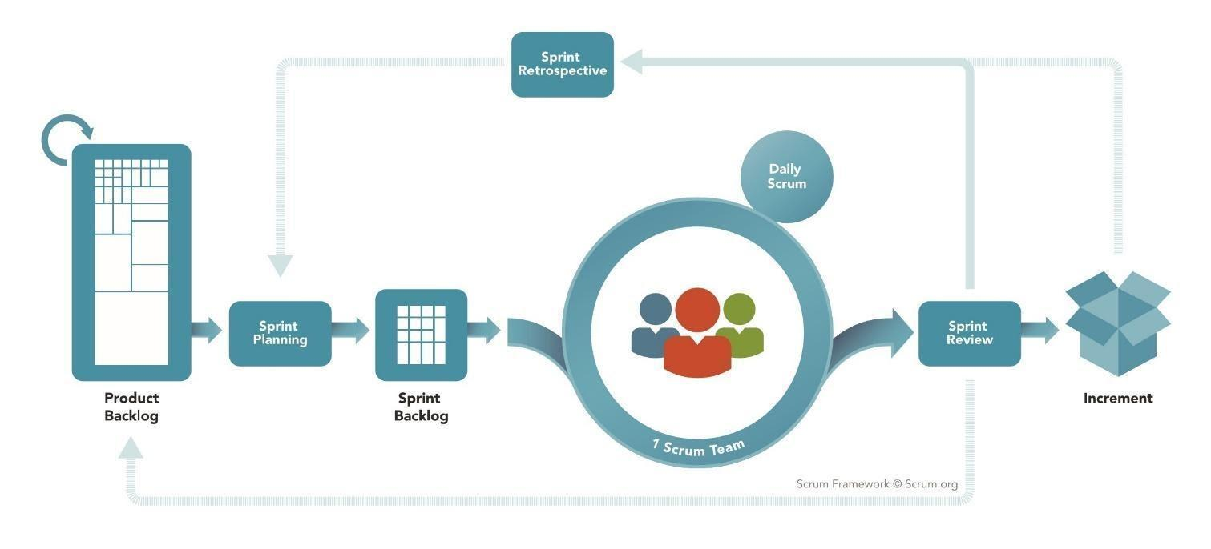

*Figure 1 - <Reference> Scrum Framework*

Reference: <https://www.scrum.org/resources/what-is-scrum>

Mumbi is developed using the Scrum model which is an agile framework for developing, delivering and maintaining products. Our team chooses this model for the following reasons:

* Scrum is designed for small and medium-sized projects, which is ideal for our four-person team.
* Each feature is assigned to two members, one is responsible for Front End, the other is in charge of Back End. This means that every person has to complete all the steps: designing, coding, implementing and testing, while still concentrating on their strengths. This allows us to work independently yet being able to collaborate and assist one another in every step of the process.
* For this project, each sprint spans 10 days and the duration of our product backlog is 11 sprints.

### Quality Management

To maximize the project quality, our team will apply the following tactics to improve the project quality:

* User acceptance tests as we develop more features.
* Cross-review each other’s code.

### Training Plan

| **Training Area** | **Participants** | **When, Duration** | **Waiver Criteria** |
| --- | --- | --- | --- |
| **C# & .Net core** | All team member | 20 man-days | Mandatory |
| **VueJs** | All team member | 20 man-days | Mandatory |
| **Firebase** | All team member | 4 man-days | Mandatory |
| **Git, Github** | All team member | 2 man-days | Mandatory |
| **Flutter** | All team member | 20 man-days | Mandatory |

*Table 5 - Training Plan*

## 3. Project Communication

### 3.1. Communication Plan

| **Communication Item** | **Who/target** | **Purpose** | **When, Frequency** | **Type,**  **Tool,**  **Method(s)** |
| --- | --- | --- | --- | --- |
| Computer | Team member | Internal communication | Always | Google meet |
| Phone | Supervisor | Upper Communication | Always | No |
| In-Person | Team members &  Supervisor | Get everyone on the same page | Daily 2 times/week | Face to face |
| In-Person | Team members & End-user | Confirm process | Weekly | Face to face |

*Table 6 - Communication Plan*

### 3.2. External Interface

| **Function** | **Contact Person (name, position)** | **Contact address (email, telephone)** | **Responsibility** |
| --- | --- | --- | --- |
| End-User | Vũ Thị Thùy Dương | duongvtt9@fe.edu.vn | - Provide document template  - Give instruction to project team  - Review deliverables  - Supervise project status  - Specify user requirement  - Control the development process  - Give out technique and business analysis support  - Analyze business rules  - Review the document and review project |
| End-User | More than 25 users |  | − Using and feedback. |

*Table 7 – External Interface*

## 4. Configuration Management

### 4.1. Tools & Infrastructures

| **Tools & Infrastructures** | **Names** |
| --- | --- |
| **Programming languages** | C#, Dart |
| **Framework** | VueJS 2.6, .Net Core 2.2, Entity Framework, Flutter |
| **DBMS** | SQL Server |
| **IDEs/Editors** | Visual Studio Code, IntelliJ |
| **UML tools** | StarUML, Draw.io |
| **Version Control** | Git |
| **Deployment server** | Amazon Web Service |
| **Project management tool** | Trello |

*Table 8 – Tools & Infrastructures*

### 4.2. Document Management

The project documents will be managed using Google Drive: <https://drive.google.com/drive/folders/1DjlNHjuP8RjWHeyc4Zfa_1qxY0G-tZZd?usp=sharing>

### 4.3. Source Code Management

The project source code will be managed: <https://drive.google.com/drive/folders/17q-h683r3qlisoBvCvjtLFABuv3x0kvw?usp=sharing>

# III. Software Requirement Specification

## 1. Overall Description

* Mumbi can create a form for users (specifically the mothers) to provide their information. Users can give their pregnancy status, child’s information, or father’s information in that form.
* After that, Mumbi creates a family tree for users based on the information they provide.
* Mumbi provides users with vaccination schedules for each child previously registered for vaccination.
* Mumbi also create a calendar for users to manage their pregnancy by the information gave to Mumbi by mothers
* Mumbi can build a development chart for a kid by the information which was given by users, users can follow the development index on the chart to figure out what is good for their children.
* Weight, height, and teeth condition are all included in the development chart.
* Mumbi can build a small community for mothers to share their experiences with others, also the lovely moments of their child by diary feature.
* Mumbi has daily news and some guidebooks that users can watch and know about a child’s care and what nutrition is needed.

## 2. User Requirements

### 2.1. Overview

### 2.1.1. Use Case Diagram

Source: [Use Case Overall](https://drive.google.com/file/d/1Ggkh0IAh1TS6UDACAz4TxJq3BUiZxghS/view?usp=sharing)

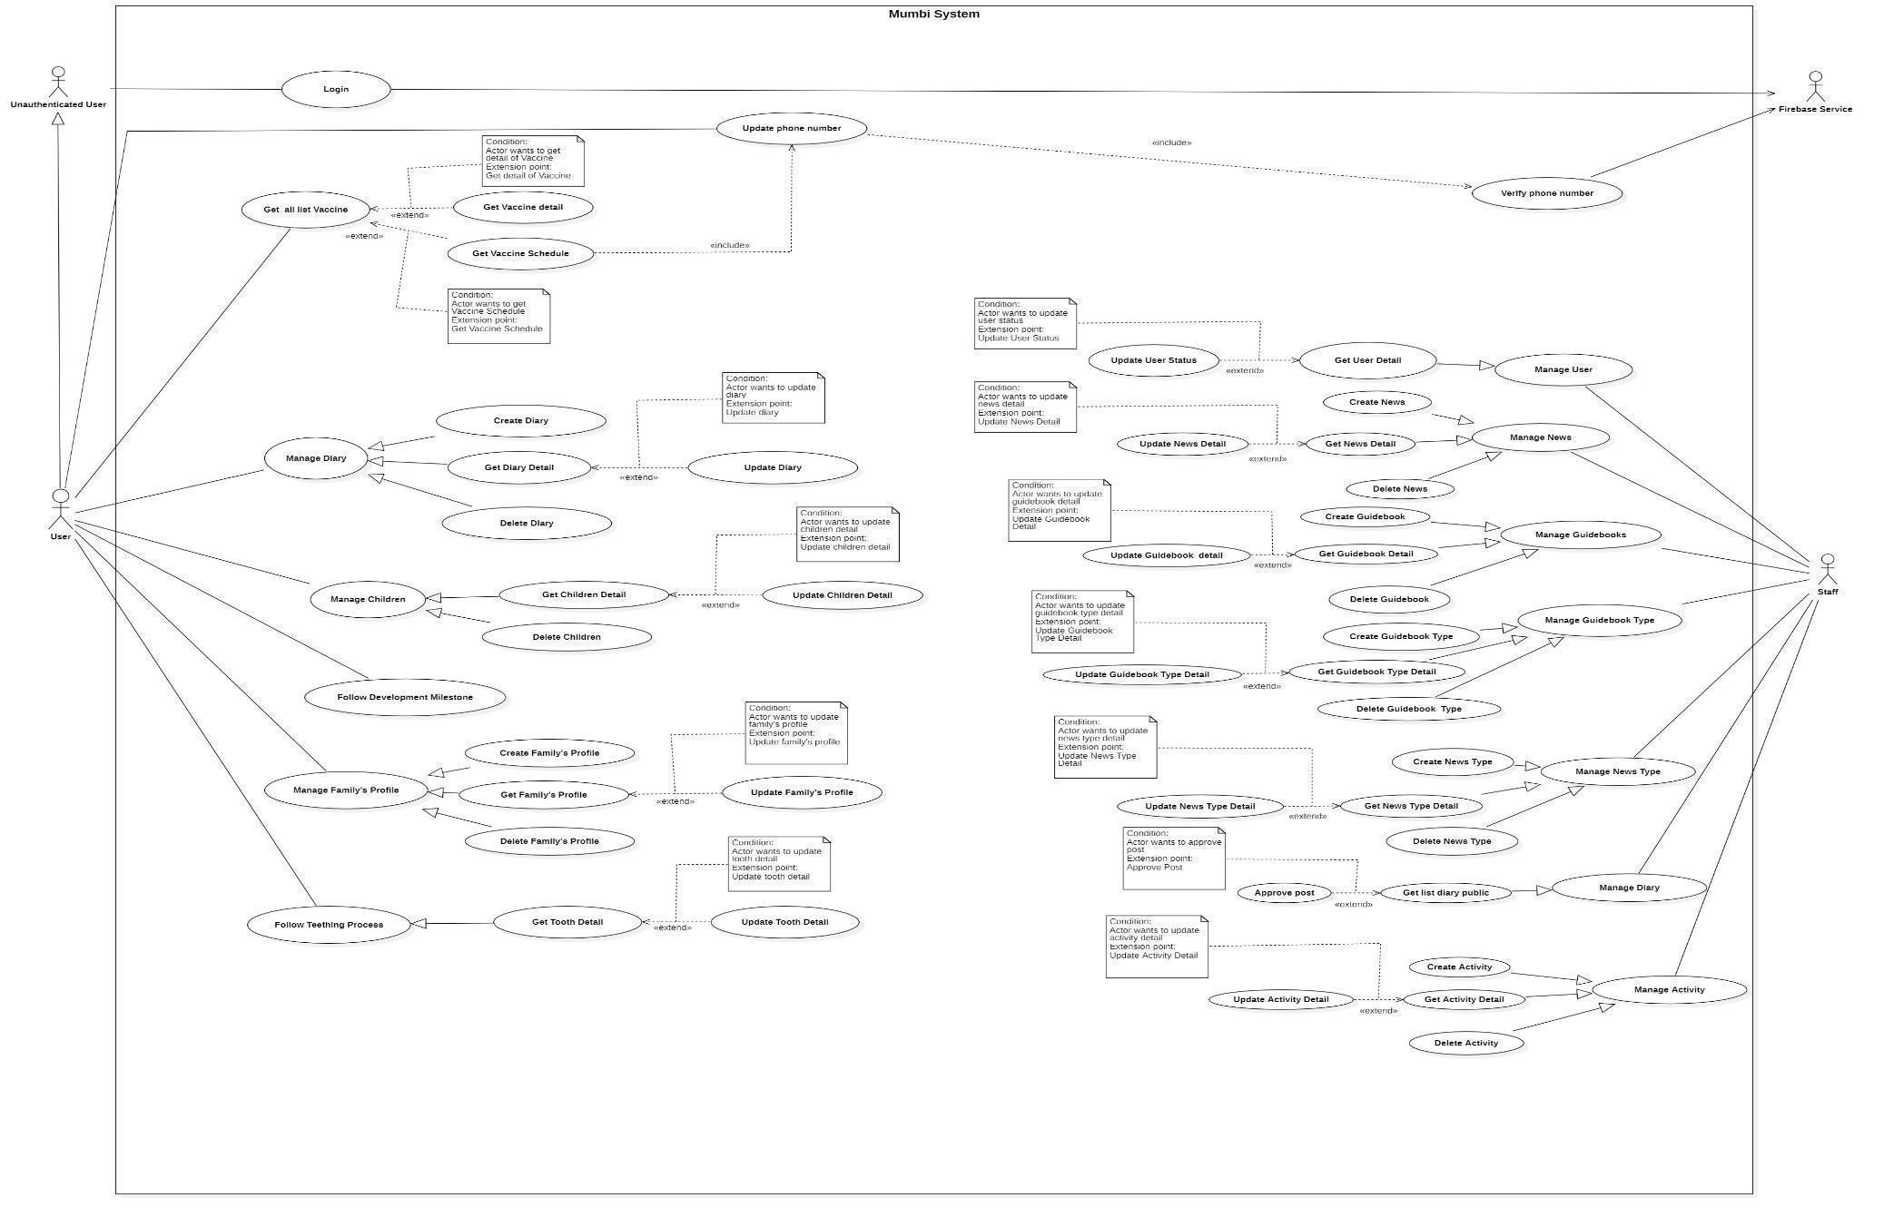

*Figure 2 - System Overview Use Case Diagram*

### 2.1.2. System Actors

| **No.** | **Actor** | **Description** |
| --- | --- | --- |
| **1** | Unauthenticated User | A guest can log in to the system to become a  user. |
| **2** | User | The user can use every utility of the application. |
| **3** | Firebase Service | Firebase Service supports sending notifications. |
| **4** | Staff | The staff manages and follows the user, news, guidebooks, approved posts, type of news, type of guidebook, action. |

*Table 9 - System Actors*

### 2.1.3. Use Cases List

| **ID** | **Use case** | **Primary Actors** | **Secondary Actors** |
| --- | --- | --- | --- |
|  | [Login](https://docs.google.com/document/d/1xhLb5dCqexeui3QgkQ-JR-Q5CwQ9WU3k/edit#bookmark=id.gjdgxs) | Unauthenticated User |  |
|  | [Update Phone number](https://docs.google.com/document/d/1xhLb5dCqexeui3QgkQ-JR-Q5CwQ9WU3k/edit#bookmark=id.30j0zll) | User | Firebase Service |
|  | [Get all list Vaccine](https://docs.google.com/document/d/1xhLb5dCqexeui3QgkQ-JR-Q5CwQ9WU3k/edit#bookmark=id.1fob9te) | User |  |
|  | [Get Vaccine detail](https://docs.google.com/document/d/1xhLb5dCqexeui3QgkQ-JR-Q5CwQ9WU3k/edit#bookmark=id.3znysh7) | User |  |
|  | [Get Vaccine Schedule](https://docs.google.com/document/d/1xhLb5dCqexeui3QgkQ-JR-Q5CwQ9WU3k/edit#bookmark=id.2et92p0) | User |  |
|  | [Create Diary](https://docs.google.com/document/d/1xhLb5dCqexeui3QgkQ-JR-Q5CwQ9WU3k/edit#bookmark=id.2s8eyo1) | User |  |
|  | [Get Diary Detail](https://docs.google.com/document/d/1xhLb5dCqexeui3QgkQ-JR-Q5CwQ9WU3k/edit#bookmark=id.17dp8vu) | User |  |
|  | [Update Diary](https://docs.google.com/document/d/1xhLb5dCqexeui3QgkQ-JR-Q5CwQ9WU3k/edit#bookmark=id.3rdcrjn) | User |  |
|  | [Delete Diary](https://docs.google.com/document/d/1xhLb5dCqexeui3QgkQ-JR-Q5CwQ9WU3k/edit#bookmark=id.26in1rg) | User |  |
|  | [Get Children Detail](https://docs.google.com/document/d/1xhLb5dCqexeui3QgkQ-JR-Q5CwQ9WU3k/edit#bookmark=id.lnxbz9) | User |  |
|  | [Update Children Detail](https://docs.google.com/document/d/1xhLb5dCqexeui3QgkQ-JR-Q5CwQ9WU3k/edit#bookmark=id.35nkun2) | User |  |
|  | [Delete Children](https://docs.google.com/document/d/1xhLb5dCqexeui3QgkQ-JR-Q5CwQ9WU3k/edit#bookmark=id.1ksv4uv) | User |  |
|  | [Create Family’s Profile](https://docs.google.com/document/d/1xhLb5dCqexeui3QgkQ-JR-Q5CwQ9WU3k/edit#bookmark=id.2jxsxqh) | User |  |
|  | [Get Family’s Profile](https://docs.google.com/document/d/1xhLb5dCqexeui3QgkQ-JR-Q5CwQ9WU3k/edit#bookmark=id.z337ya) | User |  |
|  | [Update Family’s Profile](https://docs.google.com/document/d/1xhLb5dCqexeui3QgkQ-JR-Q5CwQ9WU3k/edit#bookmark=id.3j2qqm3) | User |  |
|  | [Delete Family’s Profile](https://docs.google.com/document/d/1xhLb5dCqexeui3QgkQ-JR-Q5CwQ9WU3k/edit#bookmark=id.1y810tw) | User |  |
|  | Follow Development Milestone | User |  |
|  | [Create News](https://docs.google.com/document/d/1xhLb5dCqexeui3QgkQ-JR-Q5CwQ9WU3k/edit#bookmark=id.4i7ojhp) | Staff |  |
|  | [Get News Detail](https://docs.google.com/document/d/1xhLb5dCqexeui3QgkQ-JR-Q5CwQ9WU3k/edit#bookmark=id.2xcytpi) | Staff |  |
|  | [Update News Detail](https://docs.google.com/document/d/1xhLb5dCqexeui3QgkQ-JR-Q5CwQ9WU3k/edit#bookmark=id.1ci93xb) | Staff |  |
|  | [Delete News](https://docs.google.com/document/d/1xhLb5dCqexeui3QgkQ-JR-Q5CwQ9WU3k/edit#bookmark=id.3whwml4) | Staff |  |
|  | [Create Guidebooks](https://docs.google.com/document/d/1xhLb5dCqexeui3QgkQ-JR-Q5CwQ9WU3k/edit#bookmark=id.qsh70q) | Staff |  |
|  | [Get Guidebooks Detail](https://docs.google.com/document/d/1xhLb5dCqexeui3QgkQ-JR-Q5CwQ9WU3k/edit#bookmark=id.3as4poj) | Staff |  |
|  | [Update Guidebooks Detail](https://docs.google.com/document/d/1xhLb5dCqexeui3QgkQ-JR-Q5CwQ9WU3k/edit#bookmark=id.1pxezwc) | Staff |  |
|  | [Delete Guidebooks](https://docs.google.com/document/d/1xhLb5dCqexeui3QgkQ-JR-Q5CwQ9WU3k/edit#bookmark=id.49x2ik5) | Staff |  |
|  | Create Guidebook Type | Staff |  |
|  | Get Guidebook Type Detail | Staff |  |
|  | Update Guideboook Type Detail | Staff |  |
|  | Delete Guidebook Type | Staff |  |
|  | Create News Type | Staff |  |
|  | Get News Type Detail | Staff |  |
|  | Update News Type Detail | Staff |  |
|  | Delete News Type | Staff |  |
|  | Create Activity | Staff |  |
|  | Get Activity Detail | Staff |  |
|  | Update Activity Detail | Staff |  |
|  | Delete Activity | Staff |  |
|  | Get User Detail | Staff |  |
|  | Update User Status | Staff |  |
|  | Approve Post | Staff |  |
|  | Verify Phone number | Firebase Service |  |

*Table 10 - Use cases list*

### 2.2. Unauthenticated User

#### 2.2.1. Login

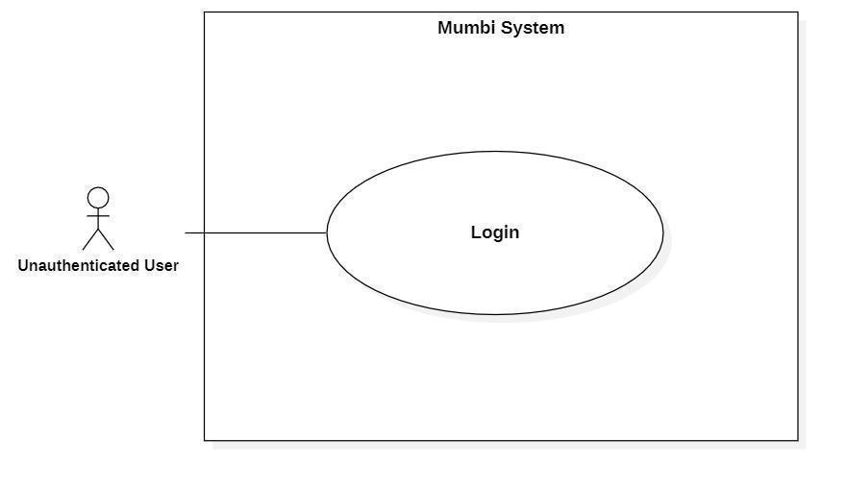

*Figure 3 - <Unauthorized User> Login*

| **UC ID and Name:** | **Login** | | |
| --- | --- | --- | --- |
| Created By: | Bui Hai Nam | Date Created: | 18/05/2021 |
| Primary Actor: | Unauthenticated User | Secondary Actors: | N/A |
| Trigger: | The actor wants to log in. | | |
| Description: | The actor uses this feature to log in to the system to use features that need authentication. | | |
| Preconditions: | For the actor who wants to be authorized as a user:  − The actor needs a Gmail account.  − The actor uses a browser that is supported by Firebase Service. For the actor who wants to be authorized as a staff of Mumbi, one needs to have an account in the system. | | |
| Post-conditions: | Success  The actor is authenticated.  Fail  The actor is not authenticated. | | |
| Normal Flow: | | **Step** | **Actor Action** | **System Response** | | --- | --- | --- | | 1 | The actor wants to log in. | The system requests account information.  **For user:**  The system requests the  actor input Gmail account.  **For a staff of Mumbi:**  The system requests the  actor input Gmail account. | | 2 | The actor inputted information. | **For user:**  The system sends an  authentication request to  Firebase Service. Firebase  Service checks the actor’s  information and  authenticates one.  *[Exception 1]*  **For a staff of Mumbi:**  The system sends an  authentication request to  Firebase Service. Firebase  Service checks the actor’s  information and  authenticates one.  *[Exception 1]* | | | |
| Alternative Flows: | N/A | | |
| Exceptions: | | **No** | **Cause** | **System Response** | | --- | --- | --- | | 1 | The Gmail account is not valid. | The system requests the actor to try again. | | | |
| Priority: | Medium | | |
| Frequency of Use: | Frequency | | |
| Business Rules: | − There are two ways to log in to the system.  1. Log in as a user: use Gmail's email to log in.  2. Log in as a Mumbi employee: use Gmail's email to log in. | | |
| Other Information: | N/A | | |
| Assumptions: | N/A | | |

*Table 11 - <Unauthorized User> Login*

### 2.3. User

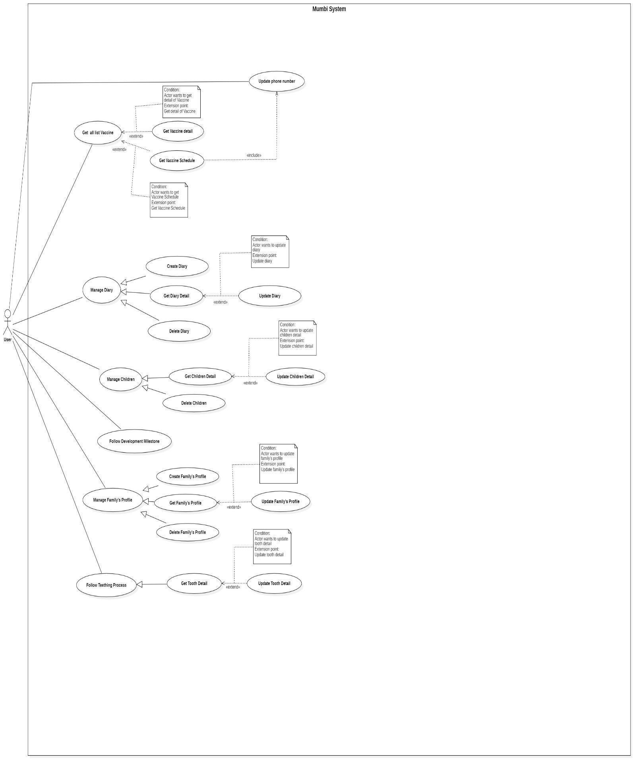

*Figure 4 - <User> Overview Use Case Diagram*

#### 2.3.1. Update Phone number

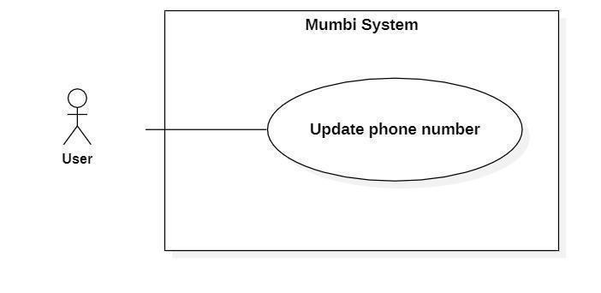

*Figure 5 - <User> Update phone number*

| **UC ID and Name:** | **Update Phone number** | | |
| --- | --- | --- | --- |
| Created By: | Do Le Tu Uyen | Date Created: | 19/05/2021 |
| Primary Actor: | User | Secondary Actors: | N/A |
| Trigger: | The actor wants to get information about vaccines. | | |
| Description: | Phone number is required when getting information about vaccines in Mumbi. The phone number may change after time, so this feature allows the user to update phone number in the system. | | |
| Preconditions: | The actor had been authorized as a user. | | |
| Post-conditions: | Success  The new phone number will be updated in the system.  Fail  The system shows an error message. | | |
| Normal Flow: | | **Step** | **Actor Action** | **System Response** | | --- | --- | --- | | 1 | The actor indicates that needs to update the phone number to get information about vaccines. | The system requests the actor to provide a phone number. | | 2 | The actor inputs the phone  number. | The system receives a phone number.  *[Exception 1]*  The system sends a request to Firebase Service to verify it.  The process as use case Verify Phone Number.  *[Exception 2]*  The system saves the phone number. | | | |
| Alternative Flows: | N/A | | |
| Exceptions: | | **No** | **Cause** | **System Response** | | --- | --- | --- | | 1 | The actor inputs the wrong  phone number’s format. | The system requests the actor to re-input the phone number. | | 2 | Verify phone number failed. | The system shows error  messages to the actor. | | | |
| Priority: | High | | |
| Frequency of Use: | Regularly | | |
| Business Rules: | − The phone number is obligatory when a user wants to get information about vaccines.  − Phone numbers can change, so this function helps to update the phone number provided to the system.  − Users need to enter their phone number into the system. The  system will send a request to Firebase then send an OTP code to this phone number. If the user enters the correct OTP, the system will store this new phone number. The update is successful. | | |
| Other Information: | N/A | | |
| Assumptions: | Số điện thoại còn đang hoạt động và có thể nhận tin nhắn từ Firebase Service.  *English:  The phone number is active and can receive messages from Firebase Service. | | |

*Table 12 - <User> Update phone number*

#### 2.3.2. Get all list Vaccine

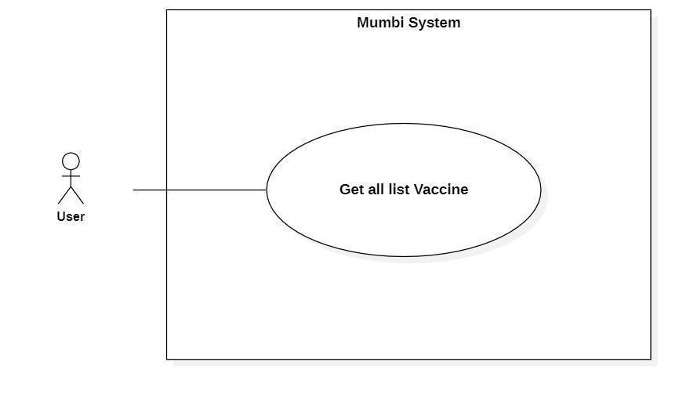

*Figure 6 - <User> Get all list Vaccine*

| **UC ID and Name:** | **Get all list Vaccine** | | |
| --- | --- | --- | --- |
| Created By: | Do Le Tu Uyen | Date Created: | 28/05/2021 |
| Primary Actor: | User | Secondary Actors: | N/A |
| Trigger: | The actor wants to get a list of vaccines | | |
| Description: | This feature allows the actor to get a list of vaccines, so that the actor can get the vaccine’s information. | | |
| Preconditions: | The actor had been authorized as a user. | | |
| Post-conditions: | Success  The actor receives a list of vaccines.  Fail  N/A | | |
| Normal Flow: | | **Step** | **Actor Action** | **System Response** | | --- | --- | --- | | 1 | The actor wants to get a list of vaccines. | The system return list of vaccines includes:   * Name * Antigen * ProducingCountry * Price | | | |
| Alternative Flows: | N/A | | |
| Exceptions: | N/A | | |
| Priority: | Medium | | |
| Frequency of Use: | Regularly | | |
| Business Rules: | − The list of vaccines returned with the prices of each vaccine is updated by date.  − Display detail of vaccine includes:   * Name * Antigen * ProducingCountry * Price | | |
| Other Information: | N/A | | |
| Assumptions: | N/A | | |

*Table 13 - <User> Get all list Vaccine*

#### 2.3.3. Get Vaccine detail

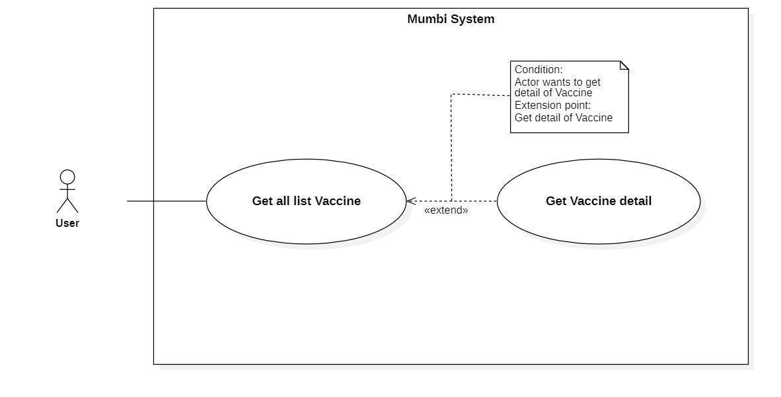

*Figure 7 - <User> Get Vaccine detail*

| **UC ID and Name:** | **Get Vaccine detail** | | |
| --- | --- | --- | --- |
| Created By: | Do Le Tu Uyen | Date Created: | 20/05/2021 |
| Primary Actor: | User | Secondary Actors: | N/A |
| Trigger: | The actor wants to get details of the vaccine. | | |
| Description: | This feature allows the actor to get detailed information of a vaccine including name, category, opened/closed date, number of slots, description, status, ... The user uses this information to decide what kind of vaccine should be injected. | | |
| Preconditions: | The actor had been authorized as a user. | | |
| Post-conditions: | Success  The actor receives details of the vaccine.  Fail  N/A | | |
| Normal Flow: | | **Step** | **Actor Action** | **System Response** | | --- | --- | --- | | 1 | The actor wants to get detail of vaccines. | The system return detail of vaccine includes:   * Name * Antigen * ProducingCountry * Price | | | |
| Alternative Flows: | N/A | | |
| Exceptions: | N/A | | |
| Priority: | Medium | | |
| Frequency of Use: | Frequency | | |
| Business Rules: | − Display detail of vaccine includes:   * Name * Antigen * ProducingCountry * Price | | |
| Other Information: | N/A | | |
| Assumptions: | N/A | | |

*Table 14 - <User> Get Vaccine detail*

#### 2.3.4. Get Vaccine Schedule

***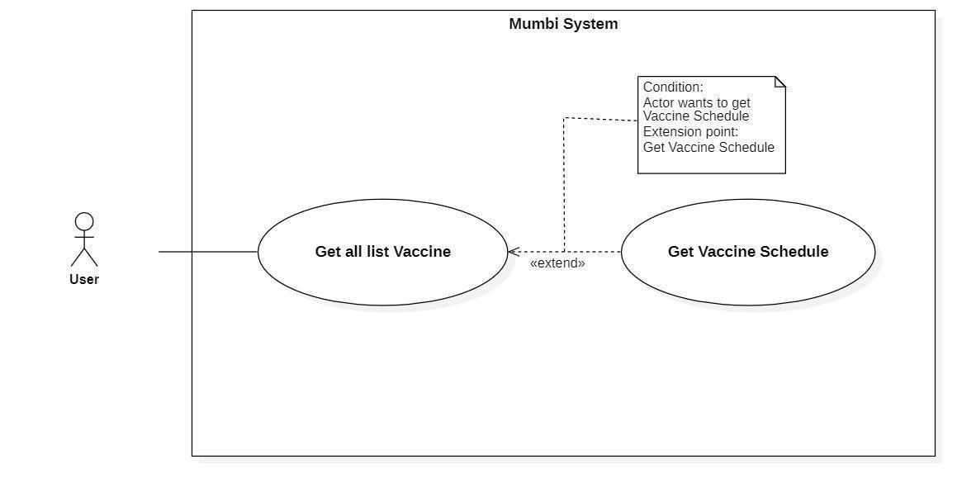****Figure 8 - <User> Get Vaccine detail*

| **UC ID and Name:** | **Get Vaccine Schedule** | | |
| --- | --- | --- | --- |
| Created By: | Do Le Tu Uyen | Date Created: | 20/05/2021 |
| Primary Actor: | User | Secondary Actors: | N/A |
| Trigger: | The actor wants to get a vaccine schedule. | | |
| Description: | This feature allows the actor to get a vaccine schedule including vaccine’s name, antigen, injection date, order injection, vaccine batch, vaccine facility, status, … The user uses this information to handle vaccine schedules easily. | | |
| Preconditions: | − The actor must update phone number.  − The actor was authorized as a user.  − The actor added baby or pregnancy information. | | |
| Post-conditions: | Success  The actor receives a vaccine schedule.  Fail  The system shows an error message. | | |
| Normal Flow: | | **Step** | **Actor Action** | **System Response** | | --- | --- | --- | | 1 | The actor wants to get vaccine schedule. | The system return detail of vaccine includes:   * VaccineName * Antigen * InjectionDate * OrderOfInjection * VaccineBatch * VaccineFacility * Status | | | |
| Alternative Flows: | N/A | | |
| Exceptions: | N/A | | |
| Priority: | Medium | | |
| Frequency of Use: | Frequency | | |
| Business Rules: | − Display detail of vaccine includes:   * Name * Antigen * InjectionDate * OrderOfInjection * VaccineBatch * VaccineFacility * Status | | |
| Other Information: | N/A | | |
| Assumptions: | N/A | | |

*Table 15 - <User> Get Vaccine Schedule*

#### 2.3.5. Create Diary

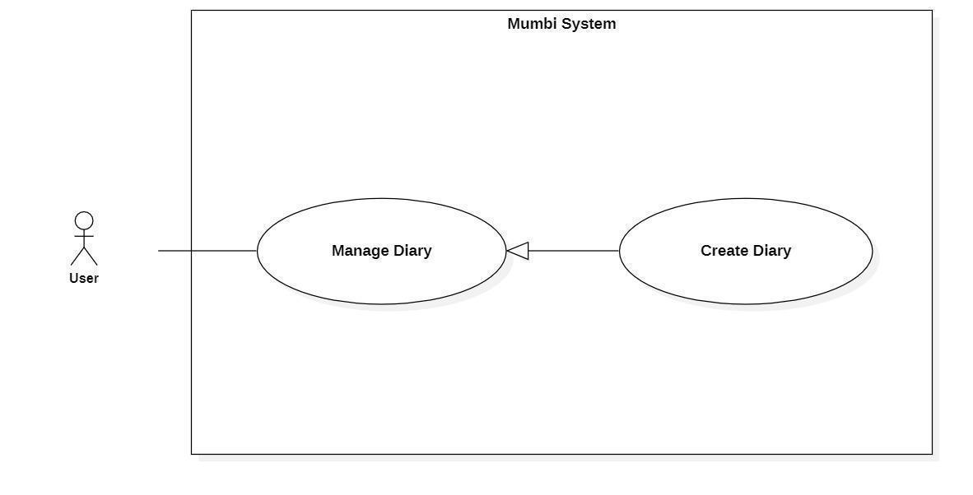

*Figure 9 - <User> Create Diary*

| **UC ID and Name:** | **Create Diary** | | |
| --- | --- | --- | --- |
| Created By: | Pham Hoang Duy | Date Created: | 20/05/2021 |
| Primary Actor: | User | Secondary Actors: | N/A |
| Trigger: | The actor sends a request to create a diary. | | |
| Description: | The actor needs to have a diary to capture memorable moments and memories. Therefore, this feature allows the user to create a diary. | | |
| Preconditions: | The actor had been authorized as a user. | | |
| Post-conditions: | Success  A new diary is created.  Fail  The system shows an error message. | | |
| Normal Flow: | | **Step** | **Actor Action** | **System Response** | | --- | --- | --- | | 1 | The actor sends a command to create a diary. | The system displays information of diary to create:   * Image * DiaryContent | | 2 | The actor fills in information about the diary. | The system receives information, create a new diary. | | | |
| Alternative Flows: | N/A | | |
| Exceptions: | N/A | | |
| Priority: | Medium | | |
| Frequency of Use: | Frequently | | |
| Business Rules: | − The diary will help users save memorable moments and memories during pregnancy and raising babies.  − The process of creating a diary:   * Fill in and select the basic information of the diary such as diary content, image. * Check the information and send a request to create a new diary to the system.   − Diary includes following fields:   * Image * DiaryContent | | |
| Other Information: | N/A | | |
| Assumptions: | N/A | | |

*Table 16 - <User> Create Diary*

#### 2.3.6. Get Diary Detail

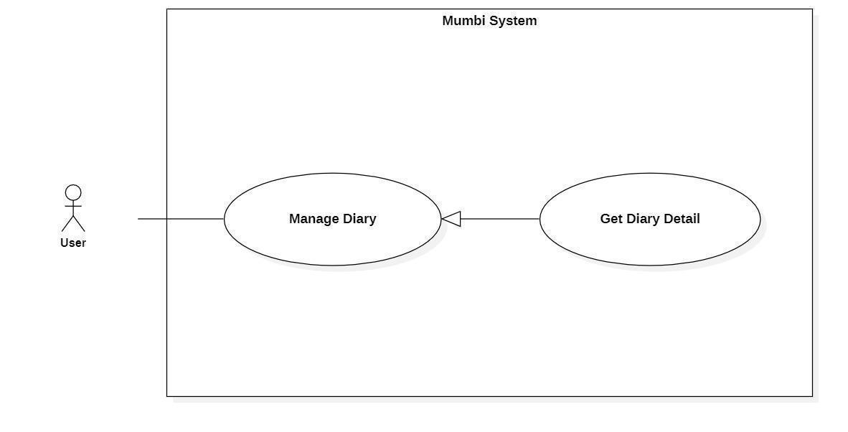

*Figure 10 - <User> Get Diary Detail*

| **UC ID and Name:** | **Get Diary Detail** | | |
| --- | --- | --- | --- |
| Created By: | Pham Hoang Duy | Date Created: | 20/05/2021 |
| Primary Actor: | User | Secondary Actors: | N/A |
| Trigger: | The actor wants to get the details of the diary. | | |
| Description: | This feature allows the actor to get detailed information of a diary including diary content, image. The user uses this information to make sure that every information is exactly. | | |
| Preconditions: | The actor had been authorized as a user. | | |
| Post-conditions: | Success  The actor receives detail of diary.  Fail  N/A | | |
| Normal Flow: | | **Step** | **Actor Action** | **System Response** | | --- | --- | --- | | 1 | The actor wants to get the details of the diary. | The system return detail of diary includes:   * DiaryContent * Image * PublicDate | | | |
| Alternative Flows: | N/A | | |
| Exceptions: | N/A | | |
| Priority: | Medium | | |
| Frequency of Use: | Frequency | | |
| Business Rules: | − Display detail of diary includes:   * DiaryContent * Image * PublicDate | | |
| Other Information: | N/A | | |
| Assumptions: | N/A | | |

*Table 17 - <User> Get Diary Detail*

#### 2.3.7. Update Diary

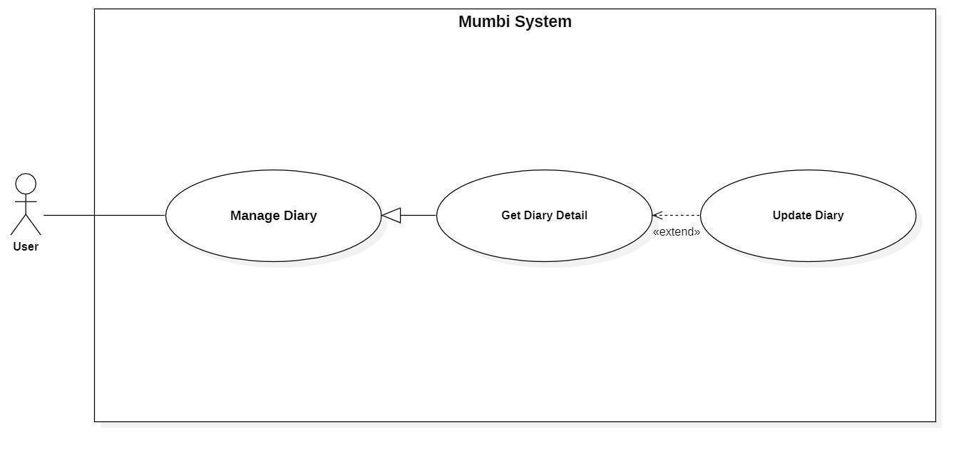

*Figure 11 - <User> Update Diary*

| **UC ID and Name:** | **Update Diary** | | |
| --- | --- | --- | --- |
| Created By: | Pham Hoang Duy | Date Created: | 19/05/2021 |
| Primary Actor: | User | Secondary Actors: | N/A |
| Trigger: | The actor indicates to update diary | | |
| Description: | Sometimes, users want to edit information in their diary. Therefore, this feature allows the actor to update the diary. | | |
| Preconditions: | The actor had been authorized as a user. | | |
| Post-conditions: | Success  The diary will be updated with new information.  Fail  The system shows an error message. | | |
| Normal Flow: | | **Step** | **Actor Action** | **System Response** | | --- | --- | --- | | 1 | The actor sends a command to update the diary. | The system requests information of diary:   * Image * DiaryContent | | 2 | The actor updates the information in the diary.  The actor sent a request to update diary. | The system updates the diary with this information. | | | |
| Alternative Flows: | N/A | | |
| Exceptions: | N/A | | |
| Priority: | Medium | | |
| Frequency of Use: | Rarely | | |
| Business Rules: | − Each diary will have its own information (for example image, content) and the above information may change over time. Therefore, the user can update it on the system.  − The diary information will include the following information:   * Image (Image) * Diary Content (DiaryContent) | | |
| Other Information: | N/A | | |
| Assumptions: | N/A | | |

*Table 18 - <User> Update Diary*

#### 2.3.8. Delete Diary

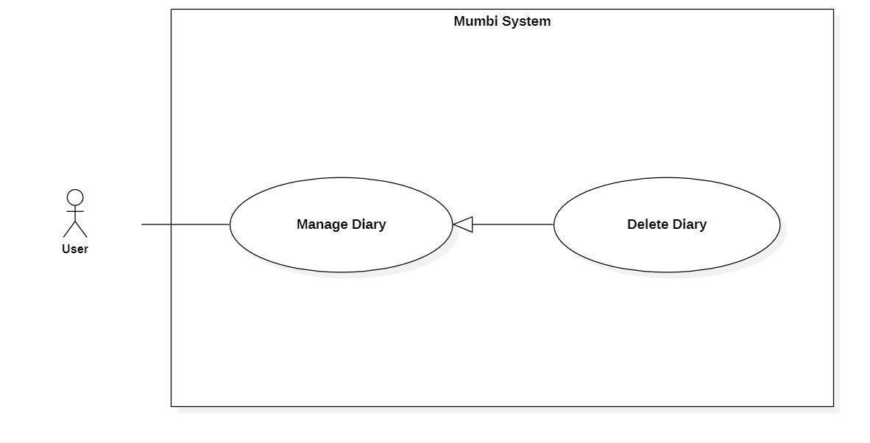

*Figure 12 - <User> Delete Diary*

| **UC ID and Name:** | **Delete Diary** | | |
| --- | --- | --- | --- |
| Created By: | Pham Hoang Duy | Date Created: | 20/05/2021 |
| Primary Actor: | User | Secondary Actors: | N/A |
| Trigger: | The actor sends a request to delete diary. | | |
| Description: | The actor needs to delete the diary from the system when it is no longer needed. Therefore, this feature allows the actor to delete the diary from the system. | | |
| Preconditions: | − The actor was authorized as a user. | | |
| Post-conditions: | Success  Send notification to the actor for deleting the diary and the selected diary will be hidden to the actor.  Fail  The system shows an error message. | | |
| Normal Flow: | | **Step** | **Actor Action** | **System Response** | | --- | --- | --- | | 1 | The actor sends a command to delete the diary. | The system returns to the actor that the diary has been deleted. | | 2 | The actor sends a command to delete the diary. | The system changes the status of the diary. | | | |
| Alternative Flows: | N/A | | |
| Exceptions: | N/A | | |
| Priority: | Medium | | |
| Frequency of Use: | Rarely | | |
| Business Rules: | − When a diary is no longer needed, the user can delete that diary from the system.  − After a diary is deleted, the status will be changed and the user should no longer see this diary. | | |
| Other Information: | N/A | | |
| Assumptions: | N/A | | |

*Table 19 - <User> Delete Diary*

#### 2.3.9. Get Children Detail

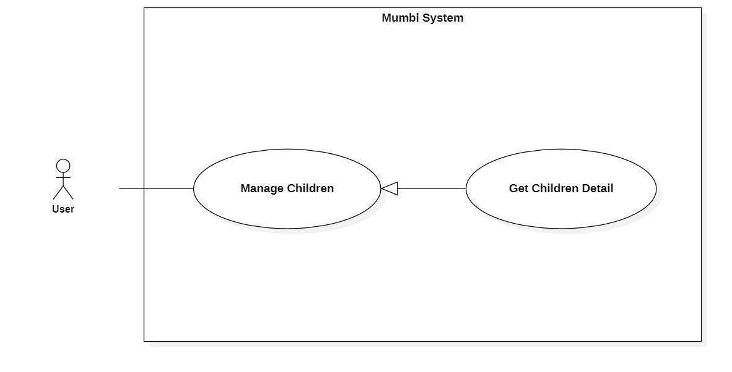

*Figure 13 - <User> Get Children Detail*

| **UC ID and Name:** | **Get Children Detail** | | |
| --- | --- | --- | --- |
| Created By: | Pham Hoang Duy | Date Created: | 20/05/2021 |
| Primary Actor: | User | Secondary Actors: | N/A |
| Trigger: | The actor wants to get details of children. | | |
| Description: | This feature allows the actor to get detailed information of a child's full name, nick name, image, gender, birthday, blood group, rh blood group, estimated born date, fingertips, head vortex... The user uses this information to make sure that every information is accurate. | | |
| Preconditions: | The actor had been authorized as a user. | | |
| Post-conditions: | Success  The actor receives details of children.  Fail  N/A | | |
| Normal Flow: | | **Step** | **Actor Action** | **System Response** | | --- | --- | --- | | 1 | The actor wants to get details of children. | The system return detail of children includes:   * Fullname * Nickname * Image * Gender * Birthday * EstimatedBornDate * Bloodgroup * RhBloodGroup * Fingertips * HeadVortex | | | |
| Alternative Flows: | N/A | | |
| Exceptions: | N/A | | |
| Priority: | Medium | | |
| Frequency of Use: | Frequency | | |
| Business Rules: | − Display detail of children includes:   * Fullname * Nickname * Image * Gender * Birthday * EstimatedBornDate * Bloodgroup * RhBloodGroup * Fingertips * HeadVortex | | |
| Other Information: | N/A | | |
| Assumptions: | N/A | | |

*Table 20 - <User> Get Children Detail*

#### 2.3.10. Update Children Detail

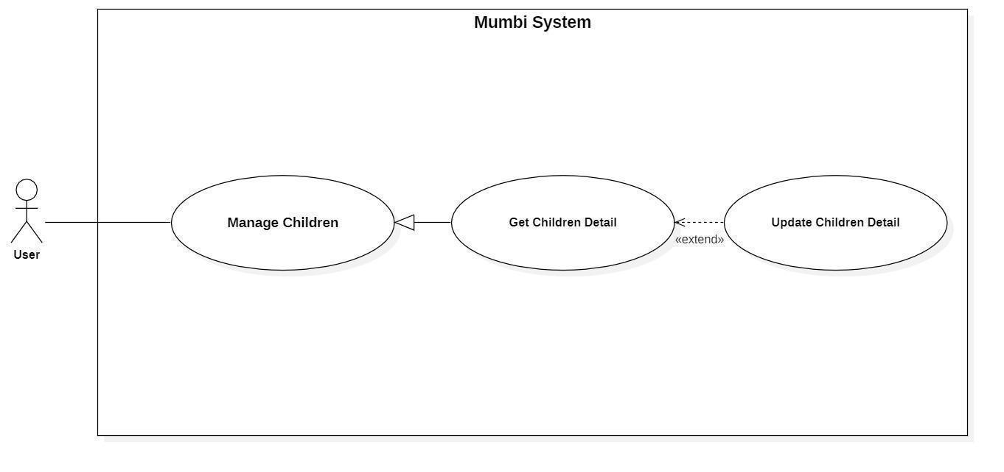

*Figure 14 - <User> Update Children Detail*

| **UC ID and Name:** | **Update Children Detail** | | |
| --- | --- | --- | --- |
| Created By: | Pham Hoang Duy | Date Created: | 19/05/2021 |
| Primary Actor: | User | Secondary Actors: | N/A |
| Trigger: | The actor indicates to update children's details. | | |
| Description: | Sometimes, users want to edit information in children's detail. Therefore, this feature allows the actor to update children's details. | | |
| Preconditions: | The actor had been authorized as a user. | | |
| Post-conditions: | Success  The children will be updated with new information.  Fail  The system shows an error message. | | |
| Normal Flow: | | **Step** | **Actor Action** | **System Response** | | --- | --- | --- | | 1 | The actor sends a command to update children's details. | The system requests information of children:   * Fullname * Nickname * Image * Gender * Birthday * EstimatedBornDate * Bloodgroup * RhBloodGroup * Fingertips * HeadVortex | | 2 | The actor updates information about the children.  The actor sent a request to update the children 's details. | The system updates the children with this information. | | | |
| Alternative Flows: | N/A | | |
| Exceptions: | N/A | | |
| Priority: | Medium | | |
| Frequency of Use: | Rarely | | |
| Business Rules: | − Each child will have its own information (for example fullname, image, gender, blood group, …) and the above information may change over time. Therefore, the user can update it on the system.  − The children information will include the following information:   * Fullname (Fullname) * Nickname (Nickname) * Image (Image) * Gender (Gender) * Birthday (Birthday) * EstimatedBornDate (EstimatedBornDate) * BloodGroup (BloodGroup) * RhBloodGroup (RhBloodGroup) * Fingertips (Fingertips) * HeadVortex (HeadVortex) | | |
| Other Information: | N/A | | |
| Assumptions: | N/A | | |

*Table 21 - <User> Update Children Detail*

#### 2.3.11. Delete Children

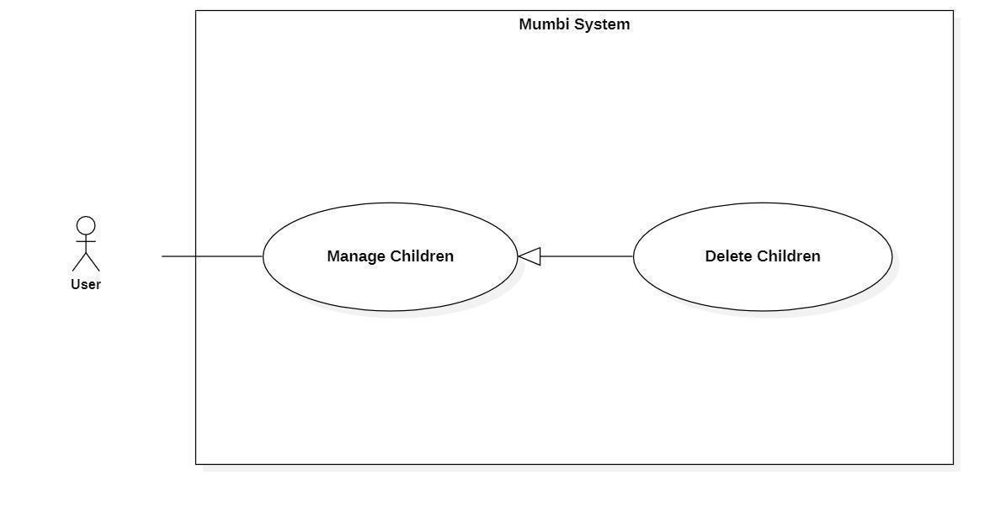

*Figure 15 - <User> Delete Children*

| **UC ID and Name:** | **Delete Children** | | |
| --- | --- | --- | --- |
| Created By: | Pham Hoang Duy | Date Created: | 20/05/2021 |
| Primary Actor: | User | Secondary Actors: | N/A |
| Trigger: | The actor sends a request to delete the children. | | |
| Description: | The actor needs to delete the children from the system when they make a mistake or when they unfortunately miscarry. Therefore, this feature allows the actor to delete the diary from the system. | | |
| Preconditions: | − The actor had been authorized as a user. | | |
| Post-conditions: | Success  Send notification to the actor for deleting children and the selected children will be hidden to the actor.  Fail  The system shows an error message. | | |
| Normal Flow: | | **Step** | **Actor Action** | **System Response** | | --- | --- | --- | | 1 | The actor sends a command to delete the children. | The system returns to the actor that the children have been deleted. | | 2 | The actor sends a command to delete the children. | The system changes the status of the children. | | | |
| Alternative Flows: | N/A | | |
| Exceptions: | N/A | | |
| Priority: | Medium | | |
| Frequency of Use: | Rarely | | |
| Business Rules: | − When the user makes the mistake of adding a baby or they unfortunately miscarry, the user can delete the baby.  − After a child is deleted, the child will be changed status. | | |
| Other Information: | N/A | | |
| Assumptions: | N/A | | |

*Table 22 - <User> Delete Children*

#### 2.3.12. Follow Development Milestone

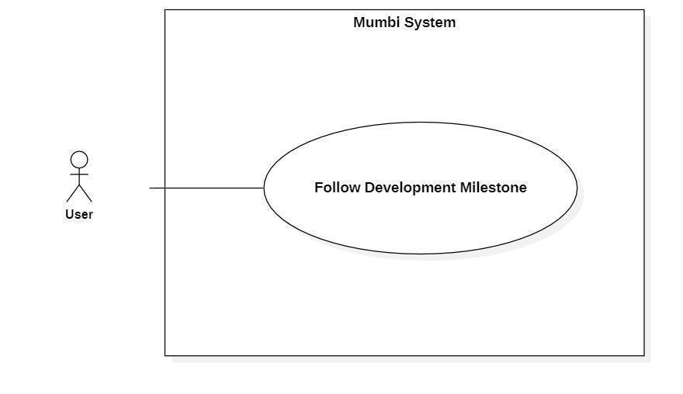

*Figure 16 - <User> Follow Development Milestone*

| **UC ID and Name:** | **Follow Development Milestone** | | |
| --- | --- | --- | --- |
| Created By: | Do Le Tu Uyen | Date Created: | 20/05/2021 |
| Primary Actor: | User | Secondary Actors: | N/A |
| Trigger: | The actor sends a request to follow development milestones. | | |
| Description: | The actor wants to monitor the development process so that we can offer solutions to help the baby develop in the best and most complete way. | | |
| Preconditions: | − The actor had been authorized as a user.  − The actor added children or pregnancy information. | | |
| Post-conditions: | Success  The actor receives information in the form of graphs and parameters for easy tracking and comparison of metrics.  Fail  The system shows an error message. | | |
| Normal Flow: | | **Step** | **Actor Action** | **System Response** | | --- | --- | --- | | 1 | The actor sends a command to follow development milestones. | The system returns to the actor information in the form of graphs and parameter:   * Weight * Height * HeadCircumference * GrossMotorSkills * FineMotorSkills | | | |
| Alternative Flows: | N/A | | |
| Exceptions: | N/A | | |
| Priority: | Medium | | |
| Frequency of Use: | Rarely | | |
| Business Rules: | − Users can track the baby's development milestones through standard index, BMI, fine motor, gross motor. In addition, users can also track indicators such as weight, height, head circumference through charts. | | |
| Other Information: | N/A | | |
| Assumptions: | N/A | | |

*Table 23 - <User> Follow Development Milestone*

#### 2.3.13. Create Family’s Profile

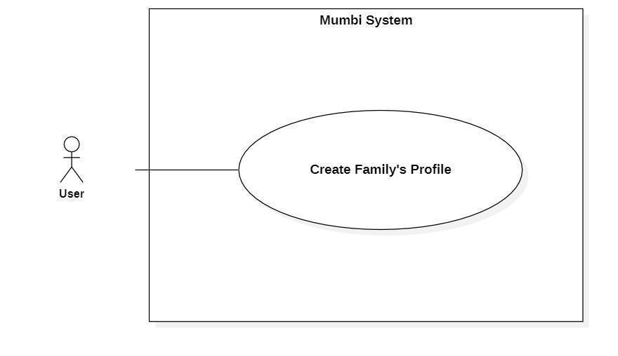

*Figure 17 - <User> Create Family’s Profile*

| **UC ID and Name:** | **Create Family’s Profile** | | |
| --- | --- | --- | --- |
| Created By: | Pham Hoang Duy | Date Created: | 20/05/2021 |
| Primary Actor: | User | Secondary Actors: | N/A |
| Trigger: | The actor sends a request to create a family’s profile. | | |
| Description: | The actor needs to have family’s profile to keep family information. Therefore, this feature allows the user to create family’s profile. | | |
| Preconditions: | The actor had been authorized as a user. | | |
| Post-conditions: | Success  A new family’s profile is created.  Fail  The system shows an error message. | | |
| Normal Flow: | | **Step** | **Actor Action** | **System Response** | | --- | --- | --- | | 1 | The actor sends a command to create a family’s profile. | The system displays information of family’s profile to create:  If the profile is father or mother:   * Fullname * Image * Birthday * Phonenumber * BloodGroup * RhBloodGroup   If the profile is children:   * Fullname * Nickname * Image * Gender * Birthday * EstimatedBornDate * Bloodgroup * RhBloodGroup * Fingertips * HeadVortex | | 2 | The actor fills in information about the family’s profile. | The system receives information, create a new family’s profile. | | | |
| Alternative Flows: | N/A | | |
| Exceptions: | N/A | | |
| Priority: | Medium | | |
| Frequency of Use: | Frequently | | |
| Business Rules: | − The process of creating a profile:   * Fill in and select the basic information of the profile such as image, fullname, birthday, blood group, rh blood group. * Check the information and send a request to create a profile to the system.   − Profile includes following fields:   * Fullname * Image * Birthday * BloodGroup * RhBloodGroup | | |
| Other Information: | N/A | | |
| Assumptions: | N/A | | |

*Table 24 - <User> Create Family’s Profile*

#### 2.3.14. Get Family’s Profile Detail

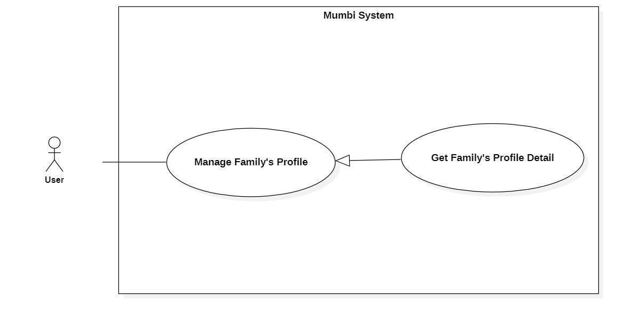

*Figure 18 - <User> Get Family’s Profile*

| **UC ID and Name:** | **Get Family’s Profile Detail** | | |
| --- | --- | --- | --- |
| Created By: | Pham Hoang Duy | Date Created: | 20/05/2021 |
| Primary Actor: | User | Secondary Actors: | N/A |
| Trigger: | The actor wants to get details of family’s profile. | | |
| Description: | This feature allows the actor to get detailed information of a profile including full name, nick name, image, gender, birthday, blood group, ... The user uses this information to make sure that every information is accurate. | | |
| Preconditions: | The actor had been authorized as a user. | | |
| Post-conditions: | Success  The actor receives details of children.  Fail  N/A | | |
| Normal Flow: | | **Step** | **Actor Action** | **System Response** | | --- | --- | --- | | 1 | The actor wants to get details of profile. | The system return detail of profile includes:  If the profile is father or mother:   * Fullname * Image * Birthday * Phonenumber * BloodGroup * RhBloodGroup   If the profile is children:   * Fullname * Nickname * Image * Gender * Birthday * EstimatedBornDate * Bloodgroup * RhBloodGroup * Fingertips * HeadVortex | | | |
| Alternative Flows: | N/A | | |
| Exceptions: | N/A | | |
| Priority: | Medium | | |
| Frequency of Use: | Frequency | | |
| Business Rules: | − Display some basic information of profile includes:   * Fullname * Image * Birthday * BloodGroup * RhBloodGroup | | |
| Other Information: | N/A | | |
| Assumptions: | N/A | | |

*Table 25 - <User> Get Family’s Profile*

#### 2.3.15. Update Family’s Profile

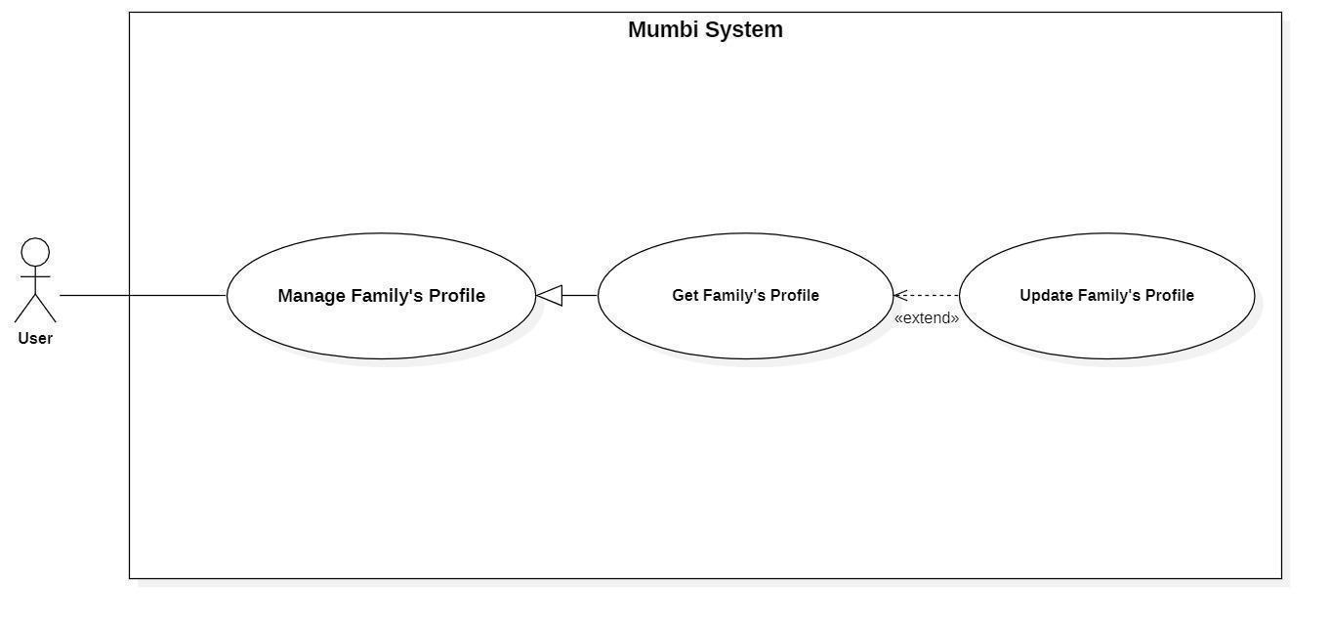

*Figure 19 - <User> Update Family’s Profile*

| **UC ID and Name:** | **Update Family’s Profile** | | |
| --- | --- | --- | --- |
| Created By: | Pham Hoang Duy | Date Created: | 19/05/2021 |
| Primary Actor: | User | Secondary Actors: | N/A |
| Trigger: | The actor indicates to update profile. | | |
| Description: | Sometimes, users want to edit information in their profile. Therefore, this feature allows the actor to update the profile. | | |
| Preconditions: | The actor had been authorized as a user. | | |
| Post-conditions: | Success  The profile will be updated with new information.  Fail  The system shows an error message. | | |
| Normal Flow: | | **Step** | **Actor Action** | **System Response** | | --- | --- | --- | | 1 | The actor sends a command to update profile. | The system requests information of profile:  If the profile is father or mother:   * Fullname * Image * Birthday * Phonenumber * BloodGroup * RhBloodGroup   If the profile is children:   * Fullname * Nickname * Image * Gender * Birthday * EstimatedBornDate * Bloodgroup * RhBloodGroup * Fingertips * HeadVortex | | 2 | The actor updates the profile.  The actor sent a request to update profile. | The system updates the profile with this information. | | | |
| Alternative Flows: | N/A | | |
| Exceptions: | N/A | | |
| Priority: | Medium | | |
| Frequency of Use: | Rarely | | |
| Business Rules: | − Each profile will have its own information and the above information may change over time. Therefore, the user can update it on the system.  − The profile information will include the following basic information:   * Fullname (Fullname) * Image (Image) * Birthday (Birthday) * BloodGroup (BloodGroup) * RhBloodGroup (RhBloodGroup) | | |
| Other Information: | N/A | | |
| Assumptions: | N/A | | |

*Table 26 - <User> Update Family’s Profile*

#### 2.3.16. Delete Family’s Profile

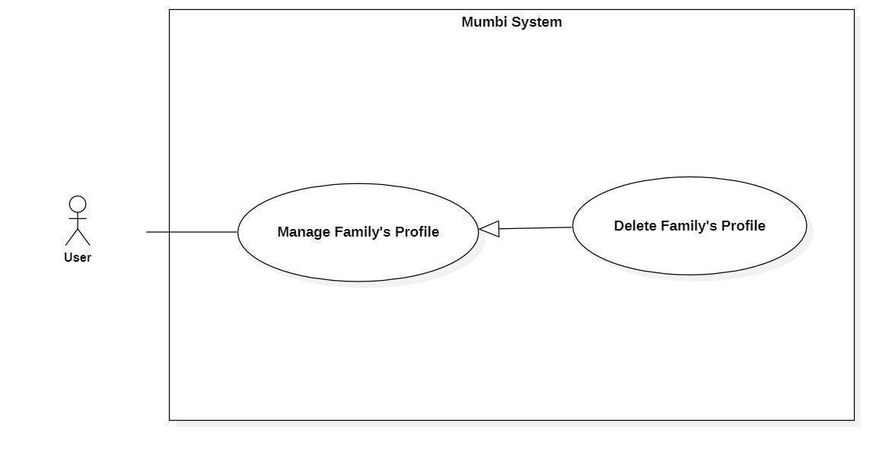

*Figure 20 - <User> Delete Family’s Profile*

| **UC ID and Name:** | **Delete Family’s Profile** | | |
| --- | --- | --- | --- |
| Created By: | Pham Hoang Duy | Date Created: | 20/05/2021 |
| Primary Actor: | User | Secondary Actors: | N/A |
| Trigger: | The actor sends a request to delete profile. | | |
| Description: | The actor needs to delete the profile from the system when it is no longer needed. Therefore, this feature allows the actor to delete the profile from the system. | | |
| Preconditions: | − The actor had been authorized as a user. | | |
| Post-conditions: | Success  Send notification to the actor for deleting the profile and the selected profile will be hidden to the actor.  Fail  The system shows an error message. | | |
| Normal Flow: | | **Step** | **Actor Action** | **System Response** | | --- | --- | --- | | 1 | The actor sends a command to delete the profile. | The system returns to the actor whose profile has been deleted. | | 2 | The actor sends a command to delete the profile. | The system changes the status of the profile. | | | |
| Alternative Flows: | N/A | | |
| Exceptions: | N/A | | |
| Priority: | Medium | | |
| Frequency of Use: | Rarely | | |
| Business Rules: | − When a profile is no longer needed, the user can delete that profile from the system.  − After a diary is deleted, the status will be changed and the user should no longer see this profile. | | |
| Other Information: | N/A | | |
| Assumptions: | N/A | | |

*Table 27 - <User> Delete Family’s Profile*

### 2.4 Staff

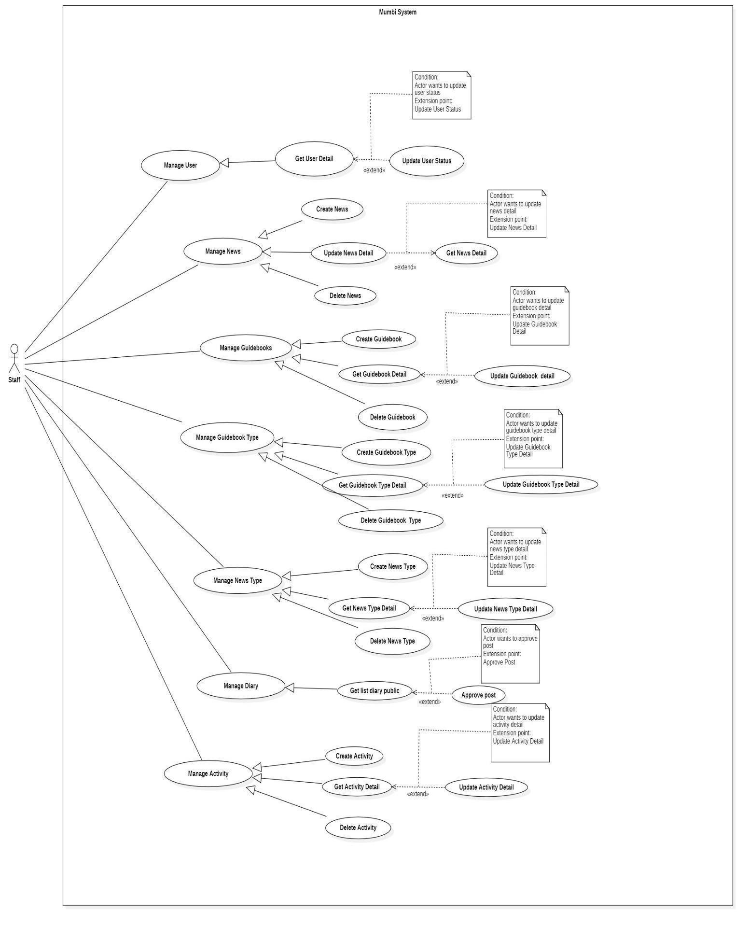

*Figure 21 - <Staff> Overview Use Case Diagram*

#### 2.4.1. Create News

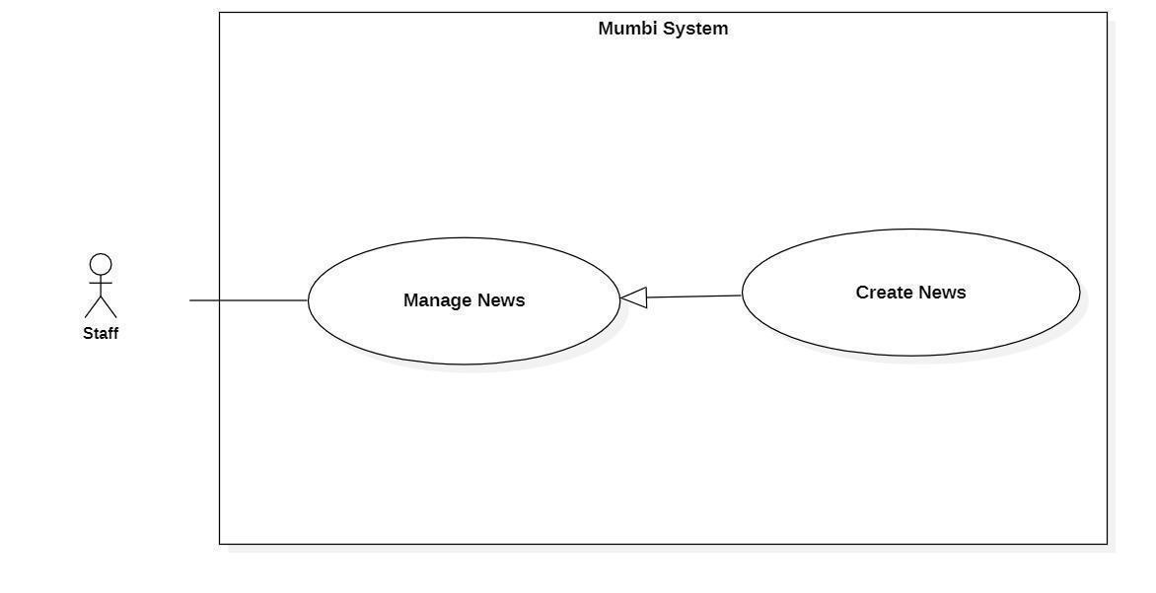

*Figure 22 - <Staff> Create News*

| **UC ID and Name:** | **Create News** | | |
| --- | --- | --- | --- |
| Created By: | Than Quoc Binh | Date Created: | 20/05/2021 |
| Primary Actor: | Staff | Secondary Actors: | N/A |
| Trigger: | The actor sends a request to create a news. | | |
| Description: | The actor needs to have news to help the user have the necessary knowledge. Therefore, this feature allows the actor to create news. | | |
| Preconditions: | The actor had been authorized as a user. | | |
| Post-conditions: | Success  New news is created.  Fail  The system shows an error message. | | |
| Normal Flow: | | **Step** | **Actor Action** | **System Response** | | --- | --- | --- | | 1 | The actor sends a command to create a news. | The system displays information of news to create:   * Image * NewsContent * Title * Type * EstimatedFinishTime | | 2 | The actor fills in information about the news. | The system receives information, create a new news. | | | |
| Alternative Flows: | N/A | | |
| Exceptions: | N/A | | |
| Priority: | Medium | | |
| Frequency of Use: | Frequently | | |
| Business Rules: | - The news will help users have the latest information as well as help users have more objective perspectives in caring and raising babies.  − The process of creating a news:   * Fill in and select the basic information of the news such as news content, image, title, type, estimated finish time. * Check the information and send a request to create new news to the system.   − News includes following fields:   * Image * NewsContent * Title * Type * EstimatedFinishTime | | |
| Other Information: | N/A | | |
| Assumptions: | N/A | | |

*Table 28 - <User> Create News*

#### 2.4.2. Get News Detail

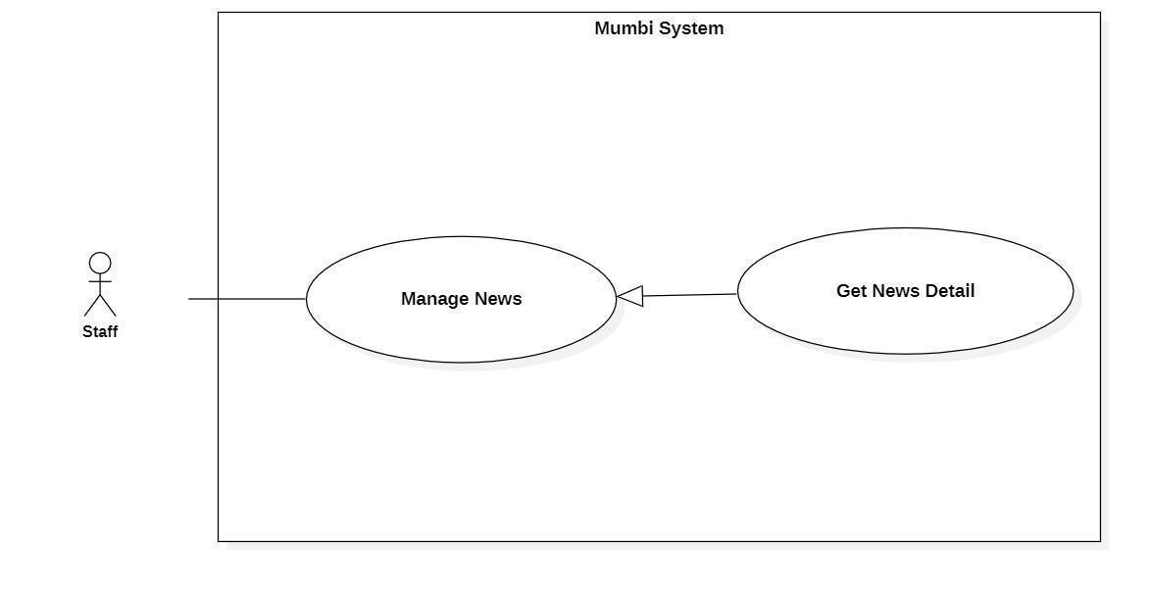

*Figure 23 - <Staff> Get News Detail*

| **UC ID and Name:** | **Get News Detail** | | |
| --- | --- | --- | --- |
| Created By: | Than Quoc Binh | Date Created: | 20/05/2021 |
| Primary Actor: | Staff | Secondary Actors: | N/A |
| Trigger: | The actor wants to get details of the news. | | |
| Description: | This feature allows the actor to get detailed information about news including news content, image, title, type… The user uses this information to make sure that every information is exactly. | | |
| Preconditions: | The actor had been authorized as a user. | | |
| Post-conditions: | Success  The actor receives details of the news.  Fail  N/A | | |
| Normal Flow: | | **Step** | **Actor Action** | **System Response** | | --- | --- | --- | | 1 | The actor wants to get details of the news. | The system return detail of news includes:   * Image * NewsContent * Title * Type * EstimatedFinishTime | | | |
| Alternative Flows: | N/A | | |
| Exceptions: | N/A | | |
| Priority: | Medium | | |
| Frequency of Use: | Frequency | | |
| Business Rules: | − Display detail of news includes:   * Image * NewsContent * Title * Type * EstimatedFinishTime | | |
| Other Information: | N/A | | |
| Assumptions: | N/A | | |

*Table 29 - <Staff> Get News Detail*

#### 2.4.3. Update News Detail

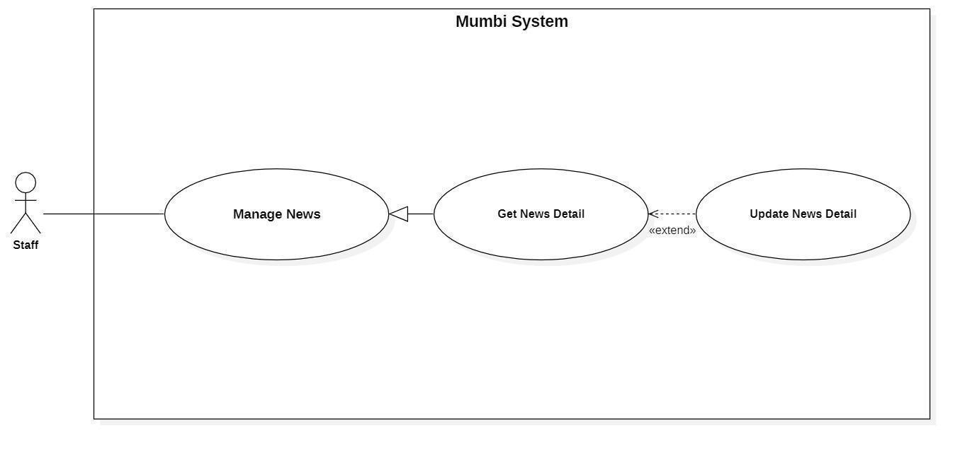

*Figure 24 - <Staff> Update News Detail*

| **UC ID and Name:** | **Update News Detail** | | |
| --- | --- | --- | --- |
| Created By: | Than Quoc Binh | Date Created: | 19/05/2021 |
| Primary Actor: | Staff | Secondary Actors: | N/A |
| Trigger: | The actor indicates to update news | | |
| Description: | Sometimes, users want to edit information in the news. Therefore, this feature allows the actor to update the news. | | |
| Preconditions: | The actor had been authorized as a user. | | |
| Post-conditions: | Success  The news will be updated with new information.  Fail  The system shows an error message. | | |
| Normal Flow: | | **Step** | **Actor Action** | **System Response** | | --- | --- | --- | | 1 | The actor sends a command to update the news. | The system requests information of news:   * Image * NewsContent * Title * Type * EstimatedFinishTime | | 2 | The actor updates the news.  The actor sent a request to update the news. | The system updates the news with this information. | | | |
| Alternative Flows: | N/A | | |
| Exceptions: | N/A | | |
| Priority: | Medium | | |
| Frequency of Use: | Rarely | | |
| Business Rules: | − Each news article will have its own information and the above information may change over time. Therefore, the staff can update it on the system.  − The news information will include the following information:   * Image (Image) * NewsContent (NewsContent) * Title (Title) * Type (Type) * EstimatedFinishTime (EstimatedFinishTime) | | |
| Other Information: | N/A | | |
| Assumptions: | N/A | | |

*Table 30 - <User> Update News Detail*

#### 2.4.4. Delete News

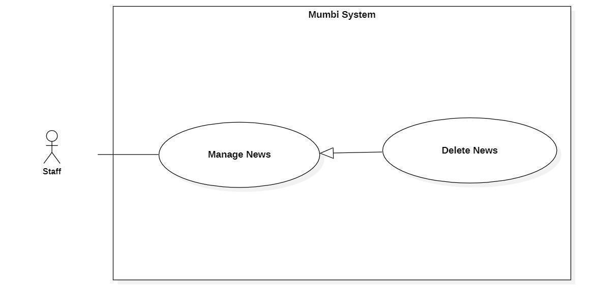

*Figure 25 - <Staff> Delete News*

| **UC ID and Name:** | **Delete News** | | |
| --- | --- | --- | --- |
| Created By: | Than Quoc Binh | Date Created: | 20/05/2021 |
| Primary Actor: | Staff | Secondary Actors: | N/A |
| Trigger: | The actor sends a request to delete the news. | | |
| Description: | The actor needs to delete the news from the system when it is no longer needed. Therefore, this feature allows the actor to delete the news from the system. | | |
| Preconditions: | − The actor had been authorized as a staff. | | |
| Post-conditions: | Success  Send notification to the actor for deleting news and the selected news will be hidden to the actor.  Fail  The system shows an error message. | | |
| Normal Flow: | | **Step** | **Actor Action** | **System Response** | | --- | --- | --- | | 1 | The actor sends a command to delete the news. | The system returns to the actor that the news has been deleted. | | 2 | The actor sends a command to delete the news. | The system changes the status of the news. | | | |
| Alternative Flows: | N/A | | |
| Exceptions: | N/A | | |
| Priority: | Medium | | |
| Frequency of Use: | Rarely | | |
| Business Rules: | − When news is no longer needed, the staff can delete that news from the system.  − After the news is deleted, the status will be changed and the staff should no longer see this news. | | |
| Other Information: | N/A | | |
| Assumptions: | N/A | | |

*Table 31 - <Staff> Delete News*

#### 2.4.5. Create Guidebooks

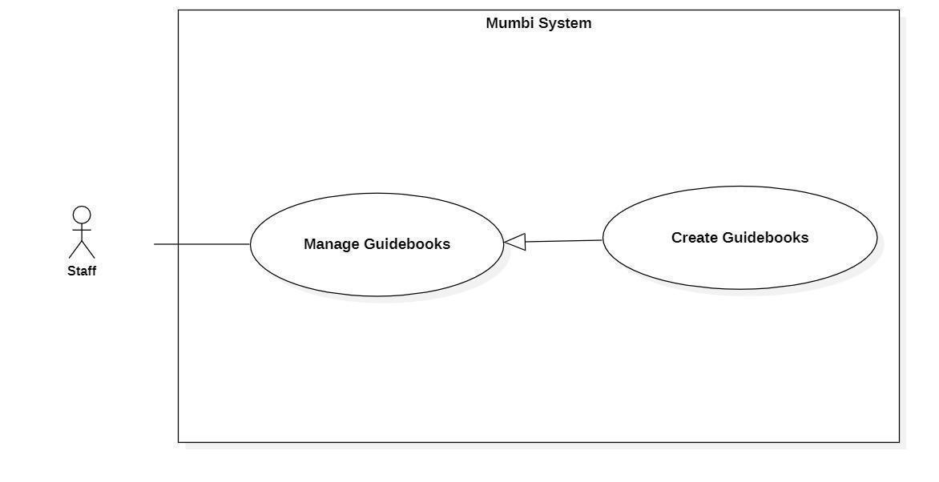

*Figure 26 - <Staff> Create Guidebooks*

| **UC ID and Name:** | **Create Guidebooks** | | |
| --- | --- | --- | --- |
| Created By: | Than Quoc Binh | Date Created: | 20/05/2021 |
| Primary Actor: | Staff | Secondary Actors: | N/A |
| Trigger: | The actor sends a request to create a guidebook. | | |
| Description: | The actor needs to have a guidebook to provide users with useful information. Therefore, this feature allows the staff to create guidebooks. | | |
| Preconditions: | The actor had been authorized as a staff. | | |
| Post-conditions: | Success  A new guidebook is created.  Fail  The system shows an error message. | | |
| Normal Flow: | | **Step** | **Actor Action** | **System Response** | | --- | --- | --- | | 1 | The actor sends a command to create a guidebook. | The system displays information of guidebook to create:   * GuidebookContent * Image * Title * Type * EstimatedFinishTime | | 2 | The actor fills in information about the guidebook. | The system receives information, create a new guidebook. | | | |
| Alternative Flows: | N/A | | |
| Exceptions: | N/A | | |
| Priority: | Medium | | |
| Frequency of Use: | Frequently | | |
| Business Rules: | - The guidebook will guide the user to take care and raise the baby in the best way.  − The process of creating a guidebook:   * Fill in and select the basic information of the guidebook such as guidebook content, image, title, type, estimated finish time. * Check the information and send a request to create a new guidebook to the system.   − Guidebook includes following fields:   * Image * GuidebookContent * Title * Type * EstimatedFinishTime | | |
| Other Information: | N/A | | |
| Assumptions: | N/A | | |

*Table 32 - <Staff> Create Guidebooks*

#### 2.4.6. Get Guidebooks Detail

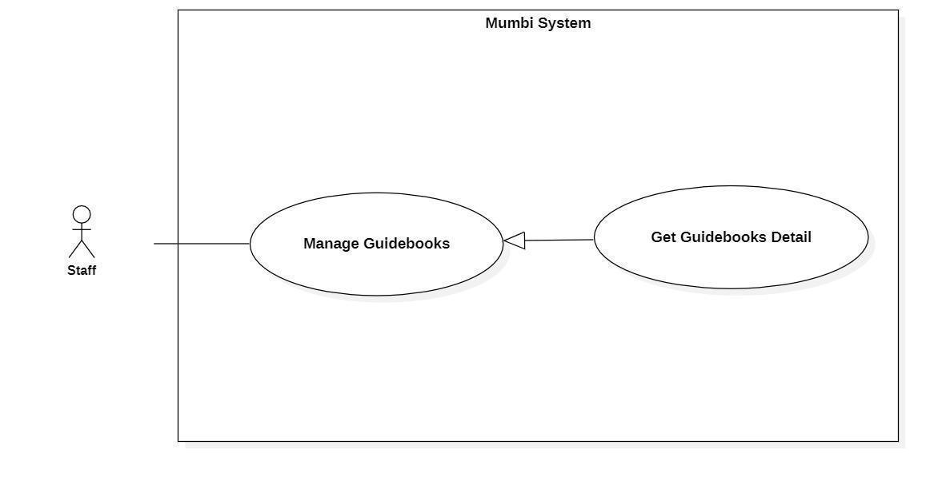

*Figure 27 - <Staff> Get Guidebooks Detail*

| **UC ID and Name:** | **Get Guidebooks Detail** | | |
| --- | --- | --- | --- |
| Created By: | Than Quoc Binh | Date Created: | 20/05/2021 |
| Primary Actor: | Staff | Secondary Actors: | N/A |
| Trigger: | The actor wants to get the details of the guidebook. | | |
| Description: | This feature allows the actor to get detailed information of a guidebook including guidebook content, image, title, type. The staff uses this information to make sure that every information is accurate. | | |
| Preconditions: | The actor had been authorized as a staff. | | |
| Post-conditions: | Success  The actor receives details from the guidebook.  Fail  N/A | | |
| Normal Flow: | | **Step** | **Actor Action** | **System Response** | | --- | --- | --- | | 1 | The actor wants to get the details of the guidebook. | The system return detail of guidebook includes:   * GuidebookContent * Image * Title * Type * EstimatedFinishTime | | | |
| Alternative Flows: | N/A | | |
| Exceptions: | N/A | | |
| Priority: | Medium | | |
| Frequency of Use: | Frequency | | |
| Business Rules: | − Display detail of guidebook includes:   * Image * GuidebookContent * Title * Type * EstimatedFinishTime | | |
| Other Information: | N/A | | |
| Assumptions: | N/A | | |

*Table 33 - <Staff> Get Guidebooks Detail*

#### 2.4.7. Update Guidebooks Detail

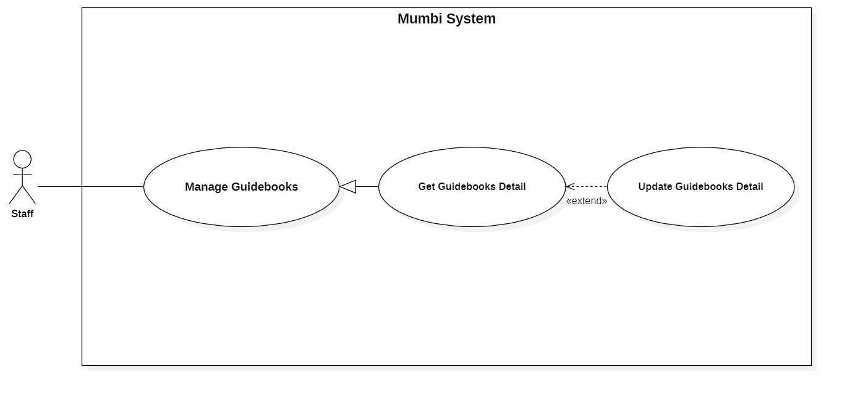

*Figure 28 - <Staff> Update Guidebooks Detail*

| **UC ID and Name:** | **Update Guidebooks Detail** | | |
| --- | --- | --- | --- |
| Created By: | Than Quoc Binh | Date Created: | 19/05/2021 |
| Primary Actor: | Staff | Secondary Actors: | N/A |
| Trigger: | The actor indicates to update guidebooks | | |
| Description: | Sometimes, users want to edit information in a guidebook. Therefore, this feature allows the actor to update the guidebook detail. | | |
| Preconditions: | The actor had been authorized as a staff. | | |
| Post-conditions: | Success  The guidebook will be updated with new information.  Fail  The system shows an error message. | | |
| Normal Flow: | | **Step** | **Actor Action** | **System Response** | | --- | --- | --- | | 1 | The actor sends a command to update the guidebook. | The system requests information of guidebook:   * Title * GuidebookContent * Image * Type * EstimatedFinishTime | | 2 | The actor updates the information in the guidebook.  The actor sent a request to update the guidebook. | The system updates the guidebook with this information. | | | |
| Alternative Flows: | N/A | | |
| Exceptions: | N/A | | |
| Priority: | Medium | | |
| Frequency of Use: | Rarely | | |
| Business Rules: | − Each guidebook will have its own information (for example image, content) and the above information may change over time. Therefore, the staff can update it on the system.  − The guidebook information will include the following information:   * Image (Image) * Title (Title) * Guidebook Content (GuidebookContent) * Type (Type) * EstimatedFinishTime (EstimatedFinishTime): | | |
| Other Information: | N/A | | |
| Assumptions: | N/A | | |

*Table 34 - <Staff> Update Guidebooks Detail*

#### 2.4.8. Delete Guidebooks

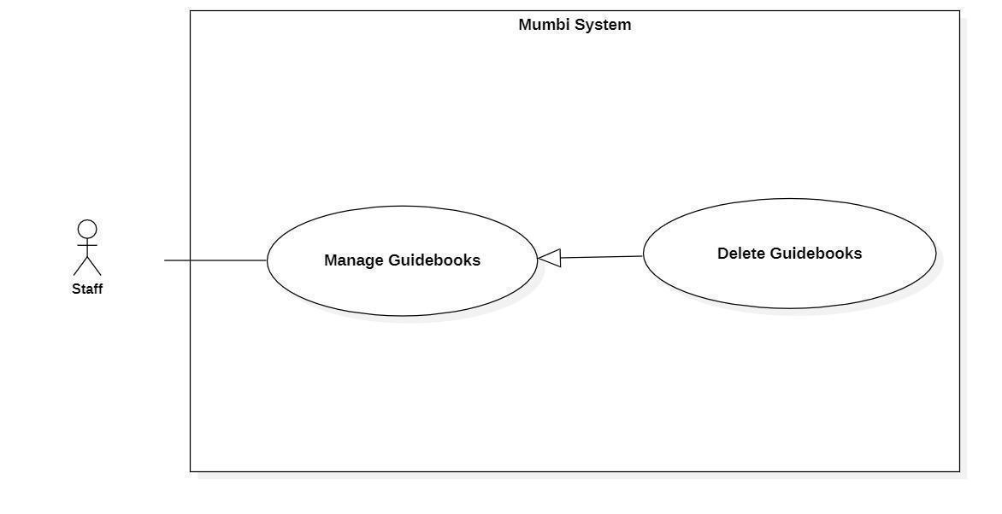

*Figure 29 - <Staff> Delete Guidebooks*

| **UC ID and Name:** | **Delete Guidebooks** | | |
| --- | --- | --- | --- |
| Created By: | Than Quoc Binh | Date Created: | 20/05/2021 |
| Primary Actor: | Staff | Secondary Actors: | N/A |
| Trigger: | The actor sends a request to delete the guidebook. | | |
| Description: | The actor needs to delete the guidebook from the system when it is no longer needed. Therefore, this feature allows the actor to delete the guidebook from the system. | | |
| Preconditions: | − The actor had been authorized as a staff. | | |
| Post-conditions: | Success  Send notification to the actor for deleting the guidebook and the selected guidebook will be hidden to the actor.  Fail  The system shows an error message. | | |
| Normal Flow: | | **Step** | **Actor Action** | **System Response** | | --- | --- | --- | | 1 | The actor sends a command to delete the guidebook. | The system returns to the actor that the guidebook has been deleted. | | 2 | The actor sends a command to delete the guidebook. | The system changes the status of the guidebook. | | | |
| Alternative Flows: | N/A | | |
| Exceptions: | N/A | | |
| Priority: | Medium | | |
| Frequency of Use: | Rarely | | |
| Business Rules: | − When a guidebook is no longer needed, the staff can delete that guidebook from the system.  − After a guidebook is deleted, the status will be changed and the staff should no longer see this diary. | | |
| Other Information: | N/A | | |
| Assumptions: | N/A | | |

*Table 35 - <Staff> Delete Guidebooks*

#### 2.4.9. Create Guidebooks Type

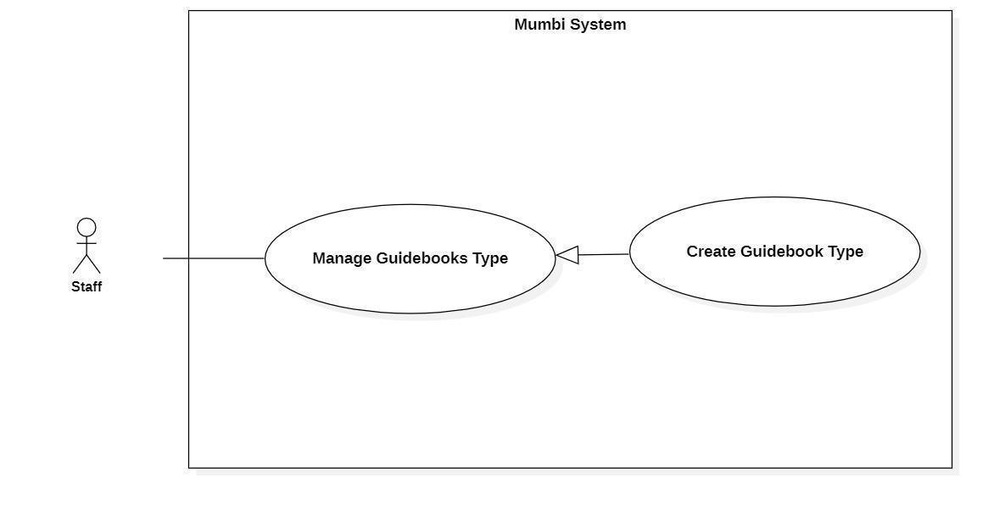

*Figure 30 - <Staff> Create Guidebooks Type*

| **UC ID and Name:** | **Create Guidebooks Type** | | |
| --- | --- | --- | --- |
| Created By: | Than Quoc Binh | Date Created: | 20/05/2021 |
| Primary Actor: | User | Secondary Actors: | N/A |
| Trigger: | The actor sends a request to create a guidebook type. | | |
| Description: | The actor needs to have a guidebook type to classify the guidebook. Therefore, this feature allows the staff to create guidebook types. | | |
| Preconditions: | The actor had been authorized as a staff. | | |
| Post-conditions: | Success  A new guidebook type is created.  Fail  The system shows an error message. | | |
| Normal Flow: | | **Step** | **Actor Action** | **System Response** | | --- | --- | --- | | 1 | The actor sends a command to create a guidebook type. | The system displays information of guidebook type to create:   * Type | | 2 | The actor fills in information about the guidebook type. | The system receives information, create a new guidebook type. | | | |
| Alternative Flows: | N/A | | |
| Exceptions: | N/A | | |
| Priority: | Medium | | |
| Frequency of Use: | Frequently | | |
| Business Rules: | − The process of creating a guidebook type:   * Fill in and select the basic information of the guidebook type. * Check the information and send a request to create a new guidebook type to the system.   − Guidebook type includes following fields:   * Type | | |
| Other Information: | N/A | | |
| Assumptions: | N/A | | |

*Table 36 - <Staff> Create Guidebooks Type*

#### 2.4.10. Get Guidebooks Type Detail

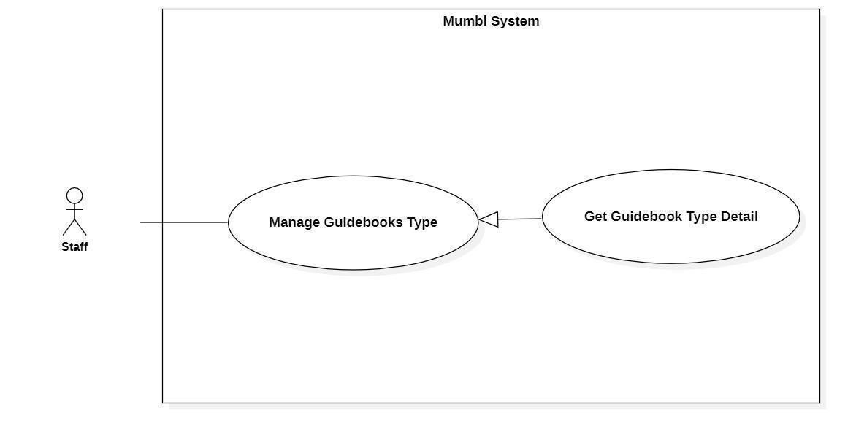

*Figure 31 - <Staff> Get Guidebooks Type Detail*

| **UC ID and Name:** | **Get Guidebooks Type Detail** | | |
| --- | --- | --- | --- |
| Created By: | Than Quoc Binh | Date Created: | 20/05/2021 |
| Primary Actor: | Staff | Secondary Actors: | N/A |
| Trigger: | The actor wants to get details of the guidebook type. | | |
| Description: | This feature allows the actor to get detailed information of a guidebook type. The staff uses this information to make sure that every information is accurate. | | |
| Preconditions: | The actor had been authorized as a staff. | | |
| Post-conditions: | Success  The actor receives details from the guidebook.  Fail  N/A | | |
| Normal Flow: | | **Step** | **Actor Action** | **System Response** | | --- | --- | --- | | 1 | The actor wants to get details of the guidebook type. | The system return detail of guidebook type includes:   * Type | | | |
| Alternative Flows: | N/A | | |
| Exceptions: | N/A | | |
| Priority: | Medium | | |
| Frequency of Use: | Frequency | | |
| Business Rules: | − Display detail of guidebook type includes:   * Type | | |
| Other Information: | N/A | | |
| Assumptions: | N/A | | |

*Table 37 - <Staff> Get Guidebooks Type Detail*

#### 2.4.11. Update Guidebooks Type Detail

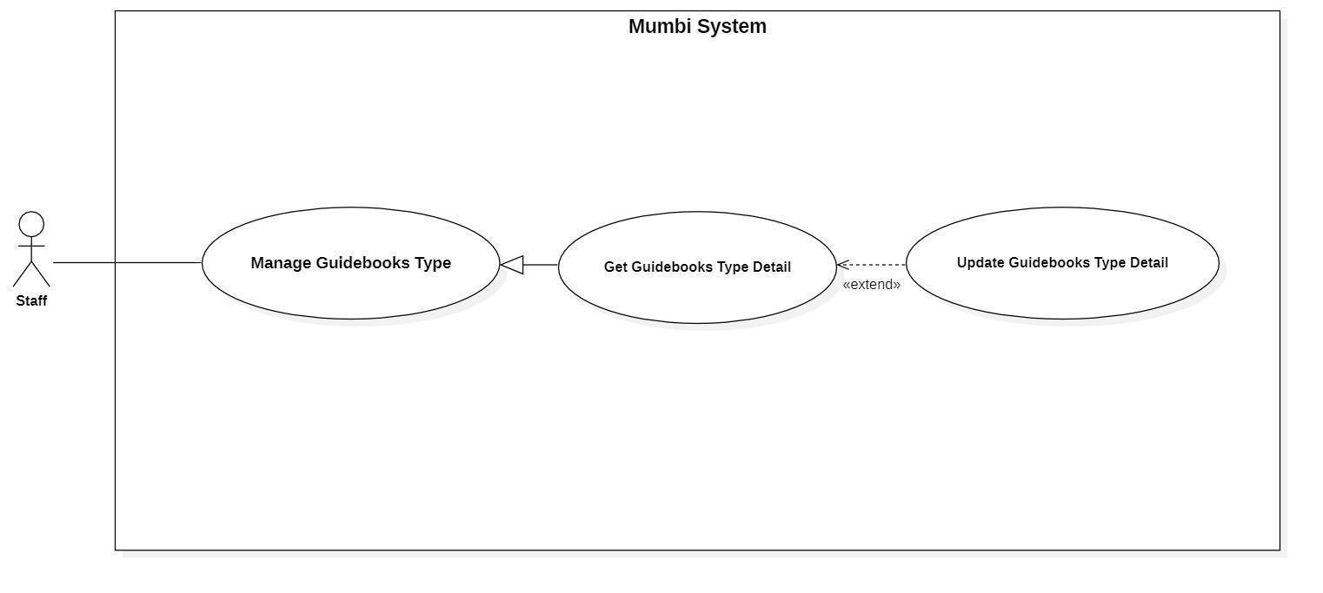

*Figure 32 - <Staff> Update Guidebooks Type Detail*

| **UC ID and Name:** | **Update Guidebooks Detail** | | |
| --- | --- | --- | --- |
| Created By: | Than Quoc Binh | Date Created: | 19/05/2021 |
| Primary Actor: | Staff | Secondary Actors: | N/A |
| Trigger: | The actor indicates to update guidebooks | | |
| Description: | Sometimes, users want to edit information in guidebook type. Therefore, this feature allows the actor to update the guidebook type detail. | | |
| Preconditions: | The actor had been authorized as a staff. | | |
| Post-conditions: | Success  The guidebook type will be updated with new information.  Fail  The system shows an error message. | | |
| Normal Flow: | | **Step** | **Actor Action** | **System Response** | | --- | --- | --- | | 1 | The actor sends a command to update the guidebook type. | The system requests information of guidebook:   * Type | | 2 | The actor updates information of the guidebook type.  The actor sends a request to update the guidebook type. | The system updates the guidebook type with this information. | | | |
| Alternative Flows: | N/A | | |
| Exceptions: | N/A | | |
| Priority: | Medium | | |
| Frequency of Use: | Rarely | | |
| Business Rules: | − Each guidebook type will have its own information and the above information may change over time. Therefore, the staff can update it on the system.  − The guidebook type information will include the following information:   * Type (Type): | | |
| Other Information: | N/A | | |
| Assumptions: | N/A | | |

*Table 38 - <Staff> Update Guidebooks Type Detail*

#### 2.4.12. Delete Guidebooks Type

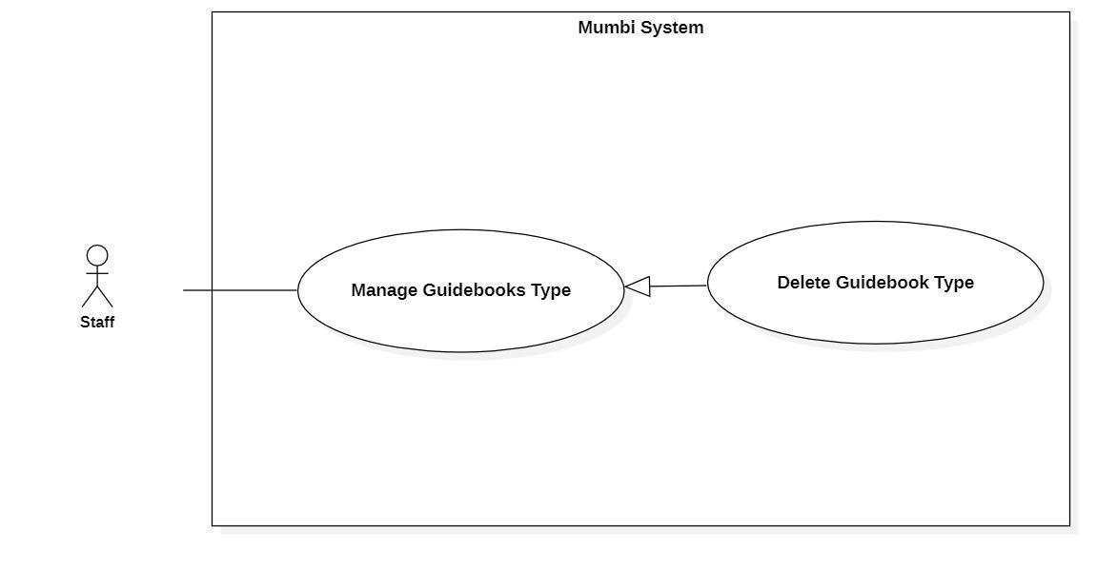

*Figure 33 - <Staff> Delete Guidebooks Type*

| **UC ID and Name:** | **Delete Guidebooks Type** | | |
| --- | --- | --- | --- |
| Created By: | Than Quoc Binh | Date Created: | 20/05/2021 |
| Primary Actor: | Staff | Secondary Actors: | N/A |
| Trigger: | The actor sends a request to delete the guidebook type. | | |
| Description: | The actor needs to delete the guidebook type from the system when it is no longer needed. Therefore, this feature allows the actor to delete the guidebook type from the system. | | |
| Preconditions: | − The actor had been authorized as a staff. | | |
| Post-conditions: | Success  Send notification to the actor for delete guidebook type and the selected guidebook type will be hidden to the actor.  Fail  The system shows an error message. | | |
| Normal Flow: | | **Step** | **Actor Action** | **System Response** | | --- | --- | --- | | 1 | The actor sends a command to delete the guidebook type. | The system returns to the actor that the guidebook type has been deleted. | | 2 | The actor sends a command to delete the guidebook type. | The system changes the status of the guidebook type. | | | |
| Alternative Flows: | N/A | | |
| Exceptions: | N/A | | |
| Priority: | Medium | | |
| Frequency of Use: | Rarely | | |
| Business Rules: | − When a guidebook type is no longer needed, the staff can delete that guidebook type from the system.  − After a guidebook type is deleted, the status will be changed and the staff should no longer see this guidebook type. | | |
| Other Information: | N/A | | |
| Assumptions: | N/A | | |

*Table 39 - <Staff> Delete Guidebooks Type*

#### 2.4.13. Create News Type

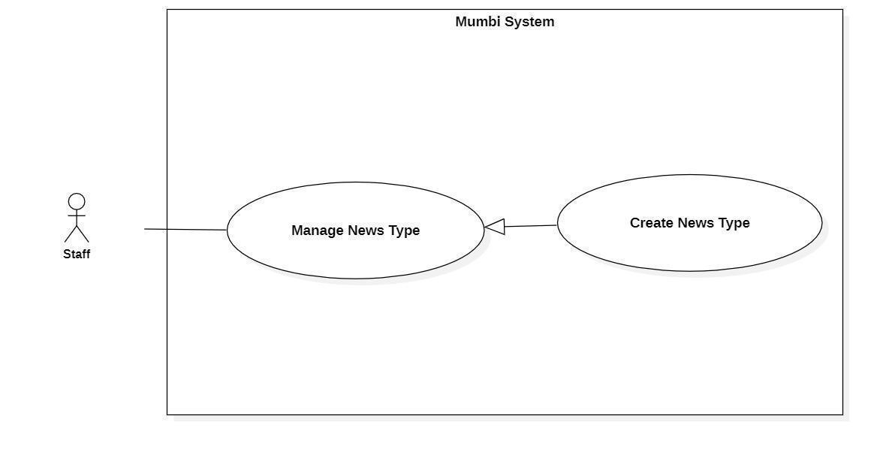

*Figure 34 - <Staff>Create News Type*

| **UC ID and Name:** | **Create News Type** | | |
| --- | --- | --- | --- |
| Created By: | Than Quoc Binh | Date Created: | 20/05/2021 |
| Primary Actor: | User | Secondary Actors: | N/A |
| Trigger: | The actor sends a request to create a news type. | | |
| Description: | The actor needs to have a news type to classify news. Therefore, this feature allows the staff to create news types. | | |
| Preconditions: | The actor had been authorized as a staff. | | |
| Post-conditions: | Success  A new news type is created.  Fail  The system shows an error message. | | |
| Normal Flow: | | **Step** | **Actor Action** | **System Response** | | --- | --- | --- | | 1 | The actor sends a command to create a news type. | The system displays information of news type to create:   * Type | | 2 | The actor fills in information about the news type. | The system receives information, create a new news type. | | | |
| Alternative Flows: | N/A | | |
| Exceptions: | N/A | | |
| Priority: | Medium | | |
| Frequency of Use: | Frequently | | |
| Business Rules: | − The process of creating a news type:   * Fill in and select the basic information of the news type. * Check the information and send a request to create a new news type to the system.   − News type includes following fields:   * Type | | |
| Other Information: | N/A | | |
| Assumptions: | N/A | | |

*Table 40 - <Staff> Create News Type*

#### 2.4.14. Get News Type Detail

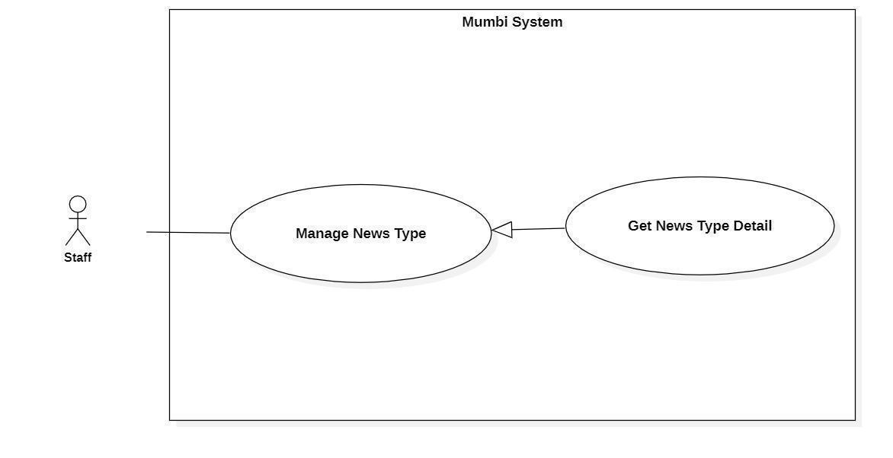

*Figure 35 - <Staff> Get News Type Detail*

| **UC ID and Name:** | **Get News Type Detail** | | |
| --- | --- | --- | --- |
| Created By: | Than Quoc Binh | Date Created: | 20/05/2021 |
| Primary Actor: | Staff | Secondary Actors: | N/A |
| Trigger: | The actor wants to get details of the news type. | | |
| Description: | This feature allows the actor to get detailed information of a news type. The staff uses this information to make sure that every information is accurate. | | |
| Preconditions: | The actor had been authorized as a staff. | | |
| Post-conditions: | Success  The actor receives details of news type.  Fail  N/A | | |
| Normal Flow: | | **Step** | **Actor Action** | **System Response** | | --- | --- | --- | | 1 | The actor wants to get the details of the guidebook. | The system return detail of guidebook includes:   * Type | | | |
| Alternative Flows: | N/A | | |
| Exceptions: | N/A | | |
| Priority: | Medium | | |
| Frequency of Use: | Frequency | | |
| Business Rules: | − Display detail of news type includes:   * Type | | |
| Other Information: | N/A | | |
| Assumptions: | N/A | | |

*Table 41 - <Staff> Get News Type Detail*

#### 2.4.15. Update News Type Detail

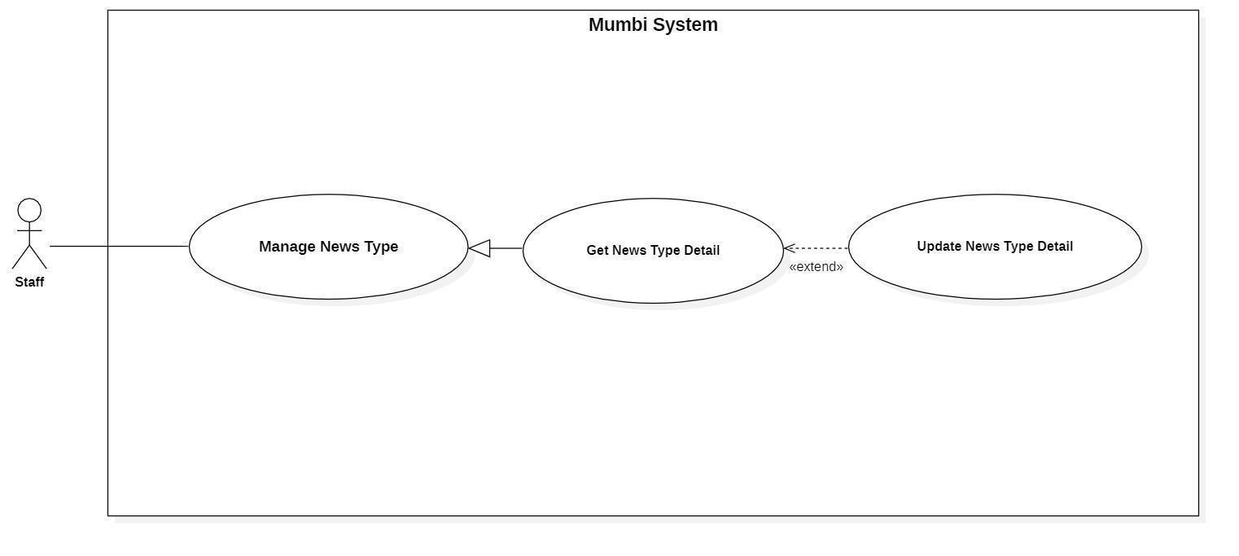

*Figure 36 - <Staff> Update News Type Detail*

| **UC ID and Name:** | **Update News Type Detail** | | |
| --- | --- | --- | --- |
| Created By: | Than Quoc Binh | Date Created: | 19/05/2021 |
| Primary Actor: | Staff | Secondary Actors: | N/A |
| Trigger: | The actor indicates to update the news type. | | |
| Description: | Sometimes, users want to edit information in news type. Therefore, this feature allows the actor to update the news type in detail. | | |
| Preconditions: | The actor had been authorized as a staff. | | |
| Post-conditions: | Success  The news type will be updated with new information.  Fail  The system shows an error message. | | |
| Normal Flow: | | **Step** | **Actor Action** | **System Response** | | --- | --- | --- | | 1 | The actor sends a command to update the news type. | The system requests information of news type:   * Type | | 2 | The actor updates information of the news type.  The actor sends a request to update the news type. | The system updates the news type with this information. | | | |
| Alternative Flows: | N/A | | |
| Exceptions: | N/A | | |
| Priority: | Medium | | |
| Frequency of Use: | Rarely | | |
| Business Rules: | − Each news type will have its own information and the above information may change over time. Therefore, the staff can update it on the system.  − The news type information will include the following information:   * Type (Type): | | |
| Other Information: | N/A | | |
| Assumptions: | N/A | | |

*Table 42 - <Staff> Update News Type Detail*

#### 2.4.16. Delete News Type

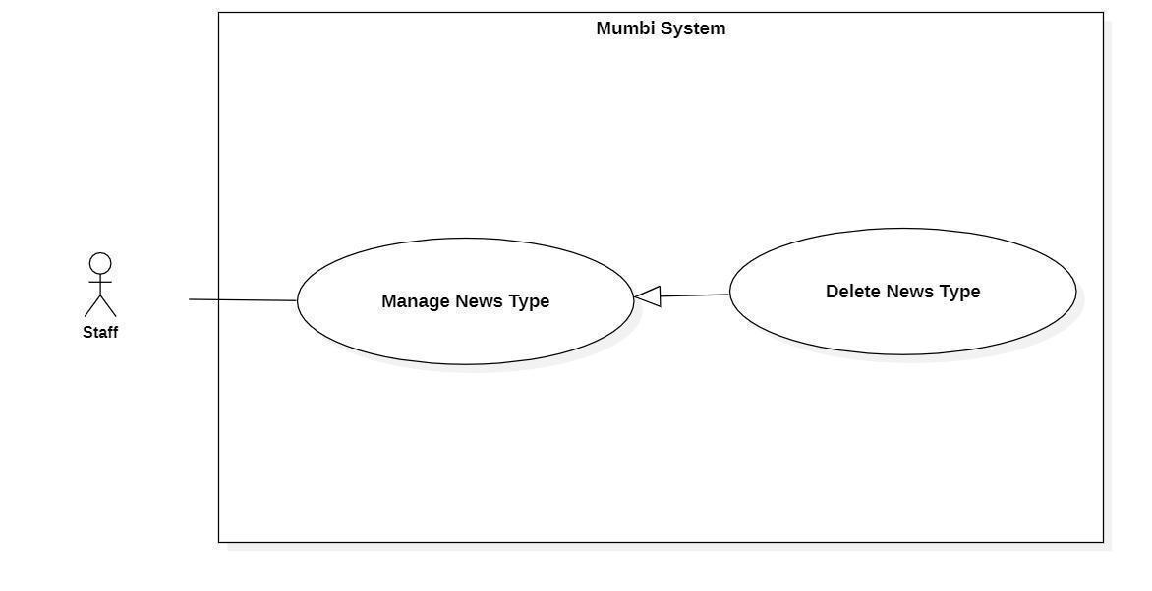

*Figure 37 - <Staff> Delete News Type*

| **UC ID and Name:** | **Delete News Type** | | |
| --- | --- | --- | --- |
| Created By: | Than Quoc Binh | Date Created: | 20/05/2021 |
| Primary Actor: | Staff | Secondary Actors: | N/A |
| Trigger: | The actor sends a request to delete the news type. | | |
| Description: | The actor needs to delete the news type from the system when it is no longer needed. Therefore, this feature allows the actor to delete the news type from the system. | | |
| Preconditions: | − The actor had been authorized as a staff. | | |
| Post-conditions: | Success  Send notification to the actor for deleting the news type and the selected news type will be hidden to the actor.  Fail  The system shows an error message. | | |
| Normal Flow: | | **Step** | **Actor Action** | **System Response** | | --- | --- | --- | | 1 | The actor sends a command to delete the news type. | The system returns to the actor that the news type has been deleted. | | 2 | The actor sends a command to delete the news type. | The system changes the status of the news type. | | | |
| Alternative Flows: | N/A | | |
| Exceptions: | N/A | | |
| Priority: | Medium | | |
| Frequency of Use: | Rarely | | |
| Business Rules: | − When a news type is no longer needed, the staff can delete that news type from the system.  − After a news type is deleted, it will be changed the status and the staff should no longer see this news type. | | |
| Other Information: | N/A | | |
| Assumptions: | N/A | | |

*Table 43 - <Staff> Delete News Type*

#### 2.4.17. Get User Detail

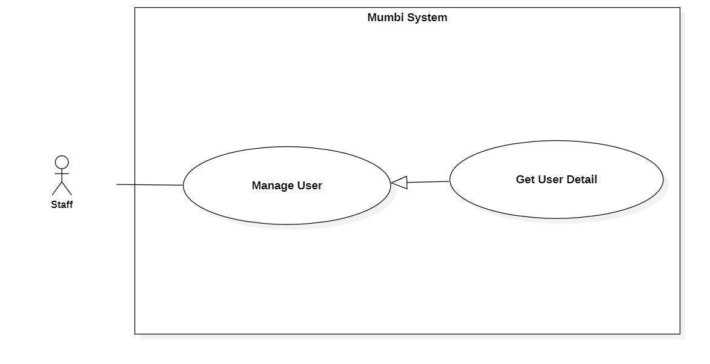

*Figure 38 - <Staff> Get User Detail*

| **UC ID and Name:** | **Get User Detail** | | |
| --- | --- | --- | --- |
| Created By: | Than Quoc Binh | Date Created: | 20/05/2021 |
| Primary Actor: | Staff | Secondary Actors: | N/A |
| Trigger: | The actor wants to get details of the user. | | |
| Description: | This feature allows the actor to get detailed information of a user including email, image, fullname. The staff uses this information to make sure that every information is accurate. | | |
| Preconditions: | The actor had been authorized as a staff. | | |
| Post-conditions: | Success  The actor receives details of the user.  Fail  N/A | | |
| Normal Flow: | | **Step** | **Actor Action** | **System Response** | | --- | --- | --- | | 1 | The actor wants to get details of the user. | The system return detail of user includes:   * Fullname * Image * Email | | | |
| Alternative Flows: | N/A | | |
| Exceptions: | N/A | | |
| Priority: | Medium | | |
| Frequency of Use: | Frequency | | |
| Business Rules: | − Display detail of user includes:   * Fullname * Image * Email | | |
| Other Information: | N/A | | |
| Assumptions: | N/A | | |

*Table 44 - <Staff> Get User Detail*

#### 2.4.18. Update User Status

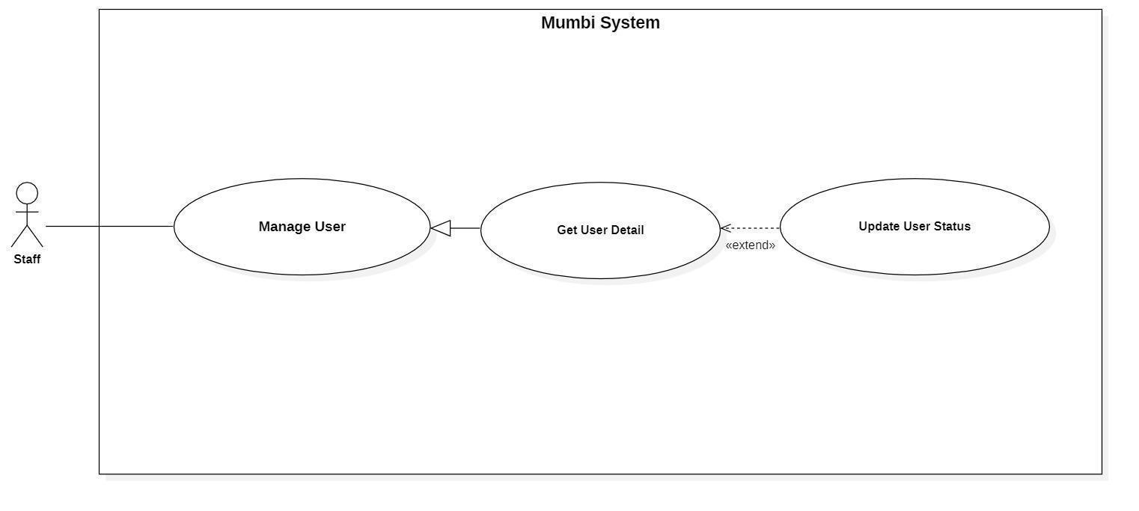

*Figure 39 - <Staff> Update User Status*

| **UC ID and Name:** | **Update User Status** | | |
| --- | --- | --- | --- |
| Created By: | Than Quoc Binh | Date Created: | 20/05/2021 |
| Primary Actor: | Staff | Secondary Actors: | N/A |
| Trigger: | The actor sends a request to update user status. | | |
| Description: | The actor needs to disable the user from the system. Therefore, this feature allows the actor to disable the user from the system. | | |
| Preconditions: | − The actor had been authorized as a staff. | | |
| Post-conditions: | Success  Send notification to the actor for disable user and the selected user will be hidden to the actor.  Fail  The system shows an error message. | | |
| Normal Flow: | | **Step** | **Actor Action** | **System Response** | | --- | --- | --- | | 1 | The actor sends a command to disable the user. | The system returns to the actor that user has been disabled. | | 2 | The actor sends a command to disable the user. | The system changes the status of the user. | | | |
| Alternative Flows: | N/A | | |
| Exceptions: | N/A | | |
| Priority: | Medium | | |
| Frequency of Use: | Rarely | | |
| Business Rules: | − After a user is disabled, the user will be changed to not logged in to the system and staff will no longer see this user. | | |
| Other Information: | N/A | | |
| Assumptions: | N/A | | |

*Table 45 - <Staff> Update User Status*

#### 2.4.19. Approve Post

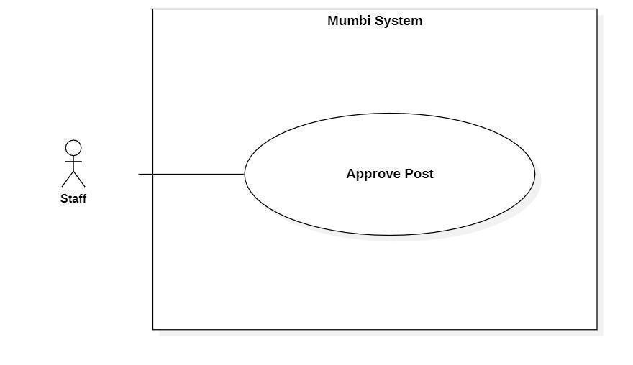

*Figure 40 - <Staff> Approve Post*

| **UC ID and Name:** | **Approve Post** | | |
| --- | --- | --- | --- |
| Created By: | Than Quoc Binh | Date Created: | 20/05/2021 |
| Primary Actor: | Staff | Secondary Actors: | N/A |
| Trigger: | The actor sends a request to approve the post. | | |
| Description: | The actor needs to approve the post when the user wants to publish a diary to the community. Therefore, this feature allows the actor to approve posts the user wants to publicize. | | |
| Preconditions: | − The actor had been authorized as a staff. | | |
| Post-conditions: | Success  The diary will be published to the community.  Fail  N/A | | |
| Normal Flow: | | **Step** | **Actor Action** | **System Response** | | --- | --- | --- | | 1 | The actor sends a command to approve the post. | The system returns to the actor that the post has been published. | | | |
| Alternative Flows: | N/A | | |
| Exceptions: | N/A | | |
| Priority: | Medium | | |
| Frequency of Use: | Rarely | | |
| Business Rules: | − After a diary is approved, it will be displayed in the community on a mobile app and the staff should no longer see this diary. | | |
| Other Information: | N/A | | |
| Assumptions: | N/A | | |

*Table 46 - <Staff> Approve Post*

#### 2.4.20. Create Activity

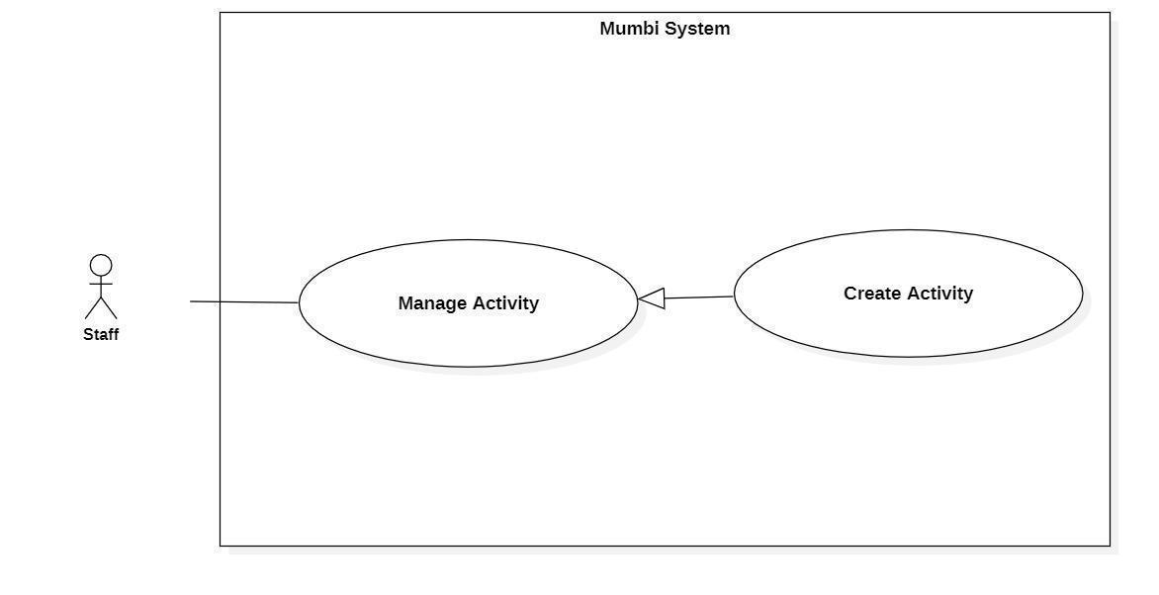

*Figure 41 - <Staff> Create Activity*

| **UC ID and Name:** | **Create Activity** | | |
| --- | --- | --- | --- |
| Created By: | Than Quoc Binh | Date Created: | 20/05/2021 |
| Primary Actor: | User | Secondary Actors: | N/A |
| Trigger: | The actor sends a request to create an activity. | | |
| Description: | The actor needs to create activity for users to get activity to help their children develop better. Therefore, this feature allows the staff to create activity. | | |
| Preconditions: | The actor had been authorized as a staff. | | |
| Post-conditions: | Success  A new activity is created.  Fail  The system shows an error message. | | |
| Normal Flow: | | **Step** | **Actor Action** | **System Response** | | --- | --- | --- | | 1 | The actor sends a command to create an activity. | The system displays information of activity to create:   * ActivityName * MediaFile * Type * SuitableAge | | 2 | The actor fills in information about the activity. | The system receives information, create a new activity. | | | |
| Alternative Flows: | N/A | | |
| Exceptions: | N/A | | |
| Priority: | Medium | | |
| Frequency of Use: | Frequently | | |
| Business Rules: | − The process of creating a activity:   * Fill in and select the basic information of the activity. * Check the information and send a request to create a new activity to the system.   − Activity includes following fields:   * ActivityName * MediaFile * Type * SuitableAge   - Type of action includes: listening music, telling story, reading poetry | | |
| Other Information: | N/A | | |
| Assumptions: | N/A | | |

*Table 47 - <Staff> Create Activity*

#### 2.4.21. Get Activity Detail

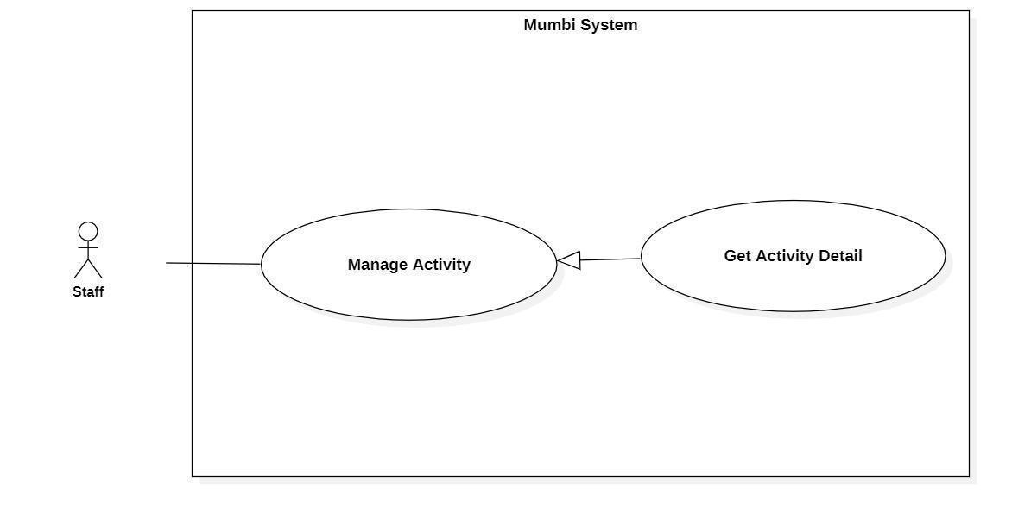

*Figure 42 - <Staff> Get Activity Detail*

| **UC ID and Name:** | **Get Activity Detail** | | |
| --- | --- | --- | --- |
| Created By: | Than Quoc Binh | Date Created: | 20/05/2021 |
| Primary Actor: | Staff | Secondary Actors: | N/A |
| Trigger: | The actor wants to get details of the activity. | | |
| Description: | This feature allows the actor to get detailed information of an activity. The staff uses this information to make sure that every information is accurate. | | |
| Preconditions: | The actor had been authorized as a staff. | | |
| Post-conditions: | Success  The actor receives details of activity.  Fail  N/A | | |
| Normal Flow: | | **Step** | **Actor Action** | **System Response** | | --- | --- | --- | | 1 | The actor wants to get details of the activity. | The system return detail of activity includes:   * ActivityName * MediaFile * Type * SuitableAge | | | |
| Alternative Flows: | N/A | | |
| Exceptions: | N/A | | |
| Priority: | Medium | | |
| Frequency of Use: | Frequency | | |
| Business Rules: | − Display detail of activity includes:   * ActivityName * MediaFile * Type * SuitableAge | | |
| Other Information: | N/A | | |
| Assumptions: | N/A | | |

*Table 48 - <Staff> Get Activity Detail*

#### 2.4.22. Update Activity Detail

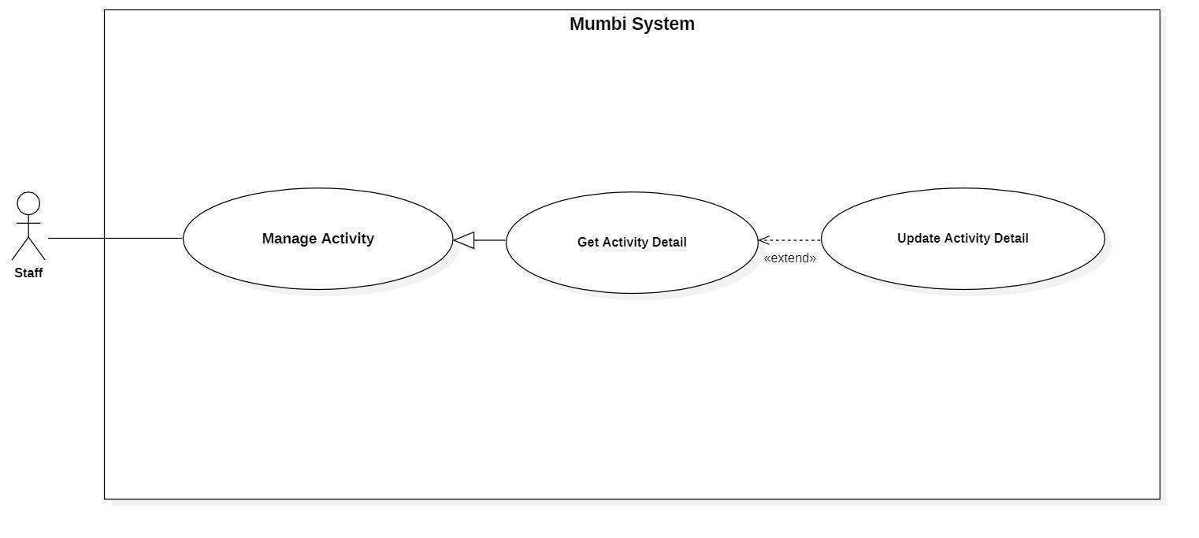

*Figure 43 - <Staff> Update Activity Detail*

| **UC ID and Name:** | **Update Activity Detail** | | |
| --- | --- | --- | --- |
| Created By: | Than Quoc Binh | Date Created: | 19/05/2021 |
| Primary Actor: | Staff | Secondary Actors: | N/A |
| Trigger: | The actor indicates to update activity. | | |
| Description: | Sometimes, users want to edit information in an activity. Therefore, this feature allows the actor to update the activity detail. | | |
| Preconditions: | The actor had been authorized as a staff. | | |
| Post-conditions: | Success  The activity will be updated with new information.  Fail  The system shows an error message. | | |
| Normal Flow: | | **Step** | **Actor Action** | **System Response** | | --- | --- | --- | | 1 | The actor sends a command to update activity. | The system requests information of activity:   * ActivityName * MediaFile * Type * SuitableAge | | 2 | The actor updates information about the activity.  The actor sends a request to update activity. | The system updates the activity with this information. | | | |
| Alternative Flows: | N/A | | |
| Exceptions: | N/A | | |
| Priority: | Medium | | |
| Frequency of Use: | Rarely | | |
| Business Rules: | − Each activity will have its own information and the above information may change over time. Therefore, the staff can update it on the system.  − The activity information will include the following information:   * ActivityName * MediaFile * Type * SuitableAge | | |
| Other Information: | N/A | | |
| Assumptions: | N/A | | |

*Table 49 - <Staff> Update Activity Detail*

#### 2.4.23. Delete Activity

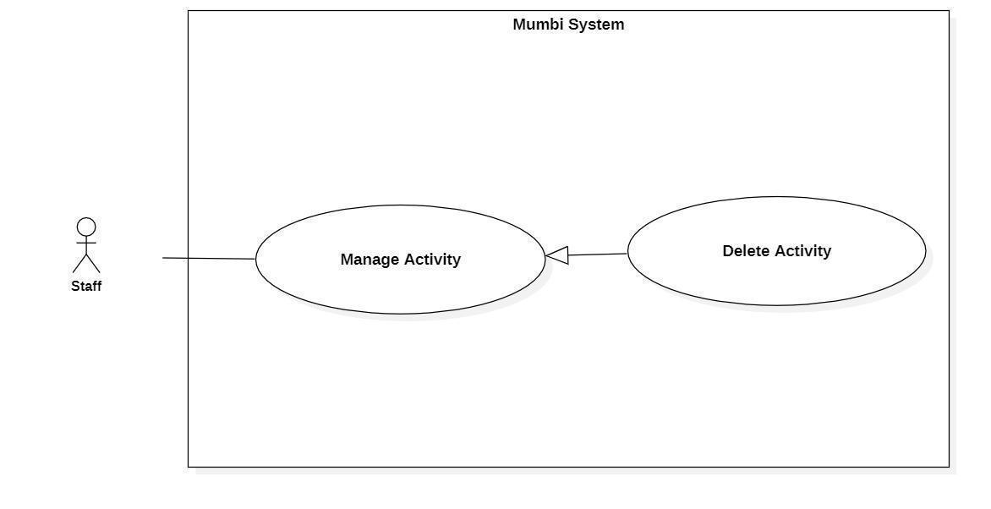

*Figure 44 - <Staff> Delete Activity*

| **UC ID and Name:** | **Delete Activity** | | |
| --- | --- | --- | --- |
| Created By: | Than Quoc Binh | Date Created: | 20/05/2021 |
| Primary Actor: | Staff | Secondary Actors: | N/A |
| Trigger: | The actor sends a request to delete activity. | | |
| Description: | The actor needs to delete the activity from the system when it is no longer needed. Therefore, this feature allows the actor to delete the activity from the system. | | |
| Preconditions: | − The actor had been authorized as a staff. | | |
| Post-conditions: | Success  Send notification to the actor for deleting activity and the selected action will be hidden to the actor.  Fail  The system shows an error message. | | |
| Normal Flow: | | **Step** | **Actor Action** | **System Response** | | --- | --- | --- | | 1 | The actor sends a command to delete the activity. | The system returns to the actor that activity has been deleted. | | 2 | The actor sends a command to delete the activity. | The system changes the status of the activity. | | | |
| Alternative Flows: | N/A | | |
| Exceptions: | N/A | | |
| Priority: | Medium | | |
| Frequency of Use: | Rarely | | |
| Business Rules: | − When an activity is no longer needed, the staff can delete that activity from the system.  − After an activity is deleted, the status will be changed and the staff should no longer see this activity. | | |
| Other Information: | N/A | | |
| Assumptions: | N/A | | |

*Table 50 - <Staff> Delete Activity*

### 2.5. Firebase Service

#### 2.5.1. Verify Phone number

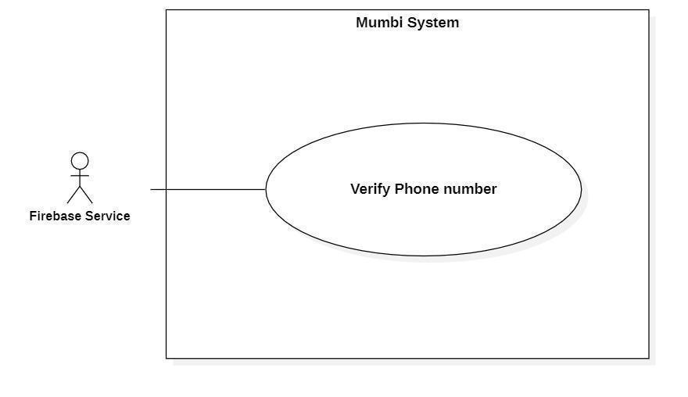

*Figure 45 - <Firebase Service> Verify Phone number*

| **UC ID and Name:** | **Verify Phone number** | | |
| --- | --- | --- | --- |
| Created By: | Bui Hai Nam | Date Created: | 20/05/2021 |
| Primary Actor: | Firebase Service | Secondary Actors: | N/A |
| Trigger: | The actor receives a request to verify the phone number. | | |
| Description: | In Mumbi, the phone number of the user is required information and it must be verified that the user is the owner. So, Mumbi can get vaccine schedules for its users. | | |
| Preconditions: | The system has received the phone number that needs to be verified. | | |
| Post-conditions: | Success  The phone number is verified.  Fail  The phone number is not verified. | | |
| Normal Flow: | | **Step** | **Actor Action** | **System Response** | | --- | --- | --- | | 1 | The actor requests a phone  number. | The system sends a request to verify a phone number. | | 2 | The actor receives the phone number.  The actor sends an OTP to the phone number.  The actor requires OTP from the system. | The system sends the phone number. | | 3 | The actor receives an OTP and checks it.  [Exception 1]  [Exception 2]  When the OTP is matched, the actor returns a success message to the system. | The system sends an OTP to the actor. | | 4 |  | The system receives messages and marks that the phone number is verified. | | | |
| Alternative Flows: | N/A | | |
| Exceptions: | | **No** | **Cause** | **System Response** | | --- | --- | --- | | 1 | The OTP is not matched. | The system shows error  messages and requests another OTP. | | 2 | The OTP is due. | The system shows error  messages and requests to re-verify the phone number. | | | |
| Priority: | High | | |
| Frequency of Use: | Regularly | | |
| Business Rules: | − Phone numbers are authenticated in the following way:   * Firebase proceeds to send an OTP to the phone number to be verified. * The user enters this code into the system. * The system sends this code to Firebase for authentication. * If the code matches and is still valid, Firebase sends a notification of success to the system. The system marks that the phone number is authenticated. | | |
| Other Information: | N/A | | |
| Assumptions: | N/A | | |

*Table 51 - <Firebase System> Verify Phone number*

## 3. Functional Requirements

## 3.1. Conceptual Diagram

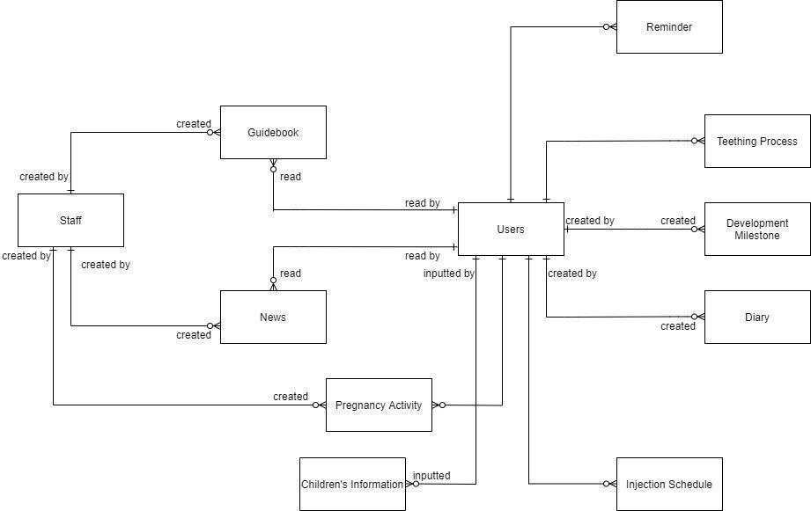

*Figure 46 - Conceptual Diagram*

## 3.2. Entity Relationship Diagram

Source: [Entity Relationship Diagram](https://drive.google.com/file/d/1vGc6ssf1v2MvTAGzuuFLsnhC9XXunOe7/view?usp=sharing)

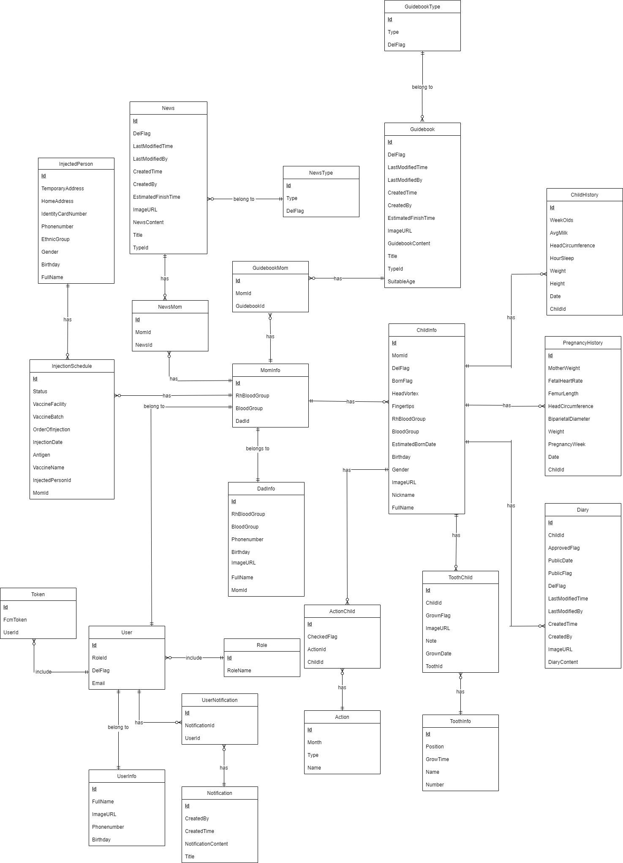

*Figure 47 - Entity Relationship Diagram*

| **No** | **Entity** | **Description** |
| --- | --- | --- |
| 1 | MomInfo | Contain information of mom |
| 2 | DadInfo | Contain information of dad |
| 3 | GuidebookMom | Contain guidebook is saved |
| 4 | Guidebook | Contain information of guidebook |
| 5 | GuidebookType | Contain type of guidebook |
| 6 | NewsMom | Contain news is saved |
| 7 | News | Contain information of news |
| 8 | NewsType | Contain type of news |
| 9 | Diary | Contain information of diary |
| 10 | ChildHistory | Contain information of child history |
| 11 | PregnancyHistory | Contain information of pregnancy history |
| 12 | ToothChild | Contain all tooth |
| 13 | ToothInfo | Contain information of tooth |
| 14 | Action | Contain information of action |
| 15 | ActionChild | Contain action child |
| 16 | User | Contain user in system |
| 17 | Role | Contain role in system |
| 18 | UserNotification | Contain user notification |
| 19 | Notification | Contain information of notification |
| 20 | UserInfo | Contain information of user |
| 21 | Token | Contain information of token |
| 22 | InjectedPerson | Contain information of injected person |
| 23 | InjectionSchedule | Contain information of injection schedule |

*Table 52 - Entity Data Dictionary*

## 3.3 System Functional Overview

### 3.3.1 Screen Flow

#### 3.3.1.1 Customer application

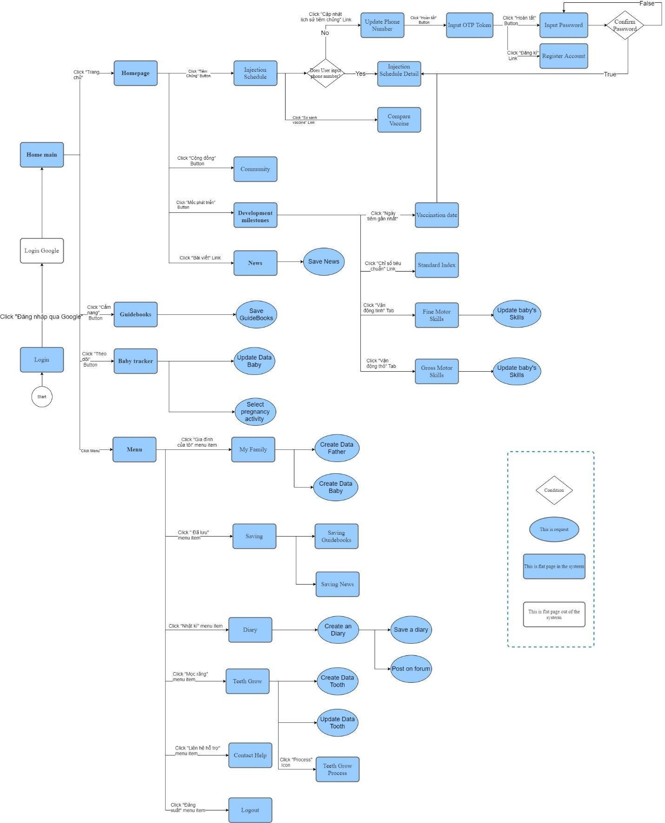

*Figure 48 - <Customer application> Screen flow*

#### 3.3.1.2. Staff application

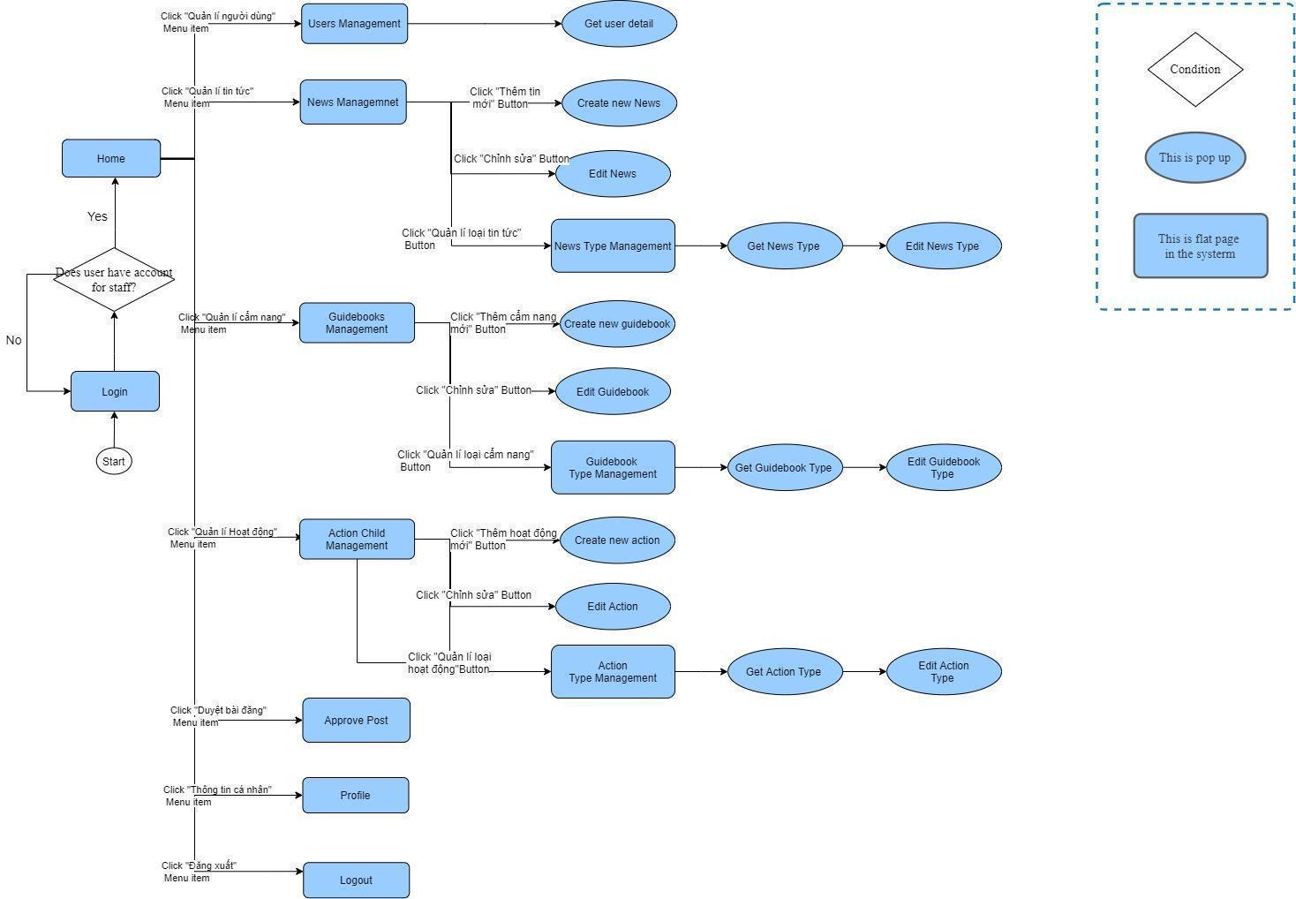

*Figure 49 - <Staff application> Screen flow*

### 3.3.2 Screen details

#### 3.3.2.1 Customer application

| **Id** | **Feature** | **Screen** | **Description** |
| --- | --- | --- | --- |
|  | Login | **Login page** | Login to system with customer role |
|  | Home | **Home main page** | View the overall of the homepage with customer role |
|  | Get guidebook | **Guidebook page** | Get full of guidebook in the system |
|  | Get baby’s development | **Baby tracker page** | Get the development detail of baby from system |
|  | Get baby’s Injection Schedule | **Injection Schedule page** | Get the Injection Schedule of baby from system |
|  | Community | **Community page** | View a list of your baby's diary |
|  | View baby’s development milestones | **Development milestones page** | View baby’s development milestones from system |
|  | View News | **News page** | View full of News in the system |
|  | Save Guidebooks | **Save Guidebooks page** | Save Guidebooks in system with customer role |
|  | Update Data Baby | **Update Data Baby page** | Update the data of baby regularly in system |
|  | Select pregnancy activity | **Select pregnancy activity page** | Select a type of customer’s pregnancy activity from system |
|  | View family members | **My Family page** | View members in customer’s family from data typed in the system |
|  | View savings | **Saving page** | View full of customer savings |
|  | Get diary | **Diary page** | View full of customers diary |
|  | View Growing teeth | **Teeth Grow page** | View and update data teeth |
|  | Contact Help | **Contact Help page** | Contact to be supported in the process customer using application |
|  | Logout | **Logout page** | Logout of system |
|  | Save News | **Save News page** | Save News in system with customer role |
|  | Create Data Father | **Create Data Father page** | Create Data Father in system with customer role |
|  | Create Data Baby | **Create Data Baby page** | Create Data baby in system with customer role |
|  | View saving guidebooks | **Saving Guidebooks page** | View customer’s saving Guidebooks in system |
|  | View saving news | **Saving News page** | View customer’s saving News in system |
|  | Create a Diary | **Create a Diary page** | Create a Diary in system with customer role |
|  | Create Data Tooth | **Create Data Tooth page** | Create baby’s Data tooth in system with customer role |
|  | Get growing teeth process | **Teeth Grow Process page** | View Timeline data of Growing Teeth |
|  | Update Phone Number | **Update Phone Number page** | Update customer’s phone number in system |
|  | Get Injection Schedule Detail | **Injection Schedule Detail page** | Get the Injection Schedule Detail of baby from system |
|  | Compare Vaccine | **Compare Vaccine page** | View list of vaccines |
|  | Save a diary | **Save a diary page** | Save a customer’s diary in system |
|  | Post on forum | **Post on forum page** | Give a post on forum in system |
|  | View Vaccination date | **Vaccination date page** | View full of Vaccination date from system |
|  | Get Standard Index | **Standard Index page** | Get baby’s Standard Index in system |
|  | Get Fine Motor Skills | **Fine Motor Skills page** | Get baby’s Fine Motor Skills in system |
|  | Get Gross Motor Skills | **Gross Motor Skills page** | Get baby’s Gross Motor Skills in system |
|  | Input OTP Token | **Input OTP Token page** | Input number of OTP Token of phone number |
|  | Update baby’s Fine Motor Skills | **Update baby’s Fine Motor Skills page** | Update baby’s Fine Motor Skills in system |
|  | Update baby’s Gross Motor Skills | **Update baby’s Gross Motor Skills page** | Update baby’s Gross Motor Skills in system |
|  | Input Password | **Input Password page** | Input password of phone number |
|  | Register Account | **Register Account page** | Fill in customer information to register Account in system |

*Table 53 - <Customer application> Screen details*

#### 3.2.2.2 Staff application

| **Id** | **Feature** | **Screen** | **Description** |
| --- | --- | --- | --- |
|  | Login | **Login page** | Login to system with staff role |
|  | View overall | **Home page** | View the overall of the homepage with staff role |
|  | Manage user | **User Management page** | Manage all of user in system |
|  | Manage News | **News Management page** | Manage all of News in system |
|  | Manage Guidebooks | **Guidebooks Management page** | Manage all of Guidebooks in system |
|  | Manage Action Child | **Action Child Management page** | Manage all of Action Child in system |
|  | Approve Post | **Approve Post page** | Check and approve customer’s Post |
|  | Get profile | **Profile page** | Get information of staff from system |
|  | Logout | **Logout page** | Logout of system with the role as staff |
|  | Get user detail | **Get user detail page** | Get information detail of user from system |
|  | Create new News | **Create new News page** | Create new News in system |
|  | Edit News | **Edit News page** | Edit News in system |
|  | Manage News Type | **News Type Management page** | Manage News Type in system |
|  | Create new action | **Create new action page** | Create new action in system |
|  | Edit Action | **Edit Action page** | Edit full of action in system |
|  | Manage Action Type | **Action Type Management page** | Manage all type of Action in system |
|  | Get News Type | **Get News Type page** | Get the type of News from system |
|  | Get Guidebook Type | **Get Guidebook Type page** | Get the type of Guidebook from system |
|  | Get Action Type | **Get Action Type page** | Get the type of Action from system |
|  | Edit News Type | **Edit News Type page** | Edit News Type in system |
|  | Edit Guidebook Type | **Edit Guidebook Type page** | Edit Guidebook Type in system |
|  | Edit Action Type | **Edit Action Type page** | Edit Action Type in system |

*Table 54 - <Staff application> Screen details*

# 4. Non-Functional Requirements

## 4.1. External Interfaces

### 4.1.1. User Interfaces

* Both the web application and mobile application user interface will be Vietnamese.

### 4.1.2. Software Interfaces

* Mobile Application: Android Operating System v10.0.
* Web Application:
* Chrome browser, Firefox browser.
* Browsers support HTML5, CSS3 and have Javascript enabled.

### 4.1.3. Communication Interfaces

* Authentication service: The system can be integrated with Firebase Authentication.
* File Storage Service: The system can be integrated with Firebase Storage.
* The system can use HTTP to transfer data.

## 4.2. Quality Attributes

### 4.2.1. Usability

* All texts, labels and messages should be written in Vietnamese.
* The web application for staff should require no more than one day of training to be used.
* It takes Customer about 10-20 minutes to get acquainted and use the app.

### 4.2.2. Reliability

* The application should handle HTTP/HTTPS requests in less than 10 seconds at any time.

### 4.2.3. Portability

* The user’s software is a mobile application.
* The staff software is a web-based application.
* The applications are working well in Chrome Browser version 65 and higher.

### 4.2.4. Security

* In order to access the application User and Staff must be authenticated by logging using their Gmail account.
* Mumbi system is currently divided into 2 roles: Users, Staffs.
* All input data are validated before saving to the database.
* Each role only accesses a group of functions.
* The system always checks for authorization and authentication before doing any features.

# IV. Software Design Description

## Overall Description

### 1.1. Assumptions

The system is designed based on the following assumptions:

* Windows 10
* Chrome 65
* SQL Server 2014
* End-user: Mumbi Staff and every user in Ho Chi Minh city

### 1.2. Design Constraints

The system should be compiled with the following items:

* End-user environment:
* Mumbi Staff in Windows 10 with Chrome browser version 65 or higher.
* Users: in Chrome browser version 65.
* Security requirement: prevent a user from cheating as much as possible.
* Network communication: this system depends on the network connection.

## 2. System Architecture Design

### 2.1. Overall Architecture

*Figure 50 - System Overall Architecture Diagram*

| **No.** | **Name** | **Description** |
| --- | --- | --- |
| **1** | Front-End Server | Client component to render and display data from the server. Client component provides functions:  - For staff: manage users, manage news, approve posts, manage guidebook, manage guidebook type, manage news type, manage pregnancy activity.  - For user: update phone number, receive vaccination schedule, follow development milestone |
| **2** | Storage Service | Storage service to store resources of users and staff. The resources such as images. |
| **3** | Cloud Message Service | Service to notify messages from the system to users. |
| **4** | Mumbi API | It handles requests from the Front End and responses from the system. |
| **5** | Business logic process layer (Domain) | It handles the business logic of the system. |
| **6** | Model | It supports the system to handle data. |
| **7** | Repository | It handles reading and writing data in the system. |
| **8** | Database | It stores the data of the system. |
| **9** | Authentication Service | This service is in charge of authenticating 3rd party  account of the staff and user and then send the result to our system. |

*Table 55 - Architecture Diagram Dictionary*

### 2.2. Package Diagram

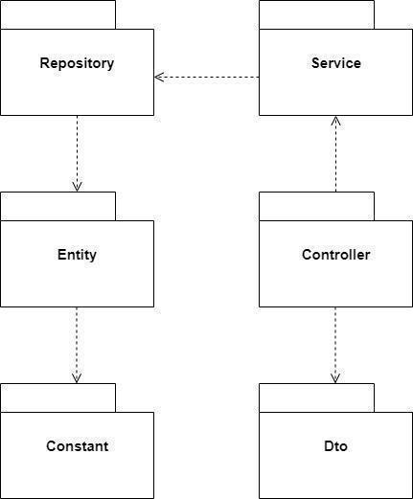

*Figure 51 - Package Diagram*

| **No.** | **Name** | **Description** |
| --- | --- | --- |
| **1** | Repository | For database calls. It keeps the interface classes that implement code to access the data layer. |
| **2** | Service | For business logic. It keeps the interface of service classes and implementation of it. |
| **3** | Entity | For mapping with database tables. |
| **4** | Constant | For constant variables. |
| **5** | Controller | For the request mapping. |
| **6** | Dto | For data transfer. |

*Table 56 - Component Diagram Dictionary*

## 3. System Detailed Design

### 3.1. Class Diagram

### 3.1.1 Class Diagram

[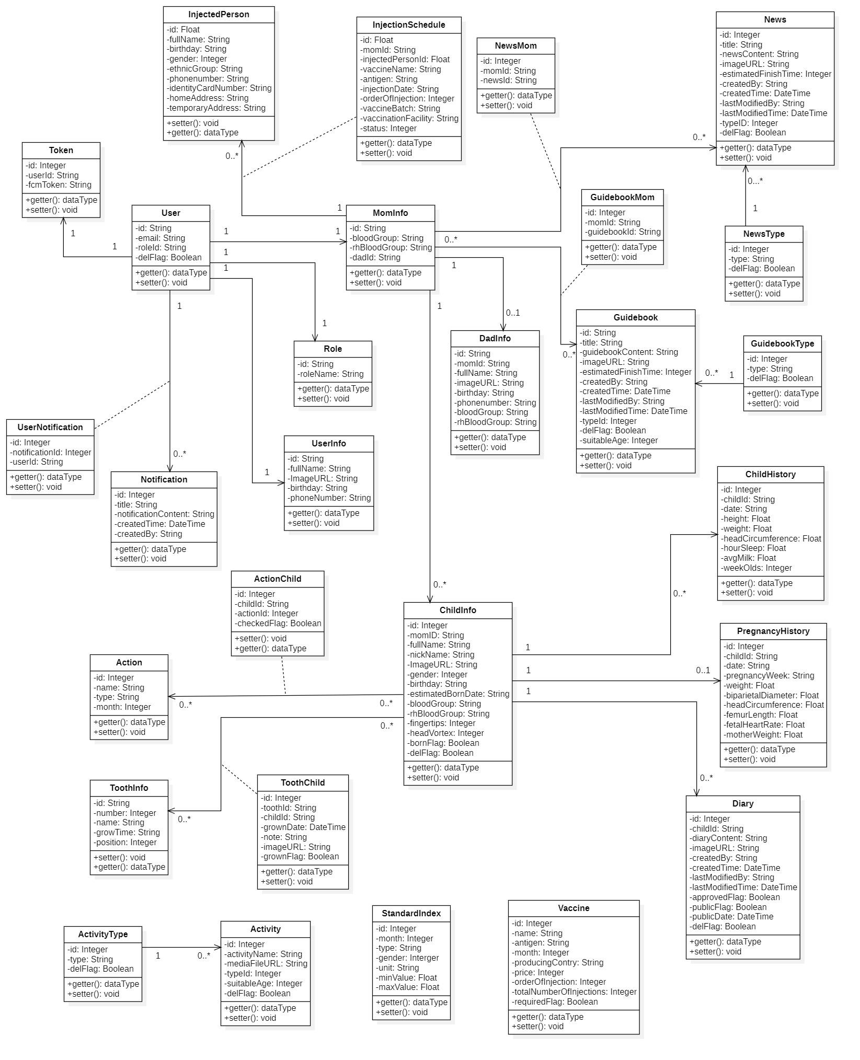](https://drive.google.com/file/d/1hTbrgzDjSf59O546pw80IIGOX0pYVvj1/view?usp=sharing)

*Figure 52 - Class Diagram*

### 3.1.2. Class Specifications

**UserInfo**

| **No.** | **Attribute** | **Data Type** | **Visibility** | **Description** |
| --- | --- | --- | --- | --- |
| **1** | id | Int | Private | Unique identifier of user |
| **2** | fullName | String | Private | The full name of user |
| **3** | imageURL | DateTime | Private | The image of user |
| **4** | birthday | String | Private | The birthday of user |
| **5** | phoneNumber | Boolean | Private | The phone number of user |

*Table 57 - <Class Specification> User*

**MomInfo**

| **No.** | **Attribute** | **Data Type** | **Visibility** | **Description** |
| --- | --- | --- | --- | --- |
| **1** | id | String | Private | Unique identifier of mom |
| **2** | bloodGroup | String | Private | The blood group of mom |
| **3** | rhBloodGroup | String | Private | The rh blood group of mom |
| **4** | dadId | String | Private | Unique identifier of dad |

*Table 58 - <Class Specification> MomInfo*

**DadInfo**

| **No.** | **Attribute** | **Data Type** | **Visibility** | **Description** |
| --- | --- | --- | --- | --- |
| **1** | id | String | Private | Unique identifier of dad |
| **2** | momId | String | Private | Unique identifier of mom |
| **3** | phoneNumber | String | Private | The phone number of a father |
| **4** | bloodGroup | String | Private | The blood group of a father |
| **5** | rhBloodGroup | String | Private | The rh blood group of a father |
| **6** | birthday | String | Private | The birthday of a father |
| **7** | fullName | String | Private | The full name of a dad |
| **8** | imageURL | String | Private | The image of a dad |

*Table 59 - <Class Specification> DadInfo*

**News**

| **No.** | **Attribute** | **Data Type** | **Visibility** | **Description** |
| --- | --- | --- | --- | --- |
| **1** | idd | Int | Private | Unique identifier of a news |
| **2** | title | String | Private | The title of a news |
| **3** | imageURL | String | Private | The image of a news |
| **4** | newsContent | String | Private | The news content of a news |
| **5** | typeID | Integer | Private | Unique identifier of type |
| **6** | estimatedFinishTime | Integer | Private | The estimated finish time of a news |
| **7** | createdBy | String | Private | The estimated finish time of a news |
| **8** | createdTime | DateTime | Private | The estimated finish time of a news |
| **9** | lastModifiedBy | String | Private | The user last modified of a news |
| **10** | lastModifiedTime | DateTime | Private | The last modified time of a news |
| **11** | delFlag | Boolean | Private | The status delete of news |

*Table 60 - <Class Specification> News*

**Token**

| **No.** | **Attribute** | **Data Type** | **Visibility** | **Description** |
| --- | --- | --- | --- | --- |
| **1** | id | Integer | Private | Unique identifier of token |
| **2** | userId | String | Private | Unique identifier of a User |
| **3** | fcmToken | String | Private | The fcm token of a token |

*Table 61 - <Class Specification> Token*

**Injection Schedule**

| **No.** | **Attribute** | **Data Type** | **Visibility** | **Description** |
| --- | --- | --- | --- | --- |
| **1** | id | Integer | Private | Unique identifier of a Injection Schedule |
| **2** | momId | String | Private | Unique identifier of a mom |
| **3** | injectedPersonId | String | Private | Unique identifier of a injected person |
| **4** | vaccineName | String | Private | The vaccine name of a vaccine in injection schedule |
| **5** | antigen | String | Private | The antigen of a vaccine in injection schedule |
| **6** | injectionDate | String | Private | The injection date of a vaccine in injection schedule |
| **7** | orderOfInjection | String | Private | The order of injection of a vaccine in injection schedule |
| **8** | vaccineBatch | String | Private | The vaccine batch of a vaccine in injection schedule |
| **9** | vaccineFacility | String | Private | The vaccine facility of a vaccine in injection schedule |
| **10** | status | String | Private | The status of a vaccine in injection schedule |

*Table 62 - <Class Specification> Injection Schedule*

**ToothChild**

| **No.** | **Attribute** | **Data Type** | **Visibility** | **Description** |
| --- | --- | --- | --- | --- |
| **1** | id | Integer | Private | Unique identifier of tooth |
| **2** | toothId | String | Private | Unique identifier of tooth |
| **3** | childId | String | Private | Unique identifier of child |
| **4** | grownDate | DateTime | Private | The grown date of tooth |
| **5** | note | String | Private | The note of tooth |
| **6** | imageURL | String | Private | The image of tooth |
| **7** | grownFlag | Boolean | Private | The status grown of tooth |

*Table 63 - <Class Specification> Tooth*

**NewsType**

| **No.** | **Attribute** | **Data Type** | **Visibility** | **Description** |
| --- | --- | --- | --- | --- |
| **1** | id | Integer | Private | Unique identifier of a news type |
| **2** | type | String | Private | The type of a news type |
| **3** | delFlag | Boolean | Private | The status delete of a news type |

*Table 64 - <Class Specification> NewsType*

**Role**

| **No.** | **Attribute** | **Data Type** | **Visibility** | **Description** |
| --- | --- | --- | --- | --- |
| **1** | id | String | Private | Unique identifier of a role |
| **2** | roleName | String | Private | The name of a role |

*Table 65 - <Class Specification> Role*

**ChildInfo**

| **No.** | **Attribute** | **Data Type** | **Visibility** | **Description** |
| --- | --- | --- | --- | --- |
| **1** | gender | Integer | Private | The gender of a child |
| **2** | fingertips | String | Private | The fingertips of a child |
| **3** | headVortex | Float | Private | The head vortex of a child |
| **4** | bloodGroup | String | Private | The blood group of a child |
| **5** | rhBloodGroup | String | Private | The rh blood group of a child |
| **6** | fullName | String | Private | The full name of a child |
| **7** | nickName | String | Private | The nickname of a child |
| **8** | imageURL | String | Private | The image of a child |
| **9** | birthday | DateTime | Private | The birthday of a child |
| **10** | id | Integer | Private | Unique identifier of a child |
| **11** | momID | String | Private | Unique identifier of a mom |
| **12** | estimatedBornDate | String | Private | The estimated born date of a child |
| **13** | bornFlag | Boolean | Private | The status born of child |
| **14** | delFlag | Boolean | Private | The status delete of child |

*Table 66 - <Class Specification> ChildInfo*

**Diary**

| **No.** | **Attribute** | **Data Type** | **Visibility** | **Description** |
| --- | --- | --- | --- | --- |
| **1** | id | Integer | Private | Unique identifier of a diary |
| **2** | diaryContent | String | Private | The content of a diary |
| **3** | imageURL | String | Private | The image of a diary |
| **4** | approvedFlag | Boolean | Private | The status approved of diary |
| **5** | childId | String | Private | Unique identifier of a child |
| **6** | publicFlag | Boolean | Private | The status public of diary |
| **7** | createdBy | String | Private | The estimated finish time of a diary |
| **8** | createdTime | DateTime | Private | The estimated finish time of a diary |
| **9** | lastModifiedBy | String | Private | The user last modified of a diary |
| **10** | lastModifiedTime | DateTime | Private | The last modified time of a diary |
| **11** | delFlag | Boolean | Private | The status delete of diary |
| **12** | publicDate | DateTime | Private | The public date of diary |

*Table 67 - <Class Specification> Diary*

**PregnancyHistory**

| **No.** | **Attribute** | **Data Type** | **Visibility** | **Description** |
| --- | --- | --- | --- | --- |
| **1** | id | Integer | Private | Unique identifier of a pregnancy history |
| **2** | childId | String | Private | Unique identifier of a child |
| **3** | headCircumference | Float | Private | The head circumference of a pregnancy in pregnancy history |
| **4** | femurLength | Float | Private | The femur length of a pregnancy in pregnancy history |
| **5** | fetalHeartRate | String | Private | The fetal heart rate of a pregnancy in pregnancy history |
| **6** | pregnancyWeek | String | Private | The week of a pregnancy in pregnancy history |
| **7** | weight | Float | Private | The weight of a pregnancy in pregnancy history |
| **8** | pregnancyType | Float | Private | The type a pregnancy |
| **9** | date | String | Private | The date of a pregnancy in pregnancy history |
| **10** | biparietalDiameter | Float | Private | The biparietal diameter of a pregnancy in pregnancy history |
| **11** | motherWeight | Float | Private | The mother weight of a pregnancy in pregnancy history |

*Table 68 - <Class Specification> PregnancyHistory*

**Activity**

| **No.** | **Attribute** | **Data Type** | **Visibility** | **Description** |
| --- | --- | --- | --- | --- |
| **1** | id | Integer | Private | Unique identifier of a activity |
| **2** | activityName | String | Private | Unique identifier of a child |
| **3** | mediaFileURL | String | Private | The media file of a activity |
| **4** | suitableAge | Integer | Private | The suitable age of a activity |
| **5** | typeId | String | Private | Unique identifier of a type |
| **6** | delFlag | Boolean | Private | The status delete of activity |

*Table 69 - <Class Specification> Activity*

**Vaccine**

| **No.** | **Attribute** | **Data Type** | **Visibility** | **Description** |
| --- | --- | --- | --- | --- |
| **1** | id | Int | Private | Unique identifier of a vaccine |
| **2** | name | String | Private | The name of a vaccine |
| **3** | totalNumberOfInjections | Integer | Private | The total number of injections of a vaccine |
| **4** | price | Float | Private | The price of a vaccine |
| **5** | producingCountry | String | Private | The producing country of a vaccine |
| **6** | antigen | String | Private | The antigen of a vaccine |
| **7** | month | Integer | Private | The month of a vaccine |
| **8** | requiredFlag | Boolean | Private | The status required of a vaccine |
| **9** | orderOfInjection | Integer | Private | The order of injection of a vaccine |

*Table 70 - <Class Specification> Vaccine*

**ChildHistory**

| **No.** | **Attribute** | **Data Type** | **Visibility** | **Description** |
| --- | --- | --- | --- | --- |
| **1** | id | Integer | Private | Unique identifier of a child history |
| **2** | childId | String | Private | Unique identifier of a child |
| **3** | headCircumference | Float | Private | The head circumference of a child in child history |
| **4** | hourSleep | Float | Private | The hour sleep of a child in child history |
| **5** | avgMilk | Float | Private | The average milk of a child in child history |
| **6** | weekOlds | Integer | Private | The week old of a child in child history |
| **7** | weight | Float | Private | The weight of a child in child history |
| **8** | date | String | Private | The date of a pregnancy in pregnancy history |
| **9** | height | Float | Private | The height of a child in child history |

*Table 71 - <Class Specification> Vaccine History*

**GuidebookType**

| **No.** | **Attribute** | **Data Type** | **Visibility** | **Description** |
| --- | --- | --- | --- | --- |
| **1** | id | Integer | Private | Unique identifier of a guidebook type |
| **2** | type | String | Private | The type of a guidebook type |
| **3** | delFlag | Boolean | Private | The status delete of a guidebook type |

*Table 72 - <Class Specification> GuidebookType*

**ActivityType**

| **No.** | **Attribute** | **Data Type** | **Visibility** | **Description** |
| --- | --- | --- | --- | --- |
| **1** | id | Integer | Private | Unique identifier of a activity type |
| **2** | type | String | Private | The type of a activity type |
| **3** | delFlag | Boolean | Private | The status delete of a activity type |

*Table 73 - <Class Specification> ActivityType*

**GuidebookMom**

| **No.** | **Attribute** | **Data Type** | **Visibility** | **Description** |
| --- | --- | --- | --- | --- |
| **1** | id | Integer | Private | Unique identifier of a guidebook mom |
| **2** | momId | String | Private | Unique identifier of a mom |
| **3** | guidebookId | String | Private | Unique identifier of a guidebook |

*Table 74 - <Class Specification> GuidebookMom*

**NewsMom**

| **No.** | **Attribute** | **Data Type** | **Visibility** | **Description** |
| --- | --- | --- | --- | --- |
| **1** | id | Integer | Private | Unique identifier of a news mom |
| **2** | momId | String | Private | Unique identifier of a mom |
| **3** | newsId | String | Private | Unique identifier of a news |

*Table 75 - <Class Specification> NewsMom*

**Guidebook**

| **No.** | **Attribute** | **Data Type** | **Visibility** | **Description** |
| --- | --- | --- | --- | --- |
| **1** | id | Integer | Private | Unique identifier of a guidebook |
| **2** | title | String | Private | The title of a guidebook |
| **3** | imageURL | String | Private | The image of a guidebook |
| **4** | guidebookContent | String | Private | The news content of a guidebook |
| **5** | typeID | Integer | Private | Unique identifier of type |
| **6** | estimatedFinishTime | Integer | Private | The estimated finish time of a guidebook |
| **7** | createdBy | String | Private | The estimated finish time of a guidebook |
| **8** | createdTime | DateTime | Private | The estimated finish time of a guidebook |
| **9** | lastModifiedBy | String | Private | The user last modified of a guidebook |
| **10** | lastModifiedTime | DateTime | Private | The last modified time of a guidebook |
| **11** | delFlag | Boolean | Private | The status delete of guidebook |
| **12** | suitableAge | Integer | Private | The suitable age of a guidebook |

*Table 76 - <Class Specification> Guidebook*

**User**

| **No.** | **Attribute** | **Data Type** | **Visibility** | **Description** |
| --- | --- | --- | --- | --- |
| **1** | id | Integer | Private | Unique identifier of user |
| **2** | email | String | Private | The email of user |
| **3** | roleId | DateTime | Private | Unique identifier of role |
| **4** | delFlag | Boolean | Private | The status delete of user |

*Table 77 - <Class Specification> User*

**UserNotification**

| **No.** | **Attribute** | **Data Type** | **Visibility** | **Description** |
| --- | --- | --- | --- | --- |
| **1** | id | Integer | Private | Unique identifier of user notification |
| **2** | notificationId | Integer | Private | Unique identifier of notification |
| **3** | userId | String | Private | Unique identifier of user |

*Table 78 - <Class Specification> UserNotification*

**Notification**

| **No.** | **Attribute** | **Data Type** | **Visibility** | **Description** |
| --- | --- | --- | --- | --- |
| **1** | id | Integer | Private | Unique identifier of notification |
| **2** | title | String | Private | The title of notification |
| **3** | notificationContent | String | Private | The notification content of notification |
| **4** | createdBy | String | Private | The estimated finish time of a notification |
| **5** | createdTime | DateTime | Private | The estimated finish time of a notification |

*Table 79 - <Class Specification> Notification*

**InjectedPerson**

| **No.** | **Attribute** | **Data Type** | **Visibility** | **Description** |
| --- | --- | --- | --- | --- |
| **1** | id | Float | Private | Unique identifier of injected person |
| **2** | gender | Integer | Private | The gender of a person in injected person |
| **3** | phonenumber | String | Private | The phone number of a person in injected person |
| **4** | ethnicGroup | String | Private | The ethnic group of a person in injected person |
| **5** | identityCardNumber | String | Private | The identity card number of a person in injected person |
| **6** | birthday | String | Private | The birthday of a person in injected person |
| **7** | fullName | String | Private | The fullname of a person in injected person |
| **8** | homeAddress | String | Private | The home address of a person in injected person |
| **9** | temporaryAddress | String | Private | The temporary address of a person in injected person |

*Table 80 - <Class Specification> InjectedPerson*

**StandardIndex**

| **No.** | **Attribute** | **Data Type** | **Visibility** | **Description** |
| --- | --- | --- | --- | --- |
| **1** | id | Integer | Private | Unique identifier of standard index |
| **2** | month | Integer | Private | The month of standard index |
| **3** | type | String | Private | The type of standard index |
| **4** | gender | Integer | Private | The gender of standard index |
| **5** | unit | String | Private | The unit of standard index |
| **6** | minValue | Float | Private | The min value of standard index |
| **7** | maxValue | Float | Private | The max value of standard index |

*Table 81 - <Class Specification> InjectedPerson*

**Action**

| **No.** | **Attribute** | **Data Type** | **Visibility** | **Description** |
| --- | --- | --- | --- | --- |
| **1** | id | Integer | Private | Unique identifier of action |
| **2** | month | Integer | Private | The month of action |
| **3** | type | String | Private | The type of action |
| **4** | name | String | Private | The name of action |

*Table 82 - <Class Specification> Action*

**ActionChild**

| **No.** | **Attribute** | **Data Type** | **Visibility** | **Description** |
| --- | --- | --- | --- | --- |
| **1** | id | String | Private | Unique identifier of action child |
| **2** | childId | String | Private | Unique identifier of child |
| **3** | actionId | String | Private | Unique identifier of action |
| **4** | checkedFlag | Boolean | Private | The status checked of action child |

*Table 83 - <Class Specification> ActionChild*

**ToothInfo**

| **No.** | **Attribute** | **Data Type** | **Visibility** | **Description** |
| --- | --- | --- | --- | --- |
| **1** | id | String | Private | Unique identifier of tooth info |
| **2** | number | Integer | Private | The number of tooth info |
| **3** | growTime | String | Private | The grow time of tooth info |
| **4** | name | String | Private | The name of tooth info |
| **5** | position | Integer | Private | The position of tooth info |

*Table 84 - <Class Specification> ToothInfo*

### 3.2. Sequence Diagram

#### 3.2.1. Login

***Summary:*** *This diagram shows the process for the actor login into the system*

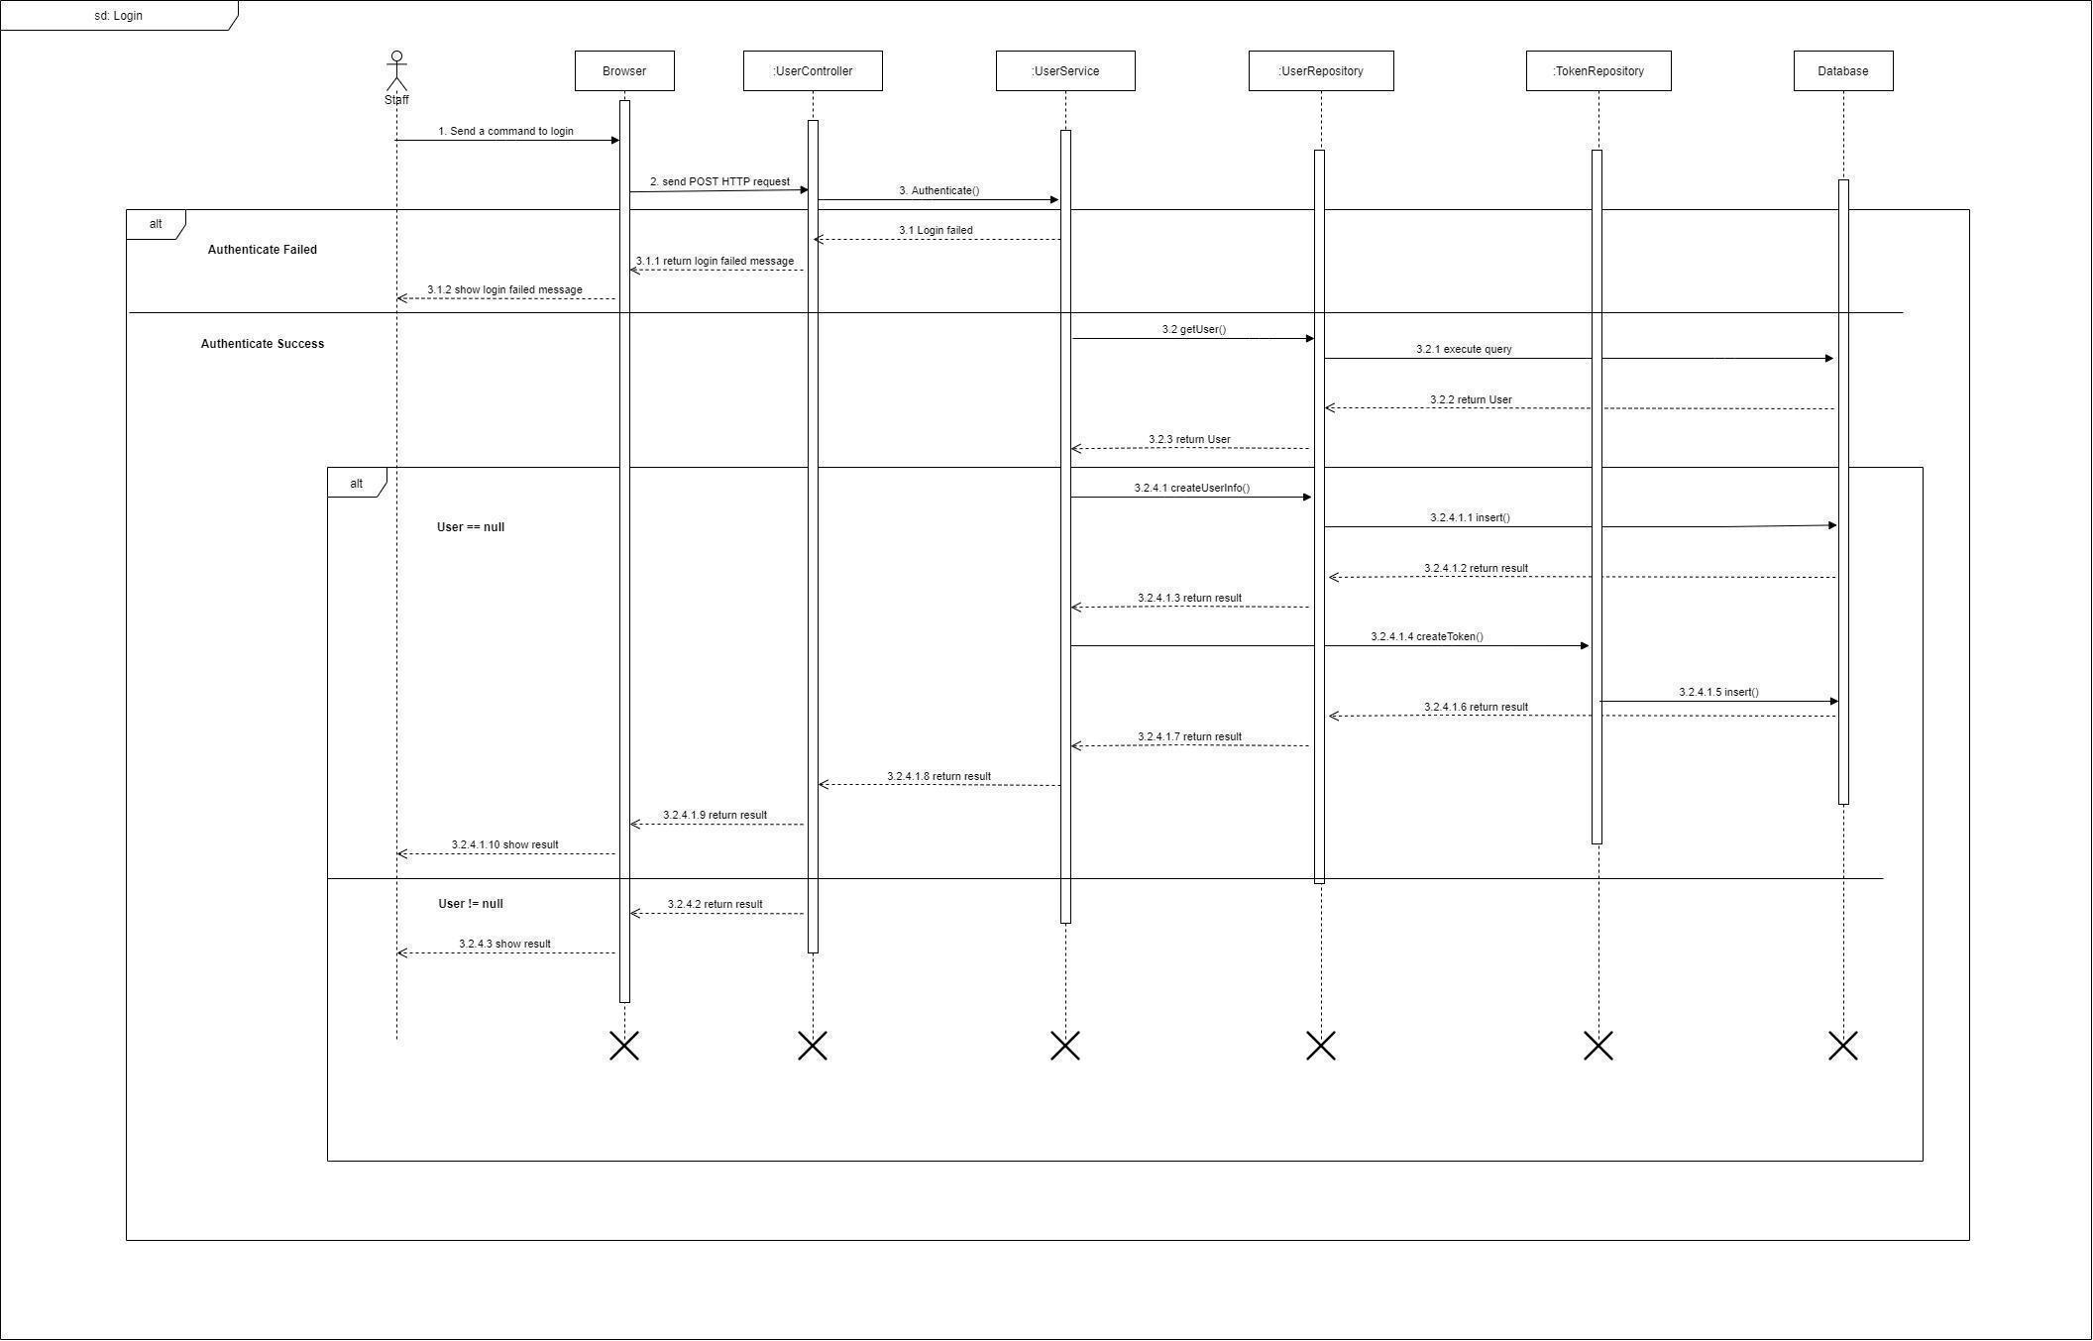

*Figure 53 - <Sequence Diagram> Login*

#### 3.2.2. Get all news

***Summary:*** *This diagram shows the process for the actor to get all News.*

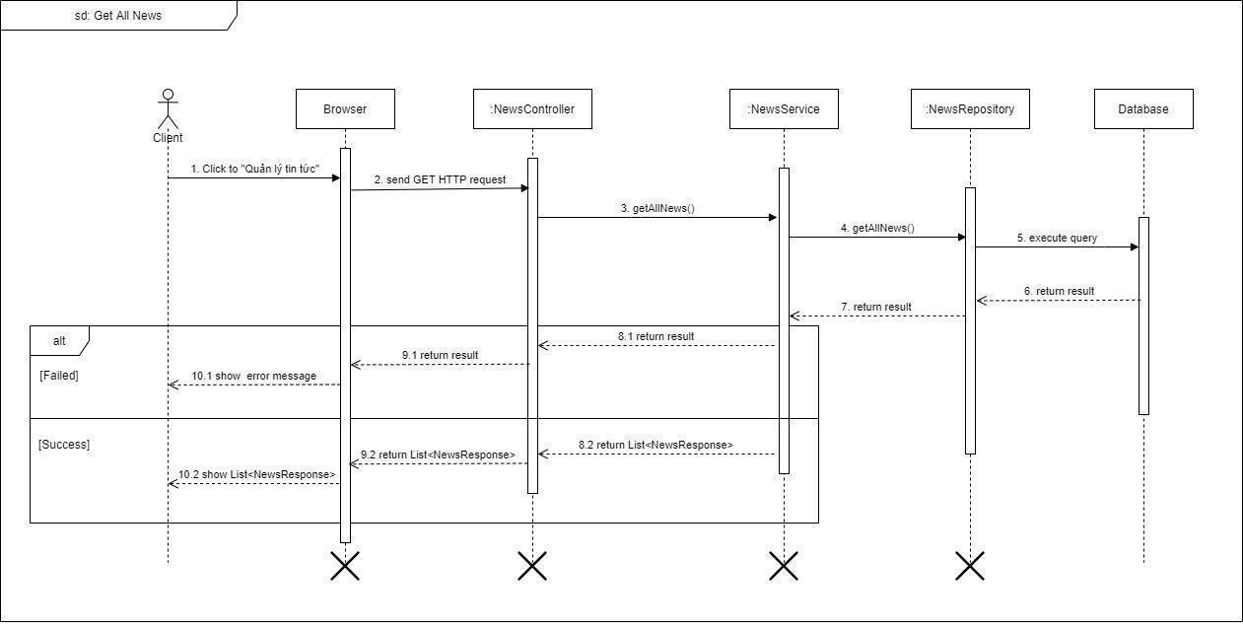

*Figure 54 - <Sequence Diagram> Get all News*

#### 3.2.3. Create news

***Summary:*** *This diagram shows the process for the actor to create news.*

*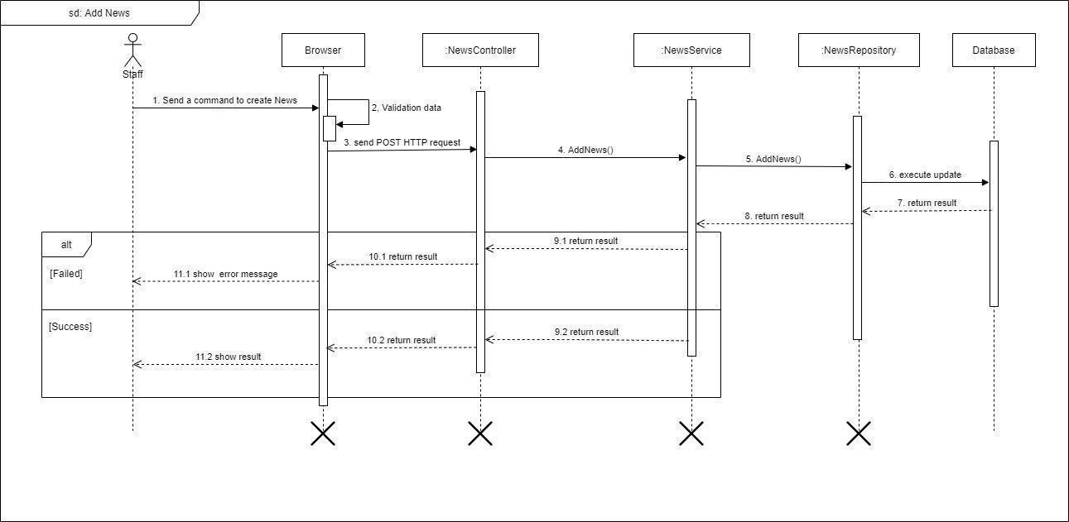Figure 55 - <Sequence Diagram> Create News*

#### 3.2.4. Update news

***Summary:*** *This diagram shows the process for the actor to update news.*

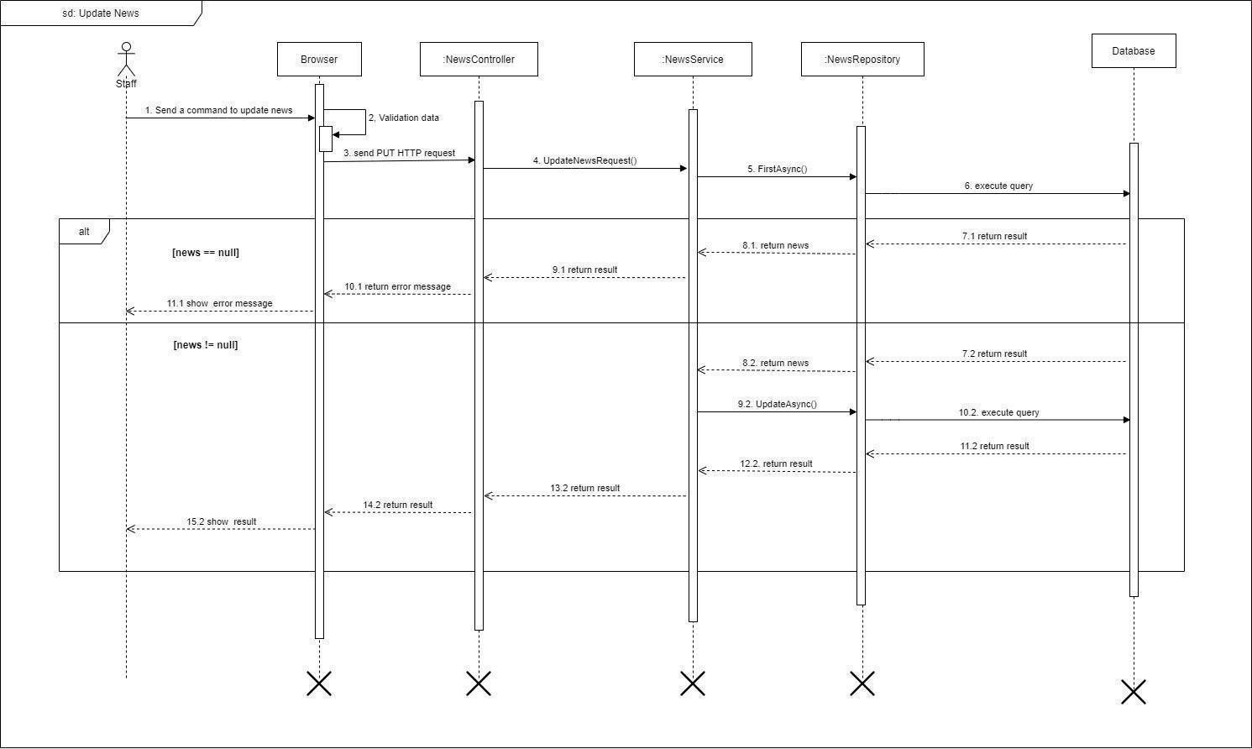

*Figure 56 - <Sequence Diagram> Update news*

#### 3.2.5. Delete news

***Summary:*** *This diagram shows the process for the actor to delete news.*

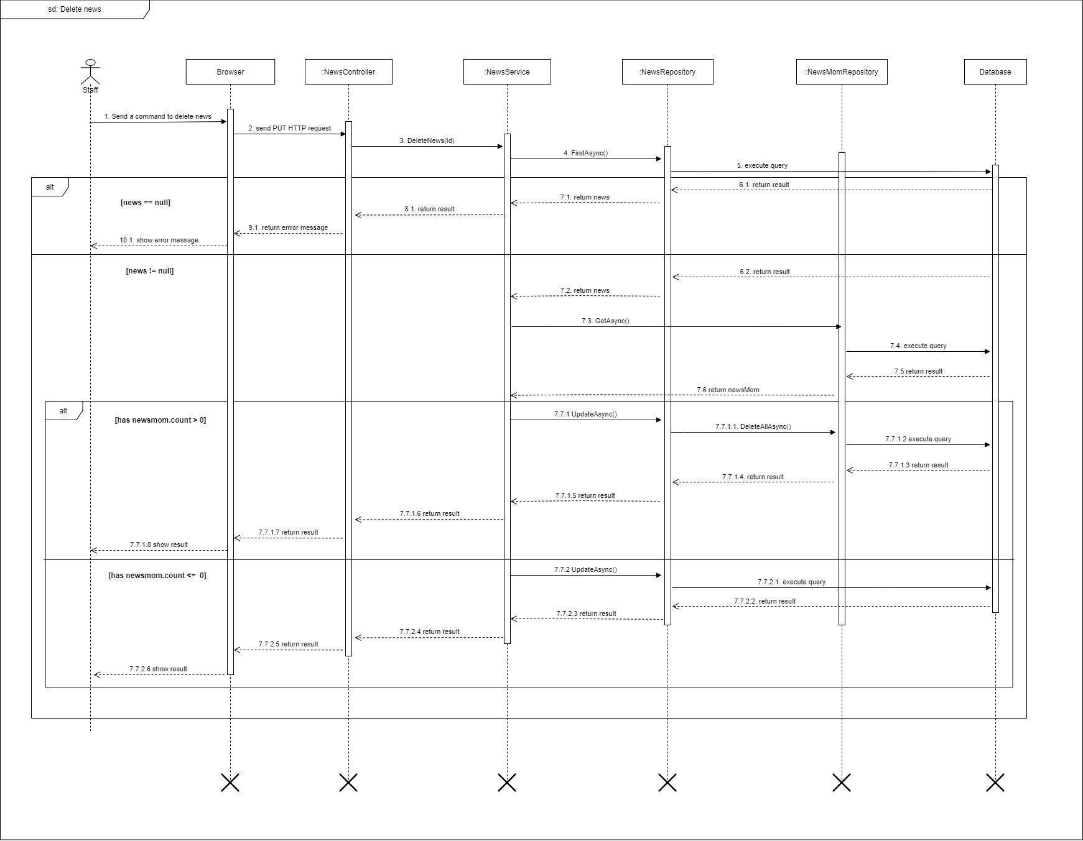

*Figure 57 - <Sequence Diagram> Delete news*

#### 3.2.6. Get all user info

***Summary:*** *This diagram shows the process for the actor get all user information.*

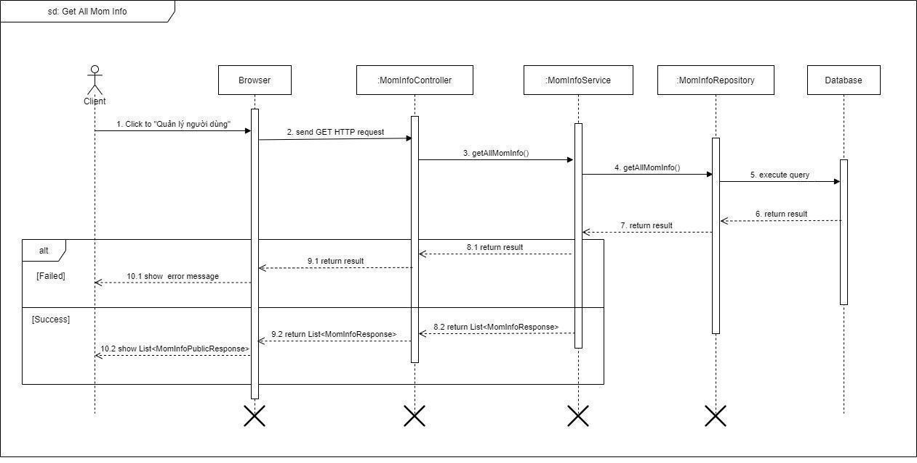

*Figure 58 - <Sequence Diagram> Get all user info*

#### 3.2.7. Delete user

***Summary:*** *This diagram shows the process for the actor delete user.*

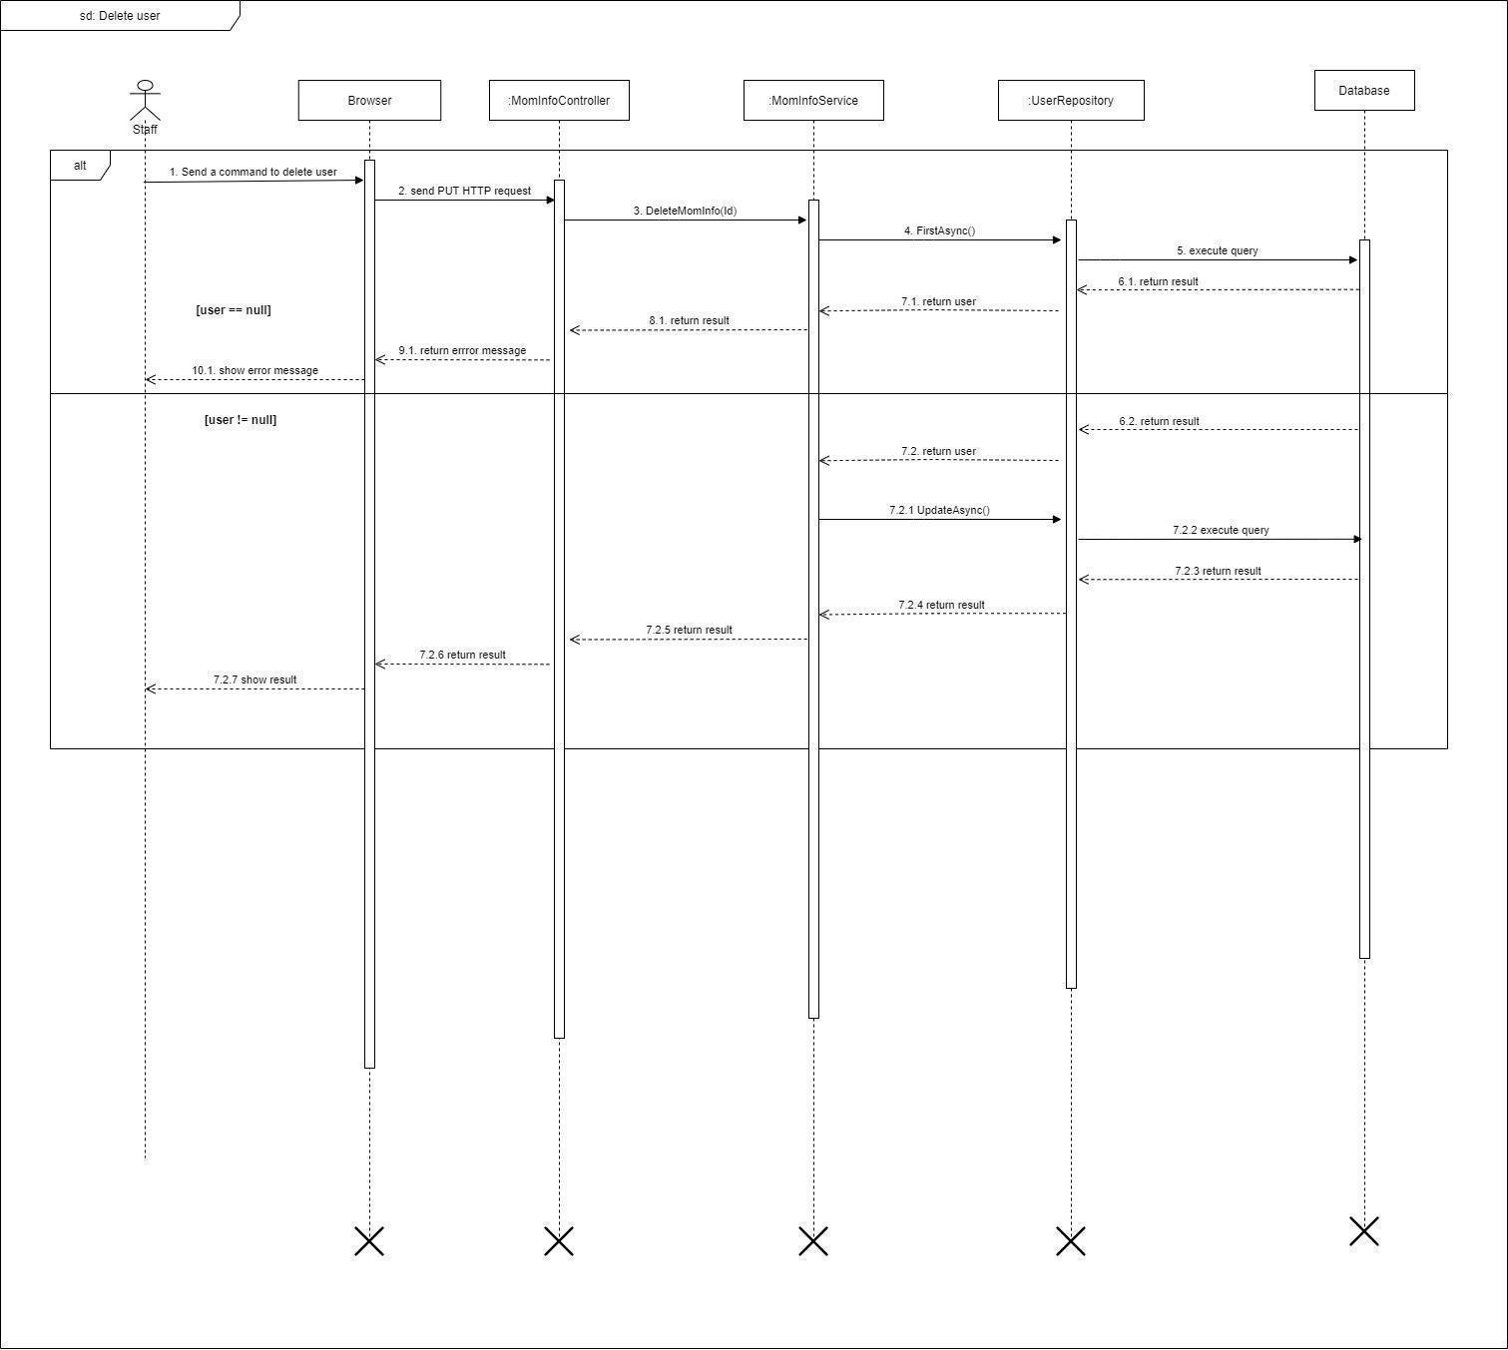

*Figure 59 - <Sequence Diagram> Delete user*

#### 3.2.8. Create guidebook

***Summary:*** *This diagram shows the process for the actor create guidebook.*

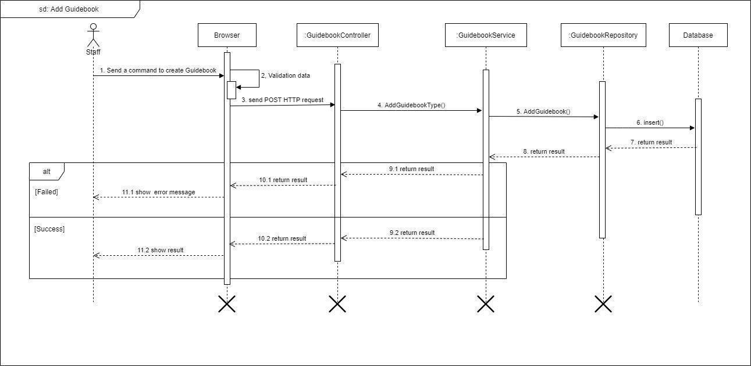

*Figure 60 - <Sequence Diagram> Create guidebook*

#### 3.2.9. Update guidebook

***Summary:*** *This diagram shows the process for the actor update guidebook.*

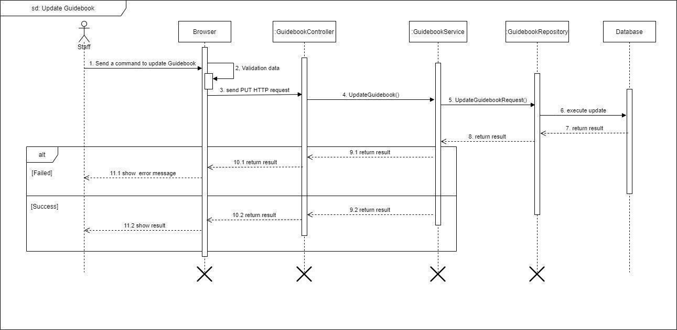

*Figure 61 - <Sequence Diagram> Update guidebook*

#### 3.2.10. Delete guidebook

***Summary:*** *This diagram shows the process for the actor delete guidebook.*

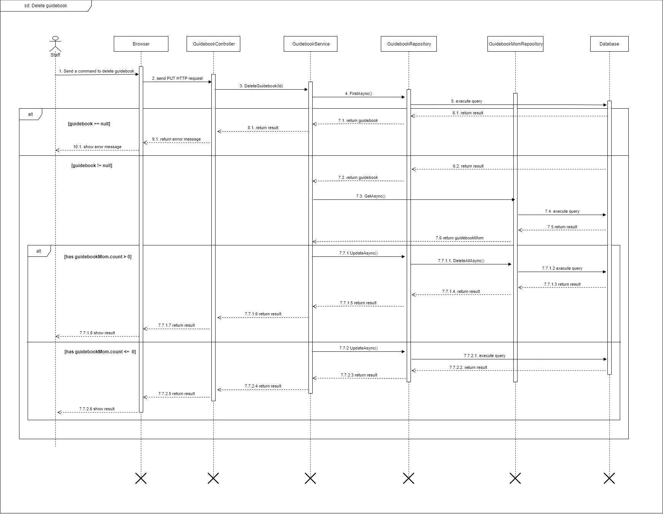

*Figure 62 - <Sequence Diagram> Delete guidebook*

#### 3.2.11. Create guidebook type

***Summary:*** *This diagram shows the process for the actor to create a guidebook type.*

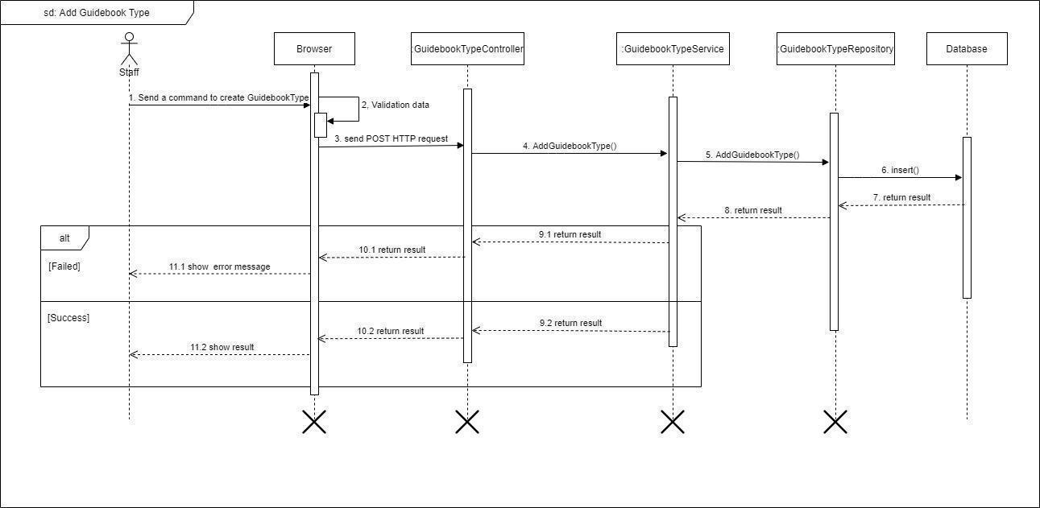

*Figure 63 - <Sequence Diagram> Create guidebook type*

#### 3.2.12. Update guidebook type

***Summary:*** *This diagram shows the process for the actor update guidebook type.*

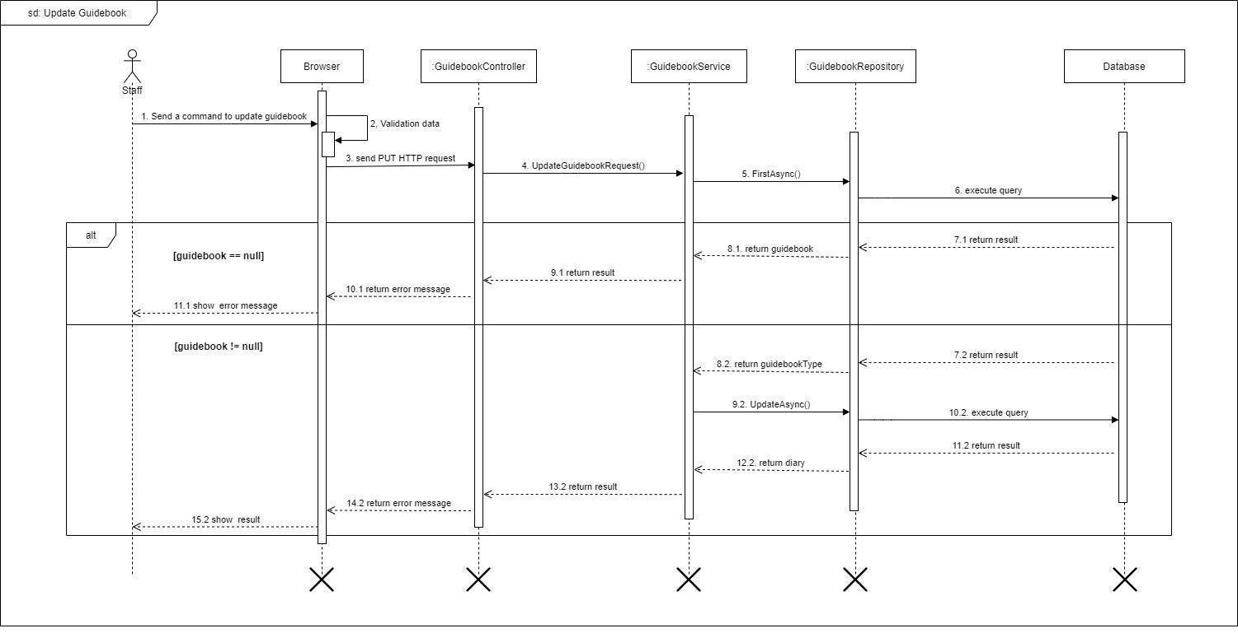

*Figure 64 - <Sequence Diagram> Update guidebook type*

#### 3.2.13. Delete guidebook type

***Summary:*** *This diagram shows the process for the actor delete guidebook type.*

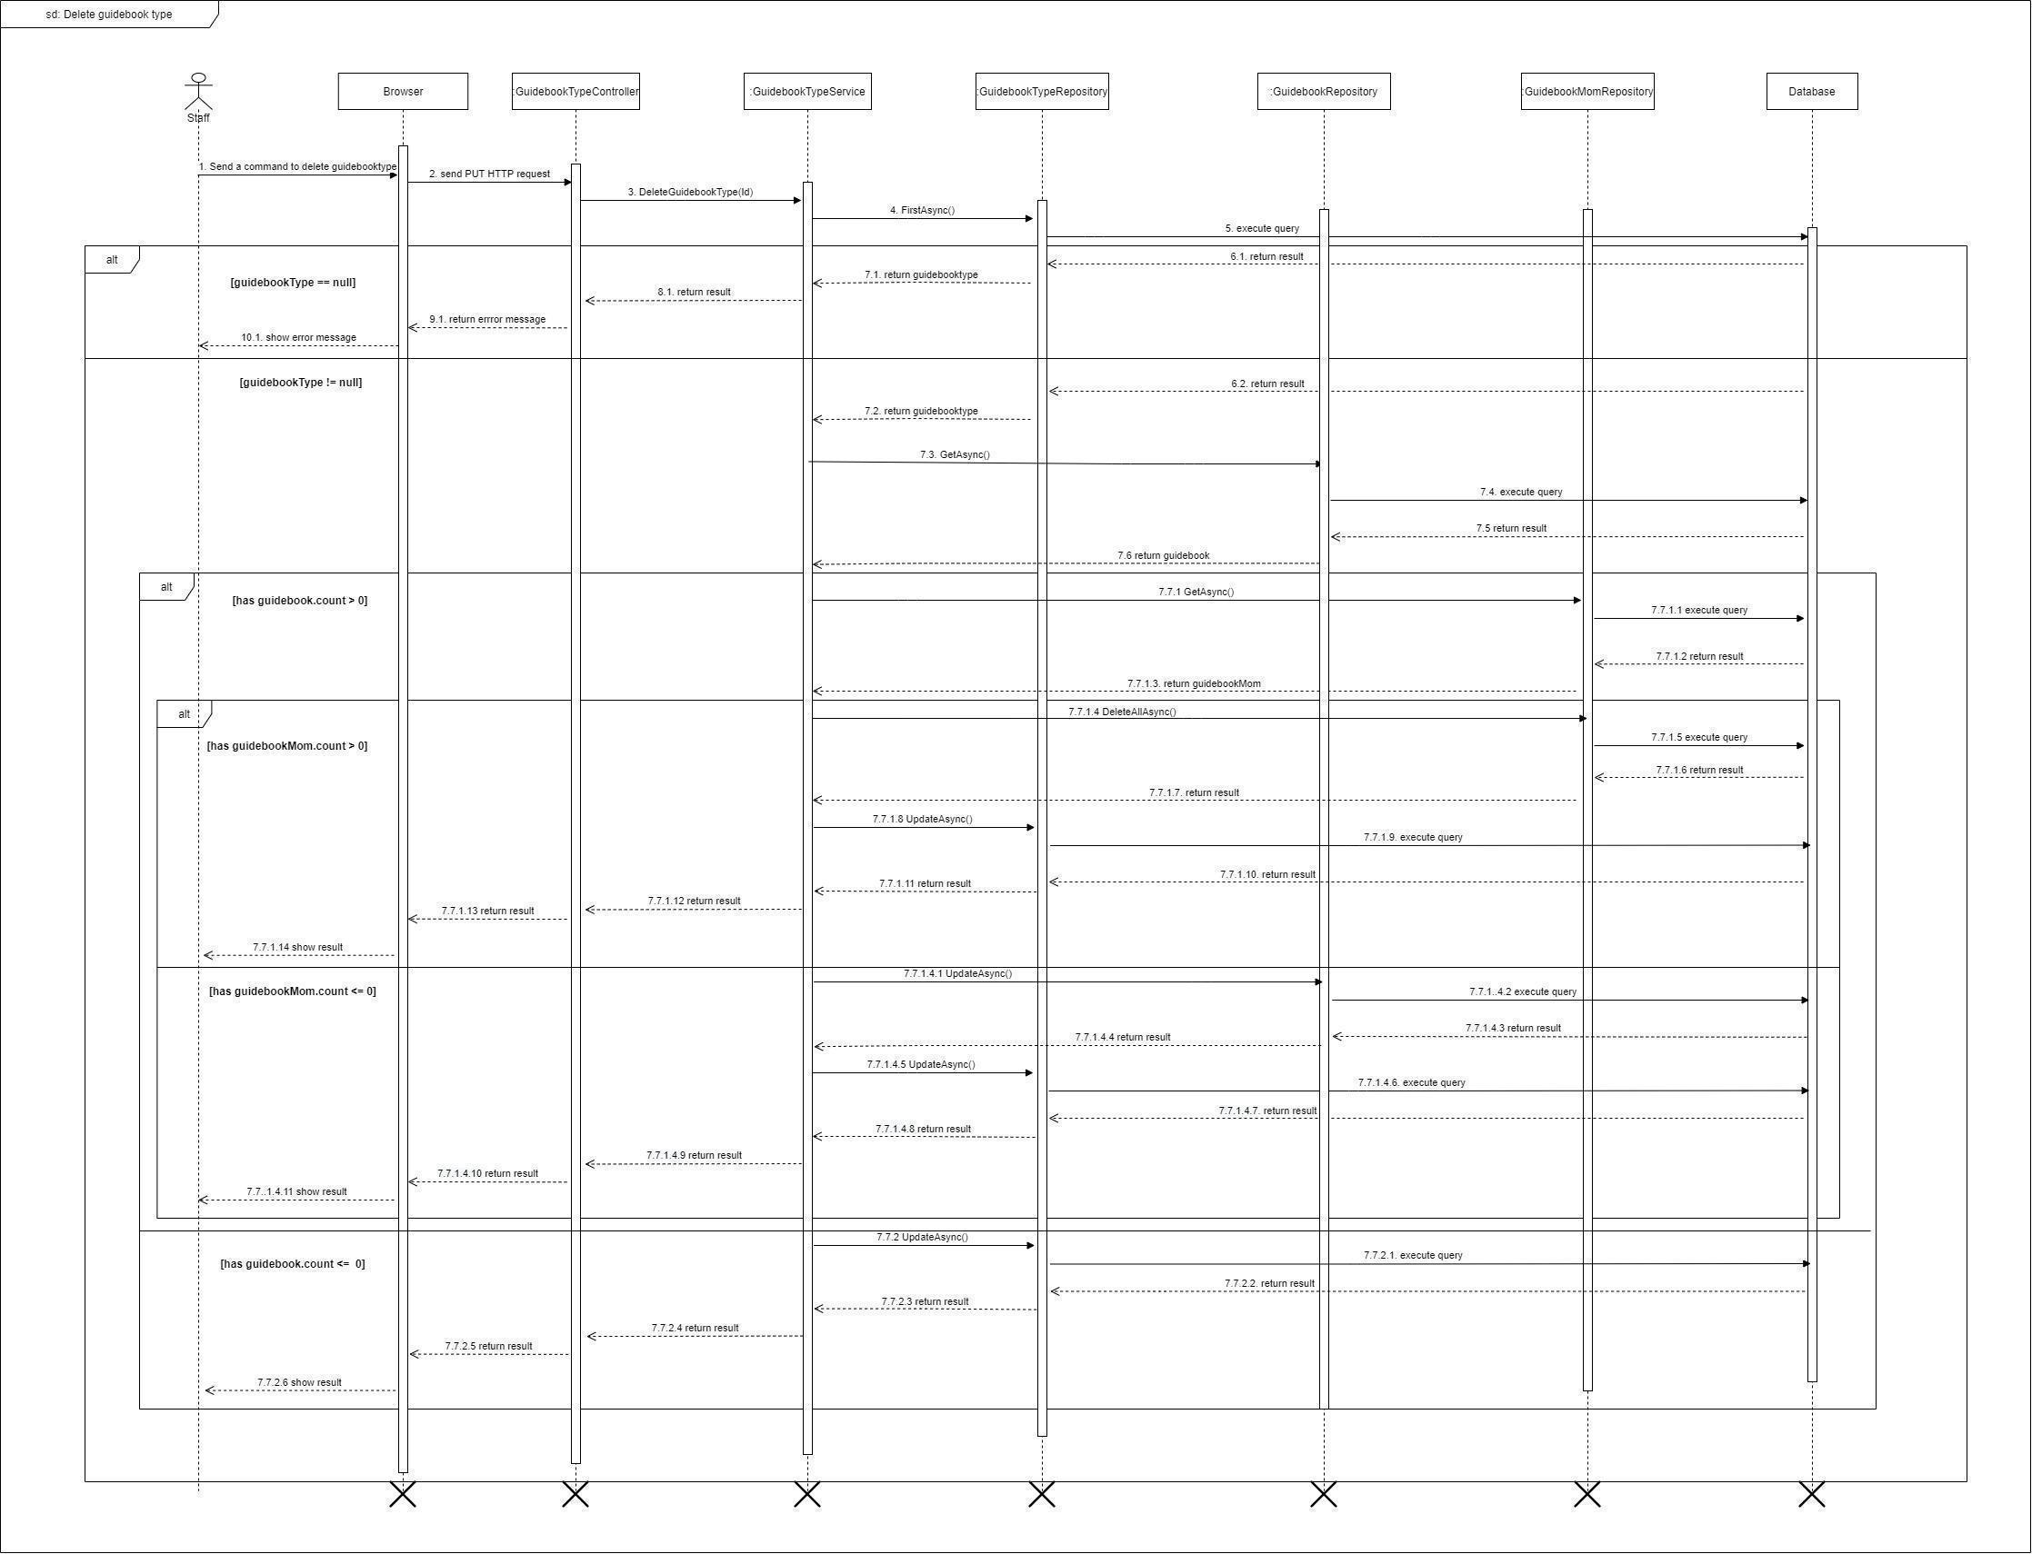

*Figure 65 - <Sequence Diagram> Delete guidebook type*

#### 3.2.14. Create news type

***Summary:*** *This diagram shows the process for the actor to create news type.*

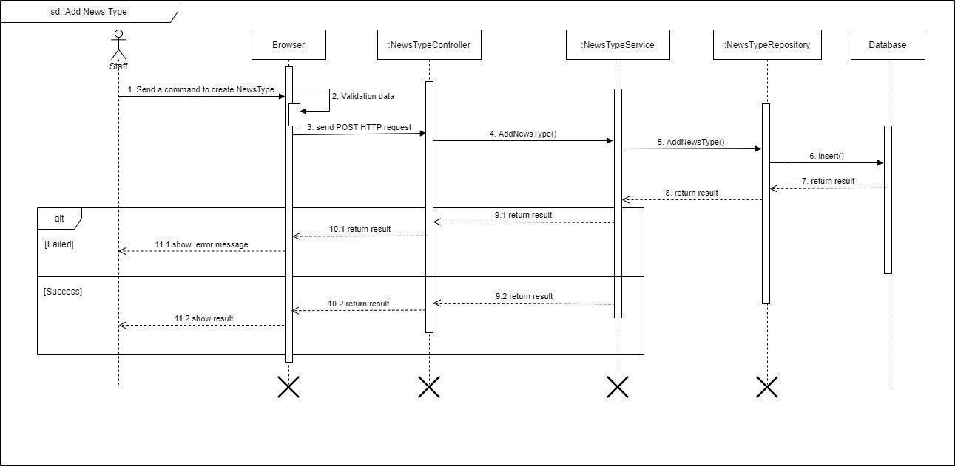

*Figure 66 - <Sequence Diagram> Create news type*

#### 3.2.15. Update news type

***Summary:*** *This diagram shows the process for the actor update news type.*

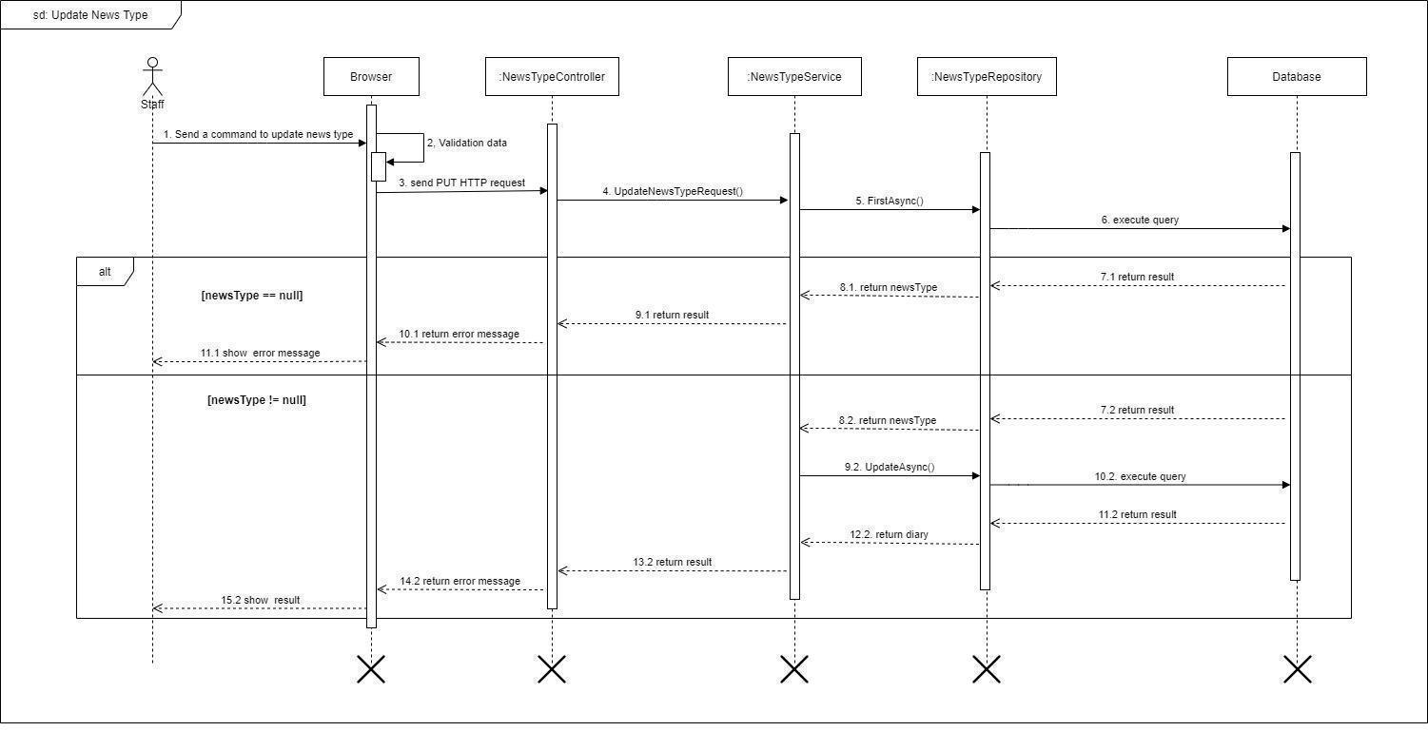

*Figure 67 - <Sequence Diagram> Update news type*

#### 3.2.16. Delete news type

***Summary:*** *This diagram shows the process for the actor to delete news type.*

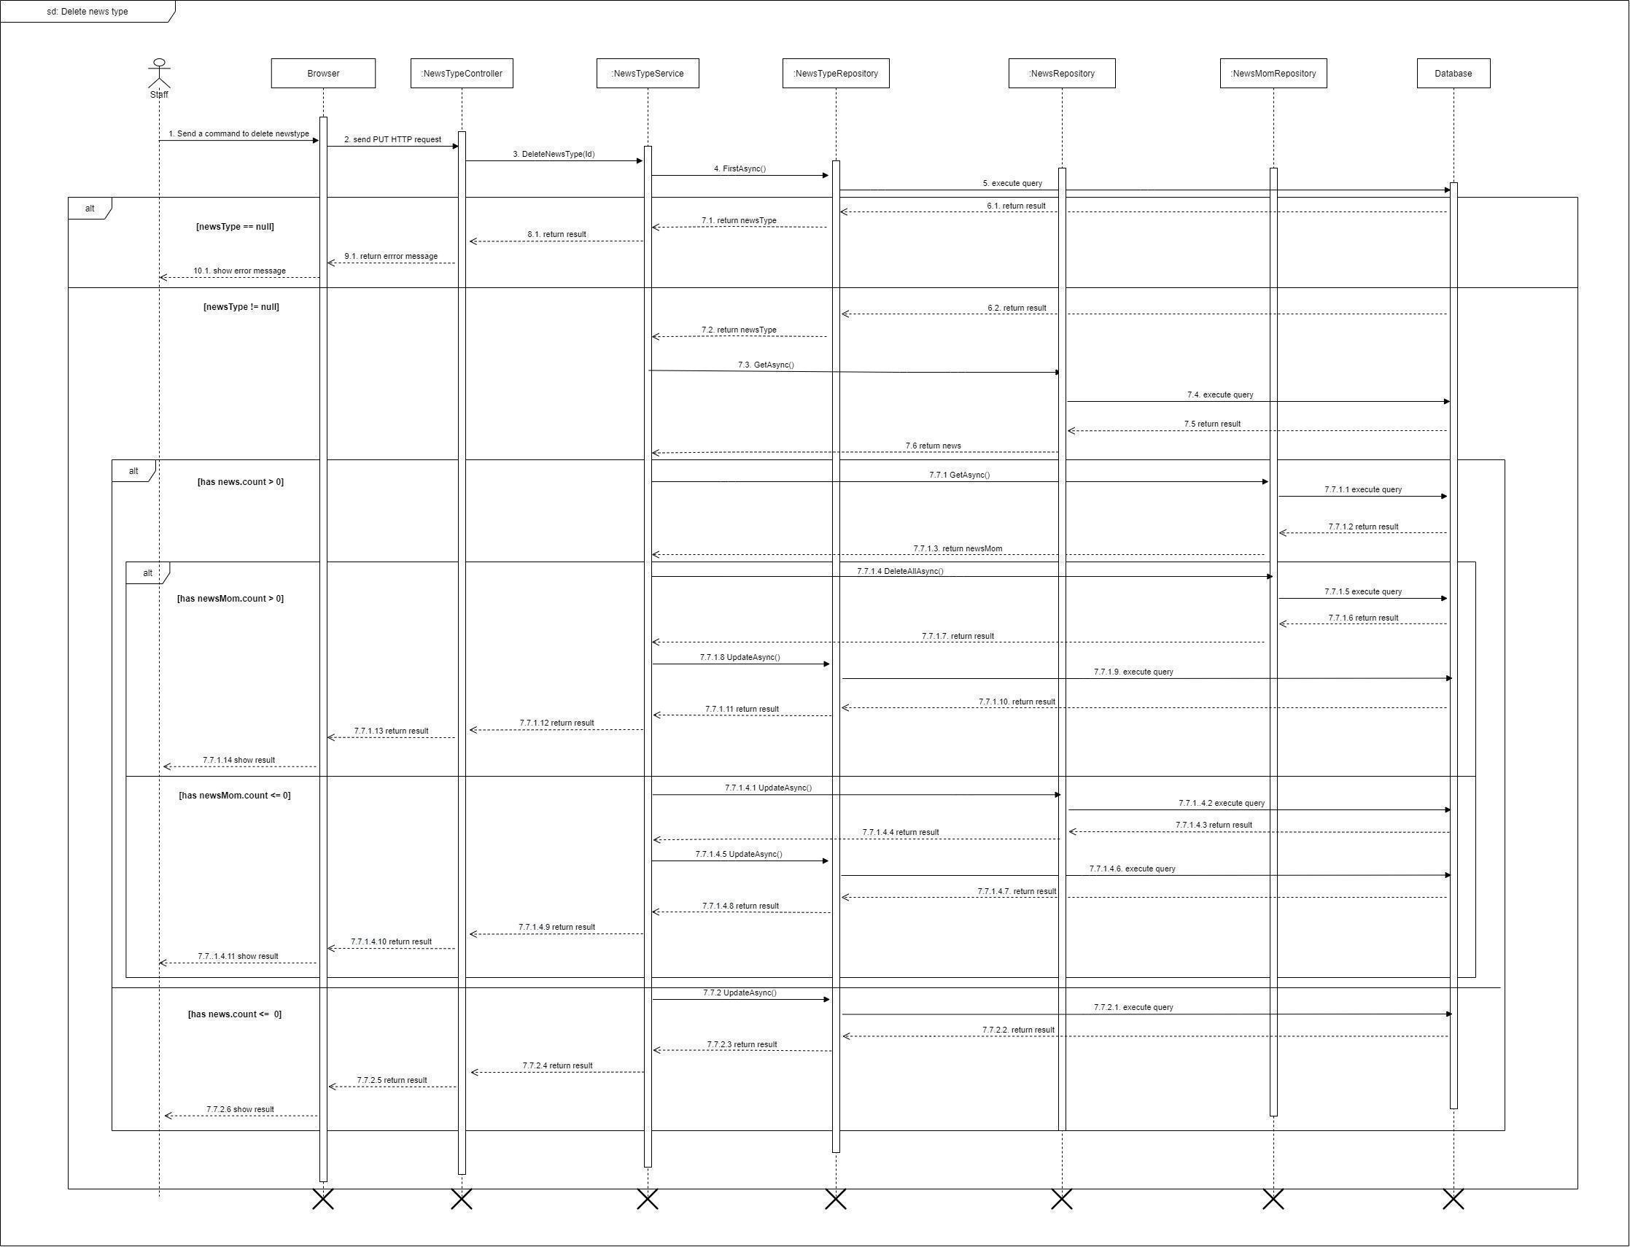

*Figure 68 - <Sequence Diagram> Delete news type*

#### 3.2.17. Approve post

***Summary:*** *This diagram shows the process for the actor to approve post.*

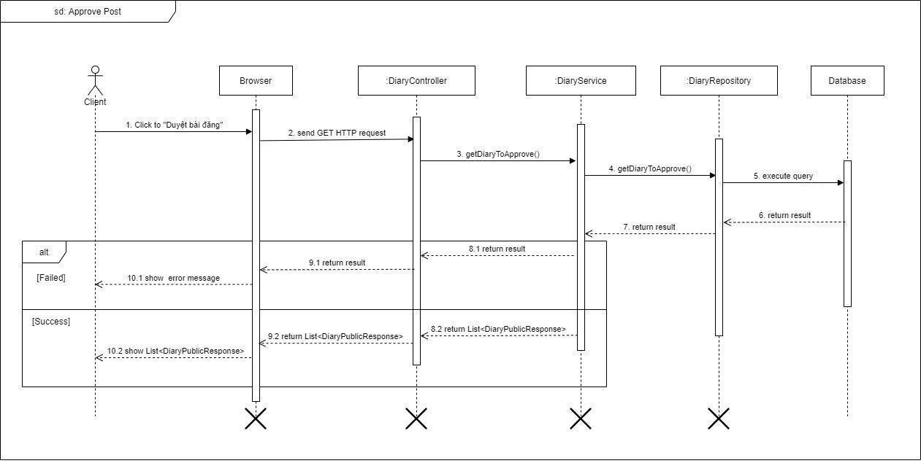

*Figure 69 - <Sequence Diagram> Approve post*

#### 3.2.18. Update diary

***Summary:*** *This diagram shows the process for the actor's update diary.*

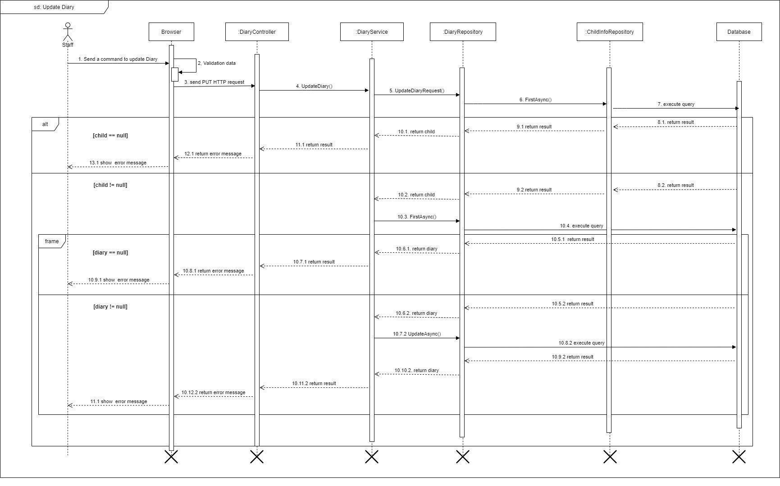

*Figure 70 - <Sequence Diagram> Update diary*

#### 3.2.19. Get profile

***Summary:*** *This diagram shows the process for the actor to get profile.*

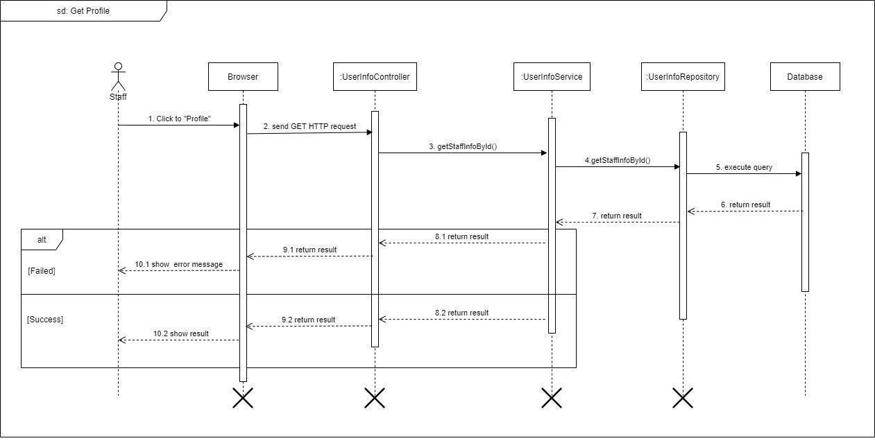

*Figure 71 - <Sequence Diagram> Get profile*

#### 3.2.20. Get all guidebook

***Summary:*** *This diagram shows the process for the actor to get all the guidebooks.*

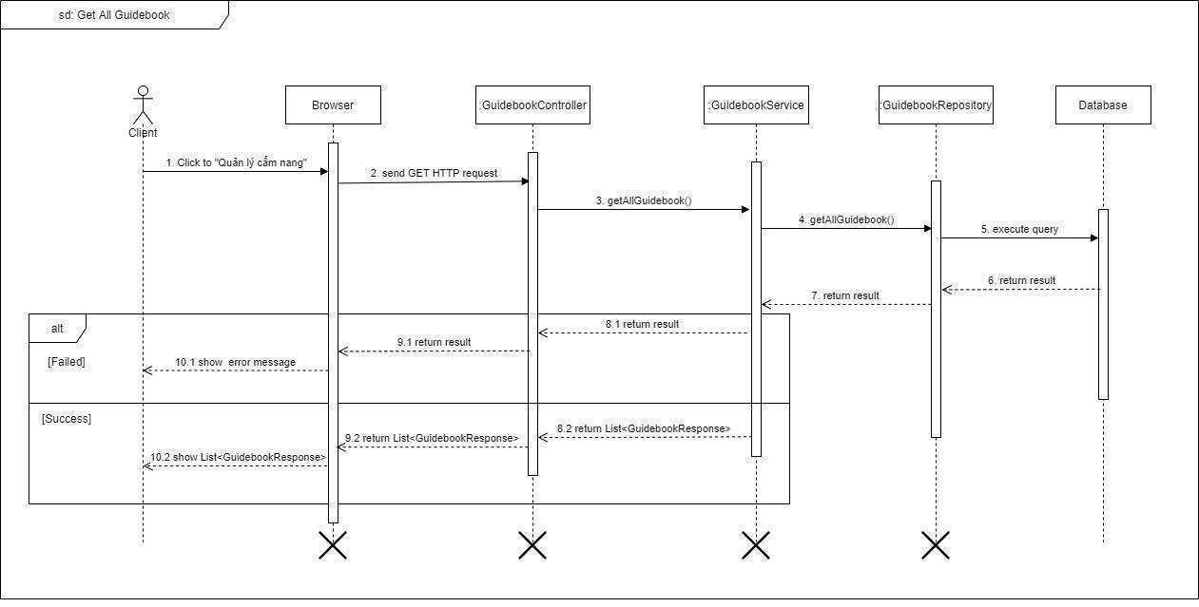

*Figure 72 - <Sequence Diagram> Get all guidebook*

#### 3.2.21. Get all guidebook type

***Summary:*** *This diagram shows the process for the actor to get all the guidebooks.*

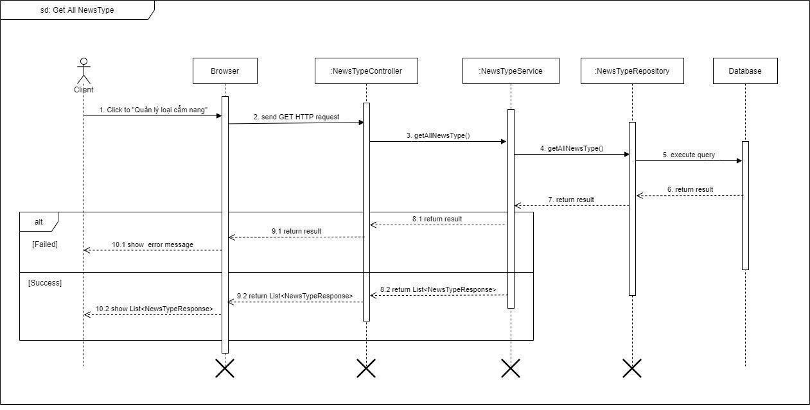

*Figure 73 - <Sequence Diagram> Get all guidebook type*

#### 3.2.22. Get all news type

***Summary:*** *This diagram shows the process for the actor to get all news type.*

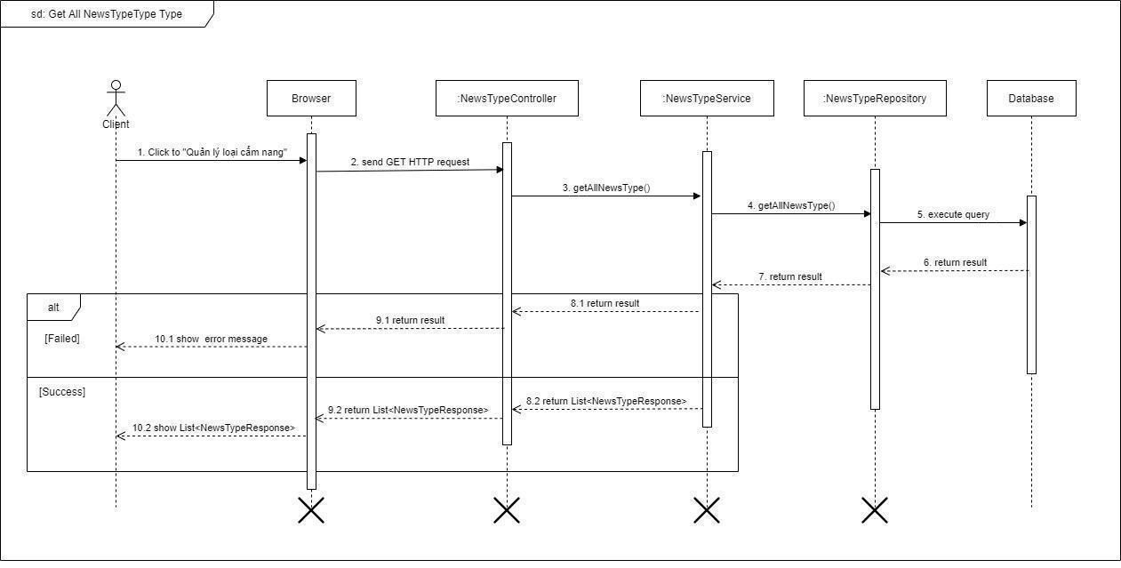

*Figure 74 - <Sequence Diagram> Get all news type*

### 3.3. Activity Diagram

### View news detail

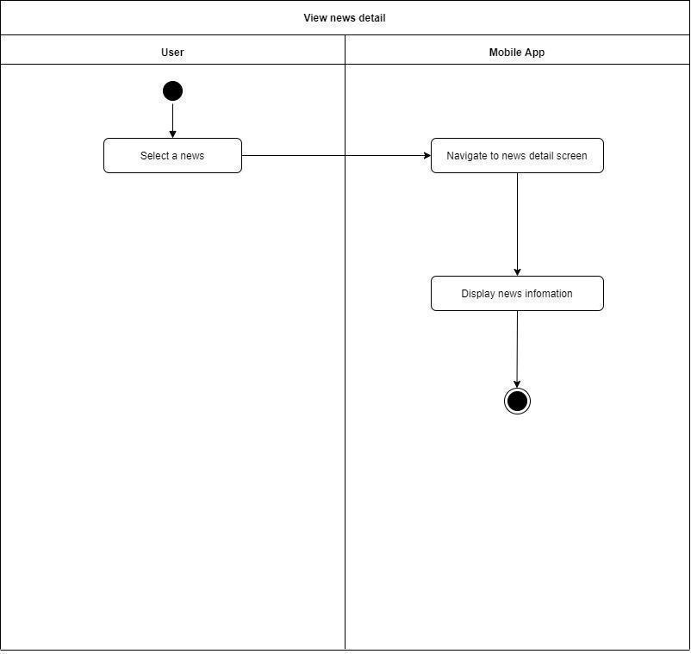

*Figure 75 - <Activity Diagram> View news detail*

### Add diary

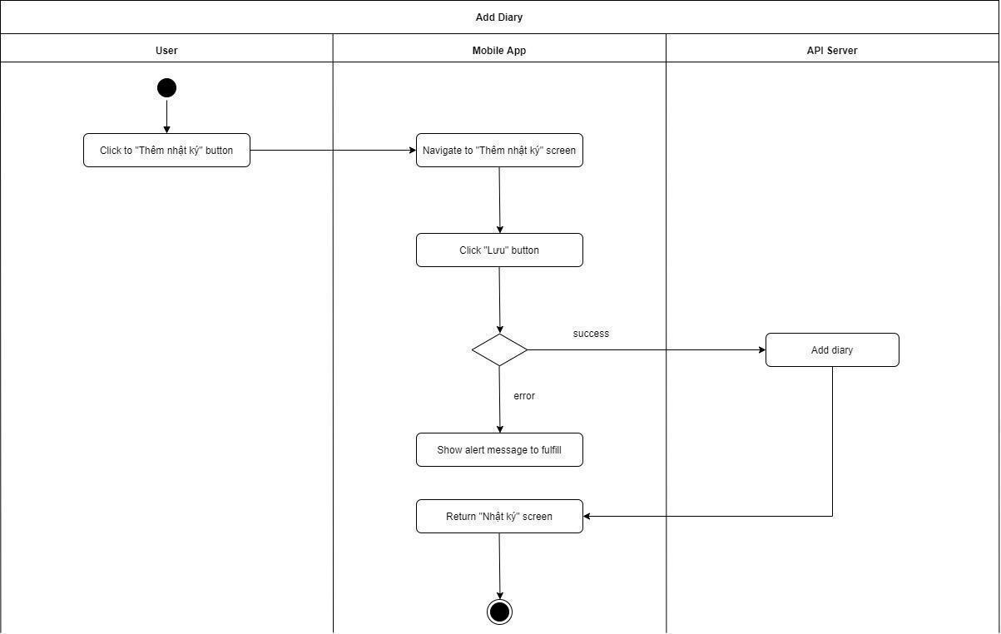

*Figure 76 - <Activity Diagram> Add diary*

### View diary detail

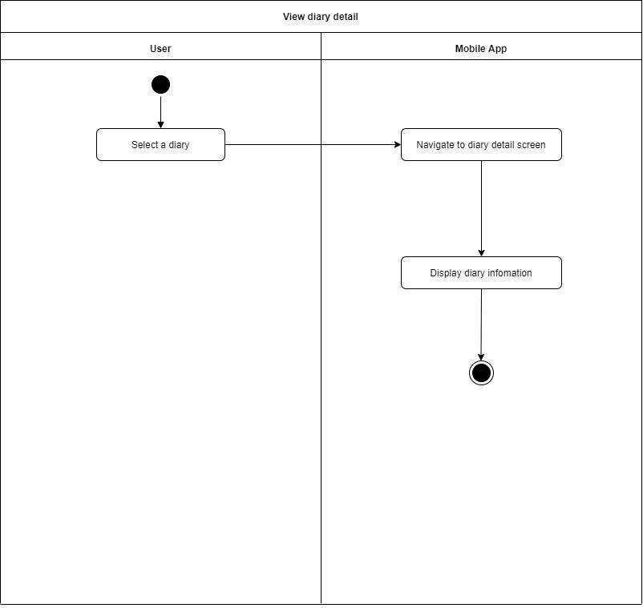

*Figure 77 - <Activity Diagram> View diary detail*

### Edit diary

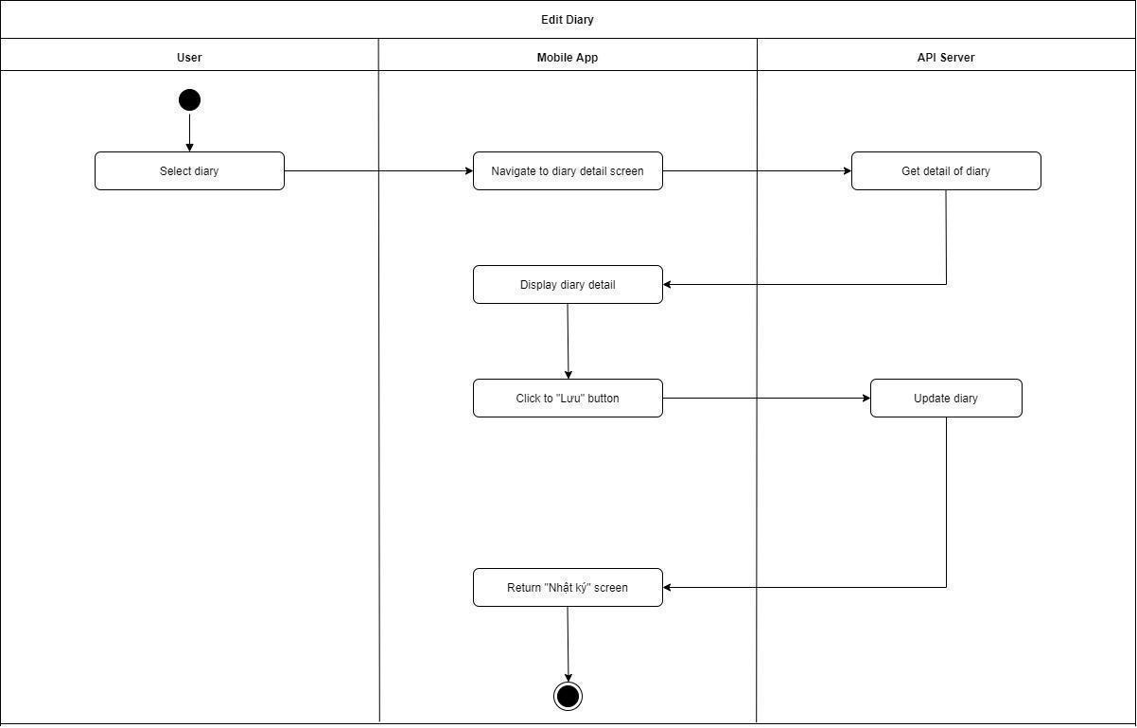

*Figure 78 - <Activity Diagram> Edit diary*

### View vaccine schedule

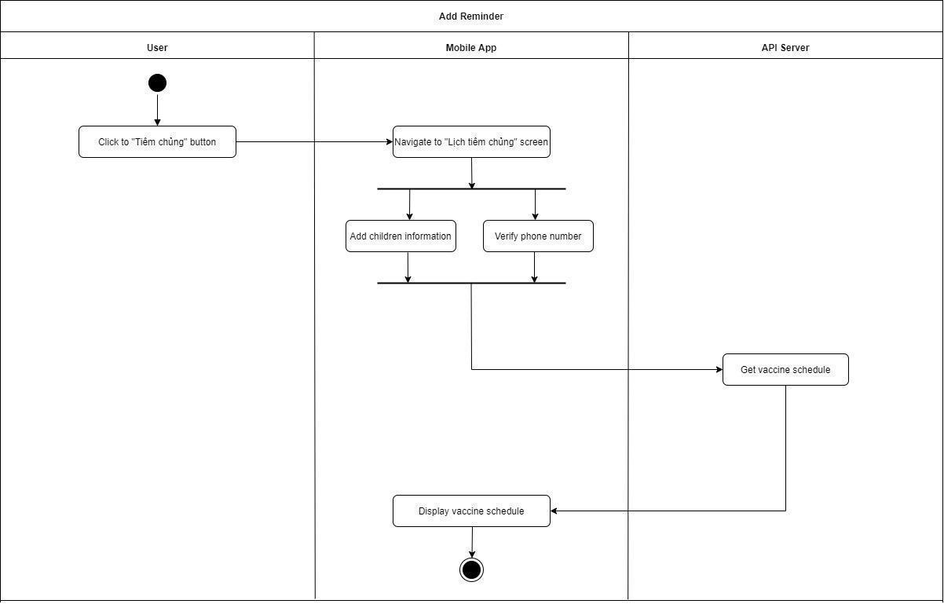

*Figure 79 - <Activity Diagram> View vaccine schedule*

### View vaccine schedule detail

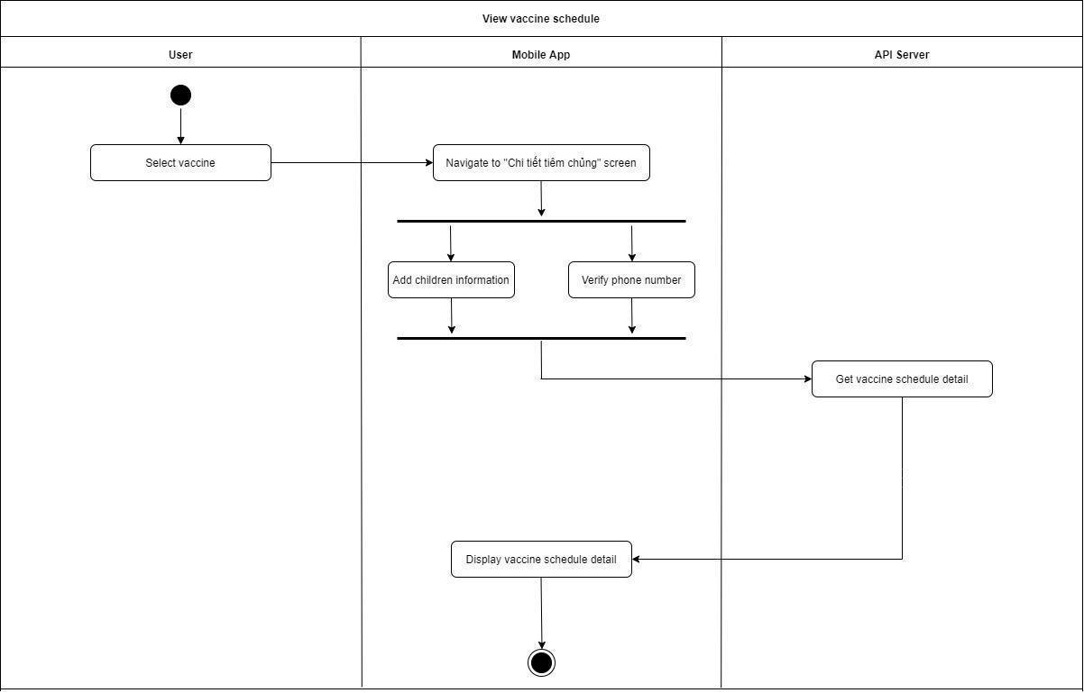

*Figure 80 - <Activity Diagram> View vaccine schedule detail*

### Add children information

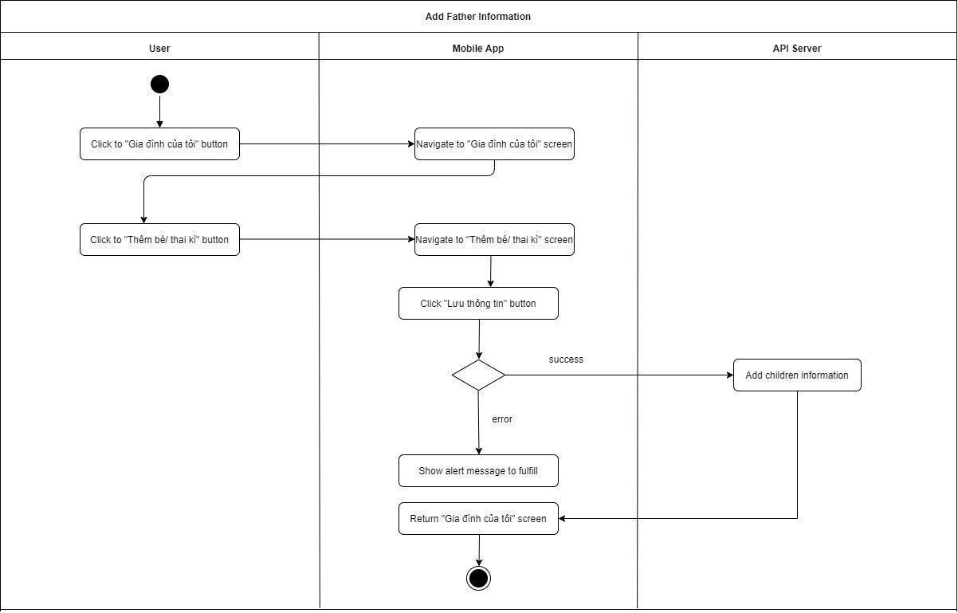

*Figure 81 - <Activity Diagram> Add children information*

### Add father information

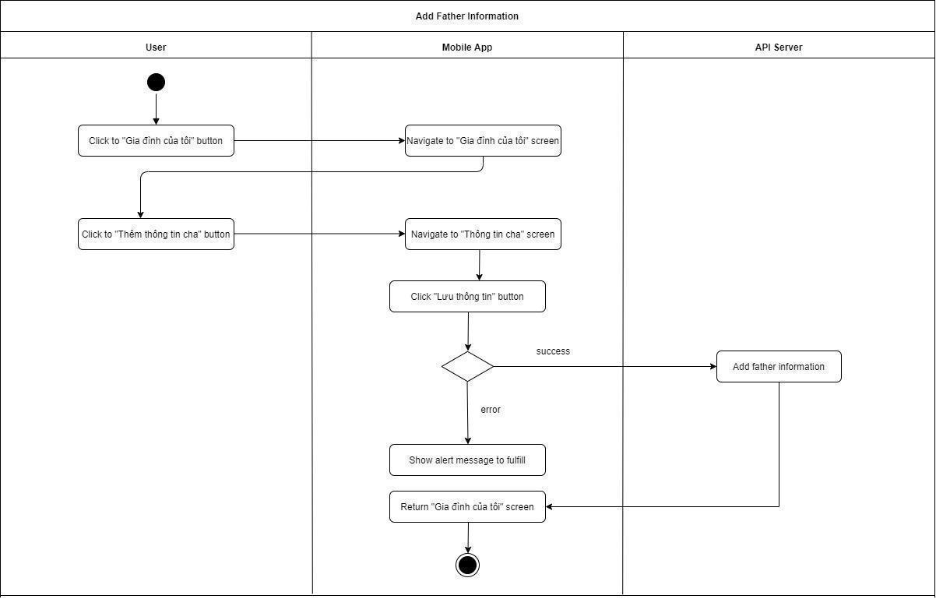

*Figure 82 - <Activity Diagram> Add children information*

### Public post to community

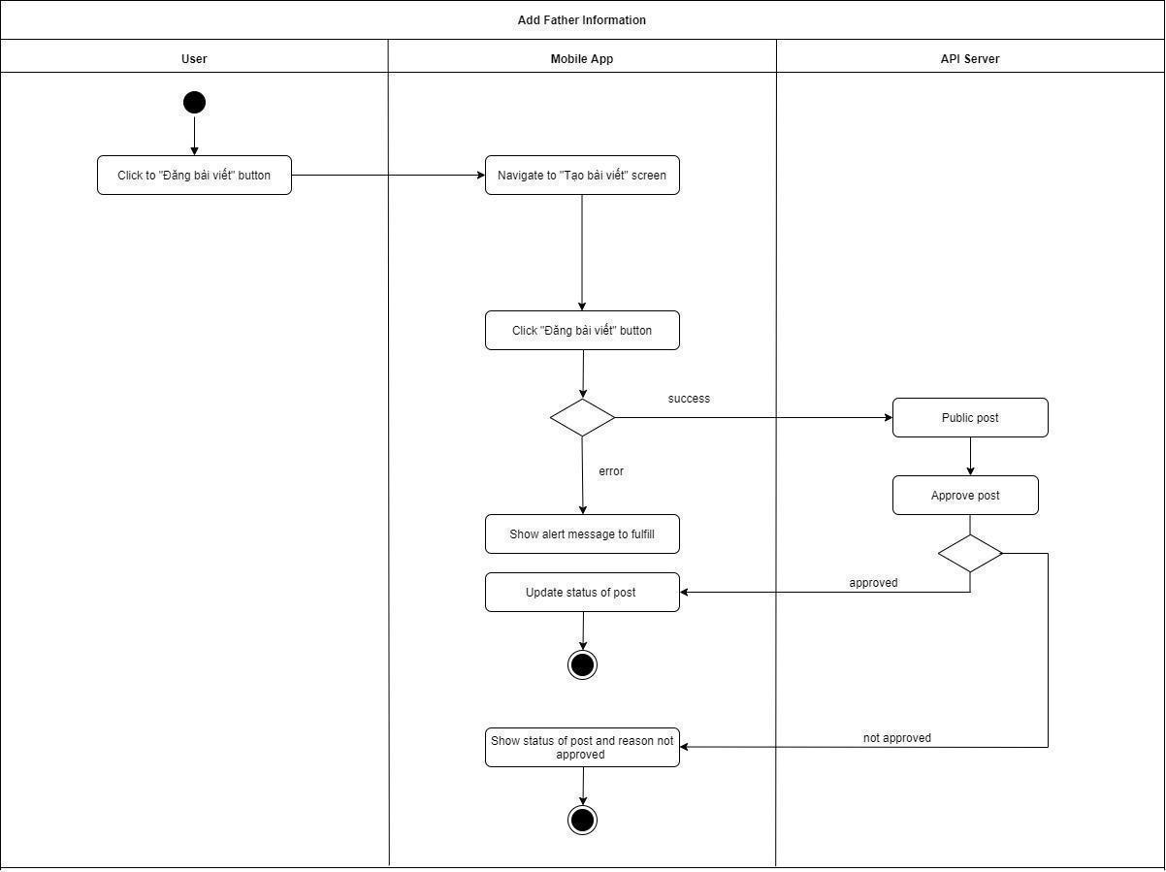

*Figure 83 - <Activity Diagram> Public post to community*

### Update teething process

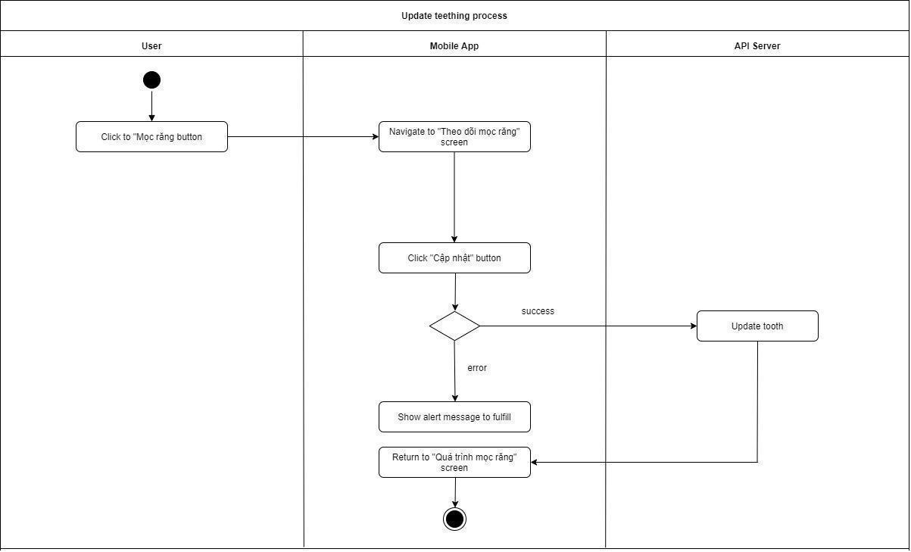

*Figure 84 - <Activity Diagram> Update teething process*

### View guidebook detail

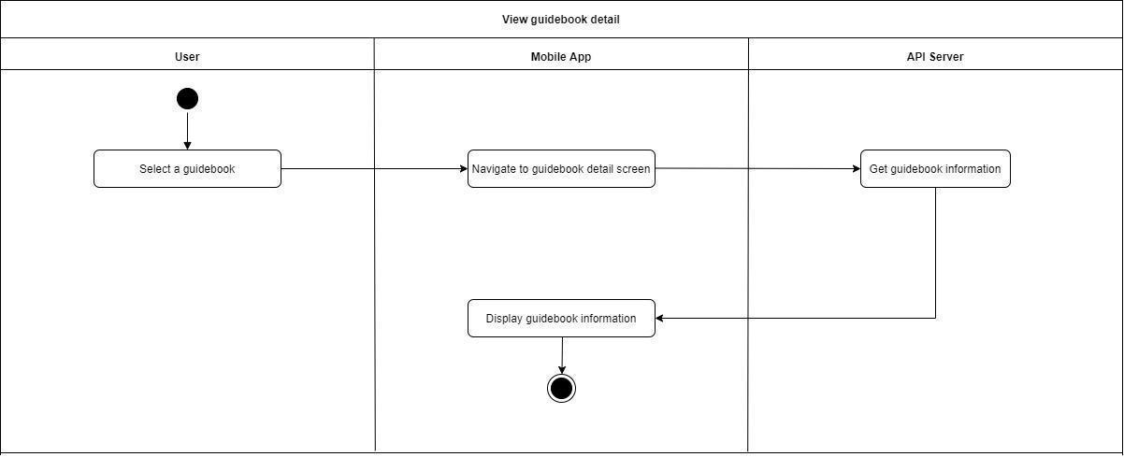

*Figure 85 - <Activity Diagram> View guidebook detaill*

### Update children information

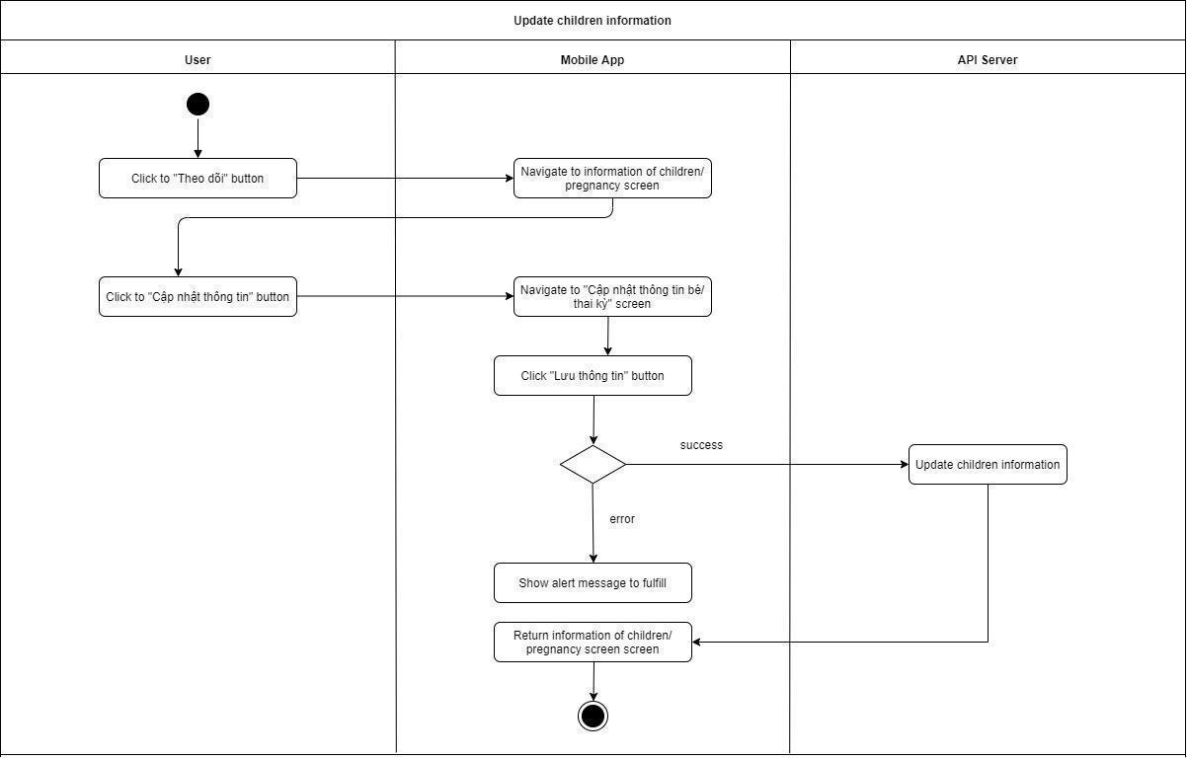

*Figure 86 - <Activity Diagram> Update children information*

## 4. Data & Database Design

### 4.1. Table Relationships

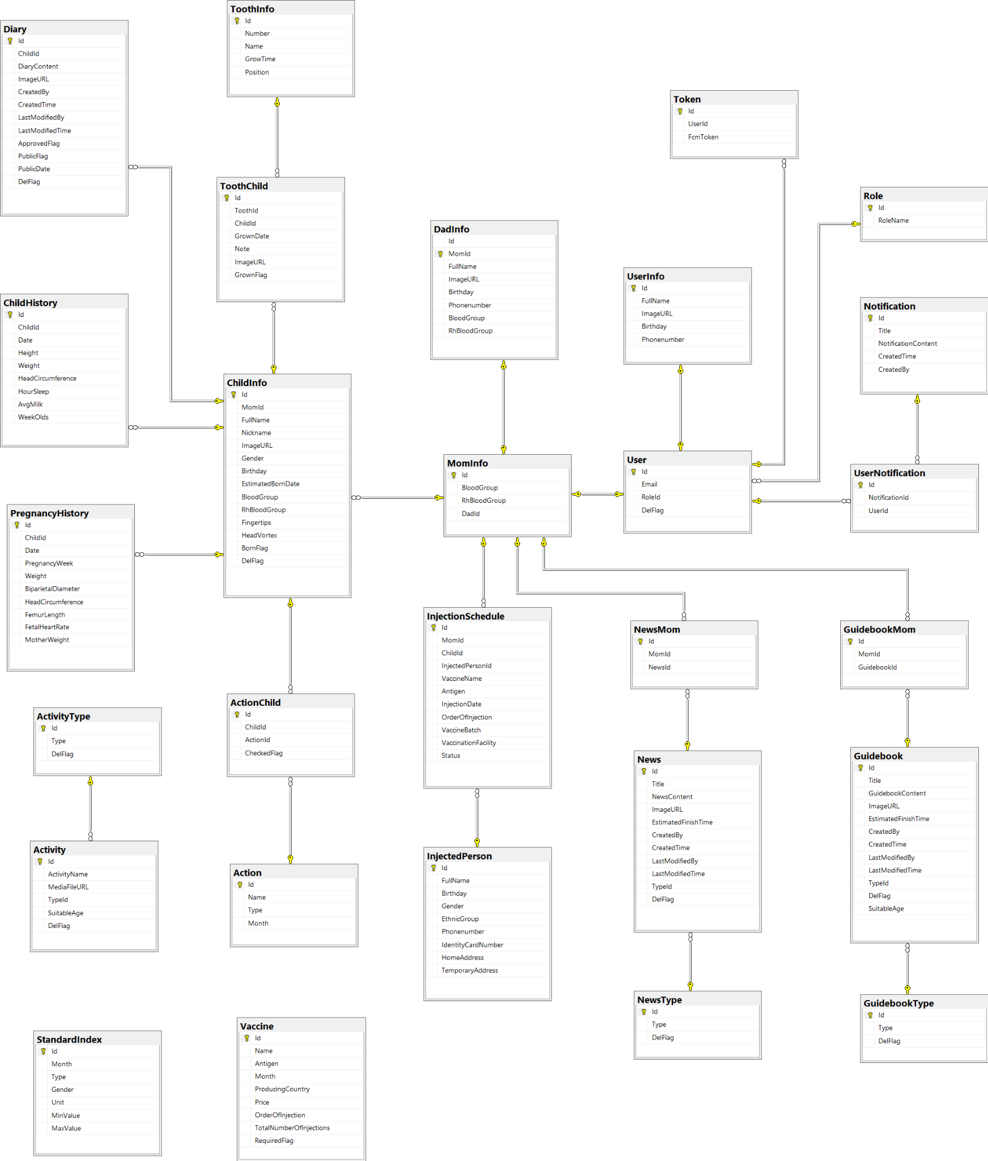

*Figure 87 - Physical Diagram*

### 4.2. Data dictionary

**UserInfo**

| **Field name** | **Type** | **Size** | **Unique** | **Not Null** | **PK/FK** | **Notes** |
| --- | --- | --- | --- | --- | --- | --- |
| Id | varchar | 100 | Yes | Yes | PK | Unique identifier of user |
| FullName | nvarchar | 200 | No | Yes |  | The full name of user |
| ImageURL | varchar | max | No | No |  | The image of user |
| Birthday | varchar | 50 | No | No |  | The birthday of user |
| PhoneNumber | varchar | 10 | No | No |  | The phone number of user |

*Table 85 - <Data dictionary> UserInfo*

**MomInfo**

| **Field name** | **Type** | **Size** | **Unique** | **Not Null** | **PK/FK** | **Notes** |
| --- | --- | --- | --- | --- | --- | --- |
| Id | varchar | 100 | Yes | Yes | PK | Unique identifier of mom |
| BloodGroup | varchar | 10 | No | No |  | The blood group of mom |
| RhBloodGroup | varchar | 10 | No | No |  | The rh blood group of mom |
| DadId | varchar | 50 | No | No |  | Unique identifier of dad |

*Table 86 - <Data dictionary> MomInfo*

**DadInfo**

| **Field name** | **Type** | **Size** | **Unique** | **Not Null** | **PK/FK** | **Notes** |
| --- | --- | --- | --- | --- | --- | --- |
| Id | varchar | 50 | Yes | Yes | PK | Unique identifier of dad |
| MomId | varchar | 100 | No | Yes | FK | Unique identifier of mom |
| Phonenumber | varchar | 10 | No | No |  | The phone number of a father |
| BloodGroup | varchar | 10 | No | No |  | The blood group of a father |
| RhBloodGroup | varchar | 10 | No | No |  | The rh blood group of a father |
| Birthday | varchar | 50 | No | No |  | The birthday of a father |
| FullName | nvarchar | 200 | No | Yes |  | The full name of a dad |
| ImageURL | varchar | max | No | No |  | The image of a dad |

*Table 87 - <Data dictionary> DadInfo*

**News**

| **Field name** | **Type** | **Size** | **Unique** | **Not Null** | **PK/FK** | **Notes** |
| --- | --- | --- | --- | --- | --- | --- |
| Id | varchar | 50 | Yes | Yes | PK | Unique identifier of a News |
| Title | nvarchar | 200 | No | Yes |  | The title of a news |
| ImageURL | varchar | max | No | No |  | The image of a news |
| NewsContent | nvarchar | max | No | Yes |  | The news content of a news |
| TypeId | int |  | No | No | FK | Unique identifier of type |
| EstimatedFinishTime | smallint |  | No | No |  | The estimated finish time of a news |
| CreatedBy | nvarchar | 100 | No | No |  | The estimated finish time of a news |
| CreatedTime | datetime |  | No | No |  | The estimated finish time of a news |
| LastModifiedBy | nvarchar | 100 | No | No |  | The user last modified of a news |
| LastModifiedTime | datetime |  | No | No |  | The last modified time of a news |
| DelFlag | bit |  | No | Yes |  | The status delete of news |

*Table 88 - <Data dictionary> News*

**Token**

| **Field name** | **Type** | **Size** | **Unique** | **Not Null** | **PK/FK** | **Notes** |
| --- | --- | --- | --- | --- | --- | --- |
| Id | int |  | Yes | Yes | PK | Unique identifier of token |
| UserId | varchar | 100 | No | Yes | FK | Unique identifier of a User |
| FcmToken | varchar | max | No | Yes |  | The fcm token of a token |

*Table 89 - <Data dictionary> Token*

**Injection Schedule**

| **Field name** | **Type** | **Size** | **Unique** | **Not Null** | **PK/FK** | **Notes** |
| --- | --- | --- | --- | --- | --- | --- |
| Id | float |  | Yes | Yes | PK | Unique identifier of a Injection Schedule |
| MomId | varchar | 100 | No | No |  | Unique identifier of a mom |
| InjectedPersonId | float |  | No | No |  | Unique identifier of a injected person |
| VaccineName | nvarchar | 100 | No | No |  | The vaccine name of a vaccine in injection schedule |
| Antigen | nvarchar | 50 | No | No | FK | The antigen of a vaccine in injection schedule |
| InjectionDate | varchar | 50 | No | No |  | The injection date of a vaccine in injection schedule |
| OrderOfInjection | tinyint |  | No | No |  | The order of injection of a vaccine in injection schedule |
| VaccineBatch | varchar | 30 | No | No |  | The vaccine batch of a vaccine in injection schedule |
| VaccineFacility | nvarchar | 100 | No | No |  | The vaccine facility of a vaccine in injection schedule |
| Status | tinyint |  | No | Yes |  | The status of a vaccine in injection schedule |

*Table 90 - <Data dictionary> Injection Schedule*

**NewsType**

| **Field name** | **Type** | **Size** | **Unique** | **Not Null** | **PK/FK** | **Notes** |
| --- | --- | --- | --- | --- | --- | --- |
| Id | int |  | Yes | Yes | PK | Unique identifier of a news type |
| Type | nvarchar | 100 | No | Yes |  | The type of a news type |
| DelFlag | bit |  | No | Yes |  | The status delete of a news type |

*Table 91 - <Data dictionary> NewsType*

**Role**

| **Field name** | **Type** | **Size** | **Unique** | **Not Null** | **PK/FK** | **Notes** |
| --- | --- | --- | --- | --- | --- | --- |
| Id | int |  | Yes | Yes | PK | Unique identifier of a Role |
| RoleName | nvarchar | 100 | No | Yes |  | The name of a Role |

*Table 92 - <Data dictionary> Role*

**ChildInfo**

| **Field name** | **Type** | **Size** | **Unique** | **Not Null** | **PK/FK** | **Notes** |
| --- | --- | --- | --- | --- | --- | --- |
| Gender | tinyint |  | No | No |  | The gender of a child |
| Fingertips | tinyint |  | No | No |  | The fingertips of a child |
| HeadVortex | tinyint |  | No | No |  | The head vortex of a child |
| BloodGroup | nvarchar | 10 | No | No |  | The blood group of a child |
| RhBloodGroup | nvarchar | 10 | No | No |  | The rh blood group of a child |
| FullName | nvarchar | 200 | No | Yes |  | The full name of a child |
| NickName | nvarchar | 200 | No | No |  | The nickname of a child |
| ImageURL | varchar | max | No | No |  | The image of a child |
| Birthday | nvarchar | 50 | No | No |  | The birthday of a child |
| Id | varchar | 50 | No | Yes | PK | Unique identifier of a child |
| MomId | varchar | 100 | No | Yes | FK | Unique identifier of a mom |
| EstimatedBornDate | varchar | 50 | No | No |  | The estimated born date of a child |
| BornFlag | bit |  | No | Yes |  | The status born of child |
| DelFlag | bit |  | No | Yes |  | The status delete of child |

*Table 93 - <Data dictionary> ChildInfo*

**Diary**

| **Field name** | **Type** | **Size** | **Unique** | **Not Null** | **PK/FK** | **Notes** |
| --- | --- | --- | --- | --- | --- | --- |
| Id | int |  | Yes | Yes | PK | Unique identifier of a diary |
| DiaryContent | nvarchar | max | No | Yes |  | The content of a diary |
| ImageURL | varchar | max | No | No |  | The image of a diary |
| ApprovedFlag | bit |  | No | Yes |  | The status approved of diary |
| ChildId | varchar | 50 | No | Yes | FK | Unique identifier of a child |
| PublicFlag | bit |  | No | Yes |  | The status public of diary |
| CreatedBy | nvarchar | 100 | No | No |  | The estimated finish time of a diary |
| CreatedTime | datetime |  | No | No |  | The estimated finish time of a diary |
| LastModifiedBy | nvarchar | 100 | No | No |  | The user last modified of a diary |
| LastModifiedTime | datetime |  | No | No |  | The last modified time of a diary |
| DelFlag | bit |  | No | Yes |  | The status delete of diary |
| PublicDate | datetime |  | No | No |  | The public date of diary |

*Table 94 - <Data dictionary> Diary*

**PregnancyHistory**

| **Field name** | **Type** | **Size** | **Unique** | **Not Null** | **PK/FK** | **Notes** |
| --- | --- | --- | --- | --- | --- | --- |
| Id | int |  | Yes | Yes | PK | Unique identifier of a pregnancy history |
| ChildId | varchar | 50 | No | Yes | FK | Unique identifier of a child |
| HeadCircumference | float | max | No | No |  | The head circumference of a pregnancy in pregnancy history |
| FemurLength | float |  | No | No |  | The femur length of a pregnancy in pregnancy history |
| FetalHeartRate | varchar | 50 | No | No |  | The fetal heart rate of a pregnancy in pregnancy history |
| PregnancyWeek | smallint |  | No | No |  | The week of a pregnancy in pregnancy history |
| Weight | float |  | No | No |  | The weight of a pregnancy in pregnancy history |
| PregnancyType | float |  | No | No |  | The type a pregnancy |
| Date | varchar | 50 | No | Yes |  | The date of a pregnancy in pregnancy history |
| BiparietalDiameter | float |  | No | No |  | The biparietal diameter of a pregnancy in pregnancy history |
| MotherWeight | float |  | No | No |  | The mother weight of a pregnancy in pregnancy history |

*Table 95 - <Data dictionary> PregnancyHistory*

**Activity**

| **Field name** | **Type** | **Size** | **Unique** | **Not Null** | **PK/FK** | **Notes** |
| --- | --- | --- | --- | --- | --- | --- |
| Id | Integer |  | Yes | Yes | PK | Unique identifier of a activity |
| ActivityName | nvarchar | 200 | No | No |  | Unique identifier of a child |
| MediaFileURL | varchar | max | No | No |  | The media file of a activity |
| SuitableAge | tinyint |  | No | No |  | The suitable age of a activity |
| TypeId | int |  | No | Yes | FK | Unique identifier of a type |
| DelFlag | bit |  | No | Yes |  | The status delete of activity |

*Table 96 - <Data dictionary> Activity*

**Vaccine**

| **Field name** | **Type** | **Size** | **Unique** | **Not Null** | **PK/FK** | **Notes** |
| --- | --- | --- | --- | --- | --- | --- |
| Id | int |  | Yes | Yes | PK | Unique identifier of a vaccine |
| Name | nvarchar | 200 | No | No |  | The name of a vaccine |
| TotalNumberOfInjections | tinyint |  | No | No |  | The total number of injections of a vaccine |
| Price | float |  | No | No |  | The price of a vaccine |
| ProducingCountry | nvarchar | 100 | No | No |  | The producing country of a vaccine |
| Antigen | nvarchar | 50 | No | No |  | The antigen of a vaccine |
| Month | tinyint |  | No | No |  | The month of a vaccine |
| RequiredFlag | bit |  | No | No |  | The status required of a vaccine |
| OrderOfInjection | tinyint |  | No | No |  | The order of injection of a vaccine |

*Table 97 - <Data dictionary> Vaccine*

**ChildHistory**

| **Field name** | **Type** | **Size** | **Unique** | **Not Null** | **PK/FK** | **Notes** |
| --- | --- | --- | --- | --- | --- | --- |
| Id | int |  | Yes | Yes | PK | Unique identifier of a child history |
| ChildId | varchar | 50 | No | Yes | FK | Unique identifier of a child |
| HeadCircumference | float |  | No | No |  | The head circumference of a child in child history |
| HourSleep | float |  | No | No |  | The hour sleep of a child in child history |
| AvgMilk | float |  | No | No |  | The average milk of a child in child history |
| WeekOlds | tinyint |  | No | No |  | The week old of a child in child history |
| Weight | float |  | No | No |  | The weight of a child in child history |
| Date | varchar | 50 | No | No |  | The date of a pregnancy in pregnancy history |
| Height | float |  | No | No |  | The height of a child in child history |

*Table 98 - <Data dictionary> Vaccine History*

**GuidebookType**

| **Field name** | **Type** | **Size** | **Unique** | **Not Null** | **PK/FK** | **Notes** |
| --- | --- | --- | --- | --- | --- | --- |
| Id | int |  | Yes | Yes | PK | Unique identifier of a child history |
| Type | nvarchar | 100 | No | Yes |  | Unique identifier of a child |
| DelFlag | bit |  | No | Yes |  | The head circumference of a child in child history |

*Table 99 - <Data dictionary> GuidebookType*

**ActivityType**

| **Field name** | **Type** | **Size** | **Unique** | **Not Null** | **PK/FK** | **Notes** |
| --- | --- | --- | --- | --- | --- | --- |
| Id | int |  | Yes | Yes | PK | Unique identifier of a activity type |
| Type | nvarchar | 100 | No | Yes |  | The type of a activity type |
| DelFlag | bit |  | No | Yes |  | The status delete of a activity type |

*Table 100 - <Data dictionary> ActivityType*

**GuidebookMom**

| **Field name** | **Type** | **Size** | **Unique** | **Not Null** | **PK/FK** | **Notes** |
| --- | --- | --- | --- | --- | --- | --- |
| Id | int |  | Yes | Yes | PK | Unique identifier of a activity type |
| MomId | varchar | 50 | No | Yes | FK | The type of a activity type |
| GuidebookId | varchar | 50 | No | Yes | FK | The status delete of a activity type |

*Table 101 - <Data dictionary> GuidebookMom*

**NewsMom**

| **Field name** | **Type** | **Size** | **Unique** | **Not Null** | **PK/FK** | **Notes** |
| --- | --- | --- | --- | --- | --- | --- |
| Id | int |  | Yes | Yes | PK | Unique identifier of a news mom |
| MomId | varchar | 50 | No | Yes | FK | Unique identifier of a mom |
| NewsId | varchar | 50 | No | Yes | FK | Unique identifier of a news |

*Table 102 - <Data dictionary> NewsMom*

**Guidebook**

| **Field name** | **Type** | **Size** | **Unique** | **Not Null** | **PK/FK** | **Notes** |
| --- | --- | --- | --- | --- | --- | --- |
| Id | int |  | Yes | Yes | PK | Unique identifier of a guidebook |
| Title | nvarchar | 100 | No | Yes |  | The title of a guidebook |
| ImageURL | nvarchar | max | No | No |  | The image of a guidebook |
| GuidebookContent | nvarchar | 200 | No | Yes |  | The news content of a guidebook |
| TypeID | int |  | No | Yes | FK | Unique identifier of type |
| EstimatedFinishTime | tinyint |  | No | No |  | The estimated finish time of a guidebook |
| CreatedBy | nvarchar | 100 | No | No |  | The estimated finish time of a guidebook |
| CreatedTime | dateTime |  | No | No |  | The estimated finish time of a guidebook |
| LastModifiedBy | nvarchar | 100 | No | No |  | The user last modified of a guidebook |
| LastModifiedTime | dateTime |  | No | No |  | The last modified time of a guidebook |
| DelFlag | bit |  | No | Yes |  | The status delete of guidebook |
| SuitableAge | tinyint |  | No | No |  | The suitable age of a guidebook |

*Table 103 - <Data dictionary> Guidebook*

**User**

| **Field name** | **Type** | **Size** | **Unique** | **Not Null** | **PK/FK** | **Notes** |
| --- | --- | --- | --- | --- | --- | --- |
| Id | varchar | 100 | Yes | Yes | PK | Unique identifier of user |
| Email | varchar | 100 | No | Yes |  | The email of user |
| RoleId | varchar | 10 | No | Yes | FK | Unique identifier of role |
| DelFlag | bit |  | No | Yes |  | The status delete of user |

*Table 104 - <Data dictionary> User*

**UserNotification**

| **Field name** | **Type** | **Size** | **Unique** | **Not Null** | **PK/FK** | **Notes** |
| --- | --- | --- | --- | --- | --- | --- |
| Id | int |  | Yes | Yes | PK | Unique identifier of user notification |
| NotificationId | int |  | No | Yes | FK | Unique identifier of notification |
| UserId | varchar | 50 | No | Yes | FK | Unique identifier of user notification |

*Table 105 - <Data dictionary> UserNotification*

**Notification**

| **Field name** | **Type** | **Size** | **Unique** | **Not Null** | **PK/FK** | **Notes** |
| --- | --- | --- | --- | --- | --- | --- |
| Id | varchar | 50 | Yes | Yes | PK | Unique identifier of notification |
| Title | tinyint |  | No | Yes |  | The title of notification |
| NotificationContent | nvarchar | 200 | No | Yes |  | The notification content of notification |
| CreatedBy | nvarchar | 50 | No | Yes |  | The estimated finish time of a notification |
| CreatedTime | tinyint |  | No | Yes |  | The estimated finish time of a notification |

*Table 106 - <Data dictionary> Notification*

**InjectedPerson Table**

| **Field name** | **Type** | **Size** | **Unique** | **Not Null** | **PK/FK** | **Notes** |
| --- | --- | --- | --- | --- | --- | --- |
| Id | float |  | Yes | Yes | PK | Unique identifier of injected person |
| Gender | tinyint |  | No | No |  | The gender of a person in injected person |
| Phonenumber | varchar | 10 | No | No |  | The phone number of a person in injected person |
| EthnicGroup | nvarchar | 20 | No | No |  | The ethnic group of a person in injected person |
| IdentityCardNumber | varchar | 12 | No | No |  | The identity card number of a person in injected person |
| Birthday | varchar | 50 | No | No |  | The birthday of a person in injected person |
| FullName | nvarchar | 200 | No | Yes |  | The fullname of a person in injected person |
| HomeAddress | nvarchar | 250 | No | No |  | The home address of a person in injected person |
| TemporaryAddress | nvarchar | 250 | No | No |  | The temporary address of a person in injected person |

*Table 107 - <Data dictionary> InjectedPerson*

**StandardIndex**

| **Field name** | **Type** | **Size** | **Unique** | **Not Null** | **PK/FK** | **Notes** |
| --- | --- | --- | --- | --- | --- | --- |
| Id | int |  | Yes | Yes | PK | Unique identifier of standard index |
| Month | smallint |  | No | Yes |  | The month of standard index |
| Type | varchar | 20 | No | Yes |  | The type of standard index |
| Gender | tinyint |  | No | Yes |  | The gender of standard index |
| Unit | varchar | 10 | No | Yes |  | The unit of standard index |
| MinValue | Float |  |  | Yes |  | The min value of standard index |
| MaxValue | float |  |  | Yes |  | The max value of standard index |

*Table 108 - <Data dictionary> Standard Index*

**ToothInfo**

| **Field name** | **Type** | **Size** | **Unique** | **Not Null** | **PK/FK** | **Notes** |
| --- | --- | --- | --- | --- | --- | --- |
| Id | varchar | 50 | Yes | Yes | PK | Unique identifier of tooth info |
| Number | tinyint |  | No | Yes |  | The number of tooth info |
| GrowTime | nvarchar | 200 | No | Yes |  | The grow time of tooth info |
| Name | nvarchar | 50 | No | Yes |  | The name of tooth info |
| Position | tinyint |  | No | Yes |  | The position of tooth info |

*Table 109 - <Data dictionary> ToothInfo*

**ToothChild**

| **Field name** | **Type** | **Size** | **Unique** | **Not Null** | **PK/FK** | **Notes** |
| --- | --- | --- | --- | --- | --- | --- |
| Id | int |  | Yes | Yes | PK | Unique identifier of tooth |
| ToothId | varchar | 50 | No | Yes | FK | Unique identifier of tooth |
| ChildId | varchar | 50 | No | Yes | FK | Unique identifier of child |
| GrownDate | dateTime |  | No | No |  | The grown date of tooth |
| Note | nvarchar | max | No | No |  | The note of tooth |
| ImageURL | varchar | max | No | No |  | The image of tooth |
| GrownFlag | bit |  | No | Yes |  | The status grown of tooth |

*Table 110 - <Data dictionary> Tooth*

# V. Software Testing Documentation

## 1. Overall Description

### Test Methodology

We are using Agile Testing Methodology. Mumbi is developed using the Scrum model and this methodology helps us to engage stakeholders in every developed module as soon as it has been built. So that, issues will be identified and fixed early and we can deliver a better product to users.

### Testing Levels

We performed the following testing attributes:

* Testing Levels: Unit Test, System Test, User Acceptance Test.
* Testing Types: Functional Testing, User Interface Testing.

## 2. Test Plan

### 2.1. Test Stages

| **Type of Test** | **Stage of Test** | | |
| --- | --- | --- | --- |
| **Unit** | **System** | **Acceptance** |
| **Functional Testing** | x | x | x |
| **User Interface Testing** |  |  | x |

*Table 111 - Test Stages*

### 2.2. Resources

### 2.3. Human Resources

| **Worker/Doer** | **Role** | **Specific Responsibilities/ Comments** |
| --- | --- | --- |
| **Phạm Hoàng Duy** | Leader | Planning. Verify test deliverables. |
| **Thân Quốc Bình** | Member | Execute test and report as planned. |
| **Bùi Hải Nam** | Member | Execute test and report as planned. |
| **Đỗ Lê Tú Uyên** | Member | Execute test and report as planned. |

*Table 112 - Human Resources in Testing phrase*

### 2.4. Test Deliverables

| **No.** | **Deliverables** | **Due Date** |
| --- | --- | --- |
| **1** | Test Document |  |

*Table 113 - Test Deliverables*

## 3. Test Cases & Test Reports

Reference: Test Cases

| **Testing Level** | **File Name** |
| --- | --- |
| **Unit Test** | Mumbi – System Test Case.xls |
| **System Test** | Mumbi – Unit Test Case.xls |

*Table 114 - Test Cases Documentations*

# VI. Release Package & User Guides

## 1. Deliverable Package

### Documents

| **No.** | **Items** | **Reference** |
| --- | --- | --- |
| **1** | Mumbi Document | [Mumbi Document](https://drive.google.com/drive/folders/1DjlNHjuP8RjWHeyc4Zfa_1qxY0G-tZZd?usp=sharing) |
| **2** | Unit Test Document | [Unit Test](https://docs.google.com/spreadsheets/d/1Dy9irRM-nW5F9apZIn-xHifClpLSq9XJ/edit?usp=sharing&ouid=112262914123854407093&rtpof=true&sd=true) |
| **3** | System Test Document | [System Test](https://docs.google.com/spreadsheets/d/1bDUy80oQxxUAwC5Ad1zD9MJ7H3I_EEq2/edit?usp=sharing&ouid=112262914123854407093&rtpof=true&sd=true) |

*Table 115 - Release Package: Document*

### Source codes

| **No.** | **Items** | **Reference** |
| --- | --- | --- |
| **1** | Mumbi Server | [Mumbi Server](https://drive.google.com/drive/folders/1NysJrzkxeRdsr2x8PEwziUrYPWrpWQRK?usp=sharing) |
| **2** | Mumbi Staff Web Application | [Mumbi Web](https://drive.google.com/drive/folders/1dFNJmcQTh6CDpaqx0SmA7flcQsey6mKs?usp=sharing) |
| **3** | Mumbi Client Mobile Application | [Mumbi Client](https://drive.google.com/drive/folders/1Ajh7_igGXy687us8_dJgwEDNtiNRr6iC?usp=sharing) |

*Table 116 - Release Package: Source Code*

## Installation Guides

### Front-End Deployment

Download and install Nodejs

In Front-end source code, config the Firebase project

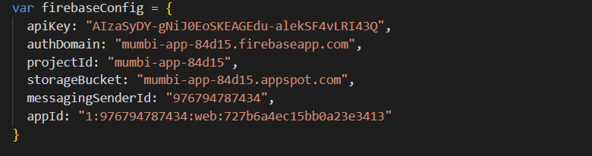

Use the command: *npm run build* to build project.

After that, use command: *npm run deploy* to deploy the application to AWS.

### 2.2. Database

1. Access to https://aws.amazon.com/vi/

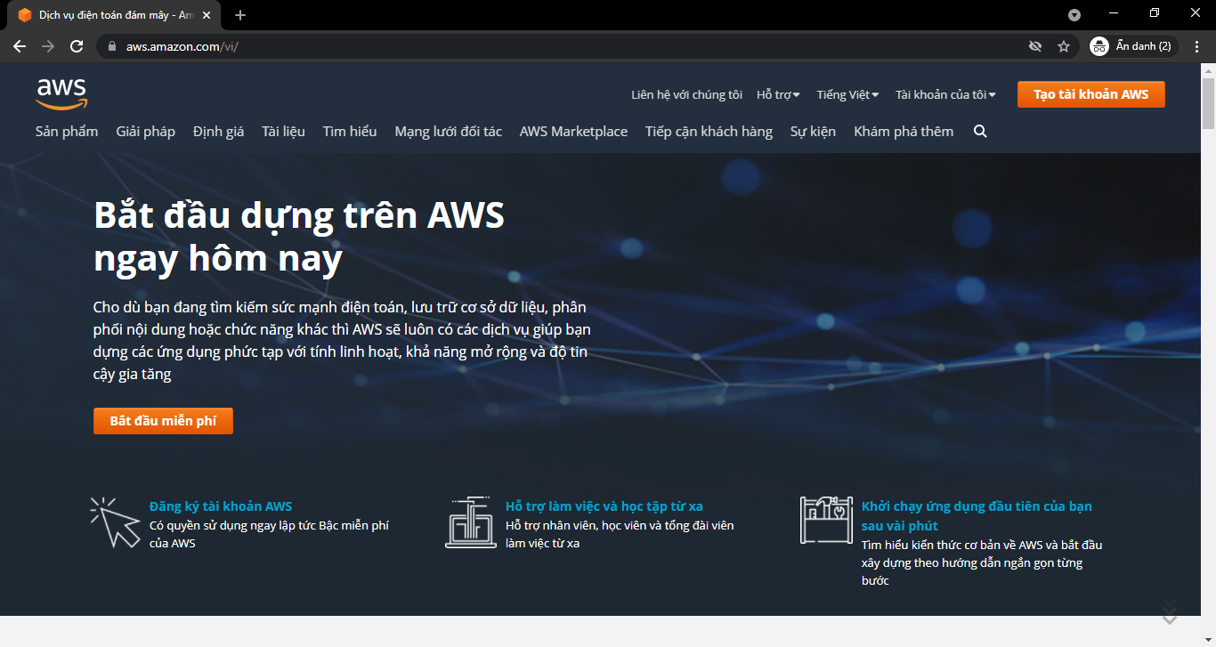

1. Click to “Services”

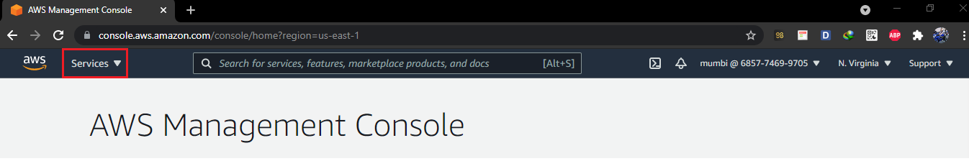

1. After entering the interface of "Service", select "RDS" in “Database”menu.

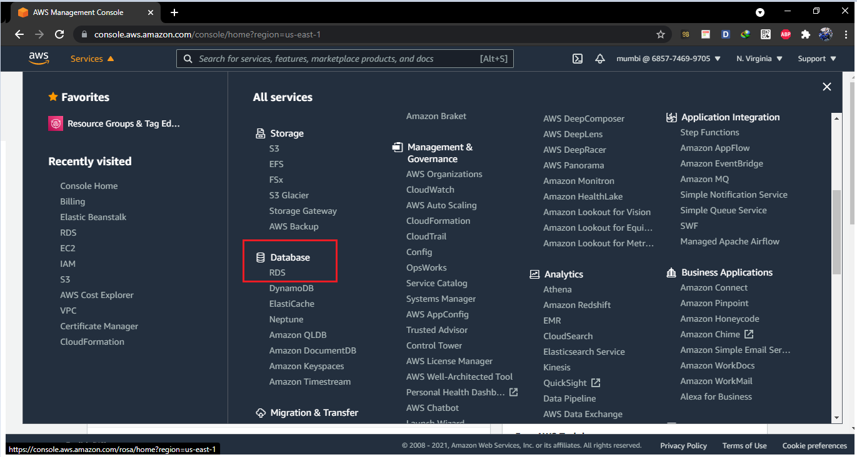

1. Click to “Create database”

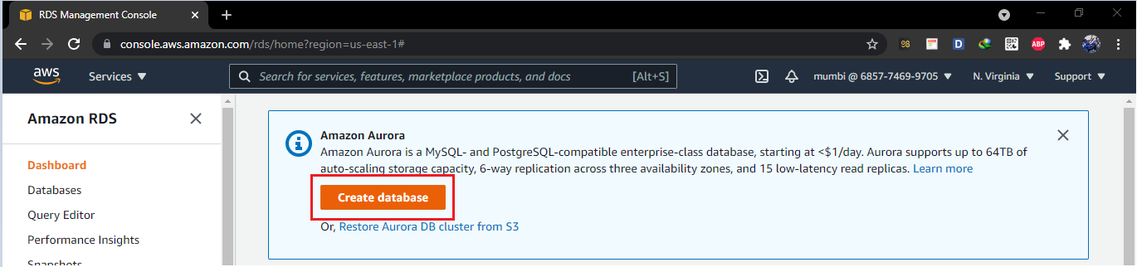

1. In Engine options, select the item “Microsoft SQL Server”.

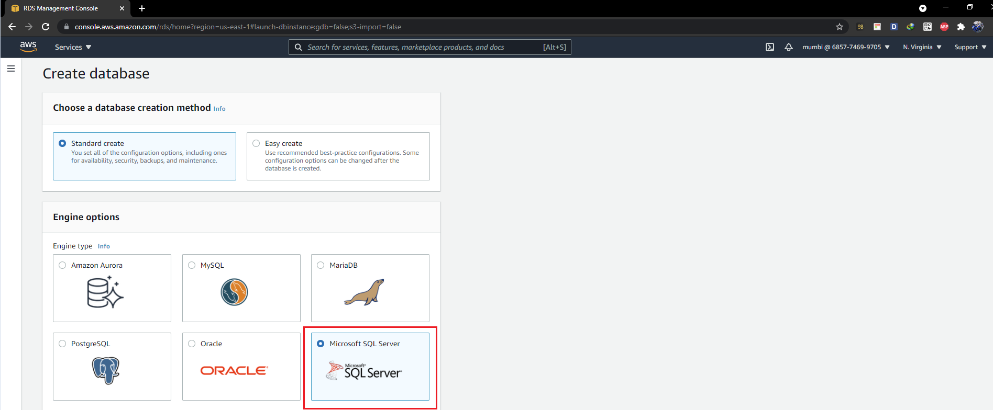

1. At the creation interface, select the corresponding items as shown, with detailed name information:

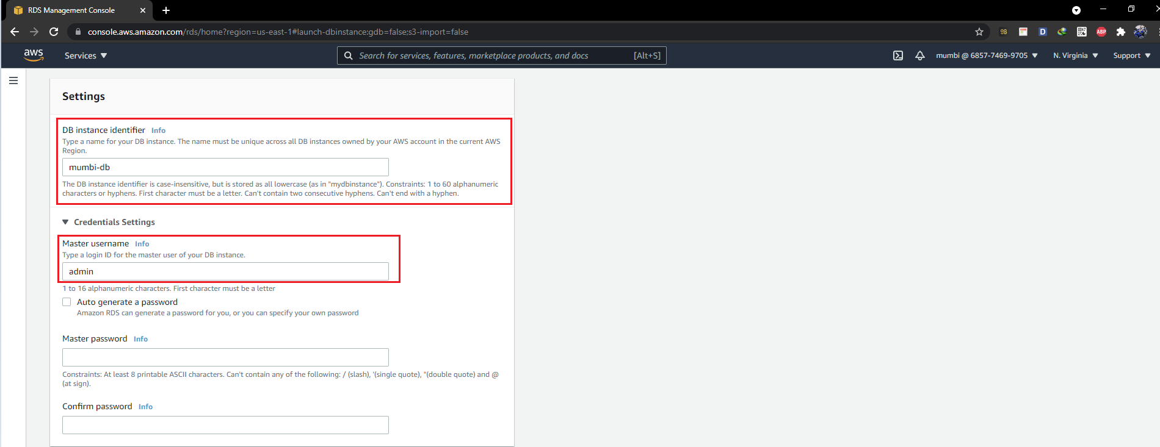

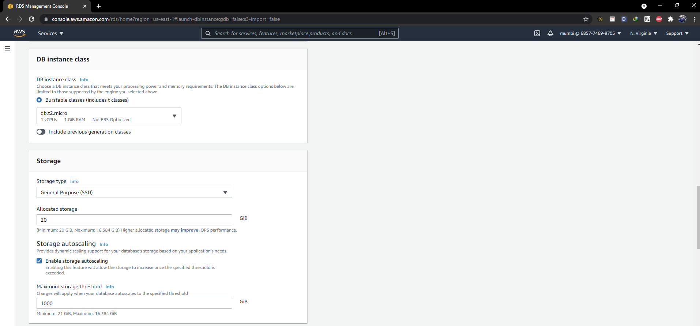

1. After configing properties of database, press “Create database”.

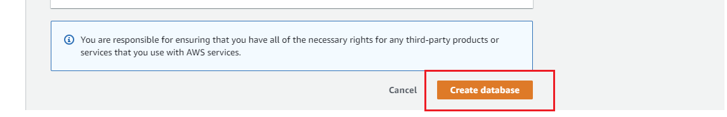

8. After successful creation, the appearance will be like this:

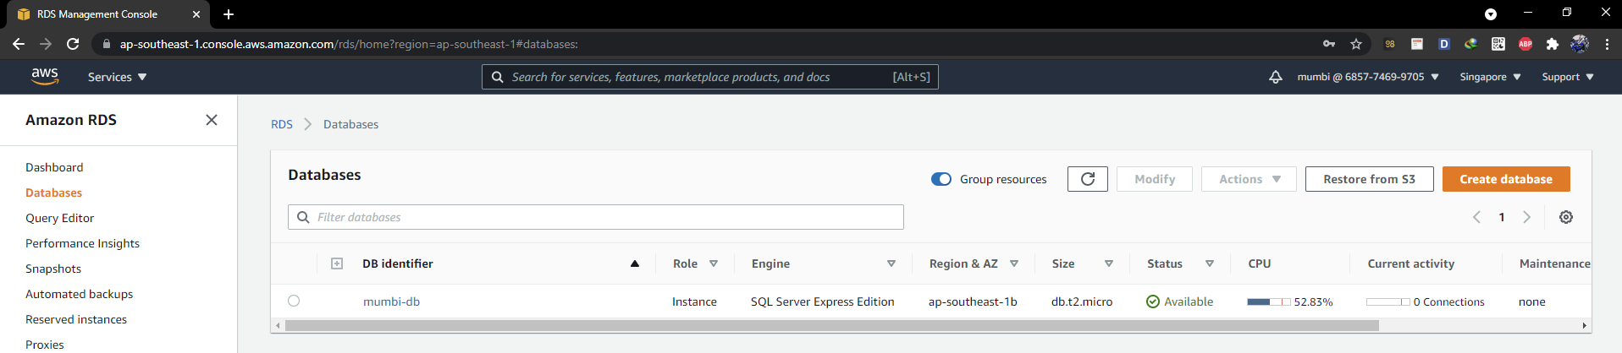

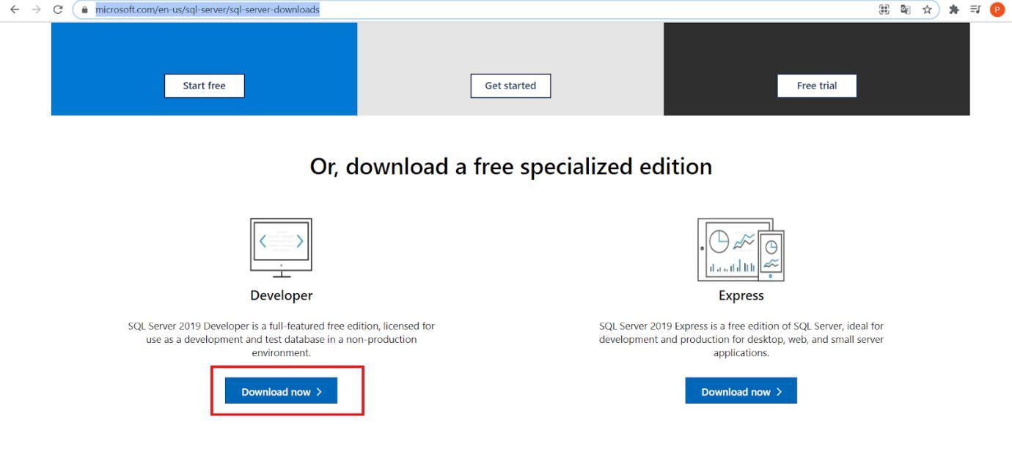

| 9. | We will load the necessary tools to access the database | | | just created: | Go |
| --- | --- | --- | --- | --- | --- |
| to |  | <https://www.microsoft.com/en-us/sql-server/sql-server-downloads>to | | download | the |
|  | |  |  |  |  |
| developer version. | | | |  |  |

1. After running the setup file and follow the instructions. Run the application "**Microsoft** **SQL Server Management Studio 18**"

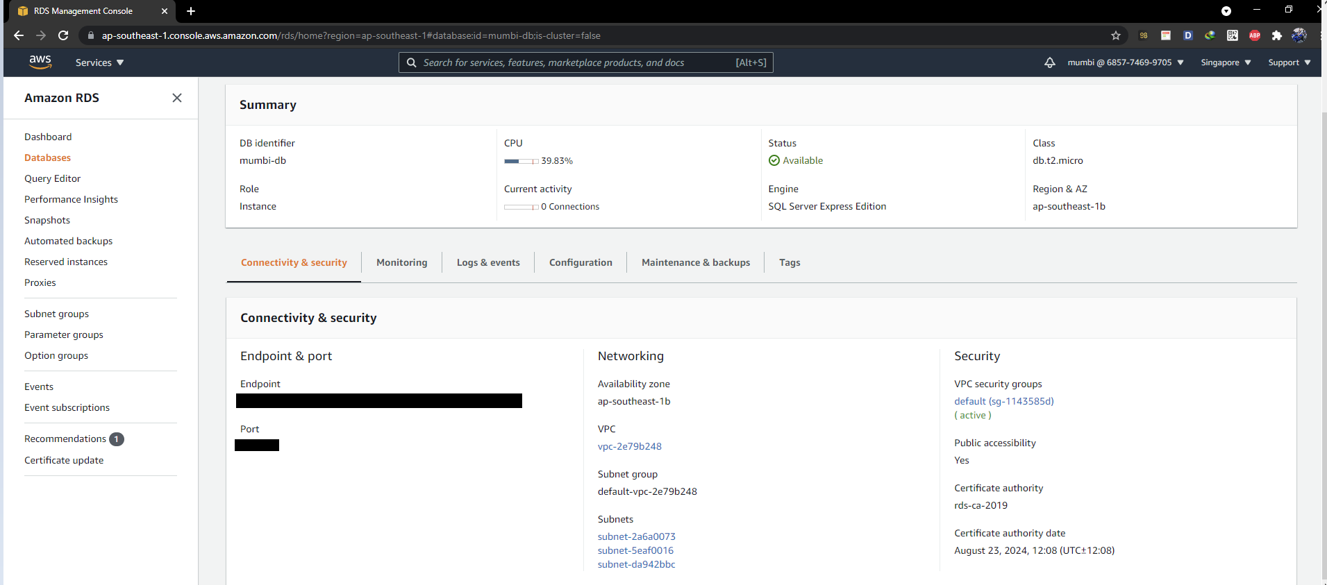

1. After creating the database, we click on "mumbi-db" on DB Identifier

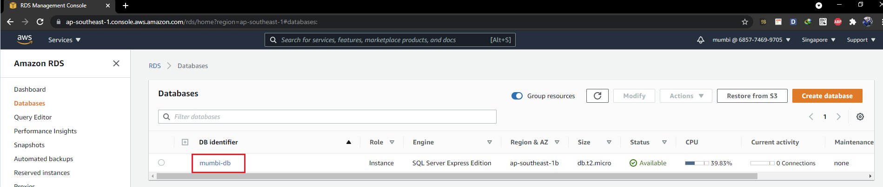

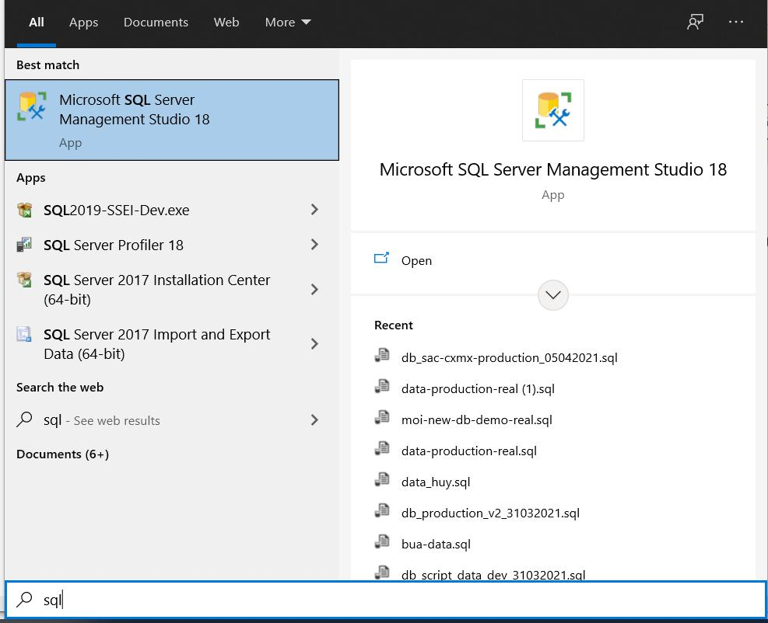We will see information such as Endpoint + port to fill in the login box when opening the application “**Microsoft SQL Server Management Studio 18**”

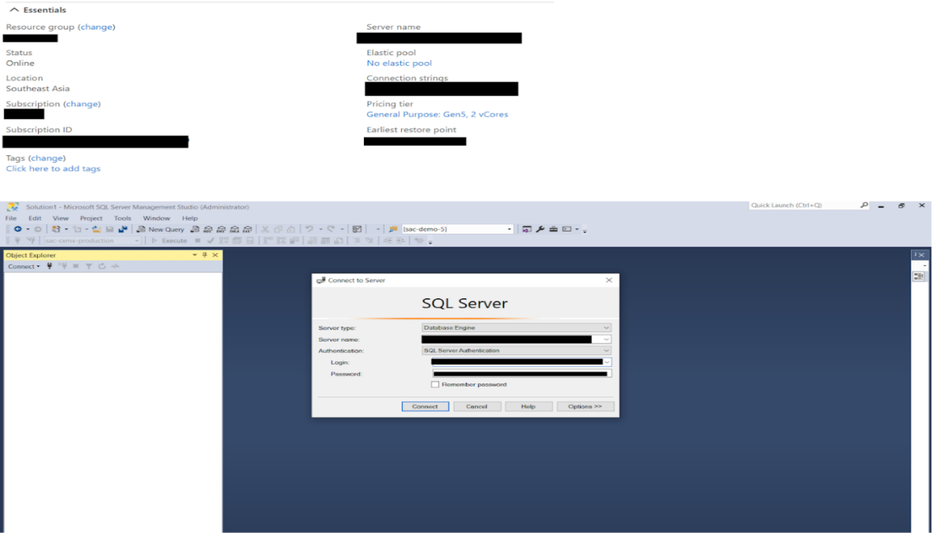

1. Screen after login, this is the database we created.

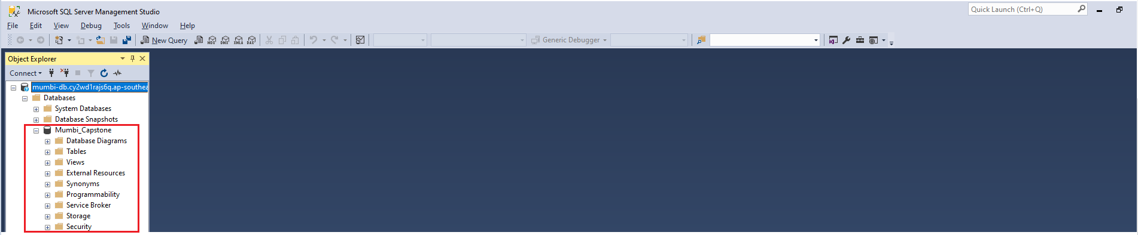

1. Now, open "mumbi-capstone.sql" in the "Release Package & User Guides" section of the database section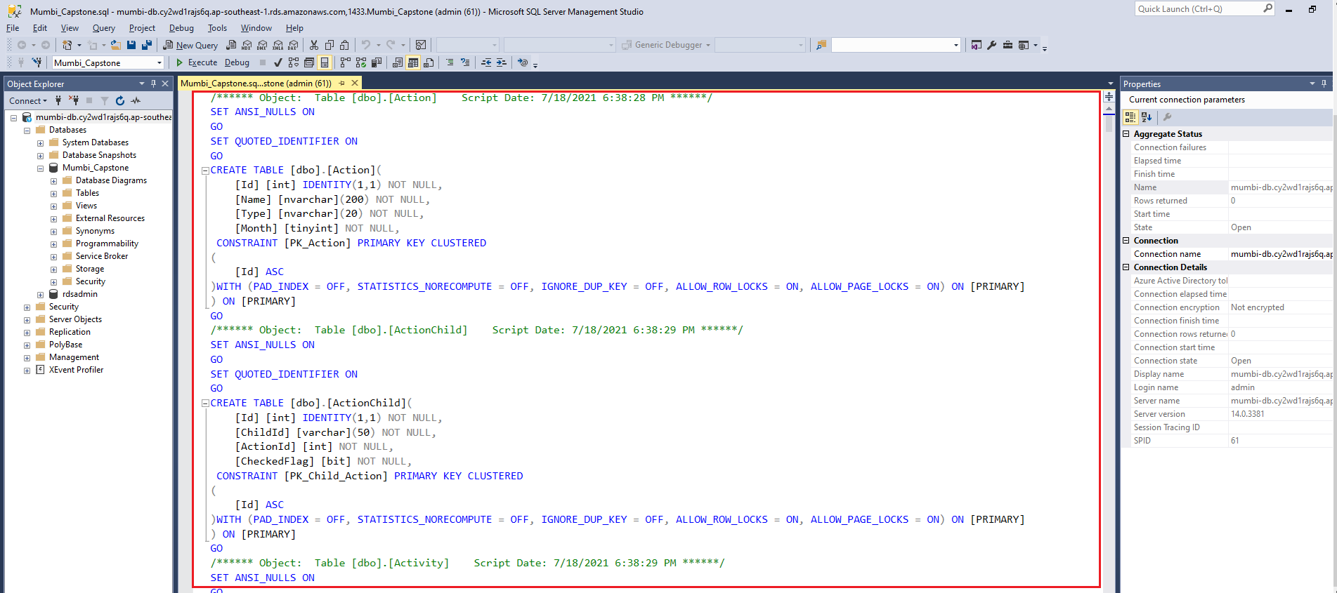

Note moving the item from master ⇒ Mumbi_Capstone

Click on the file that opens, press Ctrl + A, then press F5

Then wait for the system to process and receive the results.

### 2.3. BackEnd Deployment

1. First, to facilitate the deployment process we need the following tools:
   * Visual studio 2019
   * .Net core 2.2 SDK
   * Source code

Access to: <https://visualstudio.microsoft.com/>

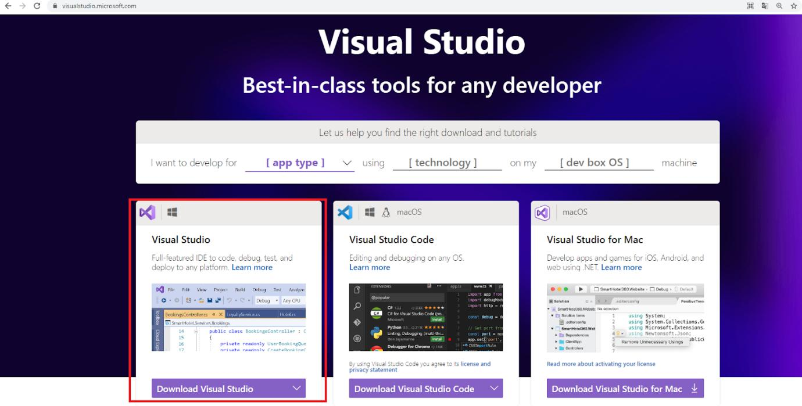

Click “Download Visual Studio” and choose the **community version 2019** to download.

1. After download, run .exe file have been downloaded. After run file .exe, we will reach this screen: and choose these options

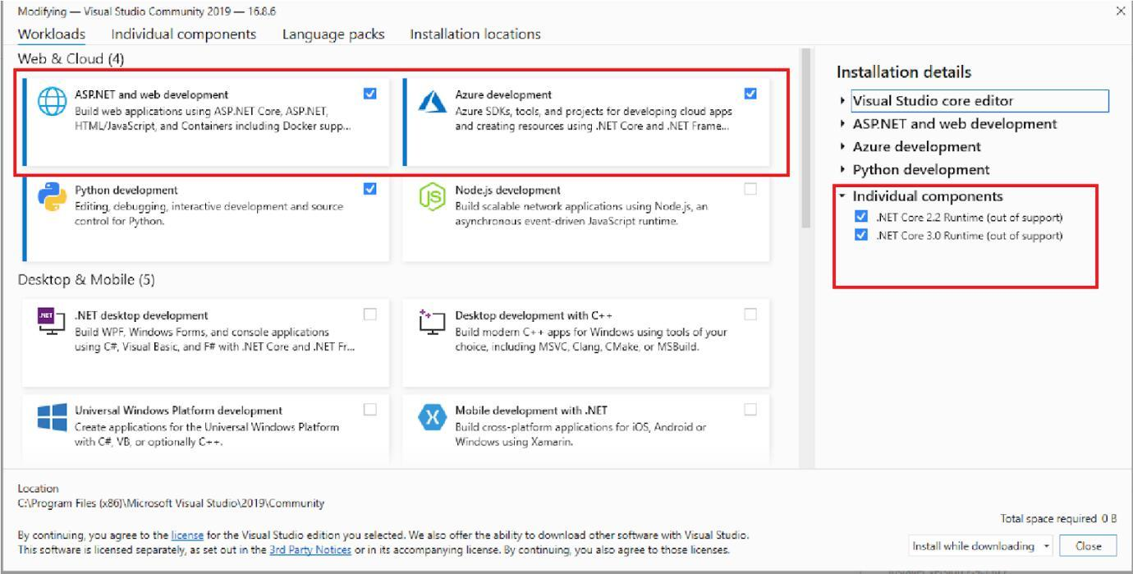

3. After, go to tab “Individual components” and do as following option:

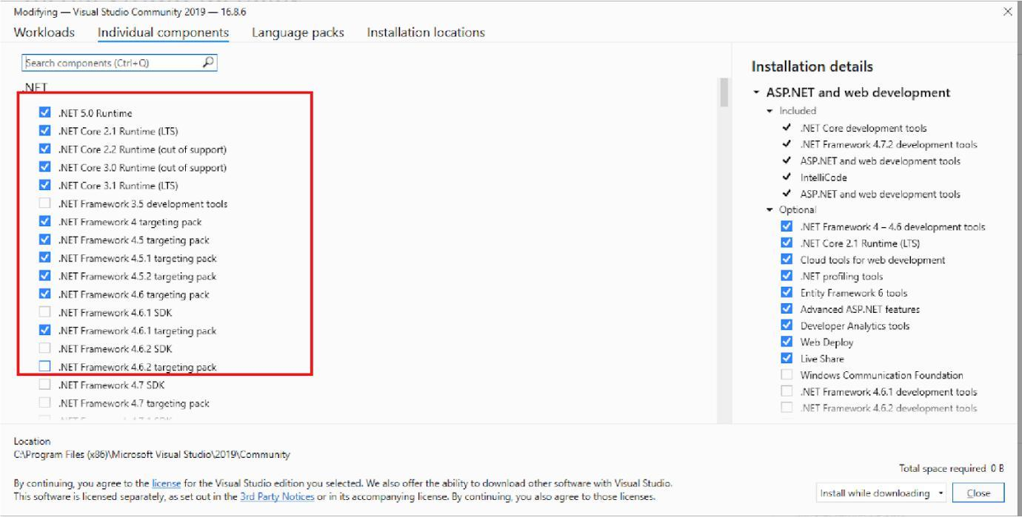

1. After choosing these files, click “Install” and finish the process to install the Visual Studio 2019 community version.

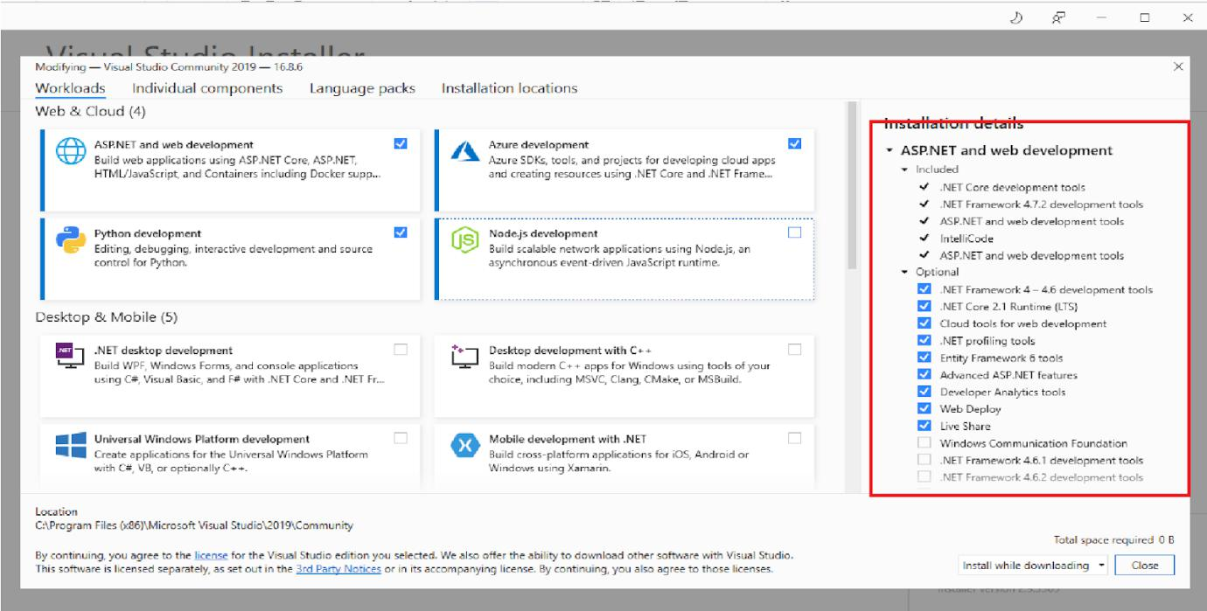

1. Access the provided source code directory:

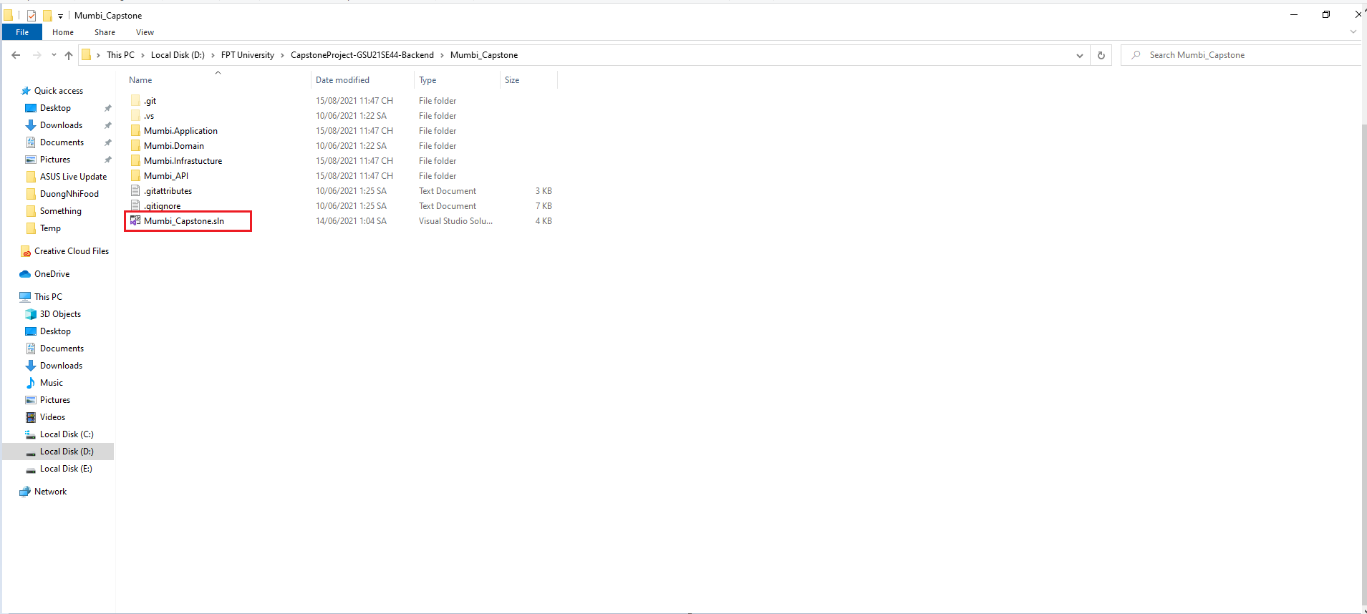

6. Click “Mumbi_Capstone.sln” to open project:

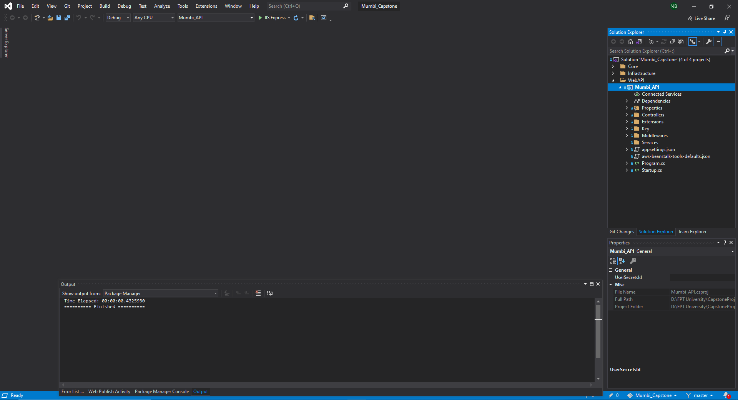

1. Right-click to “Mumbi_API” and select “Publish to AWS Elastic Beanstalk”

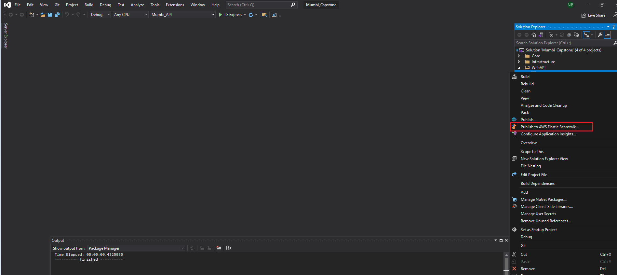

8. After clicking “Publish to AWS Elastic Beanstalk” and do follow this step:

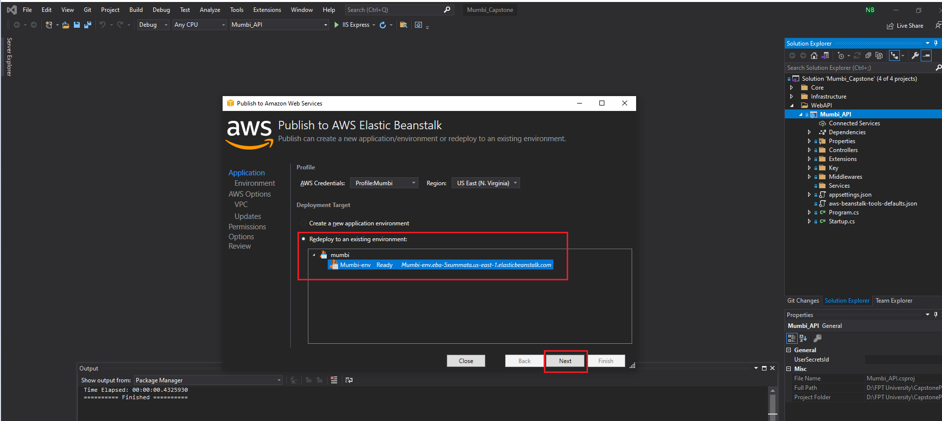

Review information and click “Deploy”

## 3. User Manual

### 3.1. Staff create news

| **No.** | **Name** | **Description** |
| --- | --- | --- |
| **1** | Thêm tin mới | Create a new news |

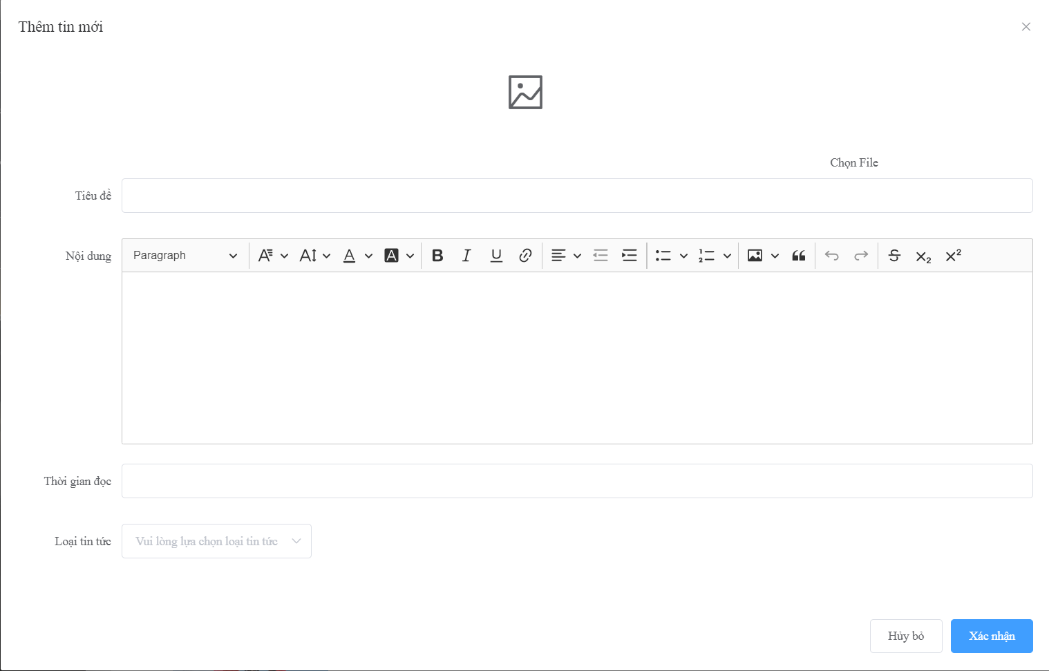

| **No** | **Name** | **Description** | **Read Only** | **Mandatory** | **Control Type** | **Data Type** |
| --- | --- | --- | --- | --- | --- | --- |
| **1** | Chọn File | Select file image to upload | No | Yes | File Upload | File |
| **2** | Tiêu đề | The title of news | No | Yes | Text Box | String |
| **3** | Nội dung | The content of news | No | Yes | Text Box | String |
| **4** | Thời gian đọc | Estimated finish time of news | No | Yes | Text box | Int |
| **5** | Loại tin tức | Type of news | No | Yes | Select | String |

| **No** | **Name** | **Description** | **Validation** |
| --- | --- | --- | --- |
| **6** | Hủy bỏ | Cancel create news | Yes |
| **7** | Xác nhận | Confirm to create news | Yes |

### 3.2. Staff create news type

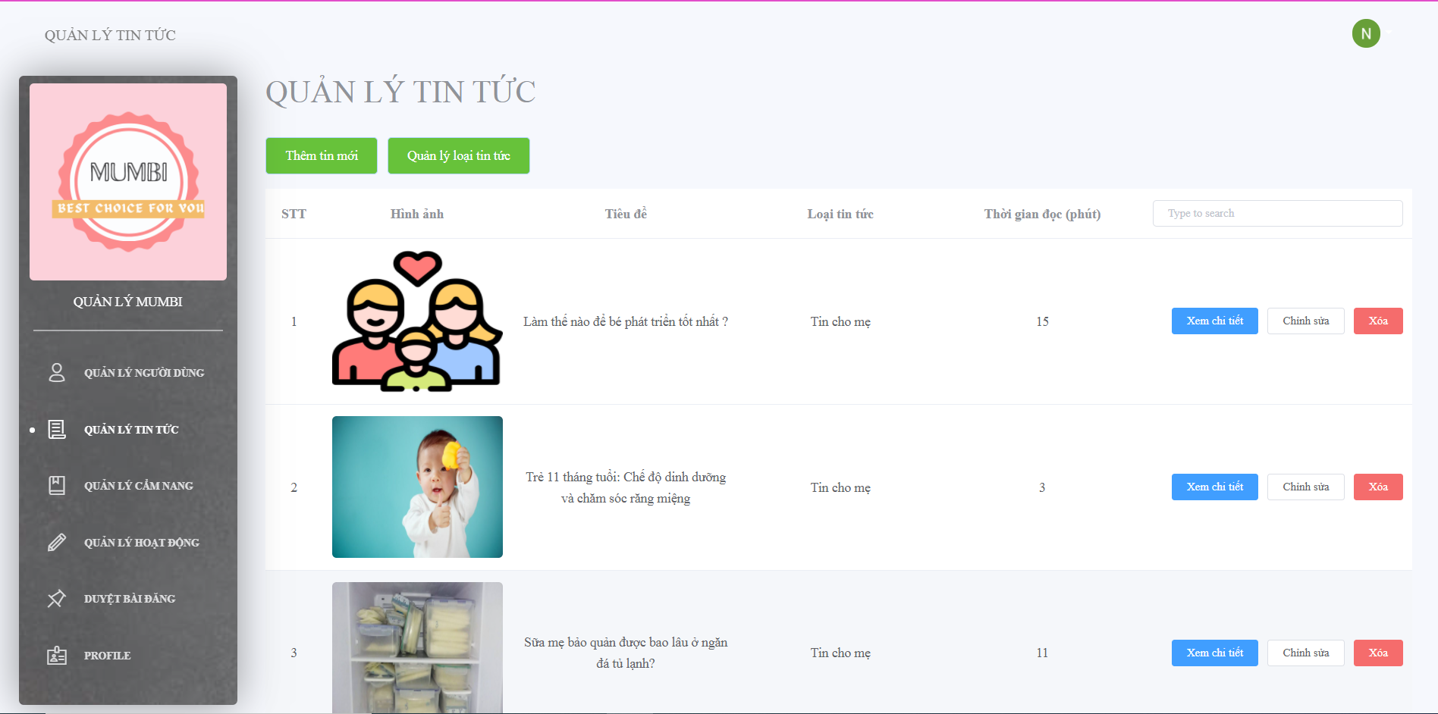

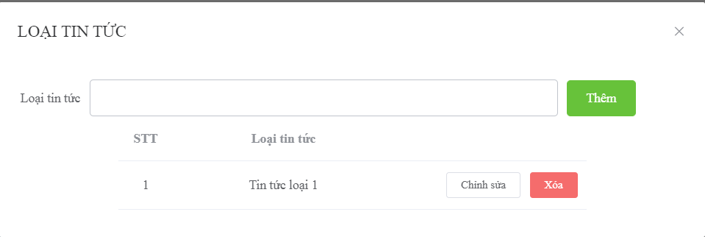

| **No.** | **Name** | **Description** |
| --- | --- | --- |
| **1** | Quản lý loại tin tức | Manage type of news |

| **No** | **Name** | **Description** | **Read Only** | **Mandatory** | **Control Type** | **Data Type** |
| --- | --- | --- | --- | --- | --- | --- |
| **1** | Loại tin tức | Type of news | No | Yes | Text Box | String |

| **No** | **Name** | **Description** | **Validation** |
| --- | --- | --- | --- |
| **2** | Thêm | Button to create type of news | Yes |
| **3** | Chỉnh sửa | Button to edit type of news | Yes |
| **4** | Xóa | Button to delete type of news | Yes |

### 3.3. Staff create guidebook

| **No.** | **Name** | **Description** |
| --- | --- | --- |
| **1** | Thêm cẩm nang mới | Create a new guidebook |

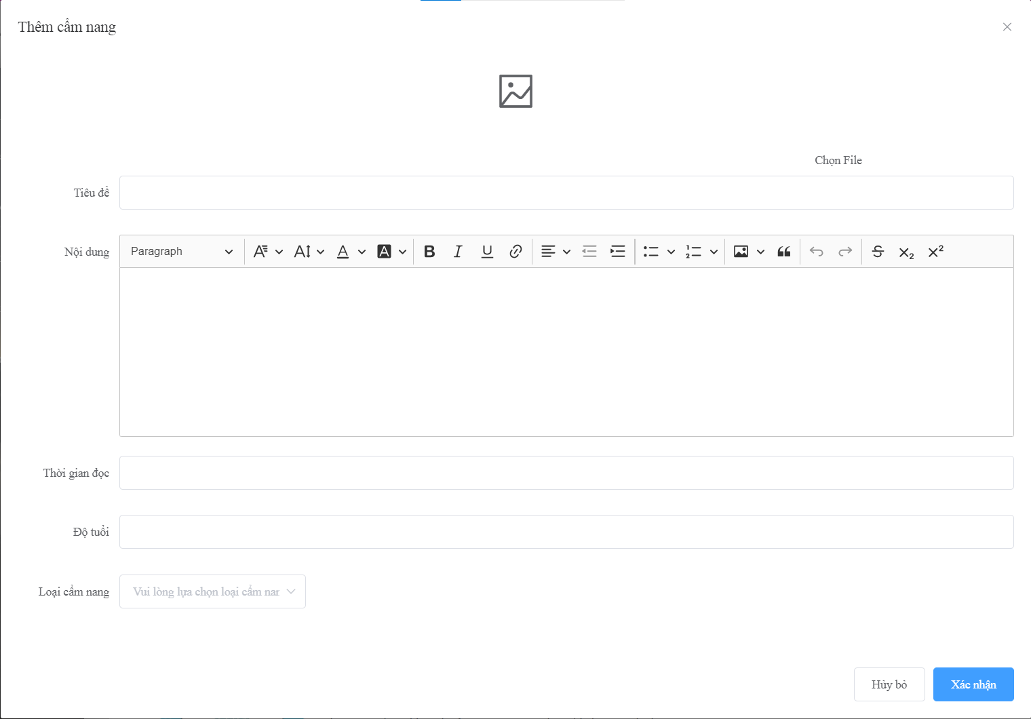

| **No** | **Name** | **Description** | **Read Only** | **Mandatory** | **Control Type** | **Data Type** |
| --- | --- | --- | --- | --- | --- | --- |
| **1** | Chọn File | Select file image to upload | No | Yes | File Upload | File |
| **2** | Tiêu đề | The title of guidebook | No | Yes | Text Box | String |
| **3** | Nội dung | The content of guidebook | No | Yes | Text Box | String |
| **4** | Thời gian đọc | Estimated finish time of guidebook | No | Yes | Text box | Int |
| **5** | Độ tuổi | Available age for guidebook | No | Yes | Text box | Int |
| **6** | Loại cẩm nang | Type of guidebook | No | Yes | Select | String |

| **No** | **Name** | **Description** | **Validation** |
| --- | --- | --- | --- |
| **7** | Hủy bỏ | Cancel create guidebook | Yes |
| **8** | Xác nhận | Confirm to create guidebook | Yes |

### 3.4. Staff create guidebook type



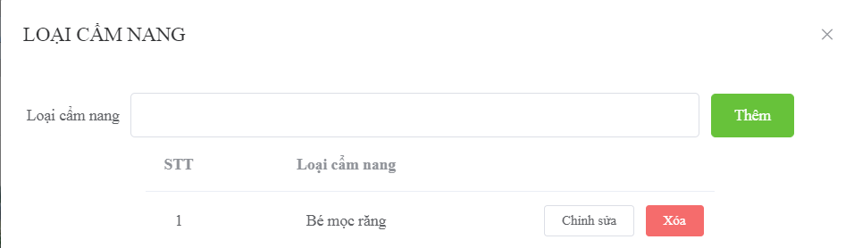

| **No** | **Name** | **Description** | **Read Only** | **Mandatory** | **Control Type** | **Data Type** |
| --- | --- | --- | --- | --- | --- | --- |
| **1** | Loại cẩm nang | Type of guidebook | No | Yes | Text Box | String |

| **No** | **Name** | **Description** | **Validation** |
| --- | --- | --- | --- |
| **2** | Thêm | Button to create type of guidebook | Yes |
| **3** | Chỉnh sửa | Button to edit type of guidebook | Yes |
| **4** | Xóa | Button to delete type of guidebook | Yes |

### 3.5. Staff create activity

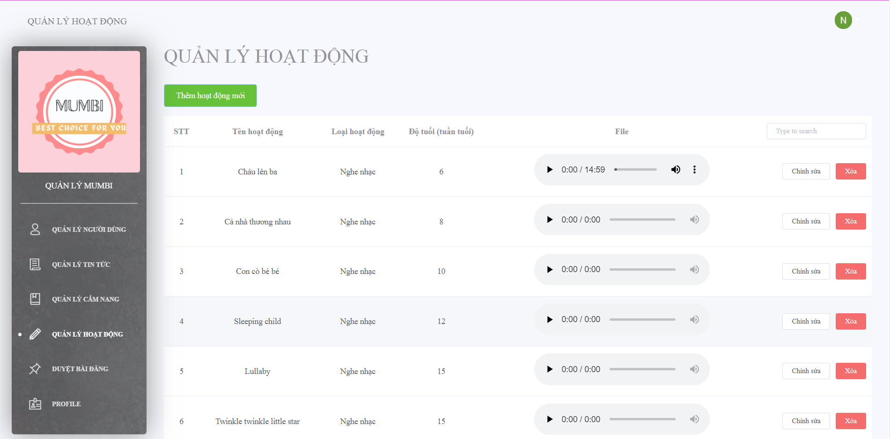

| **No.** | **Name** | **Description** |
| --- | --- | --- |
| **1** | Thêm hoạt động mới | Create a new activity |

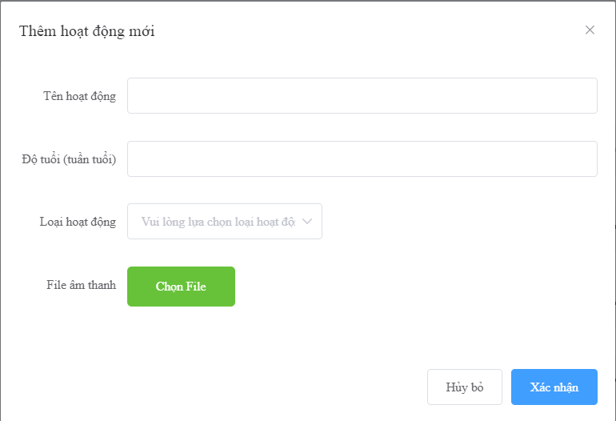

| **No** | **Name** | **Description** | **Read Only** | **Mandatory** | **Control Type** | **Data Type** |
| --- | --- | --- | --- | --- | --- | --- |
| **1** | Tên hoạt động | The name of activity | No | Yes | Text Box | String |
| **2** | Độ tuổi(tuần tuổi) | The suitable age of activity | No | Yes | Text Box | String |
| **3** | Loại hoạt động | The type activity of activity | No | Yes | Select | String |
| **4** | Chọn File | Select file audio to upload | No | Yes | File Upload | File |

| **No** | **Name** | **Description** | **Validation** |
| --- | --- | --- | --- |
| **5** | Hủy bỏ | Button to cancel create activity | Yes |
| **6** | Xác nhận | Button to confirm create activity | Yes |

1. **Customer**

### Overview

### a. Login

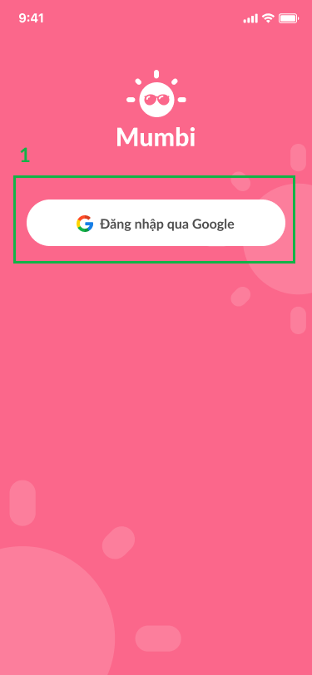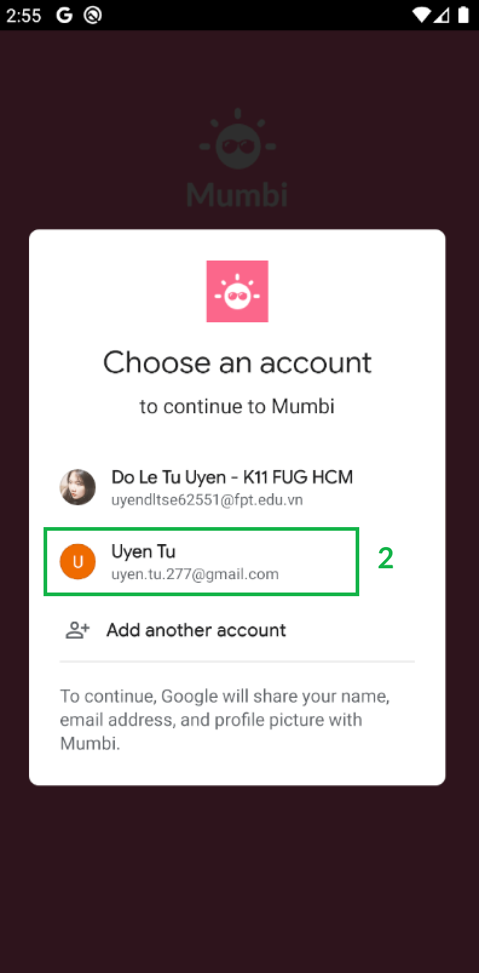

| **No** | **Name** | **Description** | **Validation** |
| --- | --- | --- | --- |
| **1** | Đăng nhập qua Google | Click button to login by Gmail | Yes |
| **2** | Chọn một tài khoản | Click item to choose account to login in the system | Yes |

### b. Homepage

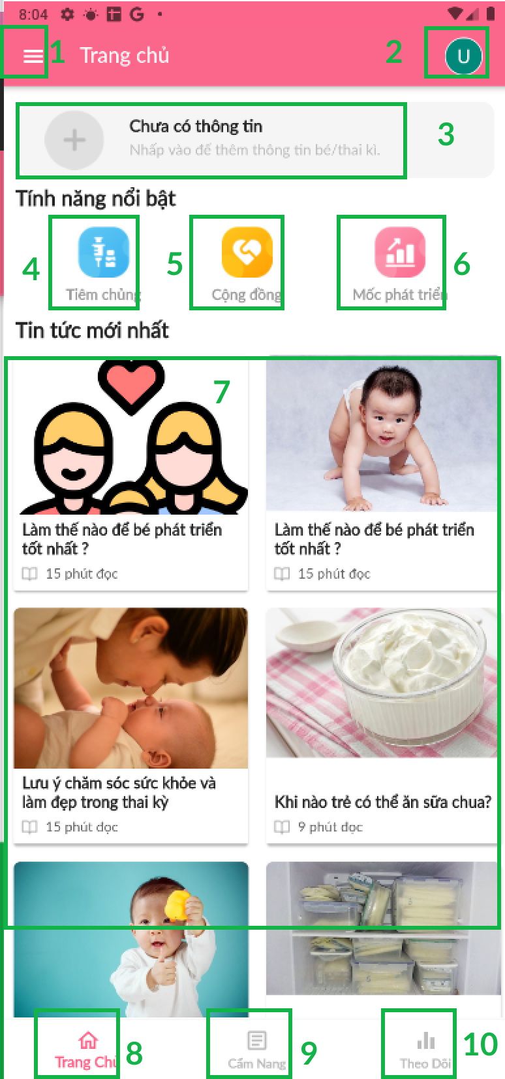

| **No** | **Name** | **Description** | **Validation** |
| --- | --- | --- | --- |
| **1.** | Menu | Click icon to show Menu | Yes |
|  | Chuyển tài khoản | Click icon to navigate to Changing user account screen | Yes |
|  | Thêm thông tin bé/thai kì | Click item to navigate to Adding information baby/pregnancy screen | Yes |
|  | Tiêm chủng | Click icon to navigate to Injection schedule screen | Yes |
|  | Cộng đồng | Click icon to navigate to Community screen | Yes |
|  | Mốc phát triển | Click icon to navigate to Managing baby’s development screen | Yes |
|  | Tin tức mới nhất | Click item to view news | Yes |
|  | Trang chủ | Click icon to navigate to Menu | Yes |
|  | Cẩm nang | Click icon to navigate to Guidebook screen | Yes |
|  | Theo dõi | Click icon to navigate to Tracking baby screen | Yes |

### c. Menu

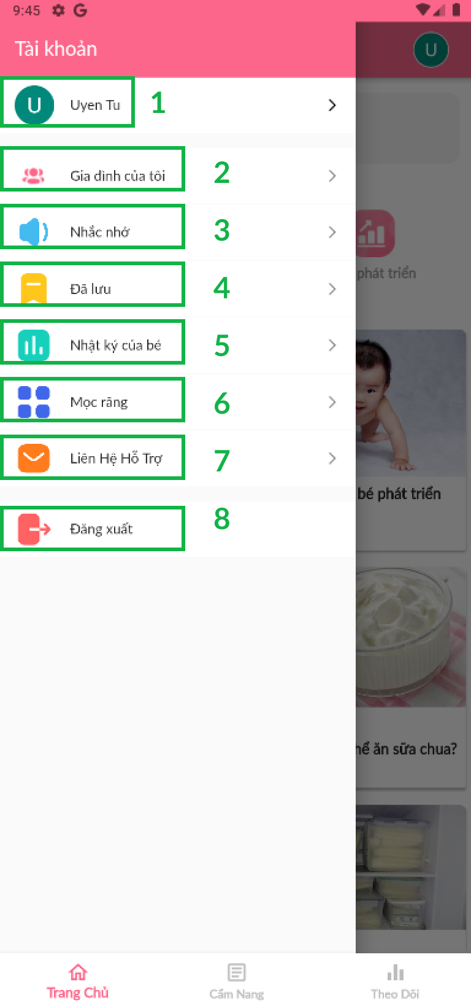

| **No** | **Name** | **Description** | **Validation** |
| --- | --- | --- | --- |
|  | Chuyển thành viên | Click item to change member | Yes |
|  | Gia đình của tôi | Click item to navigate to Family screen | Yes |
|  | Đã lưu | Click item to navigate to Storing screen | Yes |
|  | Nhật ký của bé | Click item to navigate to Diary’s baby screen | Yes |
|  | Mọc răng | Click item to navigate to Growing teeth screen | Yes |
|  | Liên hệ hỗ trợ | Click item to Contact support screen | Yes |
|  | Đăng xuất | Click item to logout the system | Yes |

### d. Change user account

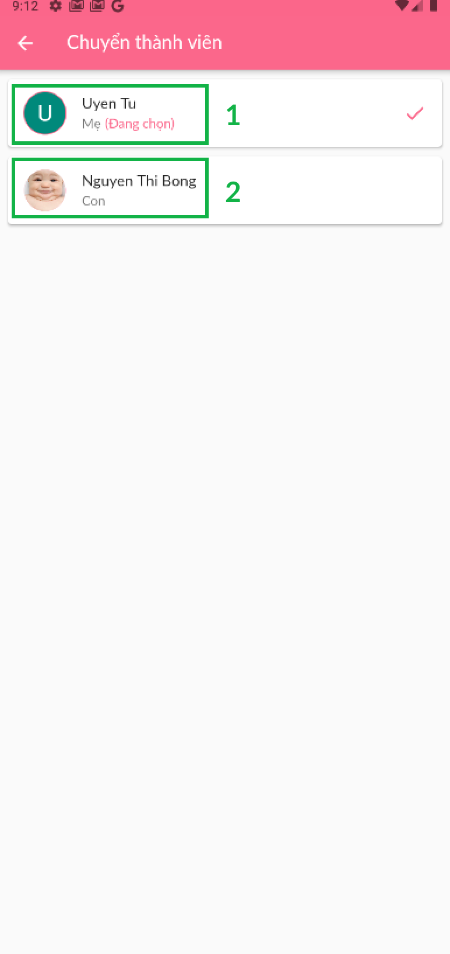

| **No** | **Name** | **Description** | **Validation** |
| --- | --- | --- | --- |
|  | Tài khoản mẹ | Click item to choose mother’s account | Yes |
|  | Tài khoản con | Click item to choose baby’s account | Yes |

### Create User account data

### Select to create user account data

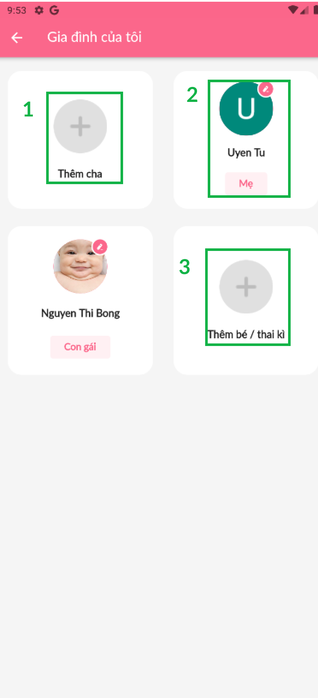

| **No** | **Name** | **Description** | **Validation** |
| --- | --- | --- | --- |
|  | Thêm cha | Click icon to create father data | Yes |
|  | Mẹ | Click icon to edit mother data | Yes |
|  | Thêm bé/thai kì | Click icon to create baby/pregnancy data | Yes |

### Create father data

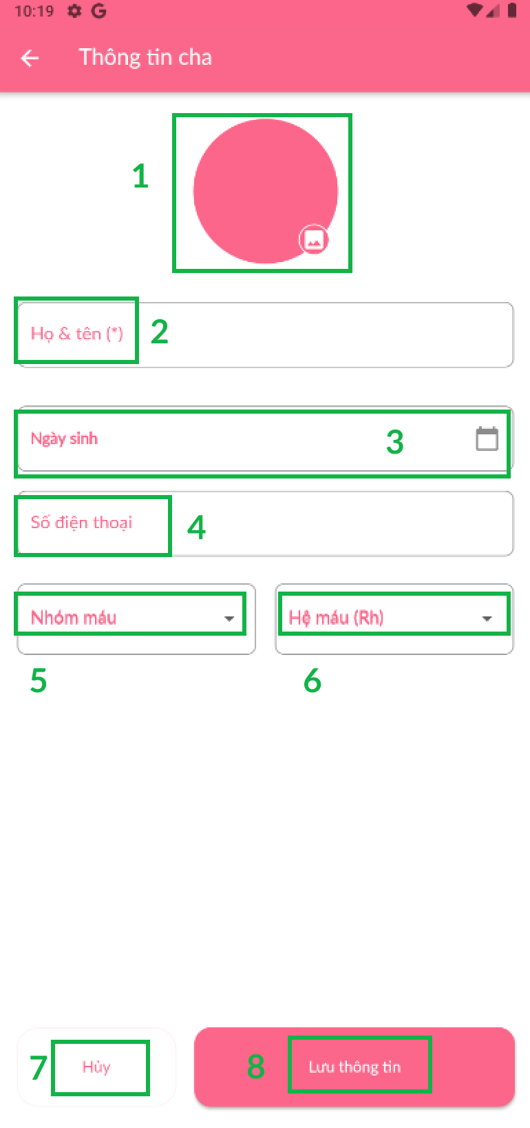

*Figure 88 Create father data*

| **No** | **Name** | **Description** | **Read Only** | **Mandatory** | **Control Type** | **Data Type** |
| --- | --- | --- | --- | --- | --- | --- |
|  | Ảnh đại diện | Click icon to update father’s avatar | No | Yes | File Upload | File |
|  | Họ và tên | Fill the father’s name | No | Yes | TextBox | Text |
|  | Ngày sinh | Choose father’s date birth | No | Yes | TextBox | DateTime |
|  | Số điện thoại | Fill the father’s phone number | No | Yes | TextBox | Number |
|  | Nhóm máu | Choose father’s blood group | No | Yes | Drop down | String |
|  | Hệ máu (Rh) | Choose father’s Rh blood group | No | Yes | Drop down | String |

| **No** | **Name** | **Description** | **Validation** |
| --- | --- | --- | --- |
| **7** | Hủy | Click button to cancel | Yes |
| **8** | Lưu thông tin | Click button to save information | Yes |

### Edit mother data

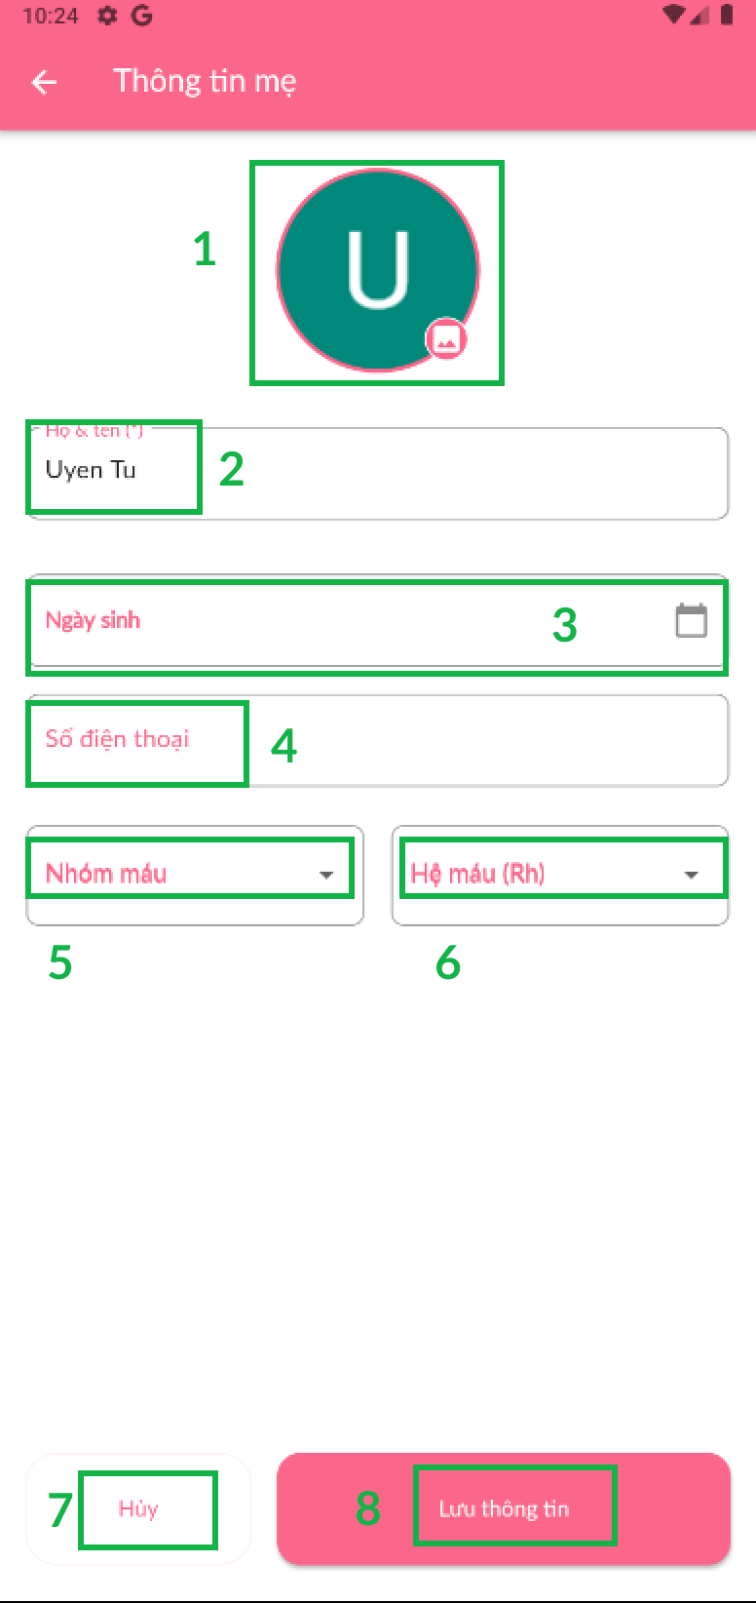

| **No** | **Name** | **Description** | **Read Only** | **Mandatory** | **Control Type** | **Data Type** |
| --- | --- | --- | --- | --- | --- | --- |
|  | Ảnh đại diện | Click icon to update mother’s avatar | No | Yes | File Upload | File |
|  | Họ và tên | Fill the mother’s name | No | Yes | TextBox | Text |
|  | Ngày sinh | Choose mother’s date birth | No | Yes | TextBox | DateTime |
|  | Số điện thoại | Fill the mother’s phone number | No | Yes | TextBox | Number |
|  | Nhóm máu | Choose father’s blood group | No | Yes | Drop down | String |
|  | Hệ máu (Rh) | Choose father’s Rh blood group | No | Yes | Drop down | String |

| **No** | **Name** | **Description** | **Validation** |
| --- | --- | --- | --- |
| **7** | Hủy | Click button to cancel | Yes |
| **8** | Lưu thông tin | Click button to save information | Yes |

### Create baby/pregnancy data

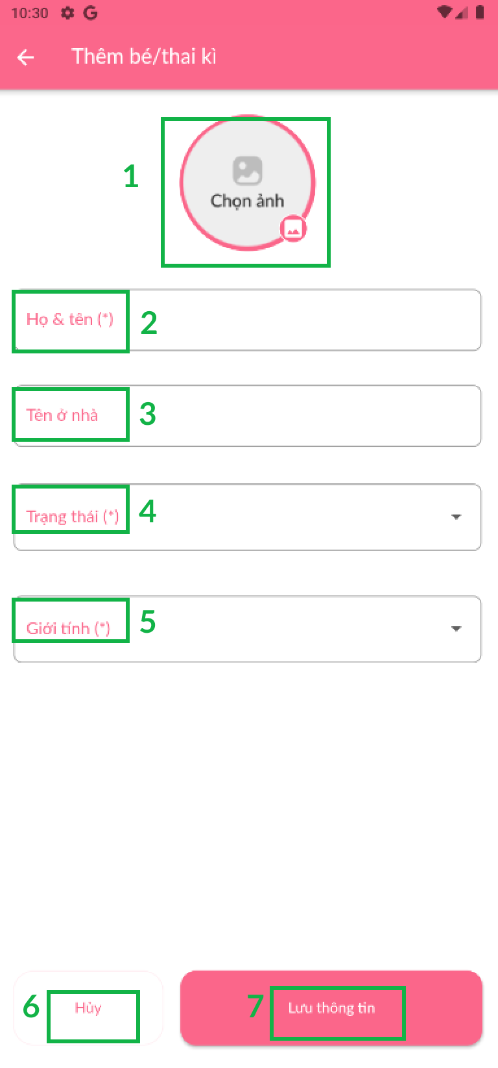

| **No** | **Name** | **Description** | **Read Only** | **Mandatory** | **Control Type** | **Data Type** |
| --- | --- | --- | --- | --- | --- | --- |
|  | Ảnh đại diện | Click icon to update baby’s avatar | No | Yes | File Upload | File |
|  | Họ và tên | Fill the baby’s name | No | Yes | TextBox | Text |
|  | Tên ở nhà | Fill the baby’s nickname | No | Yes | TextBox | Text |
|  | Trạng thái | Choose the baby’s status | No | Yes | Drop down | String |
|  | Giới tính | Choose the baby’s gender | No | Yes | Drop down | String |

| **No** | **Name** | **Description** | **Validation** |
| --- | --- | --- | --- |
| **6** | Hủy | Click button to cancel | Yes |
| **7** | Lưu thông tin | Click button to save information | Yes |

### Injection schedule



| **No** | **Name** | **Description** | **Validation** |
| --- | --- | --- | --- |
| **1** | Thêm | Button to create type of guidebook | Yes |
| **2** | Chỉnh sửa | Button to edit type of guidebook | Yes |

### Community

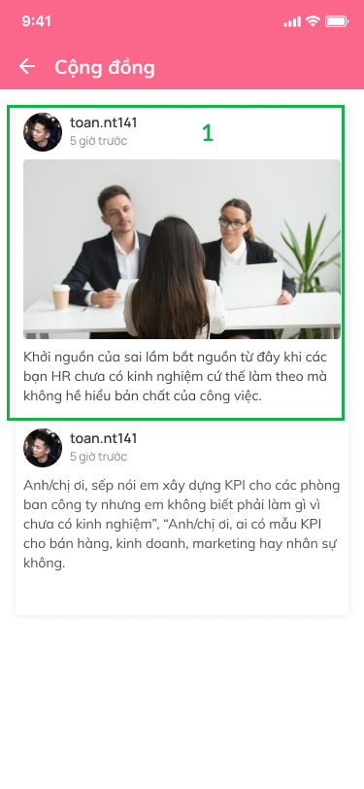

| **No** | **Name** | **Description** | **Validation** |
| --- | --- | --- | --- |
| **1** | Nhật kí của bé | Detail baby’s diary | Yes |

### Manage baby’s development

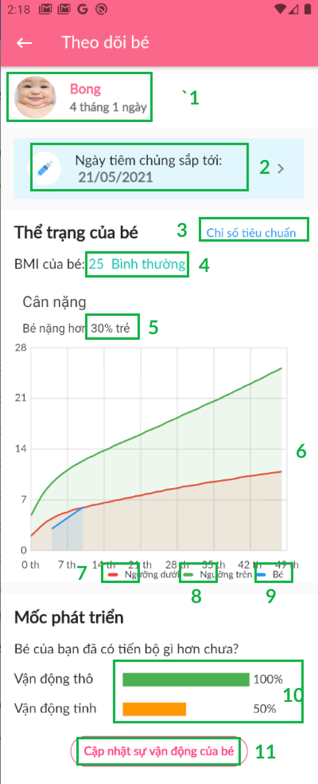

| **No** | **Name** | **Description** | **Validation** |
| --- | --- | --- | --- |
|  | Thông tin của bé | Detail baby’s information | Yes |
|  | Ngày tiêm chủng sắp tới | The next injection day of baby | Yes |
|  | Chỉ số tiêu chuẩn của bé | Click text to show baby’s standard index data | Yes |
|  | Thể trạng của bé | Baby’s physical condition | Yes |
|  | Cân nặng của bé | Baby’s weight | Yes |
|  | Biểu đồ | Detail maximum-minimum standard index data each month respectively | Yes |
|  | Dữ liệu ngưỡng dưới | Maximum data each month | Yes |
|  | Dữ liệu ngưỡng trên | Minimum data each month | Yes |
|  | Dữ liệu bé | Baby’s data each month | Yes |
|  | Mô tả số vận động tinh-thô của bé | Describe fine-gross motor skills | Yes |
|  | Cập nhật sự vận động của bé | Click button to update baby’s movement | Yes |

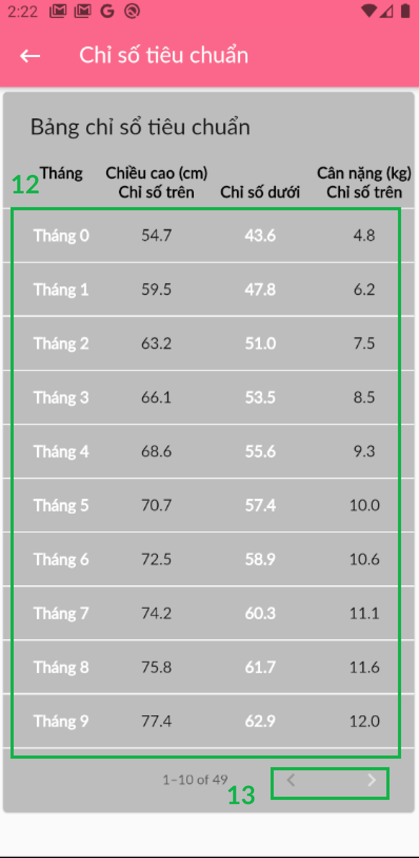

| **No** | **Name** | **Description** | **Validation** |
| --- | --- | --- | --- |
|  | Chỉ số tiêu chuẩn | Standard index data of baby | Yes |
|  | Icon | Click icon to move next and forward | Yes |

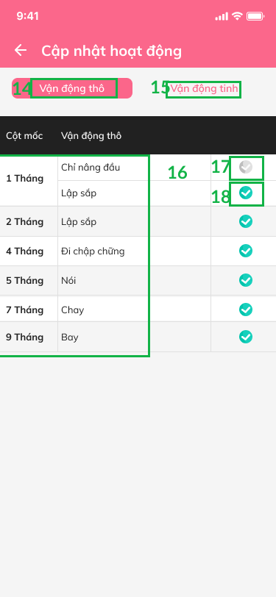

| **No** | **Name** | **Description** | **Validation** |
| --- | --- | --- | --- |
|  | Vận động thô | Gross motor skill | Yes |
|  | Vận động tinh | Fine motor skill | Yes |
|  | Cột mốc vận động thô | Detail gross motor skill each month | Yes |
|  | Icon | Icon unticked | Yes |
|  | Icon | Icon ticked | Yes |

### View News

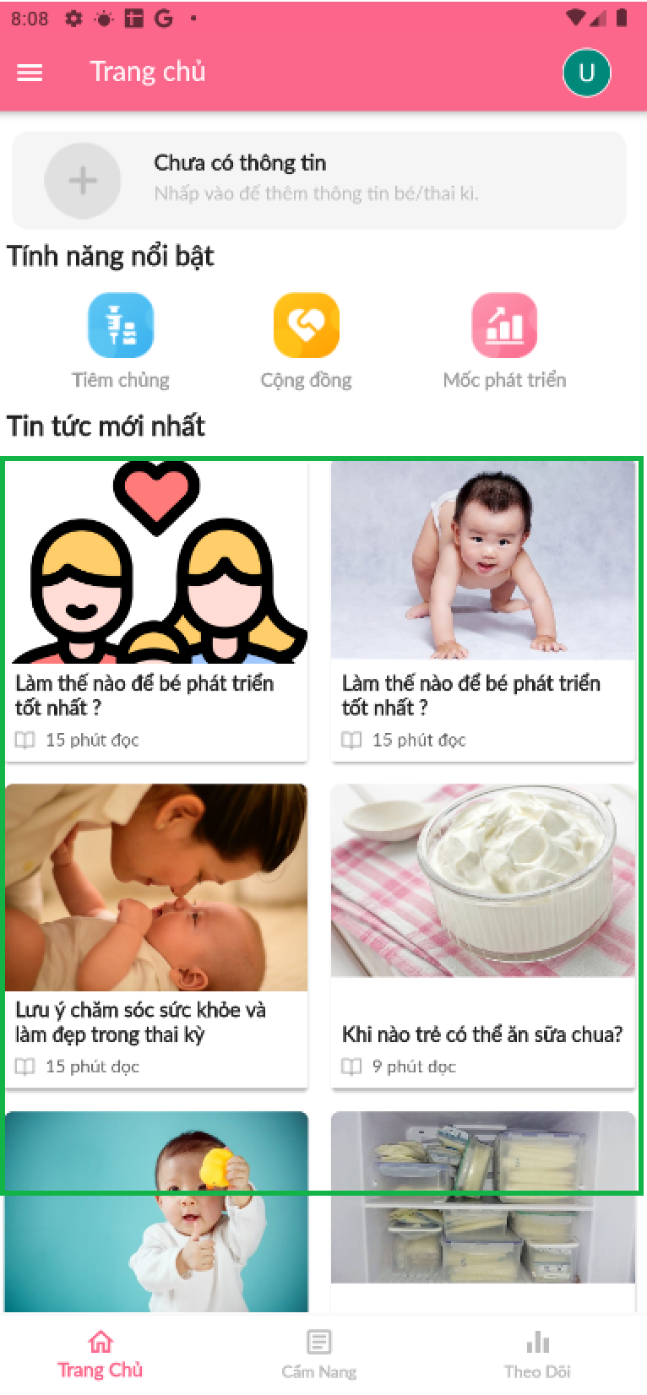

| **No** | **Name** | **Description** | **Validation** |
| --- | --- | --- | --- |
| **1** | Tin tức mới nhất | Click item to detail news | Yes |

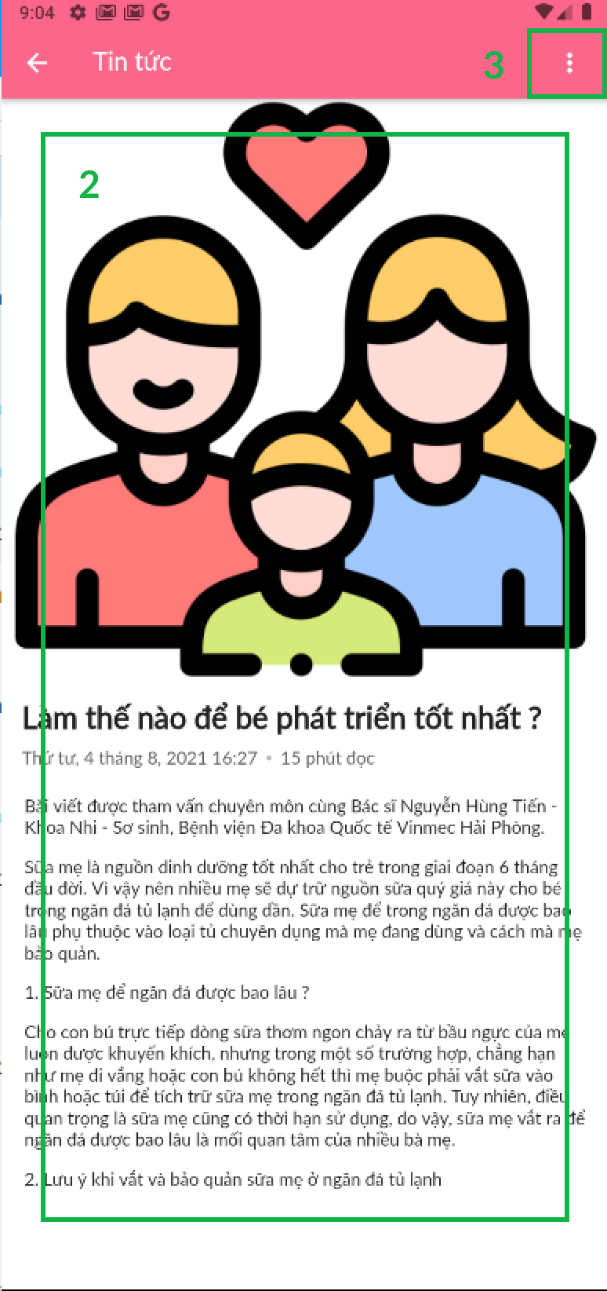

| **No** | **Name** | **Description** | **Validation** |
| --- | --- | --- | --- |
| **2** | Detail | Detail the description of News | Yes |
| **3** | Icon | Click icon to show saving post system | Yes |

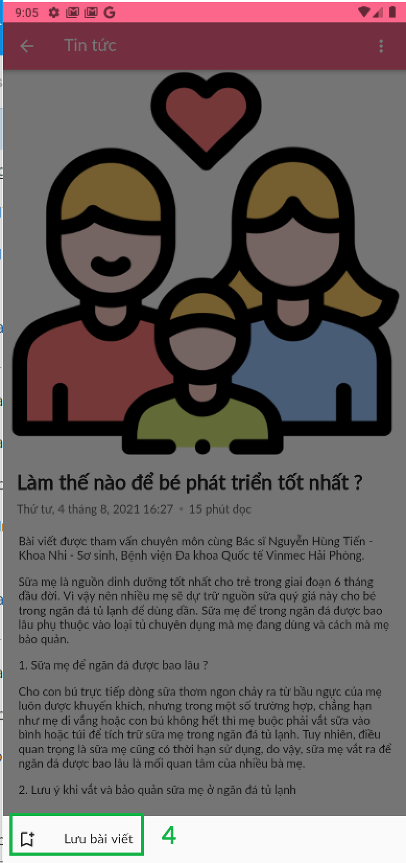

| **No** | **Name** | **Description** | **Validation** |
| --- | --- | --- | --- |
| **4** | Lưu bài viết | Click item to save post | Yes |

### View guidebook

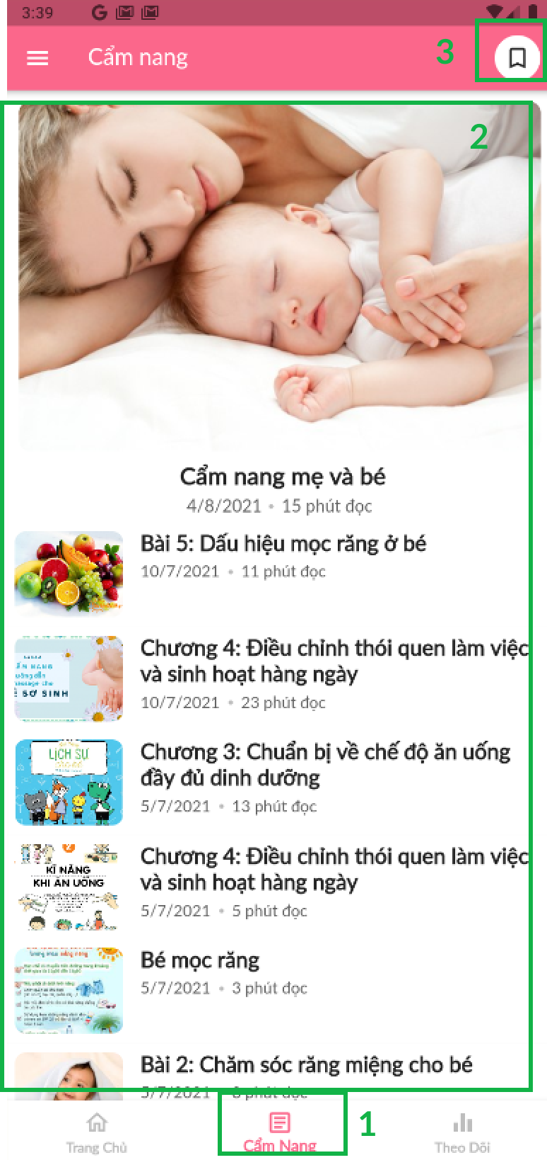

| **No** | **Name** | **Description** | **Validation** |
| --- | --- | --- | --- |
|  | Cẩm nang | Click icon to show guidebook screen | Yes |
|  | Item | Click to view detail guidebook item | Yes |
|  | Icon | Click icon to | Yes |

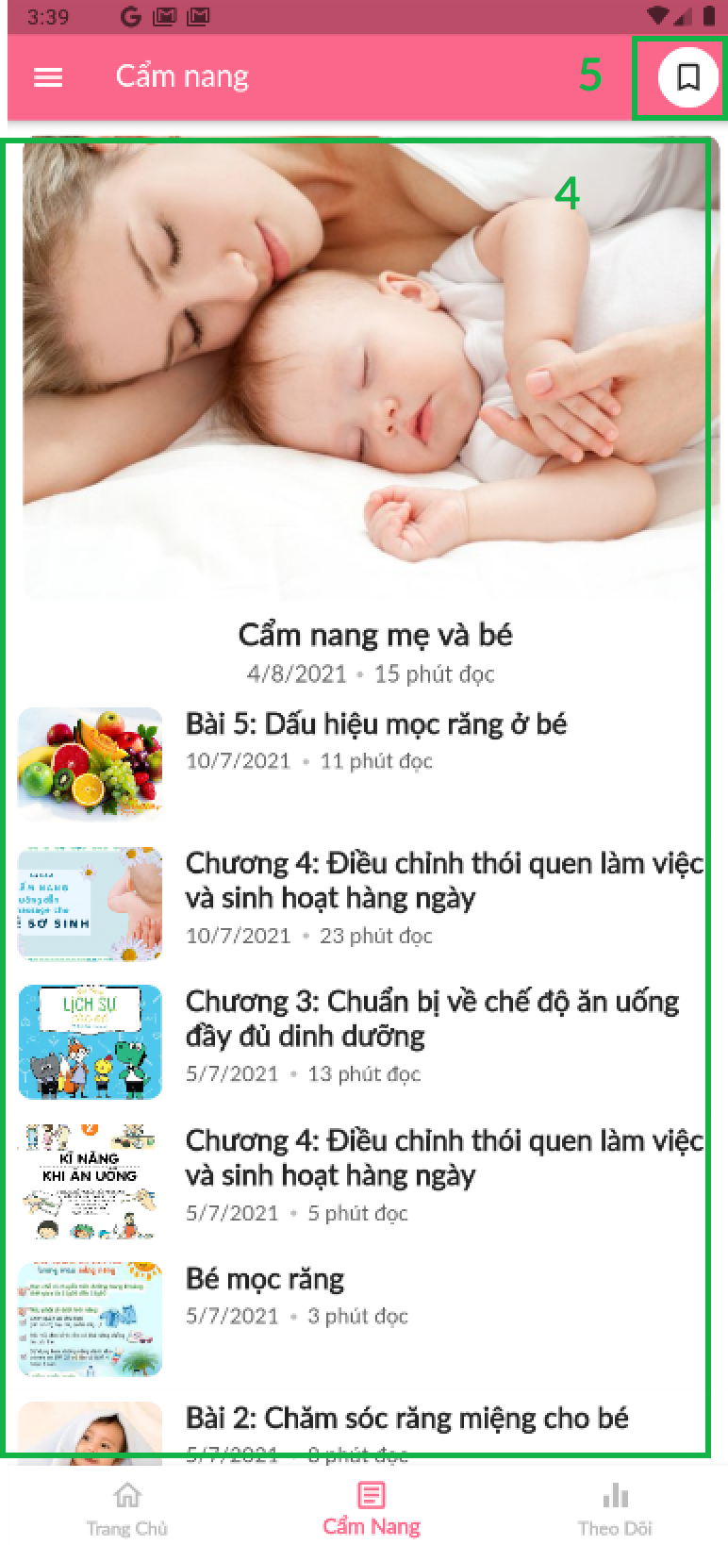

| **No** | **Name** | **Description** | **Validation** |
| --- | --- | --- | --- |
|  | Bài viết | Detail guidebook | Yes |
|  | Icon | Click icon to show saving post system | Yes |

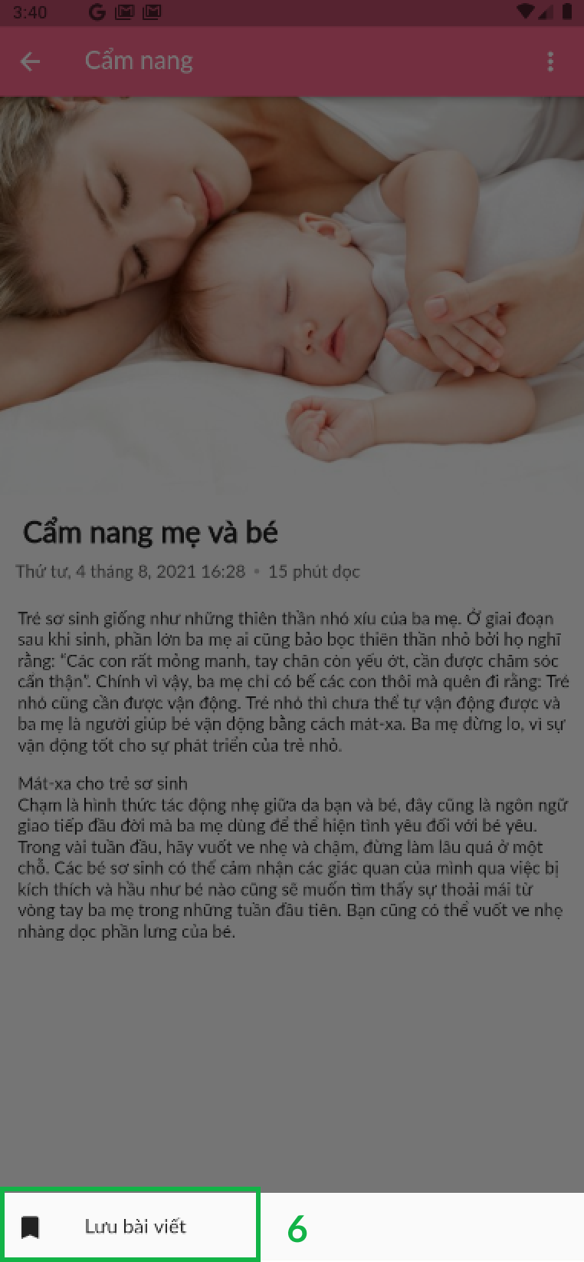

| **No** | **Name** | **Description** | **Validation** |
| --- | --- | --- | --- |
|  | Lưu bài viết | Click item to save post | Yes |

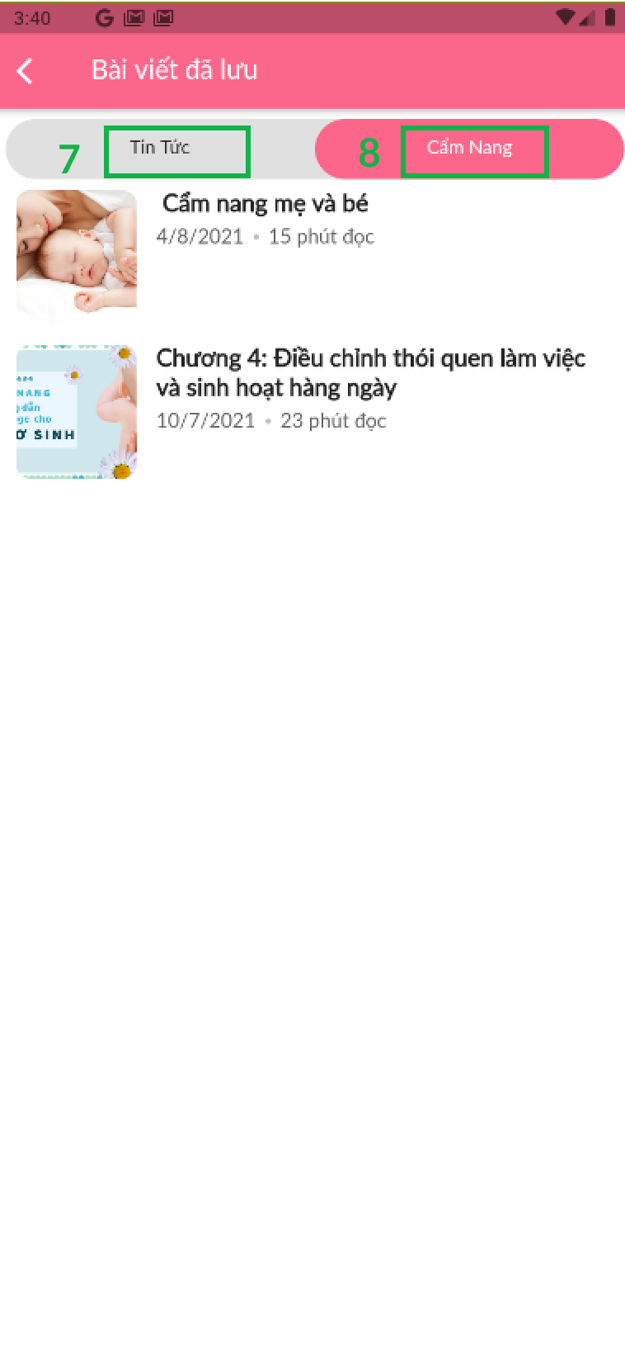

| **No** | **Name** | **Description** | **Validation** |
| --- | --- | --- | --- |
|  | Tin tức | Click button to show saving news | Yes |
|  | Cẩm nang | Click button to show saving guidebook | Yes |

### Add diary

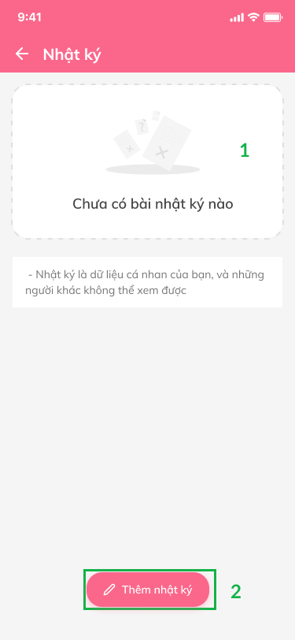 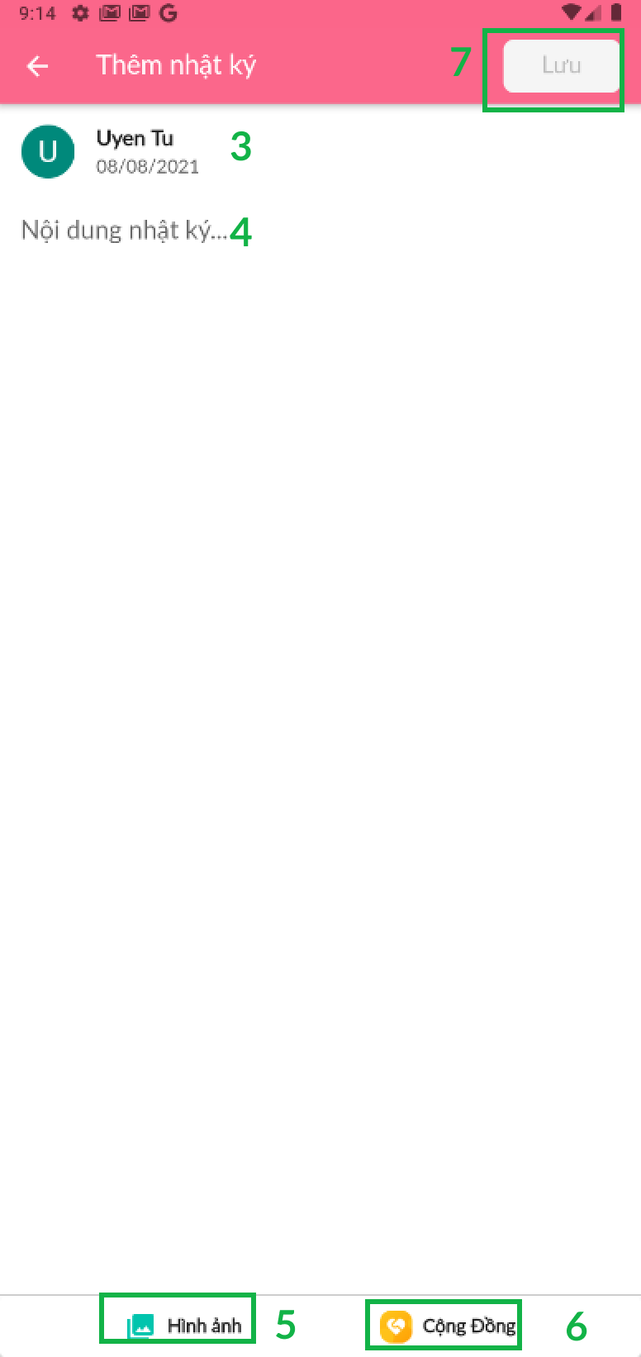

| **No** | **Name** | **Description** | **Read Only** | **Mandatory** | **Control Type** | **Data Type** |
| --- | --- | --- | --- | --- | --- | --- |
| **4** | Nội dung nhật ký | Click to write down diary | No | Yes | Text Box | String |

| **No** | **Name** | **Description** | **Validation** |
| --- | --- | --- | --- |
|  | Dữ liệu nhật ký | Diary information | Yes |
|  | Thêm nhật ký | Click item to add diary | Yes |
|  | Item | Detail user account, date time to post diary | Yes |
|  | Hình ảnh nhật ký | Click icon to upload diary image | Yes |
|  | Cộng đồng | Click icon to view Community screen | Yes |
|  | Lưu | Click button to save diary | Yes |

### Check teeth growing process

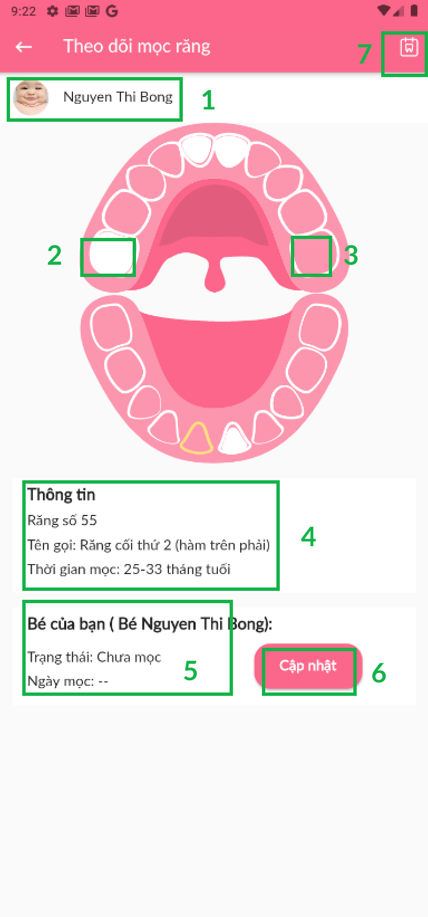 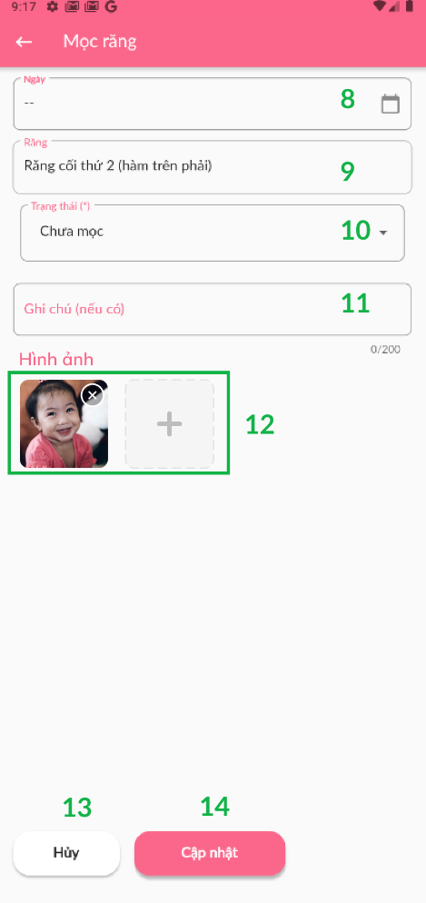 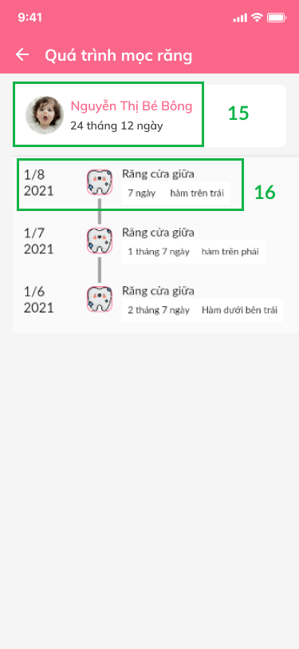

*Figure 89- Check teeth growing process*

| **No** | **Name** | **Description** | **Read Only** | **Mandatory** | **Control Type** | **Data Type** |
| --- | --- | --- | --- | --- | --- | --- |
|  | Ngày mọc răng | Choose the date growing teeth | No | Yes | TextBox | DateTime |
|  | Tên răng | Name of teeth | No | Yes | TextBox | String |
|  | Trạng thái răng | Choose teeth status | No | Yes | Dropdown | String |
|  | Ghi chú (nếu có) | Fill note (in case) | No | Yes | TextBox | Text |
|  | Upload hình ảnh | Click icon to add the growing teeth image of baby | No | Yes | Image | File |

| **No** | **Name** | **Description** | **Validation** |
| --- | --- | --- | --- |
|  | Dữ liệu bé | Baby’s name | Yes |
|  | Răng đã mọc | Growed teeth | Yes |
|  | Răng chưa mọc | Ingrown teeth | Yes |
|  | Thông tin răng | Detail teeth: number, name, growing time | Yes |
|  | Thông tin răng của bé | Detail baby’s teeth: status and growing time | Yes |
|  | Cập nhật | Click button to update teeth status | Yes |
|  | Icon | Click icon to show Growing teeth screen | Yes |
|  | Button | Click button to cancel check growing teeth process | Yes |
|  | Button | Click button to update check growing teeth process | Yes |
|  | Item | Detail growing teeth process: baby’s name and growing teeth time | Yes |
|  | Item | Detail growing each teeth process | Yes |

### Manage baby’s action

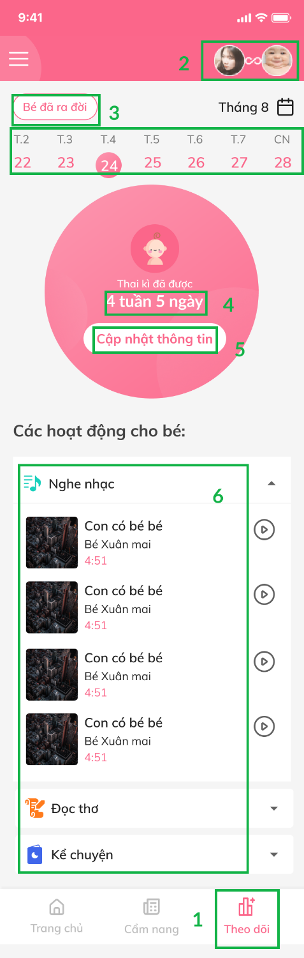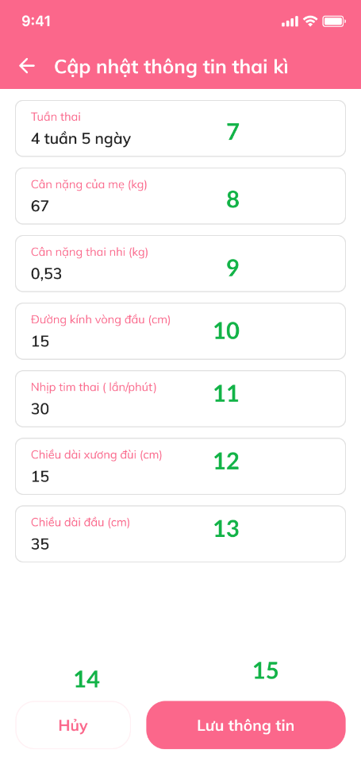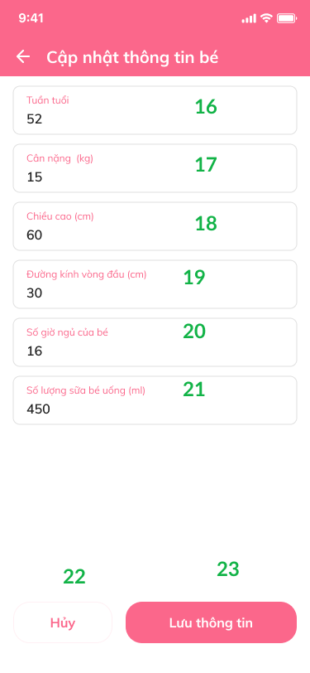

| **No** | **Name** | **Description** | **Read Only** | **Mandatory** | **Control Type** | **Data Type** |
| --- | --- | --- | --- | --- | --- | --- |
|  | Tuần thai kì | Fill in pregnancy week | No | Yes | TextBox | Text |
|  | Cân nặng của mẹ (kg) | Fill in mom’s weight | No | Yes | TextBox | Text |
|  | Cân nặng thai nhi (kg) | Fill in pregnancy’s weight | No | Yes | TextBox | Text |
|  | Đường kính vòng đầu (cm) | Fill in first round diameter (cm) | No | Yes | TextBox | Text |
|  | Nhịp tim thai (lần/phút) | Fill in the heart beat of pregnancy (times/minute) | No | Yes | TextBox | Text |
|  | Chiều dài xương đùi (cm) | Fill in the length of thigh bone (cm) | No | Yes | TextBox | Text |
|  | Chiều dài đầu (cm) | Fill in the length of head (cm) | No | Yes | TextBox | Text |
|  | Tuần tuổi của bé | Fill in the week old of baby | No | Yes | TextBox | Text |
|  | Cân nặng của bé (kg) | Fill in baby’s weight (kg) | No | Yes | TextBox | Text |
|  | Chiều cao của bé (cm) | Fill in baby’s height (cm) | No | Yes | TextBox | Text |
|  | Đường kính vòng đầu (cm) | Fill in first round diameter (cm) | No | Yes | TextBox | Text |
|  | Số giờ ngủ của bé | Fill in the number of hours baby sleep | No | Yes | TextBox | Text |
|  | Số lượng sữa bé uống (ml) | Fill in the amount of milk baby drink | No | Yes | TextBox | Text |

| **No** | **Name** | **Description** | **Validation** |
| --- | --- | --- | --- |
| **1** | Theo dõi | Click icon to show Checking baby action screen | Yes |
|  | Chuyển đổi tài khoản | Click to change user account | Yes |
|  | Bé đã ra đời | Click button to show the time baby born | Yes |
|  | Thời gian thai kì | Show the time the child was born to the present | Yes |
|  | Cập nhật thông tin | Click button to update baby’s information | Yes |
|  | Hoạt động cho bé | Click item to choose a activity for baby | Yes |
|  | Hủy | Click button to cancel baby’s changed information | Yes |
|  | Lưu thông tin | Click button to save baby’s information | Yes |
|  | Hủy | Click button to cancel baby’s changed information | Yes |
|  | Lưu thông tin | Click button to save baby’s information | Yes |